Parasitology Lecture: 1
Dr. Azhar 1-10-2019
Introduction to Parasitology (Page number 1-12)
Objectives of the lecture:
At the end of this lecture the 3rdyear student is able to:
- Define of Medical Parasitology & related important terms in this science.
- Describe relationships between the parasite and host & list their types.
- Analyses methods of transmission of parasitic diseases and factors its.
- Evaluate the preventive measures of parasitic diseases.
- Describe how parasitic infections affect communities, especially in poor countries and that knowledge of their life cycle is necessary for effective prevention and control.
- Discuss the epidemiology, and endmicity of important parasitic infections.
- List the Phyla & Classes of parasites.
- Describe the roles of write the scientific name of each parasite.
- Define some helminthes terms.
Some definitions:
Parasitology: It is the science that deals with the study of parasites.
Medical parasitology: has included the study of three major groups of animals: parasitic protozoa, parasitic helminthes (worms), and those arthropods that directly cause disease or act as vectors of various pathogens.
The parasites such as viruses, bacteria, fungi & parasites belonging to the animal kingdom.
- Parasite: is living organisms, which depend on a living host for their nourishment and survival. They multiply &/or undergo development in the host. Parasites may be simple unicellular protozoa or complex multicellular metazoa.
- Eukaryote: a cell with a well-defined chromosome in a membrane-bound nucleus. All parasitic organisms are eukaryotes.
- Protozoa: unicellular organisms, e.g. Plasmodium (malaria).
- Metazoa: multicellular organisms, e.g. helminthes (worms) and arthropods (ticks, lice).

Symbiosis: a relationship between 2 dissimilar organisms adapted to living together (each one called symbiont). 3 types:
- Mutualism (both benefit) ex. Protozoa in the digestive tract of termites.
- Commensalism (eating at the same table, one benefit the other is neither benefit nor harm) ex. Normal-flora.
- Parasitism (parasite & host) (human& hookworm).
Host: is an organism, which harbors the parasite and provides nourishment and shelter to it and is relatively larger than the parasite.
Host & parasite interact with each other resulting in:
- Destruction of the parasite.
- Infection or disease of host.
Types of parasites:
Parasites (according to place of living in their host):
  - Ectoparasites: inhabit only the body surface of the host without penetrating the tissue. (Infestation) e.g. lice, ticks.
  - Endoparasites: live in digestive tract, organs & tissues (Infection) e.g. malaria, Giardia.
Parasites (according to their dependence on their host):
- Obligate parasites: The parasite, which cannot exist without a host, e.g. Toxoplasma gondii and Plasmodium.
- Facultative parasites: Organism which may either live as parasitic form or as free living form ????.
- Free-living parasite: It refers to nonparasitic stages of active existence, which live independent of the host, e.g. Naegleria fowleri.
and
►Permanent parasites. Ex.: itching mites.
►Temporary parasites. Ex.: flea, mosquito.
►Periodic parasites. Ex.: Ancylostoma duodenalae.
- Erratic parasites. Ex.: Ascaris into fallopian tubes.
- Accidental parasites: Parasites, which infect an unusual host. Ex.: Echinococcus granulosus infects man accidentally, giving rise to hydatid cysts.
- Aberrant parasites: Parasites, which infect a host where they cannot develop further are known as aberrant or wandering parasites, e.g. Toxocara canis (dog roundworm) infecting humans.

Types of hosts:
- Definitive host: The host, in which the adult parasite lives and undergoes sexual reproduction, e.g. mosquito acts as definitive host in malaria. The definitive host may be a human or any other living being. However, man is the definitive host for e.g. filaria, roundworm, & hookworm.
- Intermediate host: The host, in which the larval stage of the parasite lives or asexual multiplication takes place. In some parasites, 2 different intermediate hosts may be required to complete the larval stages. These are known as first and second intermediate hosts.
- Paratenic host: A host, in which larval stage of the parasite remains viable without further development(the parasite neither gain nor loses its infectivity). Such host transmits the infection to another host.
- Reservoir host: an animal species on which the parasite depends for its survival in nature. It's an important source of infection in an endemic area to other susceptible hosts, e.g. dog is the reservoir host of hydatid disease.
- Accidental host: The host, in which the parasite is not usually found, e.g. man is an accidental host for echinococcosis or hydatid disease.
Life cycle and type of life cycle
- Life cycle: Is the whole process of parasite growing and developing.
- The direct life-cycle : Only one host (no intermediate host).
- The indirect life cycle : Life cycle with more than one host (intermediate host and final host).

Vector: a living carrier (e.g. an arthropod) that transports a pathogenic organism
from an infected to a non-infected host. A typical example is the female
Anopheles mosquito that transmits malaria.
- Mechanical vectors is a vector which assists in the transfer of parasitic form between hosts, but is not essential in the life cycle of the parasite. Example is:Housefly—amoebiasis
- Biological vectors (true vectors) is a vector which not only assists in the transfer of parasites, but the parasites undergo development or multiplication in their body. Examples are:
ˆ. Mosquito—Malaria, filariasis
ˆ. Sandflies—Kala-azar
ˆ. Tsetse flies—Sleeping sickness
ˆ. Reduviid bugs—Chagas’ disease
ˆ. Ticks—Babesiosis.
Disease:
  - Endemic disease: the constant presence of a disease or infectious agent within an area.
  - Epidemic disease: The occurrence of cases of an illness in a region with a frequency in excess of normal expectancy (or an outbreak of a disease).
  - Anthroponoses: has been applied for infections with parasitic species that are maintained in humans alone ex. Malaria and filariasis.
  - Zooanthroponoses: refers to infections in which human is not merely an incidental host, but an essential link in the life cycle of the parasite. Beef and pork tapeworms are the examples.
  - Zoonosis Disease: a disease of animals transmitted to man.
Carrier: is a person carry parasitic infection & transmitted to others yet himself show no signs or symptoms.

Epidemiology:
- Although parasitic infections occur globally, the majority occur in tropical regions, where there is poverty, poor sanitation and personal hygiene.
- Often entire communities may be infected with multiple, different organisms which remain untreated because treatment is neither accessible nor affordable.
- Effective prevention and control requires "mass intervention strategies” and intense community education. Examples include:
  - General improved sanitation: pit latrines, fresh water wells, piped water.
  - Vector control: insecticide impregnated bed nets, spraying of houses with residual insecticides, drainage, and landfill.
  - Mass screening and drug administration programmes which may need to be repeated at regular intervals.

Classification:
- Kingdom
- Divisions
- Phylum
- Class
- Order
- Family
- Genus: group of closely related species.
- Species: the members have the same genetic characters & capable of continued reproduction of their kind.
Scientific binomial nomenclature:
Entamoeba histolytica (italic).
or Entamoeba histolytica

Aims of studying parasitology: to study the parasites:
- Morphology
- Life cycle
- Pathogenesis &Symptomatology:
- Pathogen: parasites injured their host.
- Pathogenesis: injury results or caused by pathogen.
- Types of injury: mechanical, lytic, toxic & allergic.
- Symptoms: the manifestations of pathologic processes.
- Diagnosis:
- Samples: feces, blood, sputum, urine or tissues (biopsy).
- Detect the eggs, larvae, cysts or some other form of the parasites.
- Treatment
- Epidemiology
- Control & Prevention.
Sources of infection:
- Soil
- Water
- Food
- Insect vectors
- Animals e.g. cow, pig, dog & cat. Reservoir host.
- Other persons e.g. Persons who have parasites in their body and show clinical symptoms or from carriers.
- Self-e.g. pinworm (external autoinfection) & Strongyloides (internal autoinfection).
Modes of transmission:
- Feco-orally
- Ingestion
- Inhalation
- Skin penetration
- Insect bites
- Direct transmission: Parasitic infection may be transmitted by person-to-person contact in some cases e.g. by kissing in the case of gingival amoebae and by sexual intercourse in trichomoniasis.
- Vertical transmission: from mother to fetus transmission may take place in malaria and toxoplasmosis.
- Iatrogenic transmission: It is seen in case of transfusion malaria and toxoplasmosis after organ transplantation.

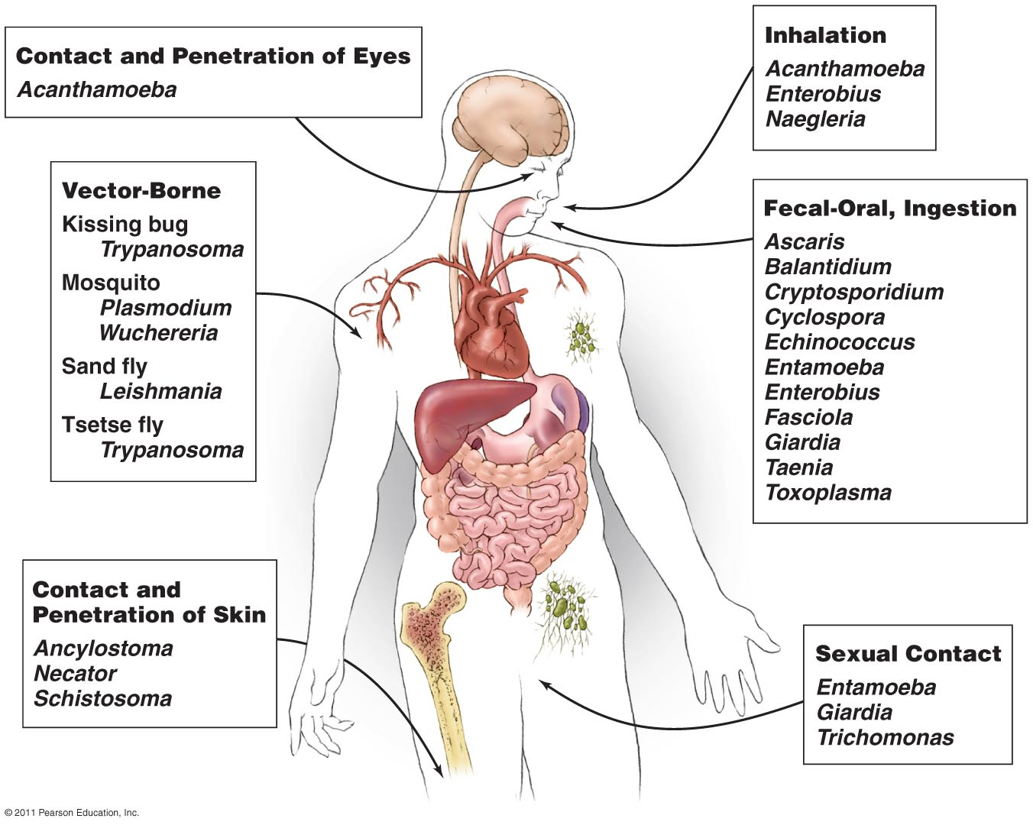

The basic factor of transmission of parasitic diseases:
Parasitic diseases Infectious diseases
- The source of the infection
- The routes of transmission
- The susceptible host
Disease terminology:
- Prepatency: infected but parasite presence can not be detected yet.
- Patency: established infection, parasite stages can be detected (malaria parasites in blood smears, worm eggs in feces etc.).
- Incubation period: time between infection and the development of symptoms (from one week to one year or more).
- Acute disease can lead to crisis which can resolve in spontaneous healing, chronic infection or death (fatal anaphylactic shock as a result of rupture of hydatid cyst & fluid released).
- Convalescence: Period after healing, absence of infectious agents, no symptoms, in certain case immunity to reinfection.
- A few parasitic infections have been shown to lead to malignancy e.g. Schistosoma haematobium may lead to bladder cancer.
Effects of the host on the parasites:
The host can produce certain degree resistance to parasites in human body or re-infection. The resistance (Immunity) is not very strong. In general, it doesn't wipe out parasites completely, but may limit the number of parasites and establish balance with parasites.
- Innate immunity
- Acquired immunity
Innate immunity:
- Barrier: Prevent parasites to invade in certain degree. Skin/Mucous membranes/Placenta.
- Acid in skin or stomach can cause damage of the parasites.
- Phagocytosis of phagocyte.
----Non-specific/effective against a wide range of parasitic infection/controlled by genetic factors, but not very strong!
Acquired immunity:
Mechanism: cellular and humoral immunity.
- Sterilizing immunity: Wipe out the parasites completely; meanwhile get a long-term specific resistance to re-infection. Rare!
- Non-sterilizing immunity: Wipe out most of the parasites, but not completely. Common!

Body syndromes against parasites:
- Heat syndromes: ( malaria )
- Dysenteric syndromes: (amoebiasis)
- Hepatic syndromes: ( hydatid cyst )
- Skin syndromes: ( lieshmaniasis )
Immune Evasion
All animal pathogens, including parasitic protozoa and worms have effective mechanism to avoid elimination by the host defense system.
Vaccination
No effective vaccine for humans has so far been developed against parasites due to their complex life cycles, adaptive responses, and antigenic variation.

The susceptible host:
In general, most people are the susceptible host (Why?). The parasite reaching a susceptible host must gain entrance and set up a favorable residence in order to complete its life cycle and cause the transmission of parasitic diseases.
The avenues of invasion:
- Digestive tract: Most common avenue of entrance. (Food/ Water transmission)
- Skin: Infective larvae perforate skin and reach to body and establish infection. (soil/ water transmission)
- Blood: Bloodsucking insects containing infective parasites bite the skin and inject parasites into human blood. (Arthropod transmission---malaria).
Pathogenesis: effects of parasites on the host
Parasitic infections may remain in-apparent or give rise to clinical disease. A few organisms, may live as surface commensals, without invading the tissue. Clinical infection produced by parasite may take many forms: acute, subacute, chronic, latent, or recurrent. Pathogenic mechanisms, which can occur in parasitic infections are:

Lytic necrosis: Enzymes produced by some parasite can cause lytic necrosis. Entamoeba histolytica lyses intestinal cells and produces amoebic ulcers.
Trauma: Attachment of hookworms on jejunal mucosa leads to traumatic damage of villi and bleeding at the site of attachment.
Allergic manifestations: Clinical illness may be caused by host immune response to parasitic infection, e.g. eosinophilic pneumonia in Ascaris infection and anaphylactic shock in rupture of hydatid cyst.
Physical obstruction: Masses of roundworm cause intestinal obstruction. Plasmodium falciparum malaria may produce blockage of brain capillaries in cerebral malaria.
Inflammatory reaction: Clinical illness may be
caused by inflammatory changes and consequent fibrosis e.g. lymphadenitis in filariasis and urinary bladder granuloma in Schistosoma haematobium infection.
Neoplasia: A few parasitic infection have been shown to lead to malignancy. The liver fluke, Clonorchis may induce bile duct carcinoma, and S. haematobium may cause urinary bladder cancer.

The prevention measures of the parasitic diseases:
- Controlling the source of the infection.
----Treatment of the patients, carriers and reservoir hosts.
- Intervention at the routes of transmission
----Managing feces and water resource, controlling or eliminating vectors and intermediate hosts.
- Protecting the susceptible hosts.
----Paying attention to personal hygiene, changing bad eating habit, taking medicine.
Laboratory Diagnosis
Laboratory diagnosis depends upon:
- Microscopy
- Culture
- Serological test
- Skin test
- Molecular method
- Animal inoculation
- Xenodiagnosis
- Imaging
- Hematology.

- Microscopy
An appropriate clinical specimen should be collected for definitive diagnosis of parasitic infections. Following specimens are usually examined to establish a diagnosis:
Stool, € Blood, Urine, Sputum, Cerebrospinal fluid (CSF), Tissue and aspirates, Genital specimens.
Kingdom: Animalia
- Protozoan unicellular
- Metazoan multicellular

Note:
- Many parasitic infections are associated with overcrowding, poor sanitation, contaminated food and water, under nutrition and other poverty-related factors.
- A major drawback in the fight against parasitic diseases is the inability to prevent them by immunization. No effective vaccine is currently available against any parasitic disease. However, host immunity is decisive in some parasitic infections.
- Increased susceptibility to many parasitic infections is a consequence of immunodeficiency, as in the HIV infected. Many new parasitic infections have been identified in AIDS patients in the developed countries.
- Control and eradication programmes had been carried out against some important parasitic diseases, such as malaria and filariasis, with varying degrees of success. But in many cases the benefits gained could not maintained and the situation has reverted to the original level or worse. This has been due to slackening of control measures or due to drug resistance in the parasite or its vector.

HELMINTH/WORM TERMINOLOGY
- Adults: sexually reproductive life cycle stage.
- Larvae: developmental or asexually reproductive life cycle stage.
- Eggs: stage protective of zygote &/or embryo.
- Cysts: usually a larval stage encapsulated in tissues of an intermediate host.
- Monoecious/hermaphroditic: both sexes in one body.
- Dioecious: sexes separate; males & females.
- Parthenogenesis: ability to produce offspring without fertilization of eggs.
- Oviparous: production of eggs, discharged from uterus of female.
- Viviparous or larviparous: production of eggs which hatch prior to discharge from uterus of female.

End of the lecture-1

