Parasitology Lecture: 7

Dr. Azhar 29/10/2019
(Page number 1-12)
Objectives of this lecture:
At the end of this lecture the student is able to:
- Describe the Guinea worm life cycle, infective form, clinical features, diagnosis, treatment and prevention.
- Define & Describe filaria & their species.
- Describe the Lymphatic filariasis life cycle, infective form, clinical features, diagnosis, treatment and prevention.

Dracunculus medinensis (Guinea worm, medina worm or serpent worm).
Disease: Dracunculiasis or Dracontiasis
Epidemiology:
- Present in the Nile Valley, northern Uganda & Kenya, Saudi Arabia, Yemen, Iraq, Iran, western India…….etc.
- Infects approximately 10 million people per year. The majority of human infections occur in parts of West Africa, East Africa, and India.
- 63% of cases, occurring in the Sudan.
Morphology:
- Adult worm resemble the filariae.
- The adult ♂ rarely recovered from humans. It measures up to 40 x 0.4 mm.
- The adult ♀ worm measures 70-120 cm. x 0.9- 1.7 mm. The vulva located near the mid-body.
- The ♀ is larviparous (rhabditoid larvae, the first stage, were seen).
- Both sexes develop to maturity in deep stomatic & visceral connective tissues.
- The prepatent period of development reach to12 months.
- Transmitted by ingestion of copepod (intermediate host).
- Reservoir hosts: canines and many other mammals.

Life cycle:
- The infection is caused by ingestion of water contaminated with water fleas (Cyclops) infected with larvae.
- The rhabditoid larvae penetrate the human digestive tract wall, lodge in the loose connective tissues and mature into the adult form in 10 - 12 weeks.
- In about a year, the gravid female migrates to the subcutaneous tissue of organs that normally come in contact with water.

- Papule is formed large blister, when immersion in water, the blister sloughs the anterior end of the worm ruptures &the motile rhabditoid larvae discharged into the water.
- Over a few weeks, this process may be repeated until the worm is sloughed.
- Larva (L1) measures 500-750 µm, motile in water.
- The larvae are picked up by copepods Cyclops, in which they develop into infective form (L3) in 2 - 3 weeks.
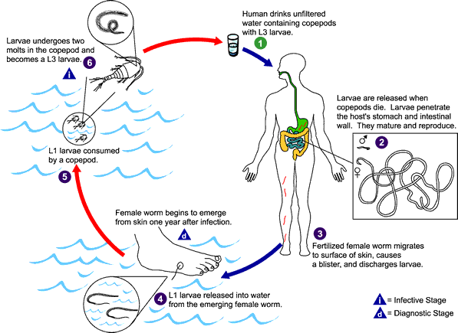
Humans become infected by drinking unfiltered water containing copepods (small crustaceans) which are infected with larvae of D. medinensis . Following ingestion, the copepods die and release the larvae, which penetrate the host stomach and intestinal wall and enter the abdominal cavity and retroperitoneal space . After maturation into adults and copulation, the male worms die and the females (length: 70 to 120 cm) migrate in the subcutaneous tissues towards the skin surface . Approximately one year after infection, the female worm induces a blister on the skin, generally on the distal lower extremity, which ruptures. When this lesion comes into contact with water, a contact that the patient seeks to relieve the local discomfort, the female worm emerges and releases larvae. The larvae are ingested by a copepod and after two weeks (and two molts) have developed into infective larvae . Ingestion of the copepods closes the cycle
Pathogenesis:
- No symptoms are produced in the infected person during the incubation period (1 year).
- After this, skin lesion, erythema, urticarial rash with intense pruritus, nausea, vomiting, diarrhea, dyspnea, giddiness & syncope.
- The lesion most frequently is on the feet & ankles, but may develop on hands, arms, trunk, shoulders and even the face.
- When the blister ruptures, the symptoms abate.
- Attempts to remove the worm by traction may reactivate the symptoms.
- Secondary infection is common.
- If the worm fails to reach the body surface dies & calcified.
- Infection with several worms is rare (in high endemic areas).
- The disability lasts usually for 1-3 months.
- Sometimes the worm travels to unusual sites such as pericardium, spinal canal or eyes with serious effects.
Diagnosis:
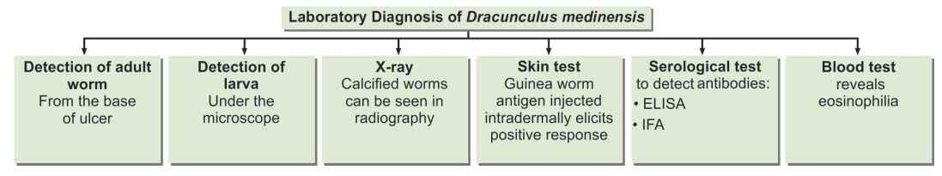
Treatment:
- Treatment includes the extraction of the adult guinea worm by rolling it a few centimeters per day or by multiple surgical incisions under local anesthesia.
- Metronidazole and thiabendazole are effective in killing the worm.
- Antihistamine or corticosteroids and antibiotics used for allergic reaction and reduce swelling so can ease removal of the worm.
Control:
- Protection of drinking water from being contaminated with Cyclops and larvae are effective, preventive measures by filter, boil, or treat water with chlorine to kill intermediate host.
- Meshed cloth or a filter made from a 0.15 mm nylon mesh, is all that is needed to filter out the copepods from the drinking water.
- Piped water prevents transfer of larvae from the water.
- People with an open Guinea worm wound should not enter ponds or wells used for drinking water. Also avoid bathing or wading in drinking water.

BLOOD AND TISSUE Nematodes (Filariae or microfilariae)
- Filariae parasitize various vertebrates including man.
- They have unique stage in their life cycle: microfilaria (L1).
- Adult live in various tissues of definitive host.
- Microfilaria larvae (L1) are motile & some of them migrate into the bloodstream, others accumulate in the skin.
- Bloodsucking arthropod is intermediate host in which it develops to infective stage (L3).
- The major blood and tissue are Wuchereria bancrofti, Brugia malayi,Onchocerca volvulus, Loa loa ) eye worm) and Mansonella spp.
According to the normal habitat of the adult worm, human filarial infections can be classified as follows:
- Lymphatic filariasis: Wuchereria bancrofti, Brugia malayi & Brugia timori.
- Subcutaneous filariasis: Onchocerca volvulus, Loa loa &Mansonella streptocerca.
- Serous cavity filariasis: Mansonella ozzardi & Mansonella perstans.
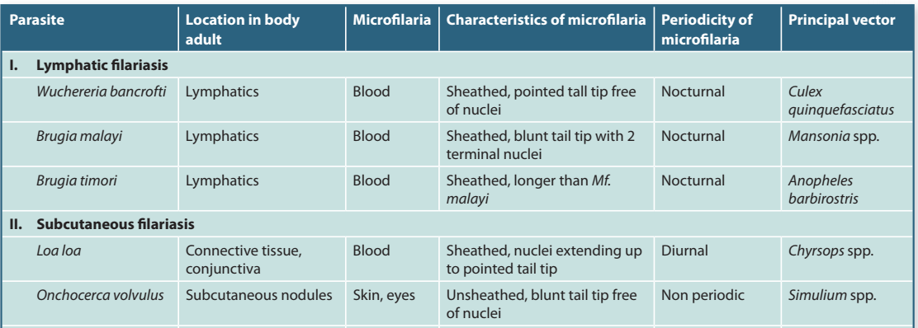

Infection with any of the filarial worms may be called filariasis, but traditionally, the term filariasis refers to lymphatic filariasis caused by Wuchereria & Brugia species.

Lymphatic filariasis:
Wuchereria bancrofti and Brugia malayi
Sheathed Microfilaria
Disease: Elephantiasis
Epidemiology:
- W. bancrofti is strictly a human pathogen and is distributed in tropical areas worldwide, whereas B. malayi infects a number of wild and domestic animals and is restricted to South-East Asia.
- Mosquitoes are vectors for both parasites.
- The largest number of cases occurs in India.
- W.bancrofti and B.malayi infect some 128 million people,
and about 43 million have symptoms.
- 95% of cases due to Wuchereria bancrofti, other species include Brugia malayi and Brugia timori.
- B.malayi infection is endemic in Asia (China, Corea, India, Indonesia, Malaysia, Philippines, Sri Lanka). W. bancrofti has a larger distribution: South-East Asia, Tropical Africa, Central and South America and Pacific Islands.
Wuchereria bancrofti
Disease: Bancroftian filariasis or Elephantiasis
Mosquito Culex intermediate host & vector.
Morphology:
- Adult worms usually found in lymph vessels. They are small & threadlike.
- The ♂ Measures 40x0.1 mm & the caudal part is curved sharply to the ventral side. It contains perianal papillae.
- The ♀ measures 80-100 x 0.24-0.30 mm, the vulva opens mid-ventrally. It is larviporous.
- The shell of the ova becomes elongated to accommodate the embryo & forms the sheath of the mature microfilaria that is discharged by the ♀ (so called sheathed microfilaria).
- Motile microfilariae make their way from lymphatics to bloodstream, in the peripheral blood with a marked nocturnal periodicity.
- The numbers of microfilariae are highest during the period 2 hours before & 2 hours after midnight. They are scant & absent during daylight hours (accumulate in the viscera, particularly in the lung).
- Microfilaria larva measures 244-296 µm, the anterior end rounded, the posterior end is tapered & the body enclosed in a large sheath.
- The wet blood films present in graceful curves. It present as a column of dark-staining nuclei. The head space is short & the tail is long.
Nocturnal periodicity: Phenomen which the number of microfilariae in peripherial blood is very low density during daytime, but increase from evening to midnight and reach the greatest density at 10 p.m to 2 a.m. May be related to cerebral activity and vaso-activity of pulmonary vessels.

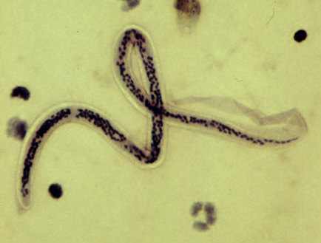
Sheathes microfilaria larva

Life cycle:
- Filariform larvae (L3) enter the human body during a mosquito bite (Anopheles & Culex) and migrate to various tissues.
- There, they may take up to a year to mature and produce microfilaria which migrate to lymphatics and, at night, enter the blood circulation.
- Mosquitoes are infected during a blood meal.
- The microfilaria grows 4 – 5 folds in the mosquito in 10 – 14 days and become infective for man.
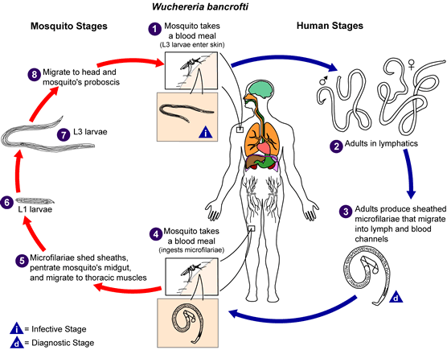
During a blood meal, an infected mosquito introduces third-stage filarial larvae onto the skin of the human host, where they penetrate into the bite wound. They develop in adults. that commonly reside in the lymphatics The microfilariae migrate into lymph and blood channels moving actively through lymph and blood. A mosquito ingests the microfilariae during a blood meal. After ingestion, the microfilariae lose their sheaths and some of them work their way through the wall of the proventriculus and cardiac portion of the mosquito's midgut and reach the thoracic muscles. There the microfilariae develop into first-stage larvae and subsequently into third-stage infective larvae. The third-stage infective larvae migrate through the hemocoel to the mosquito's prosbocis and can infect another human when the mosquito takes a blood meal.

Pathogenesis:
- Lymphangitis & lymphadenitis obstructs lymph channels
elephantiasis.
- Local &systemic sensitization.
- High fever every 8 – 10 weeks, which lasts 3 – 7 days.
- Hydrocoele due to obstruction of lymph vessels of the spermatic cord.
- Occult filariasis is due to hypersensitivity reactions to filarial antigens. Here microfilariae are not seen in blood, but may be present at the effected sites.
- There is progressive lymphadenitis due to an inflammatory response to the parasite lodged in the lymphatic channels and tissues.
- As the worm dies, the reaction continues and produces a fibro-proliferative granuloma which obstructs lymph channels and causes lymph edema and elephantiasis.
- Microfilaria causes eosinophilia and some splenomegaly.
- Not all infections lead to elephantiasis.
- The organs & tissues involved: groin gland, lower extremities one or both become elephantoid with redundant skin and external genitalia.
- Antifilarial antibodies of three classes (IgG, IgM & IgE) have been identified in patients with bancroftian filariasis.
- The lowest antibody levels were seen in patients with asymptomatic microfilaremia and the highest in microfilaremic persons, while the levels in chronic disease were intermediate.
- Pulmonary tropical eosinophilia syndrome, with nocturnal cough and wheezing, fever, and eosinophilia.

Diagnosis:
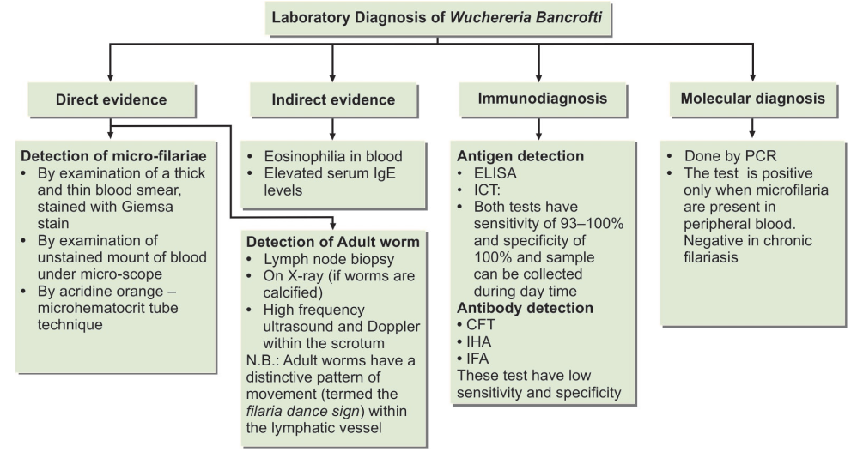
- Blood film at night (10 p.m- 2 a.m).
- Concentration techniques include centrifugation of the blood sample lyzed in 2% formalin or filtration through a Nucleopore membrane.
- Immunological tests.
- A commercially available whole-blood antigen card test (ICT) was used in Sri Lanka.
Treatment:
- Diethylcarbamazine (DEC) quickly kills microfilariae and will kill adult worms if given in full dosage over 3 weeks or sterilizes the female. This drug was given for patients and carriers.
- Mass treatment in endemic areas with DEC. DEC added to table salt (1:3000) for six months.
- Release of antigens from dying microfilaria causes allergic-type reactions – add an antihistamine and aspirin or steroids to alleviate inflammatory symptoms.
Control:
- Control vector (mosquito).
- Treated all carriers in an endemic area (source of infection).
- Rapid diagnosis and treatment of infected individuals.
- Mass drug administration at risk communities. The treatment may have to be repeated in endemic areas, every 2 years or so.
- As DEC is non-toxic, it can be safely administrated in combination with food items such as common salt.
- Personal protection against mosquito bites by insecticides, bed-nets and repellents.
Other sheathed microfilariae:
- Brugia malayi Malayan filariasis.
- Brugia timori Timoran filariasis.

The life cycle is similar to that of W. bancrofti, except that in most areas the principal mosquito vectors belong to the genus Mansonia.

End of the lecture-7

