Parasitology Lecture: 8
Dr. Azhar 30/10/2019
Onchocerca volvulus (Unsheathed Microfilariae) (Page number 1-9)
Objectives of this lecture:
At the end of this lecture the student is able to:
- Describe the River blindness causative agent, life cycle, infective form, clinical features, diagnosis, treatment and prevention.
- Describe the eye worm life cycle, infective form, clinical features, diagnosis, treatment and prevention.
- The immune response to helminthes & their evasion mechanisms.
Disease: Onchocerciasis or Blinding filariasis or River blindness
It aﬀects about 40 million people. Onchocerciasis is the second major cause of blindness in the world.
Epidemiology:
- Onchocerciasis is prevalent throughout eastern, central and western Africa, where it is the major cause of blindness.
- In the Americas, it is found in Guatemala, Mexico, Colombia and Venezuela on a worker on a coffee plantation.
- Man is the only definitive host.
- Black fly (Simulium) was the intermediate host& transmitter of the disease or vector.
- Reservoir hosts: large domestic animals, probably others.
- Prevalence variable, 5 to 80% in endemic areas near streams needed by black fly reproduction.
Morphology:
- Adults are long, slender & highly coiled.
- Adults a mated pair, are coiled up in the subcutaneous tissue as a nodules or tumor & occasionally the females found free in connective tissue.
- Some cases in which microfilariae are present in the skin without evidence of nodule.
- Adult ♂ measures 19-42 x 0.13-0.21 mm.
- Adult ♀measures 33-50 x 0.27-0.40 mm.
- The cuticle is modified to form annular thickenings in the female & a corrugated surface in male.
- The microfilaria lacks a sheath & measures about 309 x 5 –9 µm. The tail is attenuated & flexed, and non-periodic.
- The column of cells does not extend to the end of the tail.
- Microfilaria found in the upper layers of dermis, urine, the conjunctiva and rarely in peripheral blood.
Life cycle:
- The worm requires up to 1 year to reach sexual maturity & the microfilaria appear in the skin.
- The ♀ live for as long as 15 years & may be produce thousands of microfilariae each day.
- Life span in human of 1-2 years.
- Infective larvae are injected into human skin by the female black fly(Simulium).
- They develop into adult worms in 8 to 10 months.
- The adults usually occur as group of tightly coiled worms (2 - 3 females and 1 - 2 males).
- The gravid female releases microfilarial larvae, which are usually distributed in the skin.
- They are picked up by the black fly during a blood meal.
- The larvae migrate from the gut of the black fly to the thoracic muscle where they develop into infective larvae (L3) in 6 - 8 days.
- These larvae migrate to the head of the fly and then are transmitted to a second host.
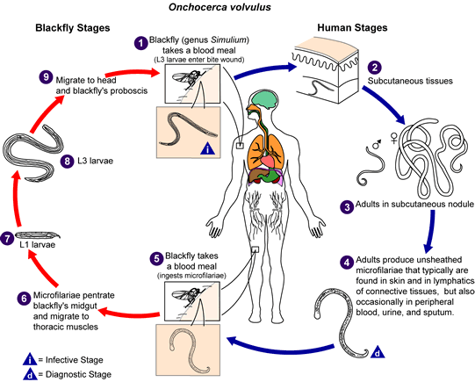
During a blood meal, an infected blackfly (genus Simulium) introduces third-stage filarial larvae onto the skin of the human host, where they penetrate into the bite wound. In subcutaneous tissues the larvae develop into adult filariae, which commonly reside in nodules in subcutaneous connective tissues. Adults can live in the nodules for approximately 15 years. Some nodules may contain numerous male and female worms. In the subcutaneous nodules, the female worms are capable of producing microfilariae for approximately 9 years. The microfilariae, unsheathed, have a life span that may reach 2 years. They are occasionally found in peripheral blood, urine, and sputum but are typically found in the skin and in the lymphatics of connective tissues. A blackfly ingests the microfilariae during a blood meal. After ingestion, the microfilariae migrate from the blackfly's midgut through the hemocoel to the thoracic muscles. There the microfilariae develop into first-stage larvae and subsequently into third-stage infective larvae. The third-stage infective larvae migrate to the blackfly's proboscis and can infect another human when the fly takes a blood meal.
Pathogenesis:
- Pathogenic potential moderate, dependent on death & decomposition of microfilariae.
- Clinical signs: adult clusters cause subcutaneous nodules, microfilariae cause blindness.
- Damage potential low/moderate, depending on host sensitivity, toxicity of worm ‘strain’, number and death/decomposition rate of larvae in eye.
- Sowda: term from Arabic word meaning black, it is important manifestation of localized onchocerciasis in Yemen. The affected area of skin is markedly pruritic, dark & thickened, shows a papular or pustular eruption. Sowda occurs predominantly in young adult males & localized limited to a lower limb. In females &children it tends to occur on the arms or back may be due to the different styles of dress & exposure to biting black flies.
- The mature adult causes local cellular reaction of a fibrotic nature
encapsulation of the worms which lie within the dense fibrous matrix single nodule or many.
- Dispersal of microfilariae into the dermal of the skin acute &chronic lesion.
- The nodules may develop on any part of the body, but are frequently located near the junction of long bones, on the pelvic arch, or on the head.
- Onchcercal nodule (Onchocercomas) In Africa nodules are usually found around the pelvic region, knees and lateral chest and spine . In Central American (except Venezuela) the nodules are commonly seen in the upper part of the body. The adult worms live in the subcutaneous tissues and in long – standing infection they form tangled masses inside fibrous nodules.
- Pruritus dermatitis.
- Atrophy, hypertrophy & abnormal pigmentation.
- Papular eruption with itching these may disappear spontaneously in a few weeks or months.
- Ocular complication are the most serious & dreaded consequences of onchocerciasis in some areas of Africa & Central America.
- Ocular involvement consists of trapping of microfilaria in the cornea, choroid, iris and anterior chambers leading to photophobia, hemorrage, lacrimation, degeneration of eye tissues and blindness.
- Lymphadenopathy.
- In some areas of Africa, individuals have hanging groin (a sac-like projection of loose, atrophied skin containing a mass of large, fibrotic, lymph gland that lead genital elephantiasis.
Diagnosis:
- Diagnosis is made by skin snip or skin biopsy of nodules.
- In patients with ocular manifestations, microflariae may be found in conjunctival biopsies.
- Serological tests are useful for the diagnosis of cases in which microflariae are not demonstrated in the skin:
-ELISA is more sensitive than skin snip tests. The test detects antibodies against specific onchocercal antigen.
-A rapid card test using antigen OV16 to detect IgG4 in serum has been evaluated.
- Molecular Diagnosis: PCR from skin snips is done in specialized laboratories and is highly sensitive and specific.

Treatment:
- Surgical removal of nodules (nodulectomy).
- Diethylcarbamazine is effective in killing the worm.
- Ivermectin for larvae.
Control:
Prevention measures include vector control (black fly) by insecticide.
Loa loa (African eye worm)
Sheathed Microfilariae
Disease: Loasis
Epidemiology:
- Loasis is limited to the areas of African equatorial rain forest.
- The life cycle of Loa loa is identical to that of Onchocerca except that the vector for this worm is the deer fly.
- The incidence in endemic areas varies greatly (8 - 75 %).
Morphology:
- The larger, female organisms are measure 40 to 70 mm in length and 0.5 mm in diameter.
- The males measure 30 to 34 mm in length and 0.35 to 0.43 mm in diameter.
- The circulating microfilaria is 300 µm by 7 µm.
- The microflariae are sheathed with column of nuclei extending completely to the tip of the tail.
- They appear in peripheral circulation only during the day from12 noon to 2 pm (diurnal periodicity).
Life cycle (للاطلاع)
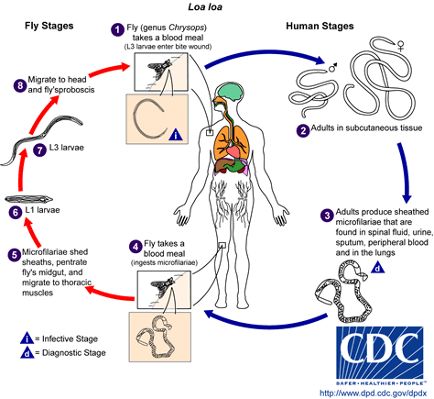
The vector for Loa loa filariasis is flies from two species of the genus Chrysops. During a blood meal, an infected fly (genus Chrysops, day-biting flies) introduces third-stage filarial larvae onto the skin of the human host, where they penetrate into the bite wound. The larvae develop into adults that commonly reside in subcutaneous tissue. Adults produce microfilariae measuring 250 to 300 μm by 6 to 8 μm, which are sheathed and have diurnal periodicity. Microfilariae have been recovered from spinal fluids, urine, and sputum. During the day they are found in peripheral blood, but during the non-circulation phase, they are found in the lungs. The fly ingests microfilariae during a blood meal. After ingestion, the microfilariae lose their sheaths and migrate from the fly's midgut through the hemocoel to the thoracic muscles of the arthropod. There the microfilariae develop into first-stage larvae and subsequently into third-stage infective larvae. The third-stage infective larvae migrate to the fly's proboscis and can infect another human when the fly takes a blood meal.
Pathogenesis:
- The infection results in subcutaneous (Calabar) swelling, measuring 5 to 10 cm in diameter, marked by erythema and angioedema, usually in the extremities.
- The organism migrates under the skin at a rate of up to an inch every two minutes.
- Consequently, the swelling appears spontaneously, persists for 4 to 7 days and disappears, and is known as fugitive or Calabar swelling.
- The worm usually causes no serious problems, except when passing through the orbital conjunctiva or the nose bridge.
Diagnosis:
Laboratory Diagnosis
Diagnosis rests on the appearance of fugitive swelling in persons exposed to infection in endemic area.
- Definitive diagnosis requires the detection of microflaria in peripheral blood or the isolation of the adult worm from the eye.
- Microflariae may be shown in peripheral blood collected during the day.
- The adult worm can be demonstrated by removal from the skin or conjunctiva or from a subcutaneous biopsy specimen from a site of swelling.
- High eosinophil count is common.
Treatment and control: are the same as those for onchocerciasis.

The immune response to helminthes:
Immune response is very difficult for these reasons:
- Multicellular parasites.
- Their size.
- Complex tissue and organ structure.
- Varied and active metabolism.
- Several forms of the parasites or stages.
- Multiple species.
The various stages of developing nematodes have stage-specific antigens, to which the host responds in various ways. Trematodes, cestodes and nematodes probably all share common antigens. Immunogenicity is a reflection of the degree and duration of parasite contact with the host's tissues. Commercially prepared vaccines are available only for nematodes. All are living worms, irradiated to arrest their development, but not their immunogenicity (ex. Vaccine against filariae).
- Most helminths extracellular & too large for phagocytosis.
- For the larger worms, e.g. some gastrointestinal nematodes host develops inflammation and hypersensitivity. Eosinophils & IgE activated to initiate inflammatory response in the intestine or lungs to expel the worms. These histamine elicited reactions are similar to allergic reactions.
- The acute response after previous exposure can involve an IgE and eosinophil mediated systemic inflammation which results in expulsion of the worms. Chronic exposure to worm antigens can cause chronic inflammation:
- Delayed type hypersensitivity (DTH), Th1 / activated macrophages which can result in granulomas.
- Th2 / B cell responses increase IgE, mast cells & eosinophils activate inflammation.
- Characteristic ADCC (Antibody-dependent cell-mediated cytotoxicity) reactions. Killer cells (e.g. macrophages, neutrophils, eosinophils) directed against target parasite by specific antibody, e. g. eosinophil killing of parasite larvae by IgE.

Helminth immune evasion strategies:
- Large size: Difficult for immune system to eliminate large parasites. Primary response is inflammation to initiate expulsion, often worms are not eliminated.
- Coating with host proteins: Tegument of cestode & trematode worms is able to adsorb host components, e.g. RBC Ags, thus giving the worm the immunological appearance of host tissue. Schistosomes take up host blood proteins, therefore, the worms are seen as “self”.
- Molecular mimicry: The parasite is able to mimic a host structure or function. e.g. schistosomes have E-selectin that may help in adhesion or invasion.
- Anatomical seclusion: Uniquely, even one nematode worm larva does this; Trichinella spiralis can live inside mammalian muscle cells for many years.
- Shedding or replacement of surface: e.g. trematodes& hookworms.
- Immunosupression: manipulation of the immune response. High burdens of nematode infection often carried with no outward sign of infection. Growing evidence that parasite secreted products include anti-inflammatory agents which act to suppress activation of effector's leukocytes e.g. a hookworm protein which inhibits neutrophil extravasation.
- Anti-immune mechanisms: e.g. liver fluke larvae secretes enzyme that cleaves antibody.
- Migration: e.g. Hookworms move about gut avoiding local inflammatory reactions.
- Production of parasite enzymes: Filarial parasites secrete a number of anti-oxidant enzymes which most likely contribute to their observed resistance to antibody-dependent cellular cytotoxicity and oxidative stress.

End of the lecture-8

