Parasitology Lecture: 6

Dr. Usama 23/ 10/2019

Strongyloides (Rhabditoidea group) (Page number 1-12)
Objectives of this lecture:
At the end of this lecture the student is able to:
- Define pseudoparasites, alternation of generations & parthenogenesis.
- Describe the Strongyloides stercoralis life cycle, infective form, clinical features, diagnosis, treatment and prevention.
- Analyze autoinfection's & their types.
- Describe the Trichinella spiralis life cycle, infective form, clinical features, diagnosis, treatment and prevention.
- Define self-cure phenomenon.

- Rhabditoidea is a large group containing mostly small, free-living forms; some of them are pseudoparasites in human.
- The parasitic members are unique because they have an alternation of free-living & parasitic generations.
- Adults of the free-living generation are dioecious.
- Adults of the parasitic generation are parthenogenetic female.
- Strongyloides stercoralis & Parastrongyloides are parasitized human.
Strongyloides stercoralis (Threadworm (
- Disease: Strongyloidiasis.
- Threadworm infection, also known as Cochin-China diarrhea, estimated at 50 - 100 million cases worldwide, is an infection of the tropical and subtropical areas with poor sanitation. Children highly affected to bad sanitation.
Morphology:
- The size and shape of threadworm varies depending on whether it is parasitic or free-living.
- The parasitic female is larger (2.7 mm x 30-40 µm) than the free-living worm (1 mm x 60 µm).
- Adult ♂ free living in soil with curved posterior end.
- Normal habitat of adult is the mucosal epithelium of the upper small intestine.
- Reproduction is parthenogenesis (without fertilization with sperm).
- Egg: ovoid and thin shelled 50-58 µm. It laid in the mucosal epithelium of the small intestine.
- Rhabditoid larva (L2) hatches into the lumen of the crypts of Leiberkühn (so the egg will not see in feces, but rhabditoid larva, L2, can be seen). Rhabditoid larva, contain mouth, feeding & have bulb short esophagus.

- L2 take 5-8 days L3: filariform larva (infective stage), not feeding, close mouth, elongated esophagus& sharply pointed tail.
- filariform larva enter by skin penetration,
Life cycle:
Alternative of generations:
- Free living generation (indirect development contains ♂ &♀).
- Parasitic generation (direct development contain ♀ only reproduces parthenogenesis). The infective larvae (L3) of S. stercoralis penetrate the skin of man, enter the venous circulation and pass through the right heart to lungs, where they penetrate into the alveoli. From there, the adolescent parasites ascend to the glottis, are swallowed, and reach the upper part of the small intestine, where they develop into adults. Ovipositing females develop in 28 days from infection. The eggs in the intestinal mucosa hatch and develop into rhbditoid larvae in man.
- These larvae can penetrate through the mucosa and cycle back into the blood circulation, lung, glottis and duodenum and jejunum; thus they continue the auto infection cycle. Alternatively, they are passed in the feces, develop into infective filariform larvae and enter another host to complete the direct cycle.
- If no suitable host is found, the larvae mature into free-living worm and lay eggs in the soil (temperature and moisture is required). The eggs hatch in the soil and produce rhbditoid larvae which develop into infective filariform larvae and enter a new host (indirect cycle), or mature into adult worms to repeat the free-living cycle.

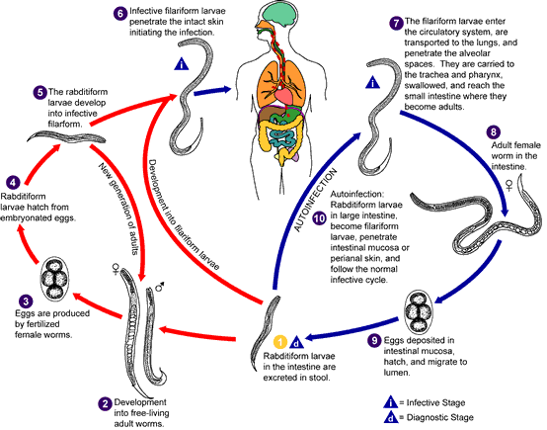
The Strongyloides life cycle is complex among helminthes with its alternation between free-living and parasitic cycles, and its potential for autoinfection and multiplication within the host. Two types of cycles exist: Free-living cycle: The rhabditiform larvae passed in the stool (1) (see "Parasitic cycle" below) can either molt twice and become infective filariform larvae (direct development) (6) or molt four times and become free living adult males and females (2) that mate and produce eggs (3) from which rhabditiform larvae hatch (4). The latter in turn can either develop (5) into a new generation of free-living adults (as represented in (2)), or into infective filariform larvae (6). The filariform larvae penetrate the human host skin to initiate the parasitic cycle (see below) (6). Parasitic cycle: Filariform larvae in contaminated soil penetrate the human skin (6), and are transported to the lungs where they penetrate the alveolar spaces; they are carried through the bronchial tree to the pharynx, are swallowed and then reach the small intestine (7). In the small intestine they molt twice and become adult female worms (8). The females live in the epithelium of the small intestine and by parthenogenesis produce eggs (9), which yield rhabditiform larvae. The rhabditiform larvae can either be passed in the stool (1) or can cause autoinfection (10). In autoinfection, the rhabditiform larvae become infective filariform larvae, which can penetrate either the intestinal mucosa (internal autoinfection) or the skin of the perianal area (external autoinfection); in either case, the filariform larvae may follow the previously described route, being carried successively to the lungs, the bronchial tree, the pharynx, and the small intestine where they mature into adults; or they may disseminate widely in the body. Autoinfection may explain the possibility of persistent infections for many years in persons who have not been in an endemic area and of hyperinfections in immunodepressed individuals.
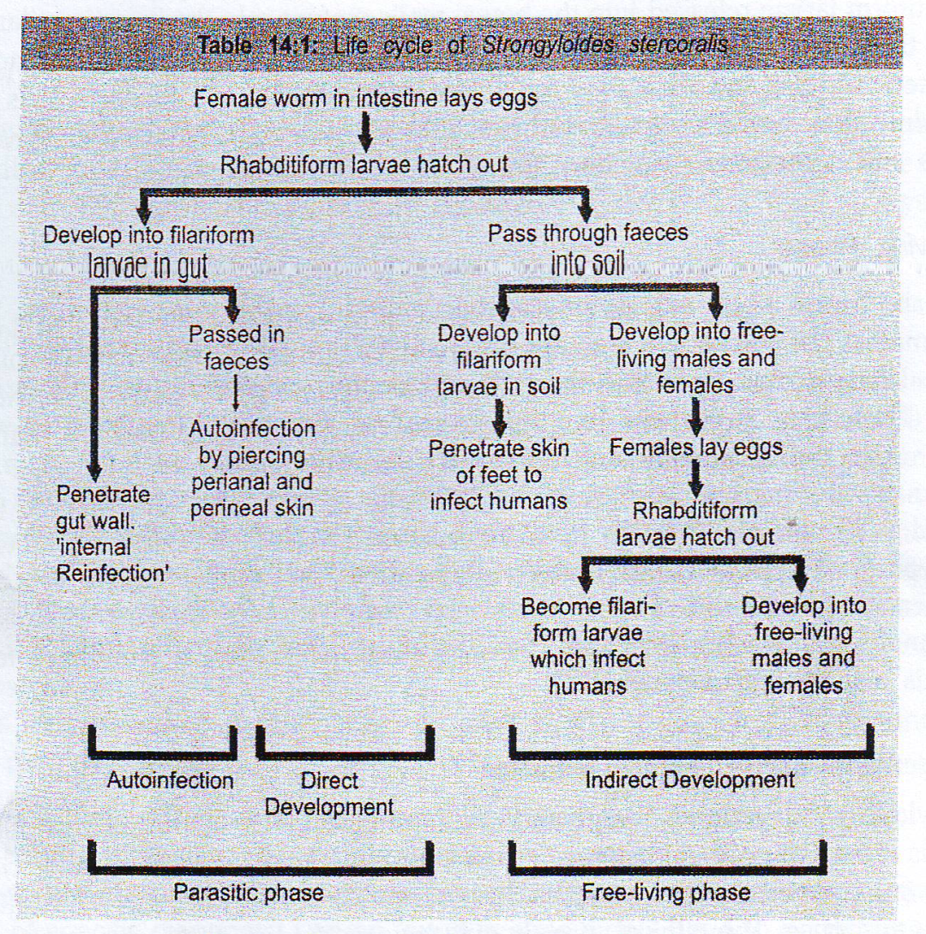

Autoinfection:
- Internal- autoinfection: larvae can penetrate the mucosa of the colon without leaving the body.
- External- autoinfection.
Autoinfection occurs at low level healthy individuals.
Pathogenesis &Clinical features:
- Strongyloidiasis is generally benign and asymptomatic, but it may sometimes cause clinical manifestations, which may be severe and even fatal, particularly in those with defective immune response or immunocompromised (AIDS-patients).
- Cutaneous: there may be dermatitis, erythema & itching.
- Larva currens: is the term applied to the cutaneous lesions observed in chronic strongyloidiasis. They are broad, rapidly developing urticarial trails, often starting at or near the anus. These often follow autoinfection with Strongyloides filariform larvae which moves rapidly (2 ─ 10 cm/hr) and lasts shorter than CLM.
- Pulmonary lesions: caused by larva migrans. Larvae may be found in the sputum.
- Intestinal infection: caused abdominal pain, peptic ulcer and diarrhea. In heavy infection, the mucosa may be honeycombed with the worm and there may be extensive sloughing, causing dysenteric stools.
- In fatal cases: moderate to severe lesions may be found in the colon, liver, kidney, heart, lymph nodes, CNS and other organs. It has been reported that circulating Strongyloides larvae may carry intestinal bacteria causing septicemia.

Diagnosis:
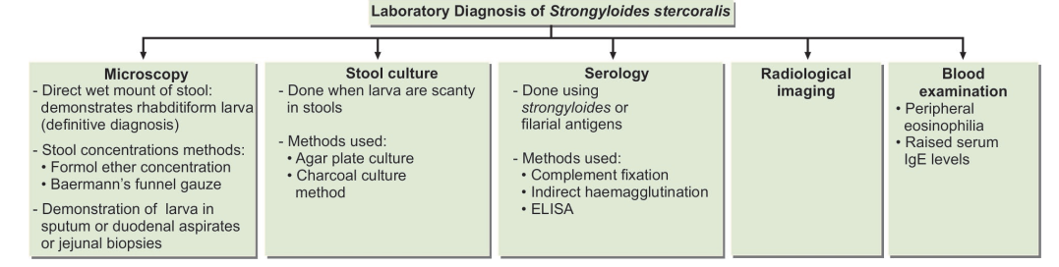
Causes of limitations of serological tests:
- Cannot distinguish between past and present infections.
- Larval antigens are not freely available.
- There is extensive cross reactions with other helminthic infections.

Treatment:
Thiabendazole & albendazole (all cases, whether symptomatic or not should be treated to prevent severe invasive disease).

Control:
Sanitation (prevent contamination of soil with human feces).

Trichinella spiralis (trichina wormتراخينا )
Disease: Trichinosis
Epidemiology trichinosis is acquired from eating poorly cooked pork & meat.
Trichinella &related species (Trichuris &Capillaria) their anterior end filiform & filled with linearly arranged large cells (stichocytes), and the collection of them known as stichosome (serve as muscle for esophagus).
Morphology:
- Adult is minute.
- The adult ♂ measured 1.4-1.6 mm. cloacal opening is terminal & guarded by a pair of conical papillae.
- The adult ♀ measures 2.2-3.5 mm x 60 µm with club-shaped posterior end.
- Transmitted by eaten raw or undercooked meat containing infective stage (encapsulated L1 in tissues).
- The larvae in the tissue (100 x 5 µm) are coiled in a lemon-shaped capsule.
Trichinella Cyst:
- Cysts are ovoid 400 µm by 250 µm in size.
- The cyst is formed by the tissue reaction around the encapsulated larvae.
- Cysts develop preferentially in muscles relatively poor in glycogen and in hypoxic environment. Therefore, the diaphragm, biceps, muscles of jaw, extraocular muscles, neck, and lower back, which are constantly active, are the ones mostly affected.
- Cysts are more abundant near the sites of attachment of muscles to tendons and bones than in other parts.
- The larva remains infective inside the cyst for years and eventually, most become calcified and die.
Life cycle:
- Infection occurs by ingestion of larvae, in poorly cooked meat, which immediately invade small intestine mucosa where they develop into adult worms and sexually differentiate within 18 to 24 hours.
- The female, after fertilization, burrows deeply in the small intestinal mucosa, whereas the male is dislodged.
- On about the 5th day eggs begin to hatch in the female uterus and young larvae are deposited (larviparaous) in the mucosa from where they reach the lymphatics, lymph nodes and the blood stream (larval migration).
- Larval dispersion occurs 4 to 16 weeks after infection.
- The larvae are deposited in muscle fiber and in striated muscle; they form a capsule which calcifies to form a cyst.
- In non-striated tissue, such as heart and brain, the larvae do not calcify; they die and disintegrate.
- The cyst may persist for several years.
- One female worm produces approximately 1500 larvae.
- Rats and rodents are primarily responsible for maintaining the endemicity of this infection.
- Man is the terminal host.
- The reservoir includes most carnivorous and omnivorous animals, such as pigs or bears, feed on infected rodents or meat from other animals.
- Humans are accidentally infected when eating improperly processed meat of these carnivorous animals.
- Human acts as intermediate and definitive host.
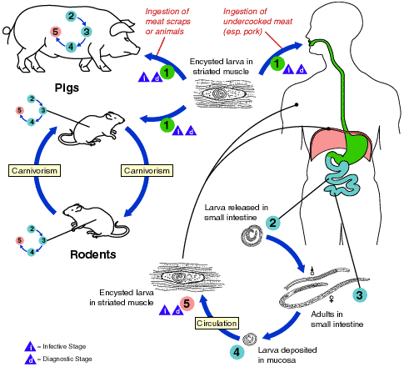
Trichinellosis is acquired by ingesting meat containing cysts (encysted larvae) of Trichinella. After exposure to gastric acid and pepsin, the larvae are released from the cysts and invade the small bowel mucosa where they develop into adult worms Their life span in the small bowel: 4 weeks. After 1 week, the females release larvae that migrate to the striated muscles where they encyst . Encystment is completed in 4 to 5 weeks and the encysted larvae may remain viable for several years. Ingestion of the encysted larvae perpetuates the cycle. Rats and rodents are primarily responsible for maintaining the endemicity of this infection. Carnivorous/omnivorous animals, such as pigs or bears, feed on infected rodents or meat from other animals. Different animal hosts are implicated in the life cycle of the different species of Trichinella. Humans are accidentally infected when eating improperly processed meat of these carnivorous animals (or eating food contaminated with such meat).
Pathogenesis & Symptoms
- Trichinosis symptoms depend on the severity of infection: light or mild infections may be asymptomatic.
- A larger numbers of infections produce symptoms according to the severity and stage of infection and organs involved.
- There are 3 stages of infection: stage of intestinal invasion (enteric phase), stage of muscle invasion (migratory phase) myositis (striations of muscles disappear) and stage of encapsulation (encystment phase: lasting for 1-8 months, the cysts calcified).
- Heavy infection produce:
❑ Myositis (striations of muscles disappear). Larva migration cause necrosis & fragmentation of these fibers followed by fibrocytic repair, also these occur in other organs (brain, eyes & lungs).
- Symptoms of acute food poisoning (adult).
- Dyspnoea.
- Fever.
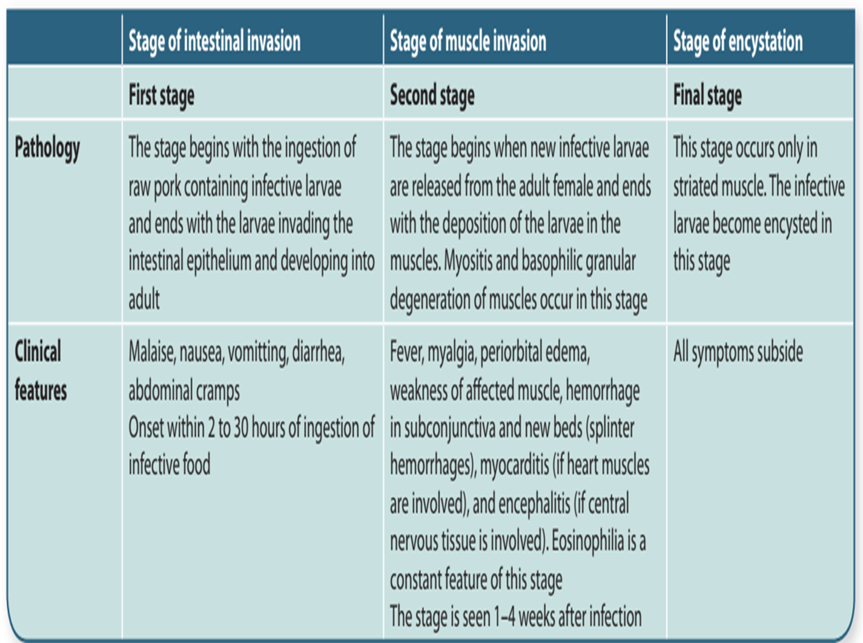

Trichinosis symptomatology
Brain and meninges  (14-28 days) | Myocardium  (10-21 days) | Circulation and muscle  (10-21 days) | Intestinal mucosa  (24-72 hrs)
Headache (supraorbital), vertigo, tinnitus, deafness, mental apathy, delirium, coma, loss of reflexes. | Chest pain, tachycardia, edema of extremities, vascular thrombosis. | Edema, peri-orbital conjunctivitis, photo phobia, fever, chill, sweating, muscle pain, spasm, eosinophilia. | Nausea, vomiting diarrhea, abdominal pain, headache.

Immunity:
- Positive skin tests for immediate and delayed hypersensitivity.
- Diagnostic antibody.
- An important expression of host resistance is active expulsion of developing or adult worms from the gut of a parasitized host (self-cure phenomenon). This occurs when a new infection initiates a host response, resulting in elimination of the old infection.
Diagnosis:
Diagnosis can be made by direct and indirect methods:
Direct Methods
1- Detection of spiral larvae in muscle tissue by performing muscle biopsy. Deltoid, biceps, gastrocnemius, or pectoralis muscles are usually selected for biopsy.
2- Detection of adult worms and larvae in the stool during the diarrheic stage.
3- Xenodiagnosis: For xenodiagnosis, biopsy bits are fed to laboratory rats, which are killed a month or so, later. The larvae can be demonstrated more easily in the muscles of such infected rats.
Indirect Methods
1- History of consumption of raw or inadequately cooked or processed pork, about two weeks earlier along with a recent episode of gastroenteritis.
2- Blood examination: It shows eosinophilia (20-95%).
3- Serology:
- There is massive hypergammaglobulinemia with elevated serum IgE. T. spiralis antibody can be detected by enzymelinked immunosorbent assay (ELISA) test using TSL-1 secreting antigens obtained from the infective stage larvae.
- Bentonite flocculation test and latex fixation test for demonstration of antibodies have also been widely used. A positive test indicates recent infection.
- Bachman intradermal test: It uses a 1:5,000 or 1:10,000 dilution of the larval antigen. An erythematous wheal appears in positive cases within 15–20 minutes. The test remains positive for years after infection.
- Radiological examination: Calcified cysts may be demonstrated on X-ray examination.
6- Molecular methods like multiplex polymerase chain reaction (PCR) are now being used for species identification of Trichinella.

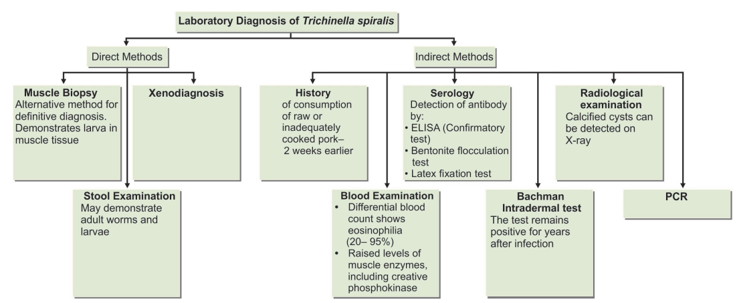
Treatment:
Mebendazole and albendazole are active against enteric stage of the parasite, but their
efficacy against encysted larva has not yet been completely demonstrated.
Control:
Deep freezing and well cooking of meat are the best ways of avoiding infection.

End of the lecture-6

