Parasitology Lecture: 5
Dr. Usama 22/ 10/2019

Larva Migrans (Page number 1-7)

Objectives of this lecture:
At the end of this lecture the student is able to:
- Define the term larva migrans & list its types.
- List the etiological agents of larva migrans.
- Describe their clinical features, diagnosis, treatment and prevention.

Larva Migrans: is the migration of larval helminthes in hosts that are suitable for long survival, but are unsuitable for their development to the mature adult stage (encapsulated in host's tissues) (paratenic hosts). This is generally seen when human infection occurs with human or nonhuman species of nematodes & other helminthes.
Types of Larva Migrans:
- Cutaneous larva migrans (Caused by human & nonhuman hookworms & Strongyloides)
- Visceral larva migrans Caused by Toxocara (nematodes of dogs &cats), Ascaris, hookworms& Strongyloides.
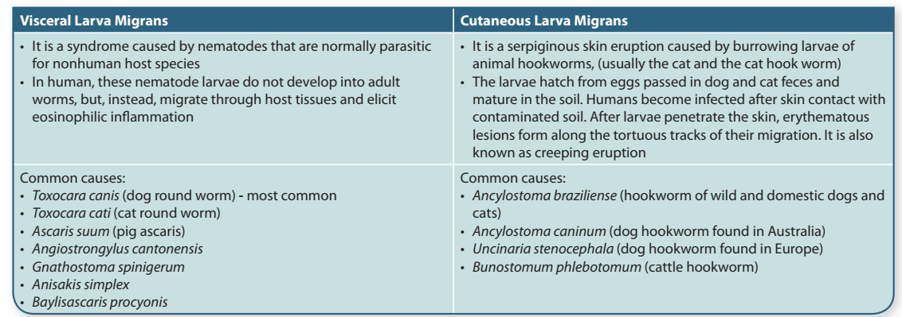
Cutaneous larva migrans (Creeping eruption)
- Causative agents: Filariform larvae (L3) of hookworms of dogs and cats (Ancylostoma braziliense & A. caninum) & Strongyloides spp.
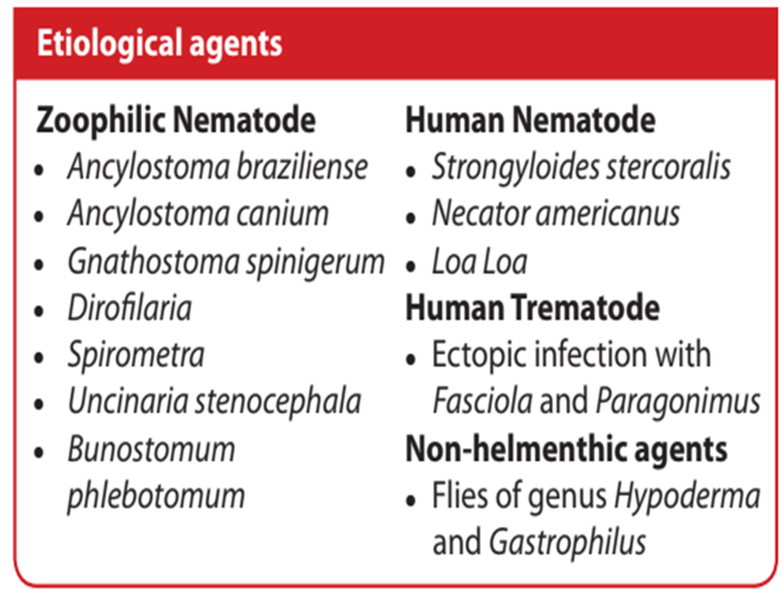

Pathogenesis:
Nematode larvae produce
- Itching.
- Pruritic.
- Reddish papules at the site of skin entry, a condition referred to as creeping eruption. As the larvae migrate through skin advancing several millimeters to a few centimeters a day, intensely pruritic, serpiginous tracks or bullae are formed. Larval activity can continue for several weeks or months, but eventually is self-limiting.
- An advancing serpiginous tunnel in the skin with an associated intense pruritus is virtually pathognomonic.
- At times serious systemic illness.
- Later migrate to the deeper tissue caused Pneumonitis & may invade cornea.
- Creeping eruption is rapid progression (10cm / hour) and the lesions disappear after several hours or days and reappear at different locations.
- Larva currens: is the item applied to the cutaneous lesion observed in chronic strongyloidiasis. They are broad, rapidly developing urticarial trails, often starting at or near the anus.
Diagnosis:
- Diagnosis usually is made clinically, biopsies are not indicated.
- Biopsy specimens typically demonstrate an eosinophilic inflammatory infiltrate, but the migrating parasite is not distinguished.
Treatment:
- The disease usually is self-limited, with spontaneous cure after several weeks or months.
- Orally administered albendazole or thiabendazole is the recommended therapy.
- Antihistaminic drugs.
- Antipruritics drugs.
Control:
- De-worming of dogs and cats.
- Elimination of stray animals.
Visceral larva migrans
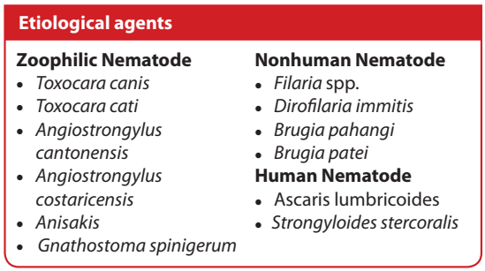
- Visceral larva migrans is an infection caused by certain parasites found in the intestines of dogs and cats.
- Persons who swallowed dirt contaminated with dog or cat feces can catch the infection.
- It caused by Toxocara (nematodes of dogs &cats) and Ascaris, hookworms and Strongyloides.
- Ascaris, hookworms and Strongyloides invade only liver & lungs (limited to the period required for larva development).
- Toxocara (Toxocara canis dog roundworm and Toxocara catti roundworms of cats) caused lesions in liver, brain & other organs including eye.
- Toxocara larva caused varies symptoms from asymptomatic to a syndrome of hypereosinophilia, hepatomegaly, moderate pulmonary infiltrations, fever, cough & hyperglobulinemia.
Toxocara canis Dog roundworm and
Toxocara catti roundworms of cats
- They can infect humans and cause damage of the visceral organs.
- Eggs from feces of infected animals are swallowed by man and hatch in the intestine.
- The larvae penetrate the mucosa, enter the circulation and are carried to liver, lungs, eyes and other organs where they cause inflammatory necrosis.
- Symptoms are due to the inflammatory reaction at the site of infection.
- The most serious consequence of infection may be loss of sight if the worm localizes in the eye.
Life cycle: (للاطلاع)

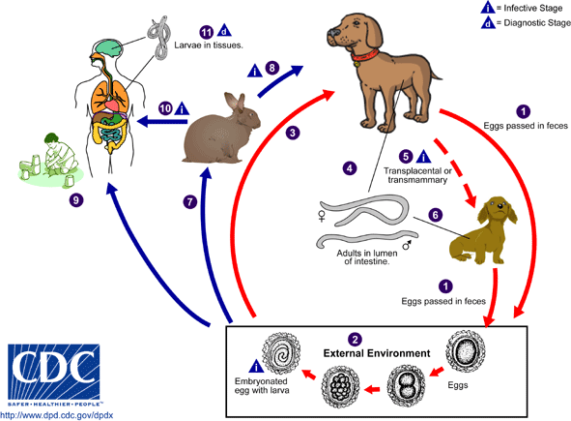

Pathogenesis:
- Weakness
- Pruritis
- Rash/uriticaria
- Dyspnoea
- Abdominal pain
- Dizziness
- Cough
- Weight loss
- Fever
- Eosinophilia
- Most human infections are mild enough to go unnoticed and apparently produce no permanent damage.
- Humans are accidental hosts of Toxocara, yet toxocariasis is seen throughout the world.
- Most cases of toxocariasis are seen in people under the age of twenty.
- Young children are at the greatest risk of infection because they play outside and tend to place contaminated objects and dirt in their mouths.
- Dog ownership is another known risk factor for transmission.
- There is also a significant correlation between high Toxocara antibody titers and epilepsy in children.
Diagnosis:
- Because the diagnosis usually is made clinically, biopsies are not indicated.
- Biopsy specimens typically demonstrate an eosinophilic inflammatory infiltrate, but the migrating parasite is not visualized.
- Eosinophilia occurs in some cases.
- Larvae have been detected in sputum and gastric washings in patients with the rare complication of pneumonitis.
- Serological test (ELISA) for larva antigen or Western blot analysis using antigens of Ancylostoma caninum are available in research laboratories, but use is not warranted routinely.
Treatment:
Thiabendazole & mebendazole to eliminate the worm and prednisone for
inflammatory symptoms.
Control:
- De-worming of dogs and cats.
- Carefully washing the hands after touching dirt and soil is very important.
- Hand washing before eating and after playing with pets, as well as after handling dirt will reduce the chances of ingesting Toxocara eggs.
- Washing all fruits and vegetables.
- Finally, teaching children not to place nonfood items, especially dirt, in their mouths will drastically reduce the chances of infection.
Larva migrans caused by other helminthes:
- Gnathostoma spp. & Spirometra (cestodes) spargonum larva.
- Alaria (trematodes) mesocercaria larva.
These parasites have been recovered from subcutaneous tissue of man & occasionally found in the tissue of man.

End of the lecture-5

