Parasitology Lecture: 4
Dr. Azhar 9 /10/2019

Hookworms (Page number 1-8)
Objectives of this lecture:
At the end of this lecture the student is able to:
- Define & list of the hookworms.
- Describe the hookworms natural host, infective form, clinical features, diagnosis, treatment and prevention.
Hookworms are the voracious blood feeders of the nematode world.
- Two principal species that infect around 900 million people on earth are:
-Necator americanus known as the american killer also known the New world hookworm.
-Ancylostoma duodenale known as the Old world hookworm.
- Prevalence world-wide, in tropics, subtropics, and warm temperate regions; some zonal variation by species.
- Definitive host: Human
- No Intermediate host
- Hookworms parasitize more than 900 million people worldwide and cause daily blood loss of 7 million liters.
- Habitat:The adult worms live in the small intestines of infected persons, mostly in the jejunum, less often in the duodenum, and infrequently in the ileum.
- N. americanus is most common in the Americas, central and southern Africa, southern Asia, Indonesia, Australia and Pacific Islands. A. duodenale is the dominant species in the Mediterranean region and northern Asia.
- In recent times, movement of infected persons has blurred the geographic differences in distribution of the two species. For example, A. duodenale is now commonly seen along with N. americanus in South India and South East Asia.
- Ancylostomiasis is the most prevalent hookworm infection and is second only to ascariasis in infections by parasitic worms.

Necator americanus (New World hookworm).

Disease:Uncinariasis (old name Uncinaria americana) or Necatoriasis.

Morphology:
- Worm strongly flexed dorsally at the anterior end of ♂ and ♀.
- The anterior end (buccal capsule) is armed with a pair of curved, ventral cutting plates, 2 poorly developed dorsal plates, and a medium dorsal tooth & in the mouth cavity a pair of short triangular lancets.
- Opening into buccal capsule a pair of cephalic (amphidial) glands which secrete an anticoagulant.
- Muscular esophagus bears a dorsal gland &paired ventrolateral glands. They secrete proteolytic enzymes.
- Adult female is about 11 x 0.4 mm, posterior end sharply conical and the vulvar opening is midventral.
- Males are smaller, is about 7-9 x 0.3 mm. the posterior end called copulatory bursa.
- Copulatory bursa: It is symmetrical, supported with rays & contains 2 copulatory spicules that are fused at their outer ends, terminating in a barb.
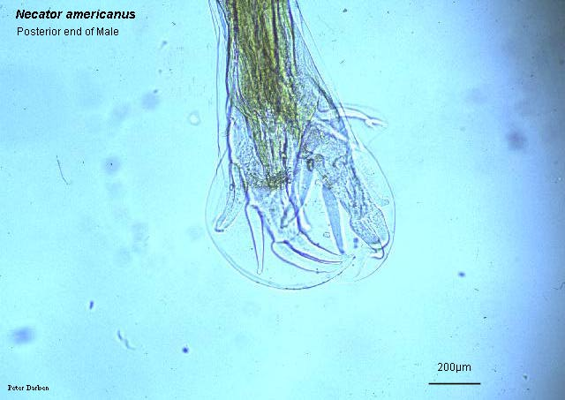
2 copulatory spicules

Ancylostoma duodenale (Old World hookworm).
Disease: Ancylostomiasis
Morphology:
- Adult worm: pinkish in color, the body is narrowed interiorly with the head curved dorsally.
- The cup-shaped mouth capsule (buccal capsule) is forward with 2-pairs of curved, ventral subequal teeth. In the depth of the capsule there is a pair of small teeth. Dorsally there is a plate with a medium cleft.
- ♂ measured 8-11x0.4-0.5 mm. Its copulatory bursa is broader than its long & supported by rays contain 2 separated copulatory spicules.
- In both, egg: thin shelled transparent, ovoid & measures 64-76 µm in early stages (4-celled) of cleavage when laid in several hours may reach the early larval stage, then hatching in 24-48 hrs to L1.
- L1 take 24-48 hrs. L2: rhabditoid larva, contain mouth, feeding & have bulb short esophagus.

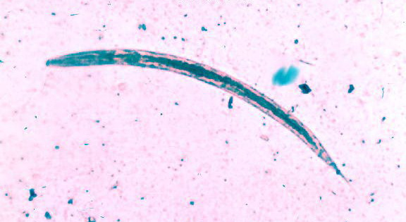
Bulb short esophagus
- L2 take 5-8 days L3: filariform larva (infective stage), not feeding, close mouth, elongated esophagus& sharply pointed tail.
- filariform larva enter by skin penetration, swallowing it dose not establish with Necator, but it does with Ancylostoma.

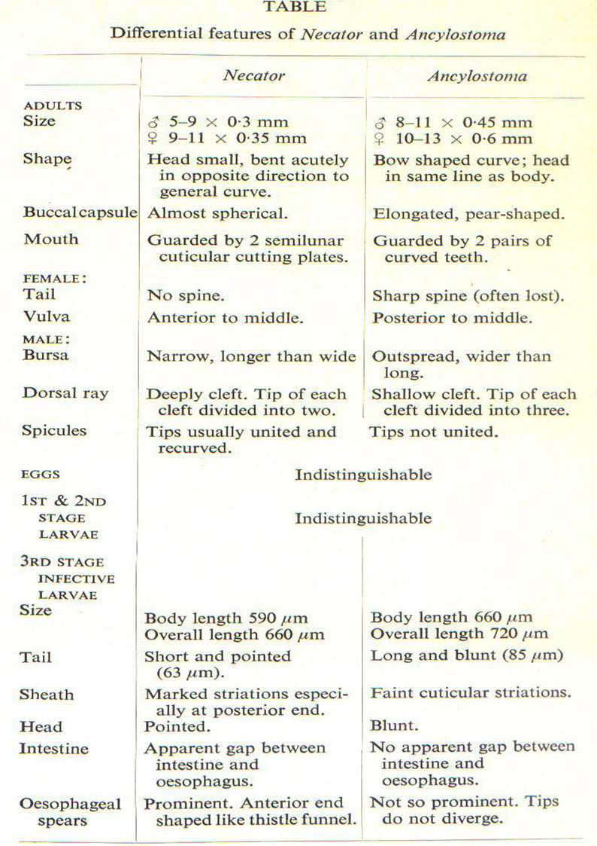
Life cycle:
- The life cycle of hookworms is identical to that of threadworms, except that hookworms are not capable of a free-living or auto-infectious cycle.
- Furthermore, A. duodenale can infect also by oral route.
- Eggs are passed in the stool and under favorable conditions (moisture, warmth, shade), larvae hatch in 1 to 2 days.
- The released rhabditiform larvae grow in the feces and/or the soil.
- After 5 to 10 days (and two molts) they become filariform (third-stage) larvae that are infective. These infective larvae can survive 3 to 4 weeks in favorable environmental conditions.
- On contact with the human host, the larvae penetrate the skin and are carried through the veins to the heart and then to the lungs. They penetrate into the pulmonary alveoli, ascend the bronchial tree to the pharynx, and are swallowed.
- The larvae reach the small intestine, where they reside and mature into adults. Adult worms live in the lumen of the small intestine, where they attach to the intestinal wall with resultant blood loss by the host.
- Most adult worms are eliminated in 1 to 2 years, but longevity records can reach several years.
- Some A. duodenale larvae, following penetration of the host skin, can become dormant (in the intestine or muscle).
- In addition, infection by A. duodenale may probably also occur by the oral, transmammary and probably transplacental route.
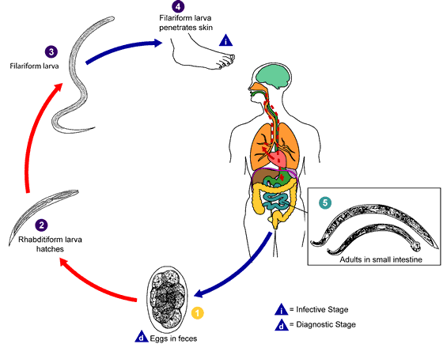
Eggs are passed in the stool (1), and under favorable conditions (moisture, warmth, shade), larvae hatch in 1 to 2 days. The released rhabditiform larvae grow in the feces and/or the soil (2), and after 5 to 10 days (and two molts) they become filariform (third-stage) larvae that are infective (3). These infective larvae can survive 3 to 4 weeks in favorable environmental conditions. On contact with the human host, the larvae penetrate the skin and are carried through the veins to the heart and then to the lungs. They penetrate into the pulmonary alveoli, ascend the bronchial tree to the pharynx, and are swallowed (4). The larvae reach the small intestine, where they reside and mature into adults. Adult worms live in the lumen of the small intestine, where they attach to the intestinal wall with resultant blood loss by the host (5). Most adult worms are eliminated in 1 to 2 years, but longevity records can reach several years.

Pathogenesis & Clinical features of hookworm disease
Site | Symptoms | Pathogenesis
Dermal | Local erythema, macules, papules (ground itch) | Cutaneous invasion and subcutaneous migration of larva
Pulmonary | Bronchitis, pneumonitis and, sometimes, eosinophilia (Löffler`s syndrome) | Migration of larvae through lung, bronchi, and trachea
Gastro- intestinal | Anorexia, epigastric pain and gastro-intestinal hemorrhage | Attachment of adult worms and injury to upper intestinal mucosa
Hematologic | Iron deficiency, anaemia, hypoproteinemia, edema, cardiac failure | Intestinal blood loss
Causes of anemia in Hookworm infection
- Blood sucking by the parasite for their food.
- Chronic hemorrhages from the punctured sites from
jejunal mucosa.
- Deficient absorption of vit. B12 and folic acid.
- Depression of hemopoitic system by deficient intake of proteins.
- Average blood loss by the host per worm per day is
0.03 mL with N. americans and 0.2 mL with A. duodenale.
With iron deficiency, hypochromic microcytic anemia is caused and with deficiency of both iron and vit. B12 or folic acid, dimorphic anemia is caused.
- Löffler`s syndrome: larval migration through the lung reach the pulmonary capillaries from cutaneous venules, penetrate into air sacs led to tissue damage & in massive migration led to pneumonitis, cough, dyspnea, high eosinophilia, nausea & vomiting. The x-ray showing scattered, shifting mottling of the lungs. This picture variable from day to day and spontaneously clears after a few days-2 weeks.
- Hookworms move several times a day to different attachment sites in the upper intestinal mucosa to ingest blood.
- They secrete an anticoagulant which causes the old attachment sites to continue to bleed.
- Heavy hookworm infection results in chronic haemorrhage from the duodenal and jejunal mucosa.
- The combination of constant blood loss due to hookworm infection and poor iron intake in the diet results in iron deficiency anaemia.
- A. duodenale ingests 4-5 times more blood each day than N. americanus.
- In a child, the continued daily loss of 10 ml of blood can lead to severe anaemia.
- Hookworm anaemia leads to dullness, affecting the working and learning capacities of patients.
- The haemoglobin level may drop drastically causing a characteristic sallow appearance of the skin, conjunctiva and tongue.
- Severe hookworm anaemia commonly leads to cardiac failure. Patient with exertional dyspnoea, palpitation, dizziness and generalized puffy oedema.
- Hookworm infection depends on three factors:
1) Number of worms present
2) Species of hookworm
3) Nutritional conditions of the infected person.
- In general fewer than 25 N. americanus in person will cause no symptoms. 500-1000 result in severe symptoms and more than 1000 may lead fatal consequences.
- Ancylostoma spp. suck more blood than N. americanus fewer worms cause greater disease. 100 worms cause severe symptoms.

Diagnosis:
Stool examination
Diagnostic stage:
- Presence of eggs in feces. Species of hookworms cannot be distinguished by egg morphology.
- Measure Hb, serum ferritin & iron.

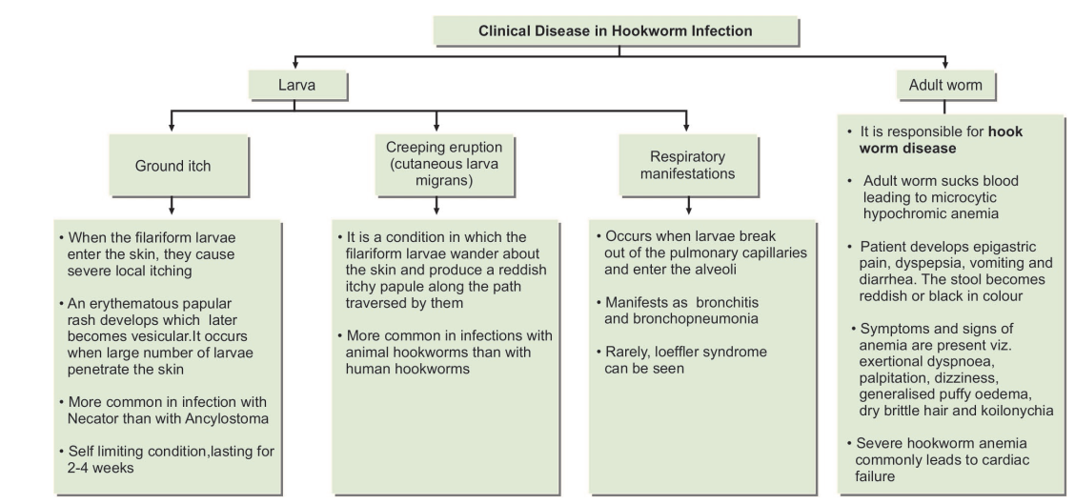
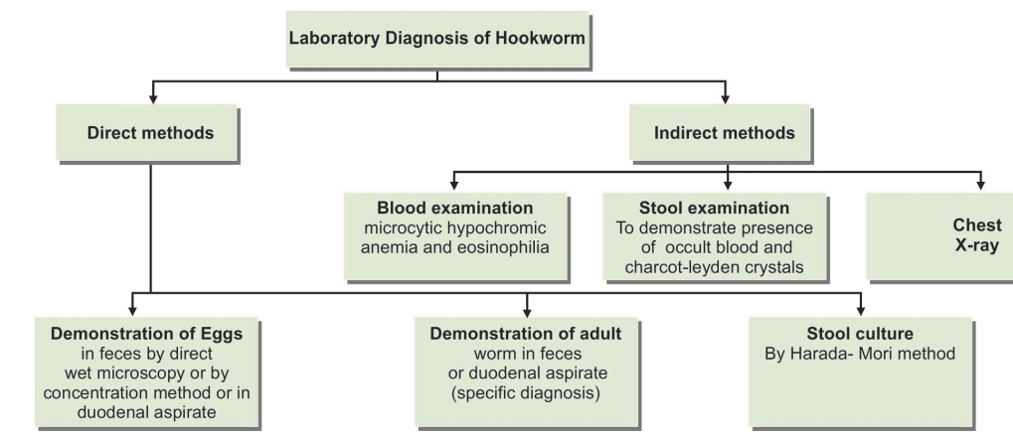

Treatment:
- Mebendazole, 200 mg, for adults and 100 mg for children, for 3 days is effective.
- In severe infection, ferrous sulfate, 200 mg, should be administered 3 times daily.
Control:
- Sanitation is the chief method of control.
- The use of footwear prevents entry of larvae through the skin of the foot.
- Gloves give similar protection to the hands of farm worker.
- Treatment of patients and carriers limits the source of infection.

End of the lecture-4

