Parasitology Lecture: 3
Dr. Azhar 8/ 10/2019
Geohelminths (Page number 1-9)
Objectives of this lecture:
At the end of this lecture the student is able to:
- Define & list of the geohelminthes or soil transmitted worms.
- Describe Trichuris trichiura natural host, infective form, clinical features, diagnosis, treatment and prevention.
- knowledge that A. lumbricoides is the largest nematode infecting human.
- Describe A. lumbricoides natural host, infective form, clinical features, diagnosis, treatment and prevention.

Soil-transmitted intestinal nematodes are called geohelminthes. In all of them eggs passed in feces undergo maturation in soil. They are classified into three categories based on their life cycle:
- Direct: ingested infective eggs directly develop into adults in the intestine, e.g. whipworms.
- Modified direct: larvae from ingested eggs penetrate intestinal mucosa enter blood stream and through the liver, heart, lungs, bronchus and esophagus, reach the gut to develop into adults, e.g. roundworms.
- Skin penetrating: infective larvae in soil penetrate host skin, reach the lung and proceed to the gut, e.g. hookworms.
Geohelminthes pose a serious health problem in poor countries, particularly among children. Their control requires general measures such as sanitation, personal hygiene and health education.
Trichuris trichiura (whipworms (
Disease: Trichuriasis
Trichuriasis is a tropical disease of children (5 to 15 yrs), 65% of the 500-700 million cases found in rural Asia.
It is seen in families and groups with poorer sanitary habits.Worldwide tropical, subtropical, warm temperate sanitation dependent.
Morphology:
- Adults are thread-like in the anterior 3/5 of the body & wider in the posterior end.
- The anterior end is threaded into mucosal epithelium of the cecum or appendix (large intestine).
- The ♀ organism is measured 35-50 mm long with a slender anterior end, while the posterior end is club-shaped.
- The ♂ is smaller and measures 30-45 mm. the posterior end is curved ventrally into coil of 360º or more with one spicule.
- The Trichuris eggs are lemon or barrel- shaped, measured 25x55µm and have transparent blister-like prominence at both ends, laid in the one celled stage become infective in about 3 wks egg with L1.
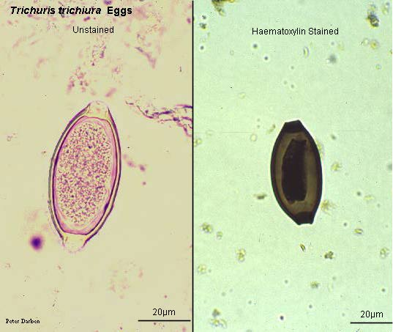
Transparent blister-like prominence at both ends

Life cycle:
- Infection occurs by ingestion of embryonated eggs (L1) from soil.
- The larva escapes the shell in the upper small intestine and penetrates the villus where it remains for 3 to 10 days.
- Upon reaching adolescence, the larvae pass to the cecum and embed in the mucosa.
- They reach the ovipositing age in 30 - 90 days from infection, produce 3000 - 10,000 eggs per day and may live as long as 4 - 8 years.
- Eggs passed in feces embryonate in moist soil within 2 to 3 weeks.
- The eggs are less resistant to desiccation, heat and cold than Ascaris eggs.
- The embryo is killed under desiccation at 37 ºC within 15 minutes. Temperatures of 52 ºC and -9 ºC are lethal.
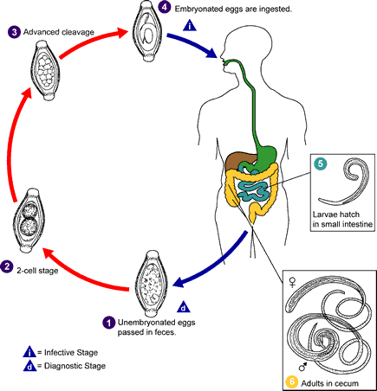

Pathogenesis:
- Light infection produces no Symptoms (less than 10 worms are asymptomatic).
- Heavy infections are characterized by intestinal damage and bloody diarrhea with abdominal pains and irritation in the wall of the lower colon and rectum may provoke prolapsed of the rectum.
- The infection may result in malnutrition, weight loss and anemia, Charcot-Leyden crystals in stool and sometimes death.
- It has been suggested that mechanical blockage of the appendiceal lumen by masses of whipworms may cause acute appendicitis.
- The life span of the worms if the infection is untreated may be from 4-8 years.
Treatment:
Mebendazole, 200 mg for adults and 100 mg for children, for 3 days or Albendazole (single dose of 400 mg) are effective.

Control:
- Sanitation.
- Hygiene & checking the consumption of unwashed fruits and vegetables grown on polluted fields can minimize the risk of infection.
- Infections must be treated.
Ascaris lumbricoides
(The large intestinal roundworm of man(
Disease: Ascariasis.
- Lumbricus meaning earthworm in Latin.
- Ascariasis can occur at all ages, but it is more prevalent in the 5 - 9 years age group.
- The incidence is higher in poor rural populations.
- Prevalence: world-wide, temperate and tropical regions, possibly 1 billion infected.
- The incidence may be as high as 80–100% in rural areas with poor sanitation.
- 40% population in Africa and Asia.
- The individual worm burden could be very high, even up to over a thousand.
- A research in Lancet journal in 1989 observed that if all the roundworms in all the people worldwide were placed end-to-end they would encircle the world 50 times.
Morphology:
- Head is provided with 3 fleshy lips.
- Adult ♂ measured 12-31 cm x 2-4mm.
- Adult ♀ measured 20-35 cm x 3-6mm, but may be up to 45 cm.
- Egg:
-Fertilized: round in shape with outer mammillated coat, thick transparent
middle coat and thin membranous inner coat single unembryonated egg.
-Unfertilized: elongated cylindrical in shape with all other characters mentioned
above.
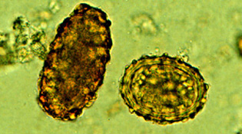
Fertilized egg (spherical)

Unfertilized egg (sub-spherical)

Host:
- Definitive host: Humans or pigs.
- Intermediate host: none.
Life Cycle:
- After infective eggs are swallowed, the larvae hatch, invade the intestinal mucosa, and are carried via the portal vein, then systemic circulation to the lungs.
- The larvae mature further in the lungs (10 - 14 days), penetrate the alveolar walls, ascend the bronchial tree to the throat, and are swallowed.
- Upon reaching the small intestine, they develop into adult worms.
- Between 2 and 3 months are required from ingestion of the infective eggs to oviposition by the adult female.
- Adult worms can live 1 to 2 years.
- Adult worms live in the lumen of the small intestine. Worms retain motility, do not attach.
- The ♀ may produce approximately 200,000 eggs per day, which are passed with the feces.
- Unfertilized eggs may be ingested, but are not infective.
- Fertile eggs When passed, the eggs are unsegmented and require outside development of about 18 days - several weeks, depending on the environmental conditions (optimum environment: moist, warm, shaded soil) until a motile embryo is formed within the egg and become infective.
- The eggs are able to survive for some months in fecal matter, sewage, or even in the 10% formalin solution used for stool preservation.
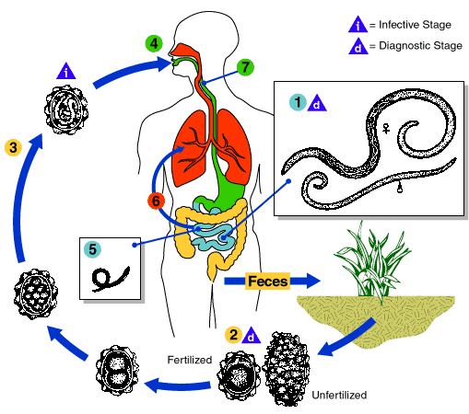

Conclusion of the life cycle:
1. Site of inhabitation: lumen of small intestine.
2. Infective stage: embryonated eggs.
3. Route of infection: by mouth.
4. No intermediate and reservoir hosts.
5. Life span of the adult: about 1 year.
Pathogenesis:
1. Adult: when worms present in small numbers causes no symptoms (85%), but heavy infection produce:
- Nutritional effect: interferes with proper digestion and absorption of food. Protein-energy malnutrition and vitamin A deficiency.
- Toxic effects: are due to hypersensitivity to the worm antigens and may be manifested as fever, urticaria, angioneurotic edema, wheezing, and conjunctivitis. These are more often seen in persons who come into contact with the worm as in laboratory technicians.
- Mechanical effects: the most important manifestations which lead to abdominal obstruction.
- Intermittent colic.
- Loss of appetite.
- Fretfulness.
- Ectopic ascariasis (Wanderlust): The worms are restless wanderers, they tend to probe and insinuate themselves into any aperture they find on the way. The wandering is enhanced when the host is ill, particularly when febrile, with temperature above 39°C. The worm may wander up or down along the gut. Going up, it may enter the opening of the biliary or pancreatic duct causing acute biliary obstruction or pancreatitis. It may enter the liver parenchyma and may lead to liver abscesses. The worm may go up the esophagus and come out through the mouth or nose. It may crawl into the trachea and the lung causing respiratory obstruction or lung abscesses. Migrating downwards, the worm may cause obstructive appendicitis. It may lead to peritonitis when it perforates the intestine, generally at weak spots such as typhoid or tuberculosis ulcers or through suture lines. This tendency makes preoperative deworming necessary before gastrointestinal surgery in endemic areas. The wandering worm may also reach kidneys.

- Larva migration through liver & lung provokes no pathological changes unless hundreds larvae are migrating lead to Löffler`s syndrome:
- Eosinphilic infiltration granuloma.
- General inflammation in acute phase.
- Fibrosis in late phase.
- Local reaction around the larvae in the tissue pnemonitis & dyspnea asthymatic type with cough &fever.
- Heavy infection causing fatal-disease.
- X-ray showing scattered, shifting mottling of the lungs. This picture variable from day to day and spontaneously clears after a few days-2 weeks (Löffler`s syndrome also caused by hookworms & Strongyloides).
- Present of Charcot-Leyden crystals. Charcot–Leyden crystals are microscopic crystals found in people who have allergic diseases such as asthma or parasitic infections such as parasitic pneumonia or ascariasis. They vary in size and may be as large as 50 µm in length. Charcot–Leyden crystals are slender and pointed at both ends, consisting of a pair of hexagonal pyramids joined at their bases. Normally colorless, they are stained purplish-red by trichrome. They consist of lysophospholipase, an enzyme synthesized by eosinophils, and are produced from the breakdown of these cells. They are indicative of a disease involving eosinophilic inflammation or proliferation, such as is found in allergic reactions and parasitic infections.
- Migrating larvae may be seen in the sputum.
- Liver abscesses.
Diagnosis:

Stool examination
Diagnostic stage: eggs in feces.
Skin test with Ascaris antigen available, but is unreliable.
Treatment:
- For larvae migration: Benzimidazole & fenbendazole.
- For adult: These include pyrantel pamoate (11 mg/kg once; maximum 1 g), albendazole (400 mg once), mebendazole (100 g twice daily for 3 days or 500 mg once), or ivermectin (150–200 mg/kg once). These medications are contraindicated in pregnancy; however, pyrantel pamoate is safe in pregnancy.
- Complete obstruction requires immediate surgical intervention.

Control:
- Sanitation
- Stop use of human feces for field fertilization before treated it.
- Treatment of vegetables and other grand crops with water containing iodine for 15 minutes kills the eggs and larvae of Ascaris and other helminthes.
- Avoid contacting soil that may be contaminated with human feces.
- Wash hands with soap and water before handling food.
- When traveling to areas where sanitation and hygiene are poor, avoid water or food that may be contaminated.
- Wash, peel or cook all raw vegetables and fruits before eating.

End of the lecture-3

