Post-term or prolonged pregnancy
Dr Ban Hadi \ F.I.C.O.G. 2019


Objectives:
by the end of this lecture, 4th year student should be able to
- Define prolonged pregnancy
- Describe the physiological changes of prolonged pregnancy
- Summarize the important points in history and examination to confirm the diagnosis
- Predict the management option for different case presentations
- Describe the complications of prolonged pregnancy

Definition:
The standard international definition of prolonged pregnancy by WHO is 42 completed weeks or more (294 days or more) from first day of last menstrual period, the gestational age having been established by ultrasound prior to 16 weeks.

Term defined as pregnancy from 37 - 41^{+6d} weeks gestation.
Post date pregnancy is pregnancy more than 40 weeks gestation

Incidence:
Incidence of post term pregnancy is 10 -15%
Dating by last menstrual period alone has 70% tendency to over estimate the gestational age (delayed ovulation).
Routine use of early ultra sound to calculate gestational age reduces incidence from 10–15% to approximately 2–5%.

Aetiology and pathology:- the most common ‘cause’ of post-term pregnancy is inaccurate pregnancy dating
The cause of prolonged pregnancy is not clear may represent simple biological variation.
Prolonged pregnancy is more common in:
1. Primigravida.
2. Previous Prolonged pregnancy 30%.
3.Anencephaly
4.Placental sulphatase deficiency
5.Male fetus
5.Adrenal hypoplasia
6.Nulliparity
7.Obesity.
8.White race.

Physiological changes associated with prolonged gestation:

1) Amniotic fluid changes:
It is quantitative & qualitative changes.
Volume reaches a peak of 1000 ml at 38 weeks & decrease progressively with prolonged gestation, amniotic fluid volume under 400 ml at 40 weeks or more is associated with fetal complications.
After 38-40 weeks amniotic fluid becomes milky & cloudy because of abundant flakes of vernix caseosa.
L/S (lecithin/sphyngomylin) ratio becomes 4:1 or greater.
Green or yellow discoloration when fetus passes meconium, the presence of meconium especially if it is thick increases the probability of poor out come.

2) Fetal changes:
45% of fetuses undelivered after their EDD continue to grow in utero.
With each additional week, more babies have a birth weight > 4000g. Macrosomia defined as fetal weight >90th centile of fetal weight for gestational age or >4500gm, this makes engagement of fetal head more difficult in labour in addition the bones will be more ossified so that moulding is reduced.
5-10 % of fetuses undelivered after EDD show wasting of their subcutaneous fat (IUGR).

3) Placental changes:
The post term placenta shows decrease in diameter & length of chorionic villi, appearance of haemorrhagic foci which are foci of calcium deposition & formation of white infarcts.
Infarcts present in 10-25% of term placenta & 60-80% of post term placenta, the placental capability to transfer oxygen and nutrients is significantly reduced in post term pregnancy.

Complications of post term pregnancy:

A.Fetal and neonatal risks:
1. Increased perinatal morbidity and mortality 2-3 times normal pregnancy

2. Post maturity syndrome: which resembles IUGR and associated with:
      - meconium stained amniotic fluid
- oligohydramnios which causes umbilical cord compression
- fetal distress due to hypoxia
- loss of subcutaneous fat with dry cracked skin reflecting placental insufficiency
Occurs in 20-30 % of prolonged pregnancy

3. Intrapartum fetal distress: Results from umbilical cord compression caused by oligohydramnios, or it may be due to placental insufficiency. This may result in fetal acidosis, neonatal seizures and perinatal death

4. Meconium aspiration syndrome: passing meconium into the amniotic fluid that may be inhaled causing breathing problems after birth

5. Fetal trauma & traumatic deliveries especially in fetal macrosomia which results in abnormal labour, shoulder dystocia which may cause brachial plexus injury, fractures of the humerus or clavicle, skull fractures & cephalic haematoma may occur in vaginal delivery of large babies.

6. Sudden infant death syndrome: more in infants of post term deliveries

B. Maternal risks:
Increased risk of dystocia, perineal trauma, operative delivery (caesarean section with its complications as hemorrhage, infection and organ injury) and considerable psychological morbidity.

Antepartum evaluation & management:

A. History:
- Reliability of gestational age estimation.
1. The patient was not using oral contraceptives, not lactating, had 3 or more regular periods before the last one & the last period was normal in duration & amount.
2. EDD calculated from LMP confirmed by US between 11-14 weeks (^{+_} 5 days).
3. The pregnancy was achieved during infertility treatment & the date of conception or embryo transfer is known

- Any risk factor like Rh incompatibility, antepartum hemorrhage, medical problems like diabetes and hypertension may pose additional risk and prompt induction of labour.
B. Examination:
- Vital signs: blood pressure
- Abdominal exam. to evaluate fetal presentation, size and engagement.
- Pelvic examination: Ripeness of the cervix is important in the management of prolonged pregnancy using Bishop score, a score of 6 or less indicates poor inducibility.
Pelvimetry to assess pelvic adequacy

C. US evaluation:
US evaluation in patient with prolonged gestation is not to determine the gestational age but to asses:
- Amniotic fluid volume: DVP <2cm or AFI <5cm indicates oligohydramnios
- Fetal size: estimated fetal size and abdominal circumference to detect macrosomia
- Fetal malformations usually detected by early US
4) Placental grade: 35% of all pregnancy at term have grade III placenta, the presence of grade III (appearance of cotyledons indenting the uterine surface of the placenta more deeply and more calcifications) doesn’t indicate fetal distress
5) Fetal wellbeing: BPP with Doppler for IUGR

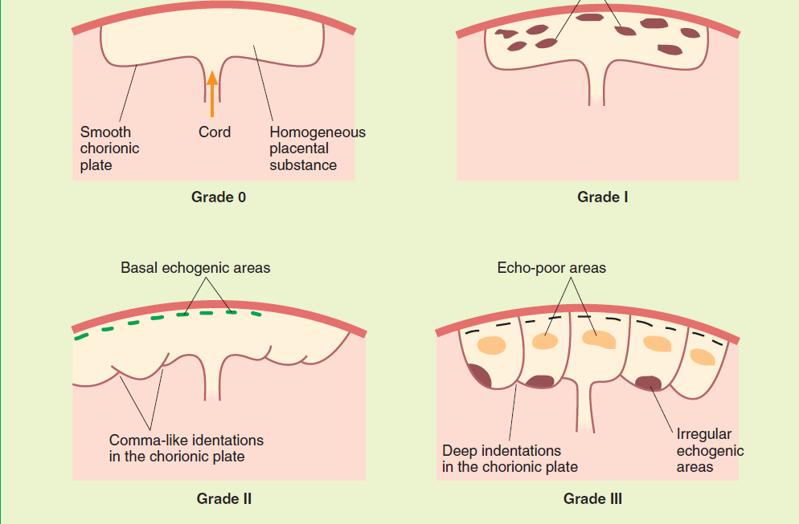

D. Fetal monitoring in post term pregnancy:
1 -Increased antenatal monitoring is indicated in form of at least twice weekly NST (non stress test) and ultrasound estimation of DVP.
2 -Fetal movements or kick count (reassuring if 4 movements in 1 hr)
3 -The biophysical profile (BPP) should be better than NST, but studies showed that it holds no advantage over NST and liquore assessment.
4 -Umbilical artery Doppler to detect IUGR, fetuses of post term pregnancy showed higher placental resistance with higher systolic\diastolic ratio. Reduced, absent or reversed end diastolic flow indicates delivery
5 -CST (contraction stress test) is invasive and time consuming. If positive (fetal heart decelerates with contraction) indicates delivery by caesarean section.

E. Sweeping the membranes at or beyond 40 weeks appears to reduce the incidence of post term pregnancy and the frequency of using other methods of induction.

F. Induction of labour at 41 completed weeks and beyond reduces the perinatal mortality, meconium staining of amniotic fluid and caesarean section compared to conservative management which involves monitoring the fetal condition until spontaneous onset of labour.

According to the evaluation above:
A-if the date is confirmed and the cervix is favourable, labour should be induced with artificial rupture of membranes and intra venous (IV) oxytocin with continuous intra partum fetal monitoring for deceleration

B-if the date is confirmed and the cervix is unfavourable there are two options:-
- Induce labour:- by using of PGE2 gel or vaginal suppositories or the use of Foley's catheter & extra-amniotic infusion of saline solution.

- Observation:-both NST & AFI should be performed twice weekly.
Delivery should take place if the NST becomes non reactive or If the AFI is <5 cm or DVP <2 cm.

C- if the date is uncertain:-
Both the NST & AFI can be performed twice weekly while waiting for spontaneous labour to occur.
Delivery should take place if the NST becomes non reactive or if the AFI <5 cm

Notes:
- Those with decreased amniotic fluid volume: amnio-infusion with 1000 ml of warm normal saline solution can be performed; it will prevent cord compression & signs of fetal distress.
- Those with baby weight > 5 kgm → CS.
- Those with baby weight > 4500 gm → CS if they are IDDM, gestational diabetes or abnormal value of oral GTT, because these babies have large subcutaneous pads in the shoulders & develop shoulder dystocia more frequently than babies of similar weight from mother without carbohydrate intolerance.
- Patient at 42 weeks should be delivered irrespective to the state of the cervix.

- Post‐term pregnancy may be prevented by:
- induction of labour;
- stripping/sweeping the membranes;
- intercourse;
- accupuncture

End of lecture

