Maldevelopment of genital tract

Genital tract malformations
Numerous malformations of the genital tract have been described, some of little clinical significance and others of considerable importance

Uterine anomalies
- Class I: Müllerian agenesis (absent uterus).
  - Uterus is not present, vagina only rudimentary or absent. The condition is also called Mayer-Rokitansky-Kuster-Hauser syndrome. The patient with MRKH syndrome will have primary amenorrhea.
- Class II: Unicornuate uterus (a one-sided uterus).
(Only one side of the Müllerian duct forms)
Rudimentary development of one horn may give rise to a very serious situation if a pregnancy is implanted there. Rupture of the horn with profound bleeding may occur as the pregnancy increases in size. The clinical picture will resemble that of a ruptured ectopic pregnancy with the difference that the amenorrhoea will probably be measured in months rather than weeks, and shock may be profound. Apoorly developed or rudimentary horn may give rise to dysmenorrhoea and pelvic pain if there is any obstruction to communication between the horn and the main uterine
cavity or the vagina. Surgical removal of this rudimentary horn is then indicated.
- Class III: Uterus didelphys, (double uterus).
  - Both Müllerian ducts develop but fail to fuse, thus the patient has a "double uterus".
( if associated with a clinical problem, may prevent descent of the head in late pregnancy, or obstruct labour by the non-pregnant horn).
- Class IV: Bicornuate uterus (uterus with two horns).
  - Only the upper part of that part of the Müllerian system that forms the uterus fails to fuse, thus the caudal part of the uterus is normal, the cranial part is bifurcated. The uterus is "heart-shaped".

- Class V: Septated uterus (uterine septum or partition).
  - The two Müllerian ducts have fused, but the partition between them is still present, splitting the system into two parts. With a complete septum the vagina, cervix and the uterus can be partitioned. Usually the septum affects only the cranial part of the uterus. A uterine septum is the most common uterine malformation and a cause for miscarriages.
Clinically, it may present with
- 1-recurrent spontaneous abortion or
- 2-malpresentation.A persistent transverse lie of the fetus in late pregnancy may suggest a uterine anomaly since the fetus tends to lie with its head in one cornu and the breech in the other.
Diagnosed done by image techniques, i.e. 3D ultrasound or an MRI. A hysterosalpingogram is not considered as useful due to the inability of the technique to evaluate the exterior contour of the uterus and distinguish between a bicornuate and septate uterus.
Treatment : A uterine septum can be corrected by hysteroscopic surgery.
- VI: arcuate uterus where there is a concave dimple in the uterine fundus within the cavity.
- Class VII: DES uterus.
  - The uterine cavity has a "T-shape" as a result of fetal exposure to diethylstilbestrol.
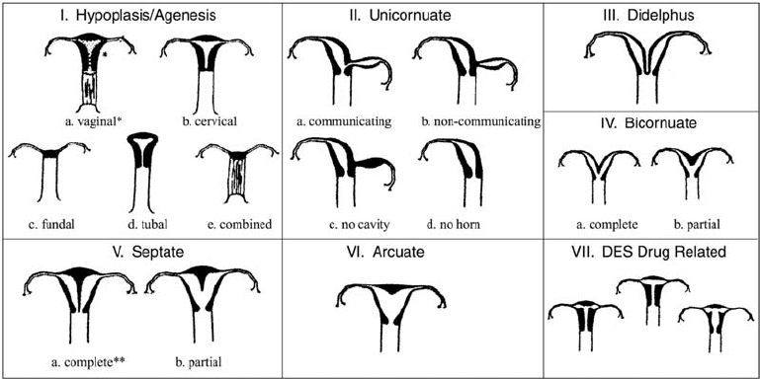

Vaginal anomalies
- Absent vagina.
ABSENCE OF THE VAGINA
Absence of the vagina is generally associated with absence of the uterus or a rudimentary uterus. This is known as MRKH syndrome.
Clinical presentation:
1- the patient will probably present between age 12 and 16 years with primary amenorrhoea.
2-Secondary sexual characteristics will be present as the ovaries are normally developed and functional.
The presumptive diagnosis of absent vagina can generally be made without difficulty at first examination.
DDx: androgen insensitivity :so in every case of apparent vaginal absence a karyotype should be performed and if chromosome analysis confirms an XY sex chromosome complement the case should be managed appropriately
management may be divided into two sections, the first devoted to
1- psychological counselling and the
2- second aspect which involves the creation of a new vagina.
DIRECT THERAPY The management of these cases is usually by non-surgical methods The patient is instructed to use graduated glass dilators initially and then if necessary a surgical approach
In those patients who fail the non-surgical technique a vaginoplasty will need to be performed. A number of techniques have been used to create a vagina artificially, the most widely used being that of McIndoe vaginoplasty.

- Vaginal atresia.
- Septate vagina ( longitudinal or transverse vaginal septa ).
Transverse vaginal septum
Where length of vagina is absent, diagnosis and management are less straight forward and the ultimate interference with fertility is greater. The upper part of the vagina will collect menstrual blood and a clinical picture similar in many ways to haematocolpos will be seen.
Imaging may be by ultrasound or by the use of magnetic resonance imaging (MRI), and both these techniques may be successful in determining the exact anatomical relationships prior to surgery being performed. Resection of the absent segment and reconstruction of the vagina may be done by either an end-to-end anastomosis of the vagina or a partial vaginoplasty.

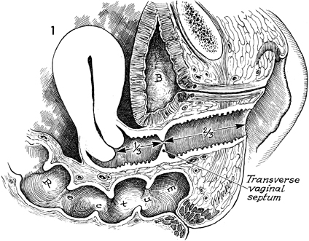

LONGITUDINAL VAGINAL SEPTUM
A vaginal septum extending throughout all or part of a vagina is not uncommon; such a septum lies in the sagittal plain in the midline.
In obstetrics this septum may have some importance if vaginal delivery is to be attempted. In these circumstances the narrow hemivagina may be inadequate to allow passage of the fetus and serious tears may occur if the septum is still intact at this time. It is therefore prudent to arrange to remove the vaginal septum as a formal surgical procedure whenever one is discovered, either before or during pregnancy. The septum may occasionally be associated with dyspareunia when similar management is indicated.
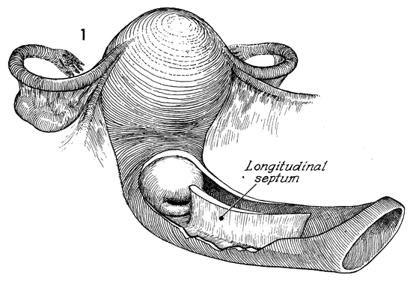
- Double vagina.
- Gartner duct cysts ( Congenital cysts; are deep cysts found along the lateral portion of vagina).
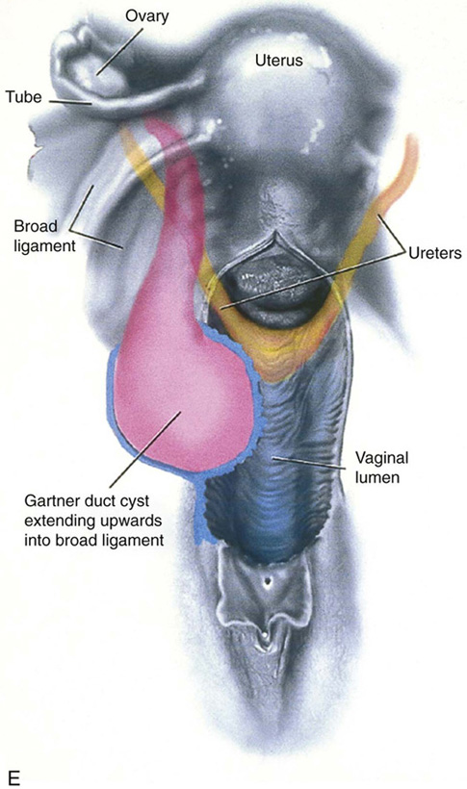

- Abnormalities of the hymen. Hymenal configurations have been described, ranging from imperforate to microperforate, to cribriform, to hymenal bands, and to hymens with central anterior, posterior, or eccentric orifices. Most common is imperforate hymen.
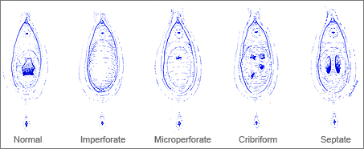

HAEMATOCOLPOS
An imperforate membrane may exist at the lower end of the vagina, which is loosely referred to as the imperforate hymen, although the hymen can usually be distinguished separately . These abnormalities of vertical fusion are seldom recognized clinically until puberty when retention of menstrual flow gives rise to the clinical features of haematocolpos, although rarely they may present in the newborn as a hydrocolpos. The features of haematocolpos are
1- predominantly abdominal pain,
2-primary amenorrhoea and
3- occasionally interference with micturition.
4-The patient is usually 14–15 years old, but may be older, and
5-a clear history may be given of regular cyclical lower abdominal pain for several months previously.
6-The patient may also present as an acute emergency if urinary obstruction develops.

Examination reveals a
1-lower abdominal swelling, and
2-per rectum a large bulging mass in the vagina may be appreciated
3-.Vulval inspection may reveal the imperforate membrane which may or may not be bluish in colour depending upon its thickness.

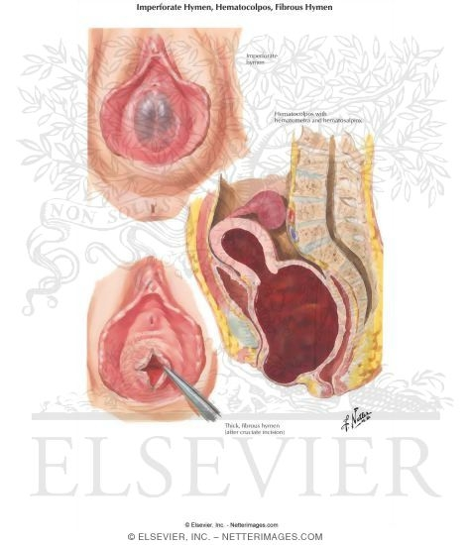

Treatment : a simple cruciate inscion of the membrane and release of the retained blood resolve the problem. Redundant portions of the membrane may be removed but nothing more should be done at this time.
Fluid will then drain naturally over some days.
Examination a few weeks later is desirable to ensure that no pelvic mass remains which might also suggest haematosalpinx.
Complication : haematosalpinx and endometriosis which may cause some fertility problems.

Vulval anomalies
- Bifid clitoris ( diphallus (
- Clitoral duplication: Treatment usually by plastic surgery.
- Clitoral hypertrophy. Clitoral hypertrophy alone is not common but may be associated with various intersex disorders.
- Enlargement of labia minora.
- Atresia of labia minora.

Wolffian duct anomalies
Remnants of the lower part of the Wolffian duct may be evident as vaginal cysts, or remnants of the upper part as thin-walled cysts lying within the layers of the broad ligament (paraovarian cysts). It is doubtful if the vaginal cyst per se calls for surgical removal, although removal is usually undertaken. The cysts may cause dyspareunia and this is the most likely reason for their discovery and surgical removal.
Anomelies of the cervix
Because the cervix forms as an integral part of the uterus, cervical anomalies are often the same as uterine anomalies. Thus, absence or hypoplasia of the cervix is rarely found with a normal uterovaginal tract.

