The Gynecological history and examination

*husband's name * patient's name
* Age *age
* Occupation *Occupation
* Residence *Residence
* Religion *Blood group&Rh
* Marital status
* Blood group&Rh

Date of admission:
G P A
LMP :( If the patient is menopaused, then mention the age of menopause)

Chief complaint: a brief statement of the general nature and duration of the main complaint.
History of presenting complaint: this section should focus on the presenting complaint, but certain important points should always be enquired about:
* Abnormal menstrual loss, regular or irregular, amount of blood loss, Passage of clots or flooding, Number of sanitary towels or tampons used
* Intermenstrual bleeding.
*Abdominal & Pelvic pain-site of pain, nature, and relation to periods, anything that aggravates or relieves the pain, radiation of pain, associated symptoms.
* Vaginal discharge- amount, colour, itching, odour, presence of blood.
Admission history: course of illness ( improved or not), medication received, investigations done until time of presentation.
Obviously if the presenting complaint is one of sub fertility or is urogynecological, the history must be appropriately tailored.

Review of other systems:
* Appetite, weight loss or gain.
* GIT, Urinary symptoms.
* Cardiovascular, respiratory and other systems.

Menstrual history:
* Age of menarche.
* Usual duration of each period and length of cycle.
* Painful cycles (treatment received).
* Age of menopause.
Past gynecological history:
* Previous gynecological surgery or treatment.
* The date of last cervical smear.
* History of discomfort, pain, or bleeding during intercourse.
* The use of contraception and type of contraception used.
* History & period of infertility (any treatment).

Past Obstetric history:
*Date of marriage, then when she conceived.
* For each pregnancy ask about: duration (term, preterm or post term), any antenatal complication (eventful or un eventful such as APH, medical diseases), mode and place of delivery, outcome of delivery, puerperal problems, breast feeding.
*Time until the next pregnancy (any contraception or infertility).
* Number of miscarriages, type of miscarriages (viable or missed), gestation at which they occurred and if the patient had curettage and its complications.

Past medical history:
* Any serious illness or medical diseases, chronic disease.
Past surgical history :
*Anesthetic complications (like scoline apnea)
* Previous operations (any postoperative complications).
* Blood transfusion.
Drug history:
* Allergy to any drug.
* Chronic drug use such as antihypertensive and antiepileptic drugs.
Family history:
* Any medical diseases such as hypertension, DM, thrombophilia.
* History of Gynecological problems such as infertility, endometriosis * History of malignancies as breast, ovarian and colonic cancer.
Social history:
* Smoking and alcohol use.
* Marital status, relative or not.
* Family problems, living environment.

Examination:
    - General examination:
- General look: consciousness, ill, well, body built( obese or thin), dyspnea.
- Hands and mucous membranes for pallor, yellowish discoloration, cyanosis and clubbing.
- Oedema (press over the lower medial third of the tibial shin for 30 seconds), other sites the medial side of the ankle and dorsum of the foot.
- If the patient has cannula examine for site and signs of thrombophlibitis.
- Lymph nodes particularly the left supraclavicular node where, in cases of abdominal malignancy one might palpate the enlarged Virchow's node ( Troissier's sign )
- Thyroid gland should be palpated
  - Vital signs:
  - B.P., pulse rate, volume and rhythm (for 30 sec.if abnormal then count for 1 min.), respiratory rate and temperature
  - Breast examination:
- Patient sitting or standing--press hands on hips to contract pectoral muscles (This maneuver accentuates any existing tissue retraction) , time of examination usually after the period
- Observe development, size, symmetry, skin changes, nipples
- Palpate the entire breast (bilateral after warming the hands) in rotatory fashion and palpate the axillary area for lymph nodes
- If there is pain then start from the normal breast first
- Press the nipples to determine any discharge

  - Abdominal examination:
  - Inspection:
- The contour of the abdomen for any distension.
- Surgical scars, Laparoscopy scars , pfannenstiel scars
- Dilated veins or striae.
- The patient is asked to cough or raise her head for any herniae , divarication of the rectus muscles
- Hair distribution , umbilicus
- Any surgical dressings (dry or soaked with blood or discharge)
- Movement with respiration(if absent indicates peritonism)

  - Palpation:
      - First, if the patient has any pain, she should be asked to point to the site, this area should not be examined until the end of palpation.
      - Using the right hand, examine the left lower quadrant and proceed to the right lower quadrant and look for the patient face.
      - palpate for masses, liver, spleen and kidneys
      - Signs of peritonism: guarding and rebound tenderness
      - examine for inguinal herniae and lymph nodes
      - if a mass is present but it is possible to palpate below, it is more likely to be abdominal mass , in case of pelvic mass one cannot palpate below it.
  - Percussion:
- Shifting dullness, ascitic fluid will settle down into a horseshoe shape and dullness in the flanks can be demonstrated, as the patient moves over to her side the dullness will move to her lowermost side. A fluid thrill can also be elicited.
- An enlarged bladder due to urinary retention will also be dull to percussion

      - Auscultation:
                - Postoperative patient listen for bowel sounds at the Mc Burney's point.

  - Pelvic examination:
- Patient's verbal consent and a female chaperone should be present for any intimate examination
- Patient should empty her bladder prior to the exam.
- Explain what is to take place during the exam
- The external genitalia are first inspected under good light with the patient in dorsal position , the hips flexed and abducted and the knees flexed, note the following:
    - Discharge, inflammation, oedema and swelling
- The left lateral position is used for examination of prolapse or to inspect the vaginal wall with a Sim's speculum
- The patient is asked to strain down to detect any prolapse and also to cough ,as this will show the sign of stress incontinence

- Speculum exam.: Holds speculum at 45‐degree angle Inserts speculum properly, Rotates speculum at full insertion, Opens speculum slowly, Identifies cervix, Secures speculum in open position, Inspects cervix, Inspects vaginal walls while removing speculum, Handles speculum appropriately, Removes speculum appropriately
- Cusco's bivalve speculum is inserted to visualize the cervix ( after warming it) a smear test could be performed at the same time

- Bimanual digital examination using the fingers of the right hand in the vagina and the left hand on the abdomen, the cervix is palpated for hardness or irregularity. The size, shape, position, mobility, and tenderness of the uterus. The adnexae are examined on each side .the uterosacral ligaments are palpated for scarring or shortening as in endometriosis
- In a virgin or a child, only rectal examination should be performed, also useful to differentiate between enterocele and rectocele and could be used to assess the size of a rectocele

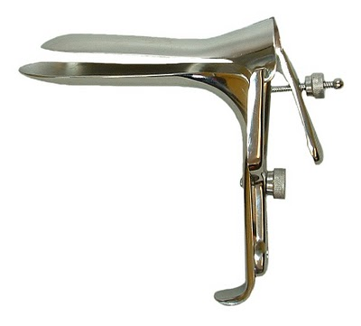

Cusco's bivalve speculum
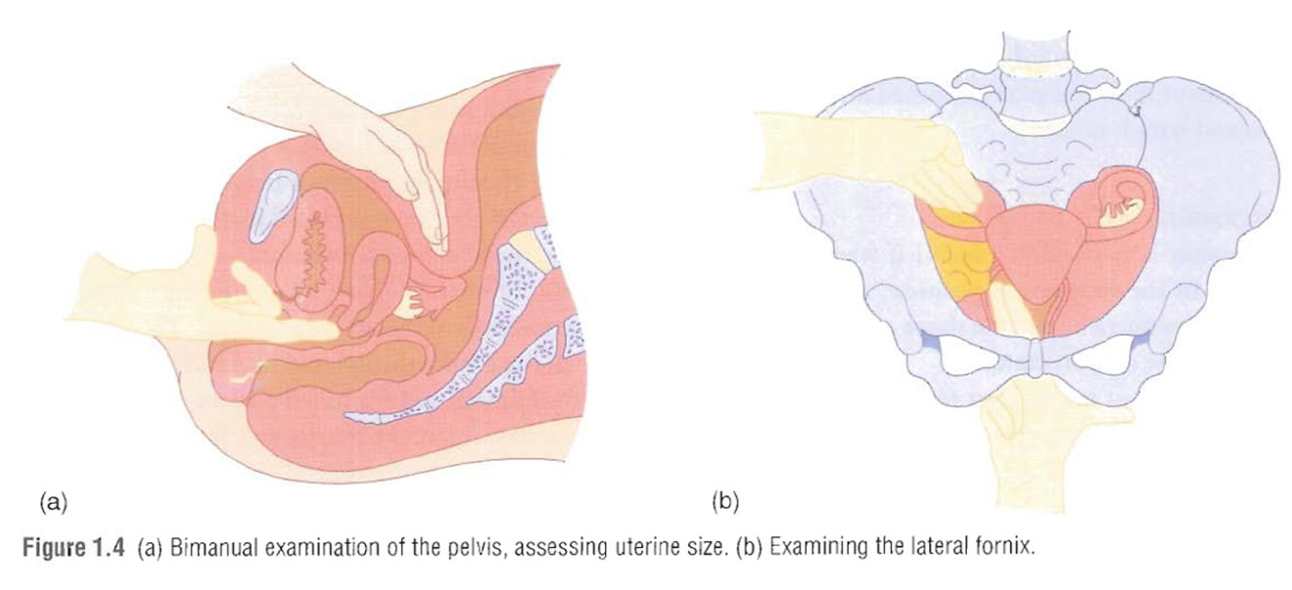
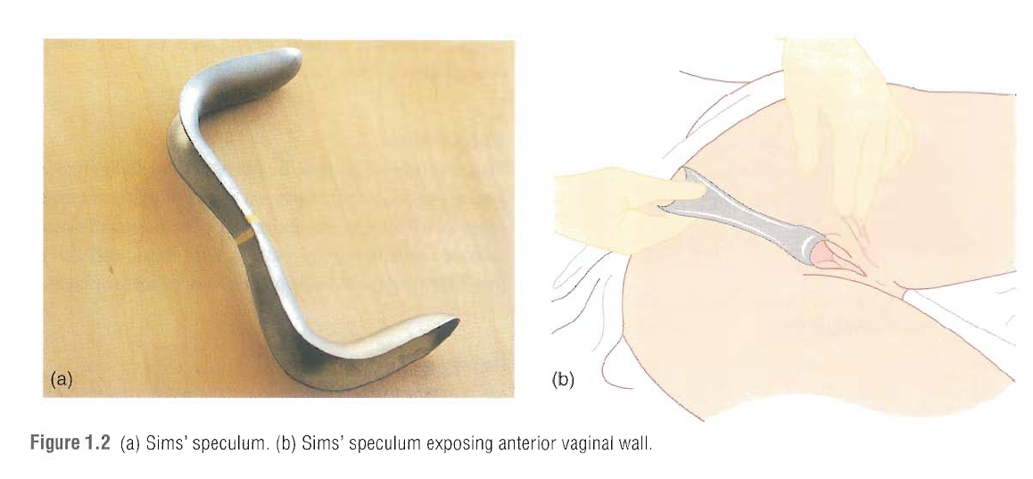

How to perform a high vaginal swab
1. Patient's verbal consent, explain to the patient what are you going to do. A female assistant should be present for intimate exam.
2. Wash hands, wear gloves and use sterile speculum after warming it.
3. The patient's external genitalia examined under good light in dorsal position with hips flexed and abducted and knees flexed.
4. Cusco's bivalve speculum is inserted while closed in oblique direction with the lock directed posteriorly then opened to visualize the cervix and fix the screw
5.the swab is introduced into the posterior vaginal fornix then closed, labeled and sent to the lab.
6. After complete the exam. Loose the screw, close the speculum and remove it.

How to perform a pap smear
1. The smear should be done while the patient is not menstruating, at 10 to 20 days after the 1st day of the last menstrual period.
2. For 2 days before the test there should be no intercourse, no vaginal douching, spermicidal preparation or medication.
3. Patient's verbal consent, explain to the patient what are you going to do. A female assistant should be present for intimate exam.
4. Wash hands, wear gloves and use sterile speculum after warming it.
5. The patient's external genitalia examined under good light in dorsal position with hips flexed and abducted and knees flexed.
6. Cusco's bivalve speculum is inserted while closed in oblique direction with the lock directed posteriorly then opened to visualize the cervix and fix the screw
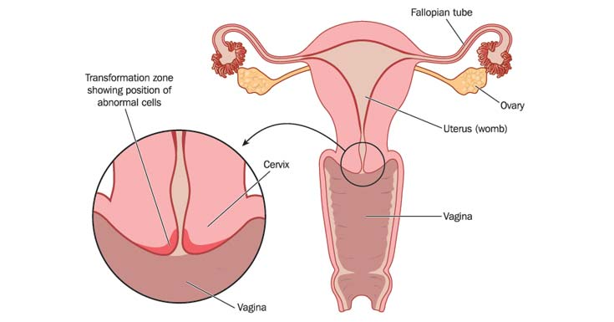

7. The Ayre's spatula is inserted into the SCJ rotate it through 360 degrees, avoid too much and too little force, then spread the cells on a glass slide, put it in a fixative, label it and send it to the lab.
8. Use the endocervical brush through introducing it into the cervical canal, rotate it and collect the cells on a paper or a slide and put it in the fixative.
9. After complete the exam. Loose the screw, close the speculum and remove it.
