Dr.Ghassan Lec.1 Anatomy
Nose and paranasal sinuses
The nose consists of the external nose and the nasal cavity.
External nose:
It has a free tip and is attached to the forehead by the root or the bridge of the nose. The external orifices of the nose are called the nostrils. The external nose is formed by:
The nasal bone, frontal process of the maxilla, frontal bone, upper and lower nasal cartilages and the muscles acting on the nose.

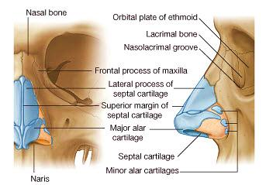
Nasal cavity:

It extends from the nostrils anteriorly to the choanae [posterior nasal aperture] posteriorly. It is divided into right and left halves by the nasal septum. Each half has a roof, a floor, lateral wall and medial wall.
Each cavity of the nose is 5 cm in hight, and 5-7 cm in length. Its width narrows transversely, 1.5 cm at the floor, and only 1-2 mm at the roof.

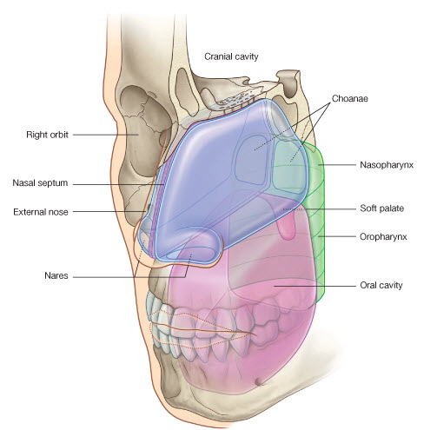

The mucous membrane of the nasal cavity:

It is tightly attached to the underlying periosteum and form a muco-periosteum .Its epithelium is pseudo-stratified columnar.
The mucous membrane is of two types
- Olfactory mucous membrane: it contains the olfactory nerve cells and lines the roof,upper1/3 of the medial wall and the upper 1/3 of the lateral wall[[the superior concha and the spheno-ethmoidal recess].the olfactory nerve fibers pass through the cribriform plate and end in the olfactory bulbs.
- Respiratory mucous membrane: it lines the lower 2/3 of the nasal cavity and its function is to warm, moisten and clean the inspired air

The floor of the nasal cavity:
5 cm long, formed by the palatine process of the maxilla and the horizontal process of the palatine bone [upper surface of the hard palate].
Nerve supply: nasopalatine nerve.
The roof of the nasal cavity:
7 cm long and has three parts:
- The middle part is formed by the cribriform plate of the ethmoid bone and is horizontal
- The anterior part is formed by the nasal bone ,nasal part of the frontal bone and the nasal cartilage[sloping part]
- The posterior part is formed by the anterior and inferior surface of the body of the sphenoid[sloping part]
Nerve supply: olfactory nerve.

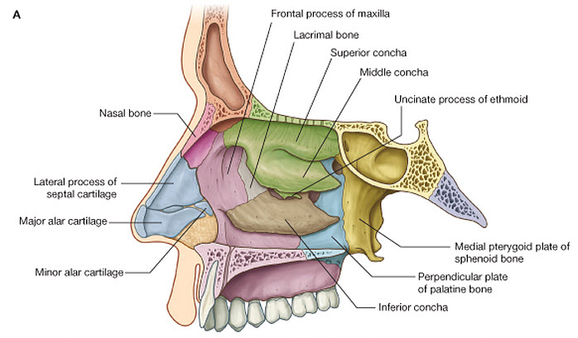

Septum of the nose [the medial wall]:
It is formed by: vomer bone, perpendicular pate of the ethmoid bone, septal cartilage and the nasal crests of the [maxilla, nasal bone, palatine bone, frontal bone and the sphenoid bone].
Nerve supply of the septum:
The special sensation [sense of smell]: by the olfactory nerve to the upper part of the septum [area lined by the olfactory mucousa] .
General sensory nerves:
1. Anterosuperior part: is supplied by the anterior ethmoidal nerve.
2. Anteroinferior part: is supplied by the infra-orbital nerve.
3. Posterosuperior part: is supplied by the nasopalatine nerve.
4. Posteroinferior part: is supplied by the nasopalatine nerve.
The nasopalatone nerve:
Is long slender nerve that arises from the pterygopalatine ganglion and enters the nasal cavity through the sphenopalatine foramen. In the nasal cavity it runs medially across the roof and then anteroinferior [in groove on the surface of the vomer] to reach the floor. In the floor it passes through the incisive canal and foramen to reach the inferior surface of the hard palate where it anastomoses with the greater palatine nerve.
It supplies the floor, the posterior part of the septum and the mucous membrane of the anterior part of the hard palate.
Blood supply of the septum:
1. Anterosuperior part: is supplied by the anterior ethmoidal artery and posterior ethmoidal artery.
2. Anteroinferior part: is supplied by the superior labial branch of the facial artery.
3. Posterosuperior part: is supplied by posterior septal branch of sphenopalatine artery.
4. Posteroinferior part: is supplied by posterior septal branch of sphenopalatine artery.

Little's area (Kiesselbach area): it is the common site of the bleeding from the nose, lies in the anteroinferior part of the septum, and contains the anastomosis between the arteries that supply the septum.
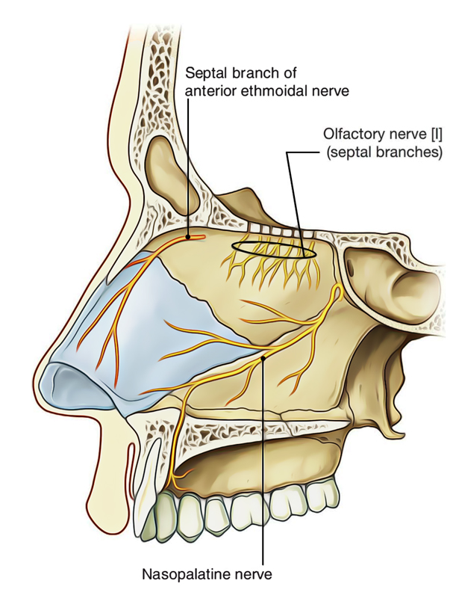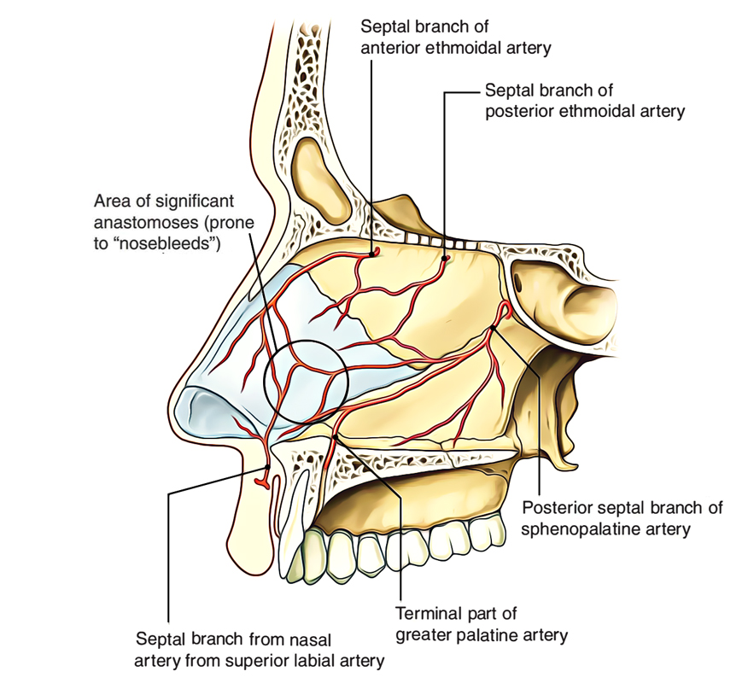

Lateral wall of the nasal cavity:
It is marked by three projections called the conchae. The conchae are three bony plates, covered with highly vascular muco-perioesteum, project from the lateral wall of the nasal cavity and curved inferiorly. The superior and middle conchae are processes from the ethmoid bone while the inferior concha is a separated bone. The meatuses are spaces lie inferior and lateral to the conchae.
The lateral wall is divided into three parts:
1. The anterior part: is called the vestibule [lies above the nostril].
2. The middle part: is called the atrium. It is small depression lies anterior to the middle meatus, above and slightly posterior to the vestibule.
- The posterior part: it is containing the conchae and the meatuses.
The bones of the lateral wall:
1. The labyrinth of the ethmoidal bone and its conchae.
2. The inferior concha.
3. Perpendicular plate of the palatine bone.
4. Medial pterygoid plate.
5. Frontal process of maxilla.
6. Nasal bone.
7. Maxilla.
8. Body of the sphenoid
9. Lacrimal bone.
The bones of the lateral wall contain air filled spaces [the ethmoid and the maxillary sinuses].
The features of the lateral wall:
1. Superior concha: it lies in the posterosuperior part of the cavity, and is very short .It begins inferior to the cribriform plate and ends anterior to the body of the sphenoid.
Sphenoethmoidal recess is a space lies posterosuperior to the superior concha, and the sphenoid sinus opens into its posterior part.
2. Middle concha: it is much larger and extends from the atrium to the level of the choanae.
3. Inferior concha: longer than the middle concha and about midway between the floor of the nose and the middle concha.

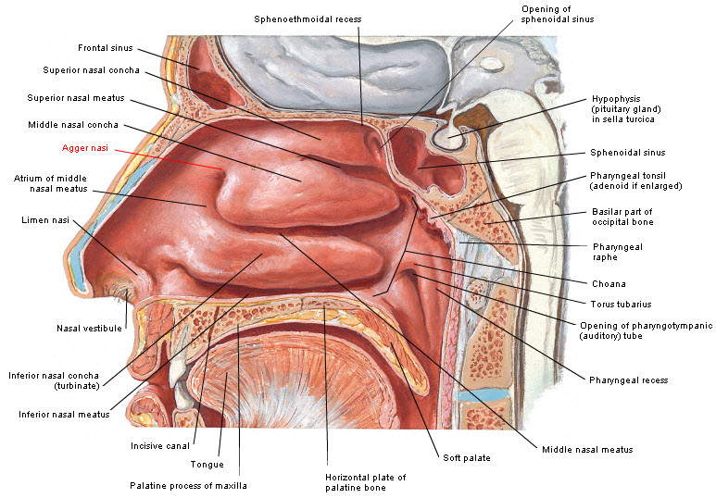
4. Superior meatus: is a narrow space lateral and inferior to the superior concha. The posterior ethmoidal sinus opens into its anterosuperior part.
5. Middle meatus: it is longer and deeper than the superior meatus, and lies lateral and inferior to the middle concha. It has the following features:

- The hiatus semilunaris: it is a deep curved groove, runs posteroinferior .The maxillary sinus, the anterior ethmoidal sinus and the frontal sinus open into it.

- Bulla ethmoidalis: it is a prominent bulge, lies above the hiatus, and caused by bulging of the underling middle ethmoidal sinus. This sinus opens into its upper border.

- The infundibulum: it is a funnel-shaped passage or opening at the anterosuperior part of the hiatus. It leads to the frontal sinus.
- The opening of the maxillary sinus: it lies in the posterior part of the hiatus.
- The opening of the anterior ethmoidal sinus: it lies in the anterior part of the hiatus.
The position of the opening of the frontal sinus favors the flow of secretions from it to the opening of the maxillary sinus .so the infection tends to spread from the frontal sinus to the maxillary sinus.
6. Inferior meatus: it lies inferior and lateral to the inferior concha, between the floor of the nose and the inferior concha.
The nasolacrimal duct opens into the anterior part of the meatus. This opening is wide and the mucous membrane at its medial side is raised up as the lacrimal fold. These acts as a flap valve which prevents the air and the secretions being enter the duct when the intranasal pressure is raised.

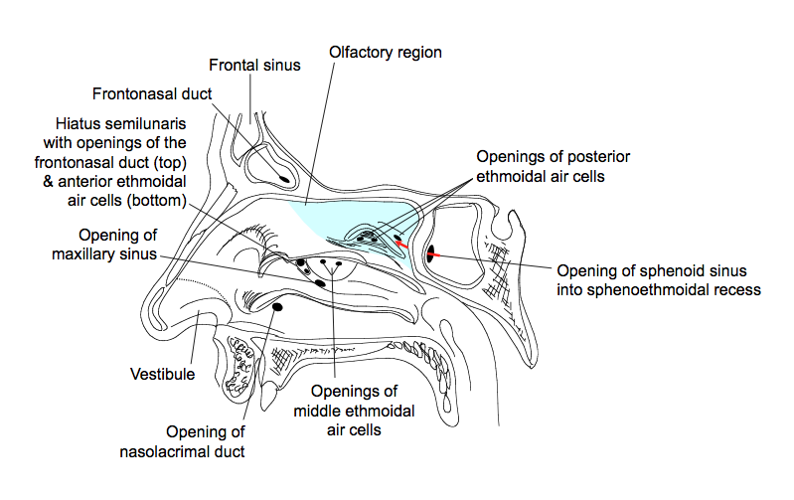

Nerve supply of the lateral wall
The special sensation [sense of smell]: by the olfactory nerve to the upper part of the lateral wall [area lined by the olfactory mucousa].
General sensory nerves:
1. Anterosuperior part: is supplied by the anterior ethmoidal nerve.
2. Anteroinferior part: is supplied by the nasal branch of the anterior superior alveolar nerve and internal nasal branch of the infra-orbital nerve.
3. Posterosuperior part: is supplied by the posterior superior lateral nasal nerves of the pterygopalatine ganglion.
4. Posteroinferior part: is supplied by the posterior inferio lateral nasal nerves of the pterygopalatine ganglion.
Greater [anterior] palatine nerve:
It is largest branch of the pterygopalatine ganglion ,descends vertically through the greater palatine canal and foramen[with the greater palatine branch of the maxillary artery].it enters the palate at the posterolateral corner of the inferior surface ,then runs forwards in a groove on the inferior surface of the hard palate close to its lateral margin. At the incisive foramen it communicates with terminal branches of the nasopalatine nerve.
Branches
- Two lateral nasal branches: pass through the perpendicular plate of palatine bone to the mucous membrane of the lateral wall of nose
- Lesser palatine nerves [middle and posterior]: they descend through lesser palatine canal and foramen to supply the soft palate and the tonsil.
- Terminal branches: to the mucous membrane of the hard palate
Blood supply of the lateral wall:
1. Anterosuperior part: is supplied by the anterior ethmoidal artery and posterior ethmoidal artery.
2. Anteroinferior part: is supplied by lateral nasal branch of the facial artery and the greater palatine artery.
3. Posterosuperior part: is supplied by sphenopalatine artery.
4. Posteroinferior part: is supplied by the ascending palatine branch of the facial artery and the greater palatine artery.

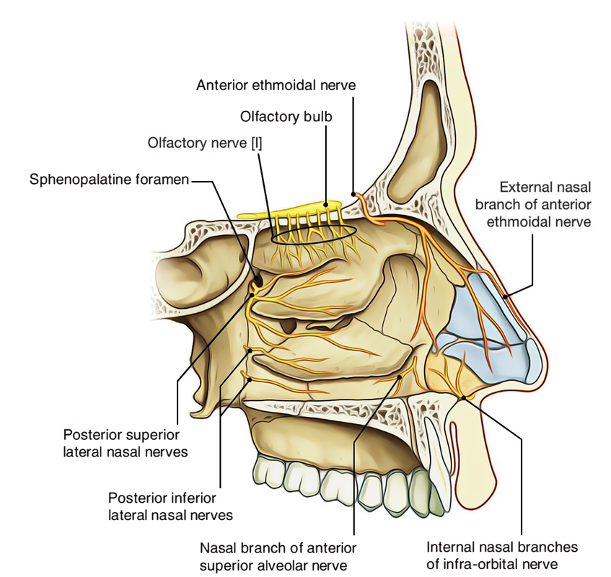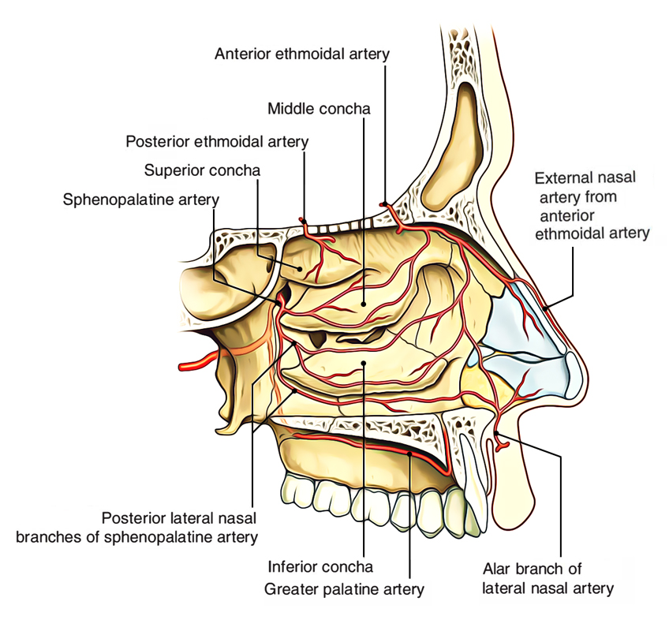

Paranasal sinuses
Air –filled cavities found in the interior of the maxilla, the frontal bone, the ethmoid bone and the sphenoid bone. They decrease the weight of the skull and add resonance to the voice.
The sinuses are lined by the ciliated columnar epithelium, rich in mucus secreting cells. The cilia push the mucus towards the nasal cavity through small openings [lie in the lateral wall of nasal cavity].obstruction of these openings lead to accumulation of the secretion which becomes infected and leads to the sinusitis.

The frontal air sinus
Are paired, asymmetrical cavities in the frontal bone. The two sinuses are separated by from each other by bony septum which is not median. They lay just the root of the nose and the upper margin of the orbit and about 2-3 cm in height and width .they open into the anterior part of the hiatus semilunaris of the middle meatus through the infundibulum. They are absent at birth, well developed between 7-8 years, but reach full size only after puberty.
Nerve supply: the supra-orbital and suprstrochlear nerves.
Ethmoidal air sinuses
Are multiple, thin walled cavities occupy the whole of the ethmoidal labyrinth [that lies between the nasal cavity and the orbit]. They separate from the orbit by thin plate of bone so infection of the ethmoid sinus may transmit to the orbit.
Each of ethmoid air sinuses has three groups of cells:
- Anterior ethmoidal group: opens into the middle meatus at the anterior part of hiatus and is supplied by the anterior ethmoidal nerve
- Middle ethmoid group: opens into the middle meatus at the upper border of the bulla ethmoidalis and is supplied by the anterior ethmoidal nerve.
- Posterior ethmoidal group: opens into the superior meatus and is supplied by the posterior ethmoidal nerve.

Sphenoid air sinus
Two in number, lie within the body of the sphenoid and open into the sphenoethmoidal recess. Both of them may extend into the wings and pterygoid processes of the sphenoid bone.
Relation
Anteriorly: the nasal cavity.
Posteriorly: thick layer of bone which separate it from the cranial cavity, pons and the basilar artery.
Superiorly: the pituitary gland and the intercavernous sinuses.
Inferiorly: the nasopharynx.
Laterally: the cavernous sinus.
Nerve supply
Posterior ethmoidal nerve and the pharyngeal branch of the pterygopalatine ganglion.
Maxillary sinus
It is the largest of the paranasal sinuses and occupies the whole of the body of the maxilla.
It has the shape of three sided pyramid.

- Apex [directed laterally] extends into the zygomatic process of the maxilla.
- Base is the lower part of the lateral wall of the nose.
- Roof is formed by the orbital plate of the maxilla [floor of the orbit]. The infra-orbital nerve and vessels runs in the roof.
- Floor is formed by the alveolar process of the maxilla [opposite to molar and premolar teeth].

- Three sided wall are formed by the orbital, anterior and infratemporal surfaces of the maxilla. The posterior superior alveolar nerve and vessels run in the infratemporal and anterior walls of the sinus, while the anterior superior alveolar nerve and vessels run in the orbital and anterior surfaces.

The maxillary sinus opens into the middle meatus of the nasal cavity at the posterior part of the hiatus semilunaris. This opening lies in the superior part of its base, so the secretion to escape, the sinus must nearly filled.
The roots of the teeth are separated by a thin layer of bone from the maxillary sinus. If it absent, the infected teeth may lead to sinusitis or sinusitis may lead to the toothache
Nerve supply
Posterior superior alveolar nerve, anterior superior alveolar nerve and infraorbital nerve.

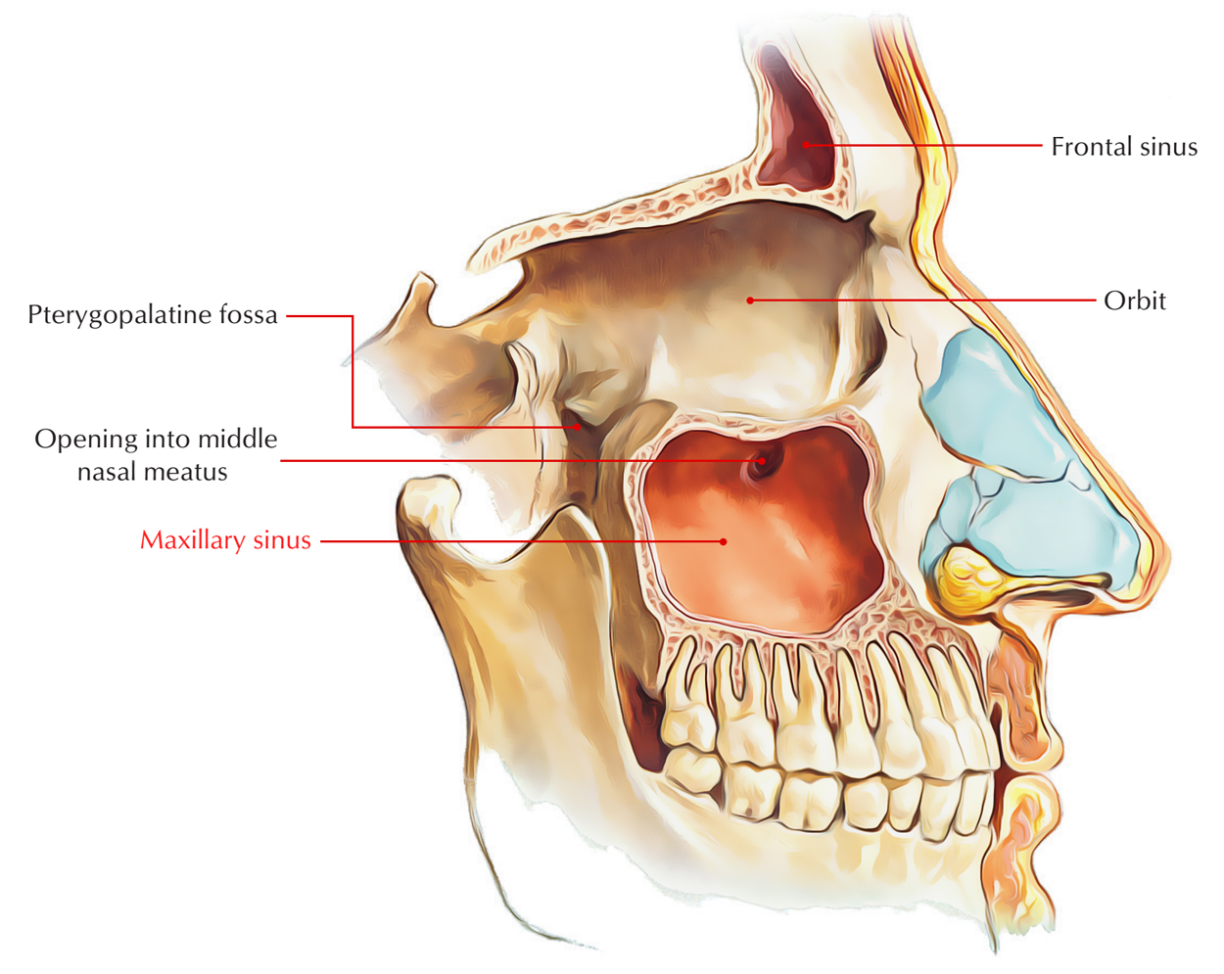
Sinusitis
Because the paranasal sinuses are continuous with the nasal cavities through apertures that open into them, infection may spread from the nasal cavities, producing inflammation and swelling of the mucosa of the sinuses (sinusitis) and local pain. Sometimes several sinuses are inflamed (pansinusitis), and the swelling of the mucosa may block one or more openings of the sinuses into the nasal cavities.

