University of Mustansiriyah Dr.shatha Al-Khateeb
Collage of Medicine Lec7&8 (1-19)
Clinical biochemistry Department 2017-2018

Hypothalamus and pituitary gland
The pituitary gland consist of two parts,the anterior pituitary ,or adenohypophysis,and the posterior pituitary,or neurohypophysis.Though very closely related anatomically,they are embryologically and functionally quite distinct. Together the hypothalamus and pituitary gland regulate every body system. The hypothalamus is an important part of the brain and is a primary endocrine organ in two different ways:
Hypothalamus and the Posterior Pituitary
The hypothalamus is an important part of the brain with many functions. Neurons of the hypothalamus synthesize and secrete two hormones, antidiuretic hormone (ADH) and oxytocin. The cell bodies of these neurons are found in two nuclei of the hypothalamus and have axons that descend along a thin stalk of tissue called the infundibulum and end in the posterior pituitary gland. The hormones are released at the axon terminals, diffuse into the capillaries and are distributed throughout the body in the bloodstream.
ADH and oxytocin are peptides and are considered neurohormones because of their secretion by neurons.
Hypothalamus and the Anterior Pituitary
The hypothalamus exerts control of the anterior pituitary by secreting tropic hormones which are hormones that regulate the secretion of other hormones by either stimulating or inhibiting their secretion.
The anterior pituitary is non-neural tissue which unlike the posterior pituitary has no direct nervous connection with the hypothalamus. The tropic hormones secreted by the neurosecretory cells of the hypothalamus reach the target cells of the anterior pituitary by the hypothalamic-pituitary portal system.

Tropic hormones from the hypothalamus act upon cells that secrete tropic hormones in the anterior pituitary. Except for one, all hormones secreted by the hypothalamus and anterior pituitary are peptides.

Hypothalamus | Tropic Effect | Anterior Pituitary | Effect/ Target Organ
Prolactin releasing hormone (PRH) | + | Prolactin | Mammary gland development/milk secretion
Prolactin inhibiting hormone (dopamine) | -
Thyrotropin releasing hormone (TRH) | + | Thyroid stimulating hormone (TSH) | Secretion of thyroid hormone by thyroid gland
Corticotropin Releasing Hormone (CRH) | + | Adrenocorticotropic hormone (ACTH) | Adrenal Cortex
Growth hormone releasing hormone (GHRH) | + | Growth hormone | Growth and energy metabolism/secretion of insulin-like growth factors by liver
Growth hormone inhibiting hormone (GHIH) | - | Growth hormone
Gonadotropin releasing hormone (GNRH) | + | Follicle stimulating hormone (FSH)/Luteinizing hormone (LH) | FSH: development of sex cells/LH: secretion of sex hormones and stimulation of ovulation

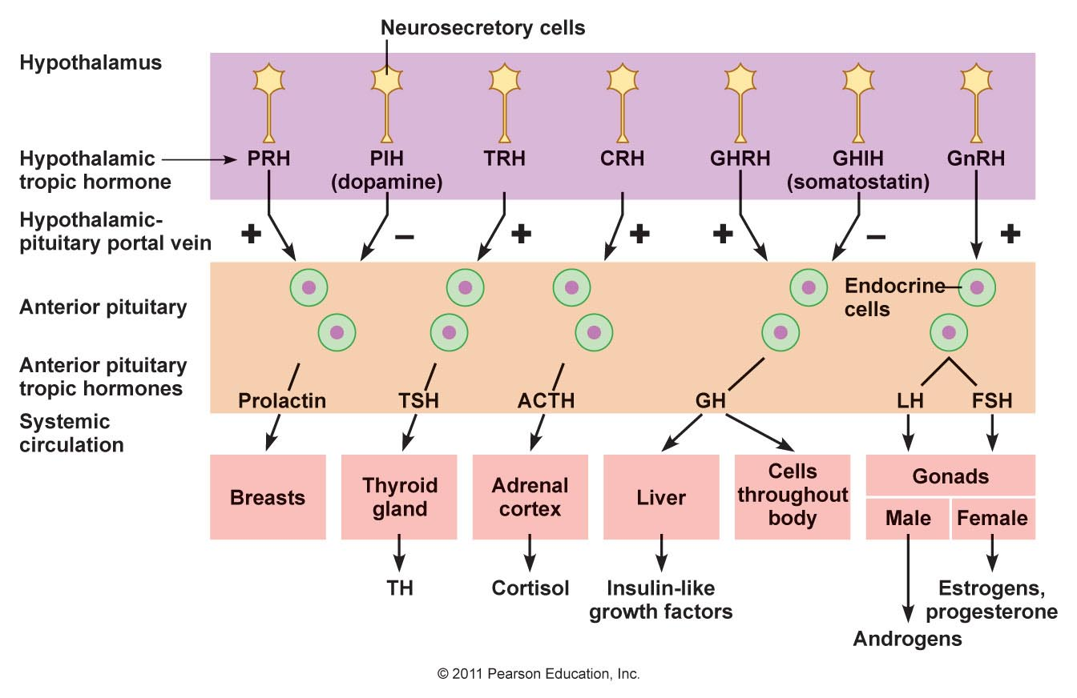
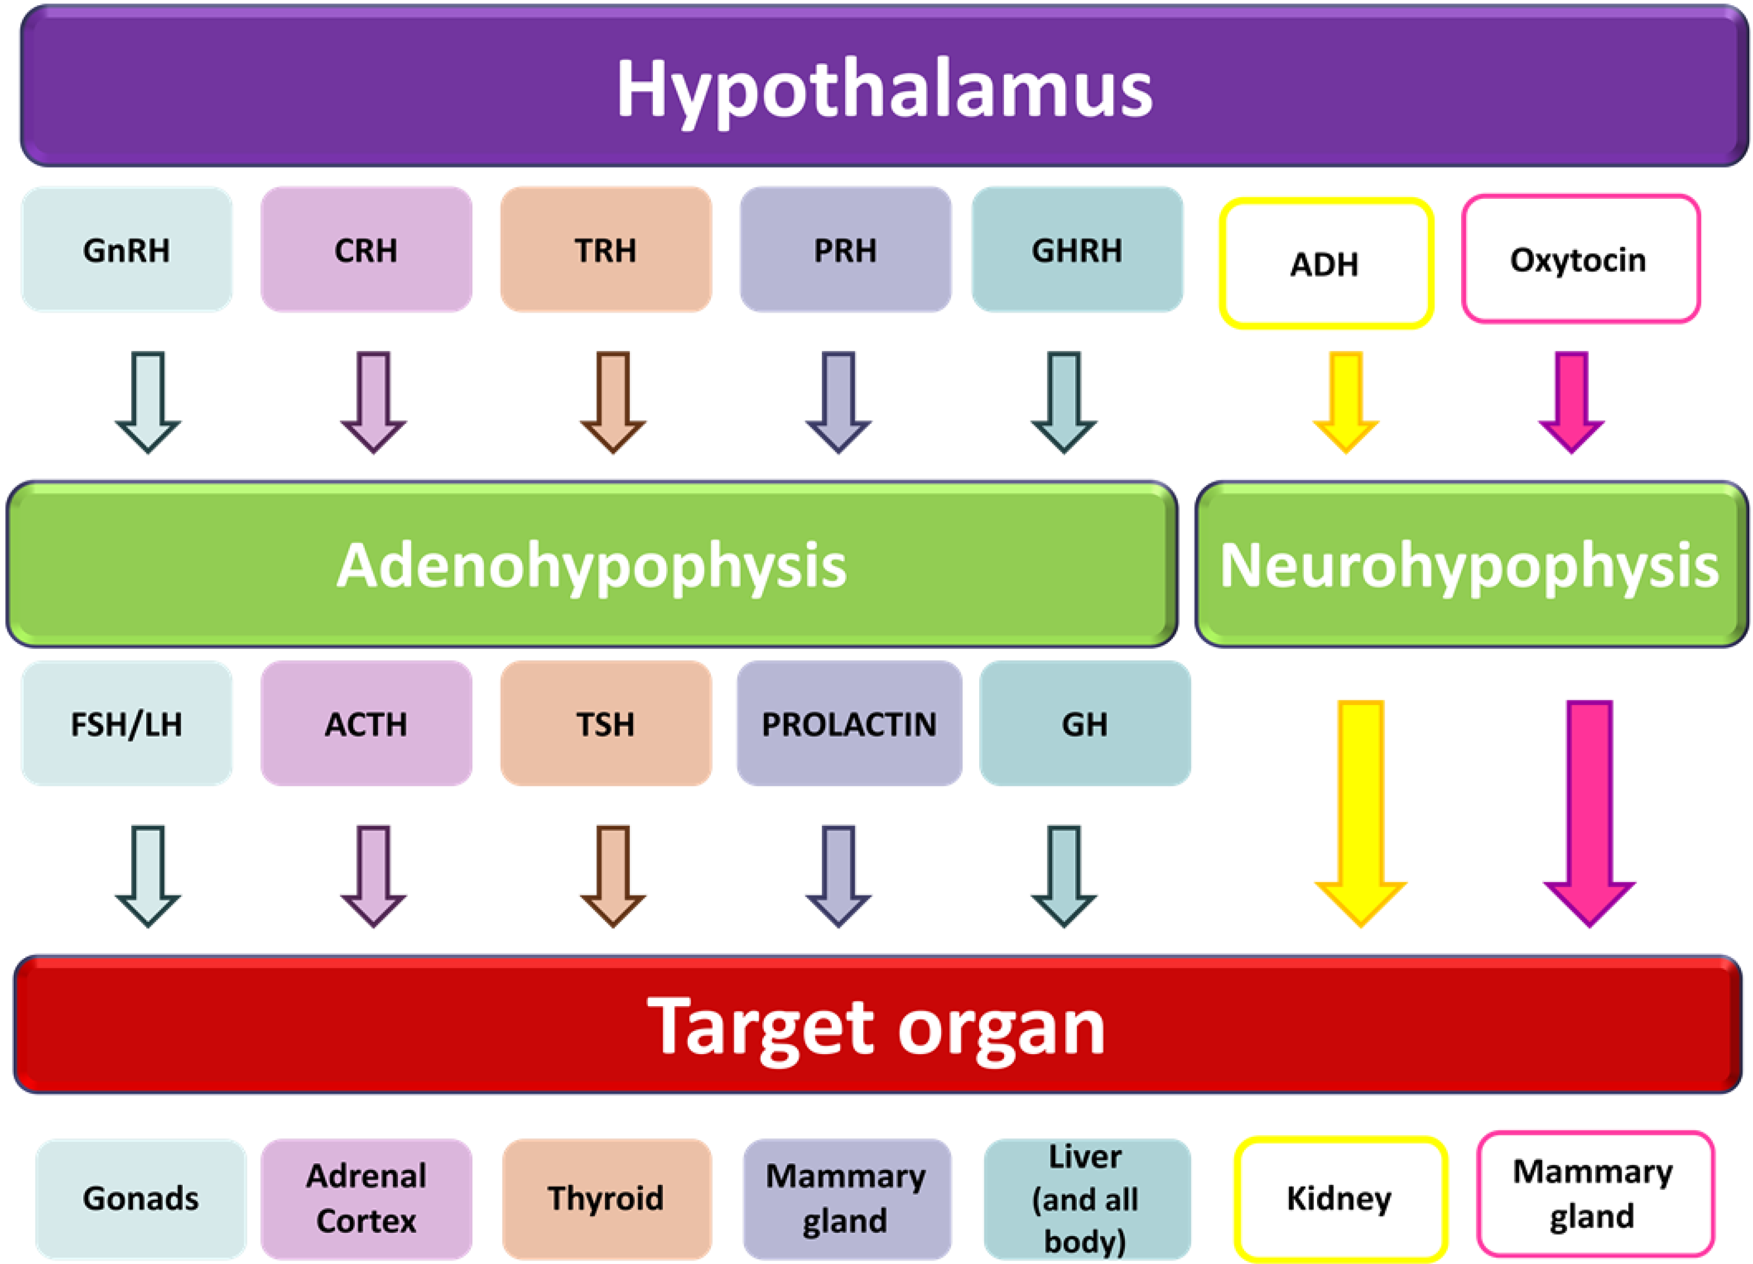
The hypothalamus and the posterior pituitary lobe
Two structurally similar peptide hormones Antidiruretic hormone (ADH) and Oxytocin, are synthesized in the hypothalamus and transported down nerve fibers of pituitary stalk attached to specific carrier proteins (neurophysin).
The H.are stored in the posterior pituitary gland and are released independently of each other into the blood-stream under hypothalamic control together with neurophysin.
Antidiuretic hormone (ADH)(Arginine Vasopressin (AVP)
Vasopressin is a nine amino acid peptide, it is synthesized primarily in the supraoptic nuclei of hypothalamus, a peptide hormone that controls the reabsorption of molecules in the tubules of the kidneys by affecting the tissue's permeability. It also increases peripheral vascular resistance, which in turn increases arterial blood pressure. It plays a key role in homeostasis, by the regulation of water, glucose, and salts in the blood. It is derived from a preprohormone precursor that is synthesized in the hypothalamus and stored in vesicles at the posterior pituitary. Most of it is stored in the posterior pituitary to be released into the bloodstream; however, some AVP is also released directly into the brain, where it plays an important role in social behavior and bonding. Arginine vasopressin (AVP), also known as vasopressin, argipressin or antidiuretic hormone (ADH).
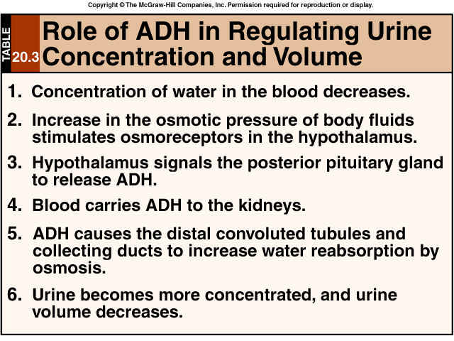
Osmolarity of the extracellular fluid control ADH release: Increased osmolarity stimulate the osmoreceptors in the hypothalamus which stimulates the ADH release.
The major function of ADH controls:
  - Maintain water homeostasis.
  - There is water reabsorption by the kidney and urine concentrated.
  - ADH in sufficient quantity induces generalized vasoconstriction that leads to increase in the arterial blood pressure.
ADH release is stimulated by:
1-The increase in serum osmolality. 2- The decrease in intravascular blood volume. 3-Physical Stress, surgery, and even anxiety.
Diabetes Insipidus occurs when: 1- ADH is inadequate or 2- Kidneys are not responsive to ADH.
Diabetes Insipidus may be:
1-Neurogenic Diabetes insipidus. It is caused by:
    - Trauma, tumor or inflammation of the brain.
    - ADH level is low.
    - Surgical ablation of the pituitary gland.
2-Nephrogenic diabetes insipidus. It is caused by:
1.Renal collecting system unresponsiveness to ADH.
2.ADH level is raised.
ADH release is stimulated by: Sleep , At night , In erect position, with pain, Stress, exercise. chemical agents like catecholamine.
ADH release is inhibited by: The increase in plasma volume , Decrease plasma osmolality,
Alcohol, Phenytoin, Glucocorticoids.

Vasopressin is responsible for increasing water absorption in the collecting ducts of the kidney nephron.Vasopressin increases water permeability of kidney collecting duct by inducing translocation of aquaporin-CD water channels in the kidney nephron collecting duct plasma membrane.
The physiological ADH release occur with plasma osmolality in a narrow range (284-295 mOsm/kg)
Thus when plasma osmolality.
< 280 mOsm/kg ــــــــــــــــــــــ> ADH secretion↓
When > 290 mOsm/kgــــــــــــــــــ> ADH secretion ↑
And when ECF volume ↓ـــــــــــــــــ> ADH secretion ↑
When ECF volume ↑ــــــــــــــــــــــــــ> ADH secretion ↓
Thirst will stimulate ADH secretion.
The half – life of ADH is 10-20 min. Excessive secretion results in dilutional hyponatraemia,with a risk of water intoxication; decrease secretion results in diabetes insipidus,a condition in which there is uncontrolled excretion of water with a tendency to severe dehydration.
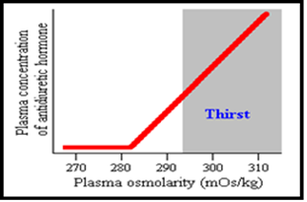

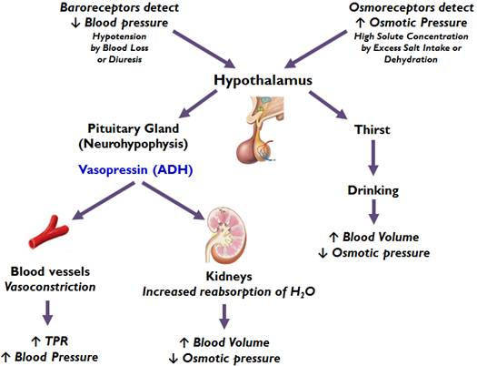

Function

One of the most important roles of AVP is to regulate the body's retention of water; it is released when the body is dehydrated and causes the kidneys to conserve water, thus concentrating the urine and reducing urine volume. At high concentrations, it also raises blood pressure by inducing moderate vasoconstriction.

Kidney: Vasopressin has two effects by which it contributes to increased urine osmolality (increased concentration) and decreased water excretion. These are:
1.) Increasing the water permeability of distal tubule and collecting duct cells in the kidney, thus allowing water reabsorption and excretion of more concentrated urine, i.e., antidiuresis. Vasopressin also increases the concentration of calcium in the collecting duct cells, by episodic release from intracellular stores. (Vasopressin, acting through cAMP).
Cyclic-AMP activates protein kinase A (PKA) by binding to its regulatory subunits and allowing them to detach from the catalytic subunits. Detachment exposes the catalytic site in the enzyme, allowing it to add phosphate groups to proteins (including the aquaporin-2 protein), which alters their functions.
2.) Increasing permeability of the inner medullary portion of the collecting duct to urea by regulating the cell surface expression of urea transporters, which facilitates its reabsorption into the medullary interstitium as it travels down the concentration gradient created by removing water from the connecting tubule, cortical collecting duct, and outer medullary collecting duct.

Cardiovascular system
Vasopressin increases peripheral vascular resistance (vasoconstriction) and thus increases arterial blood pressure. This effect appears small in healthy individuals; however it becomes an important compensatory mechanism for restoring blood pressure in hypovolemic shock such as that which occurs during hemorrhage.

Control of Antidiuretic Hormone Secretion
The most important variable regulating antidiuretic hormone secretion is plasma osmolarity, or the concentration of solutes in blood. Osmolarity is sensed in the hypothalamus by neurons known as an osmoreceptors, and those neurons, in turn, simulate secretion from the neurons that produce antidiuretic hormone.
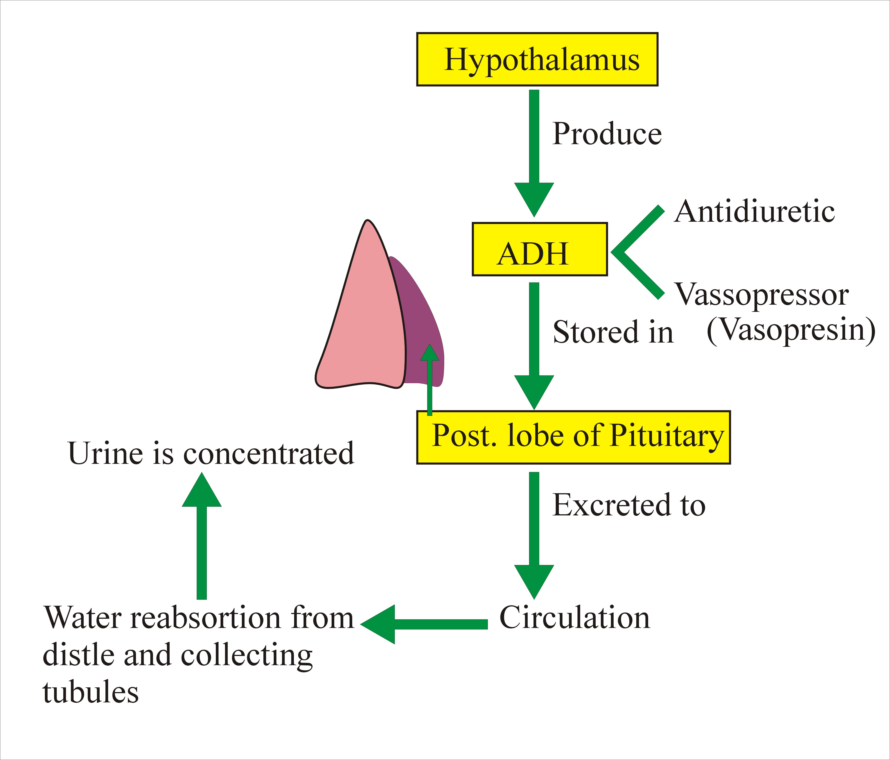
When plasma osmolarity is below a certain threshold, the osmoreceptors are not activated and antidiuretic hormone secretion is suppressed.
When osmolarity increases above the threshold, the ever-alert osmoreceptors recognize this cue to stimulate the neurons that secrete antidiuretic hormone.
There is an interesting parallel between antidiuretic hormone secretion and thirst. Both phenomena appear to be stimulated by hypothalamic osmoreceptors, although probably not the same ones. The osmotic threshold for antidiuretic hormone secretion is considerably lower than for thirst.
Secretion of antidiuretic hormone is also simulated by decreases in blood pressure and volume, conditions sensed by stretch receptors in the heart and large arteries.
Another potent stimulus of antidiuretic hormone is nausea and vomiting, both of which are controlled by regions in the brain with links to the hypothalamus.

Many factors influence the secretion of vasopressin:
- Ethanol (alcohol) reduces the calcium-dependent secretion of AVP by blocking voltage-gated calcium channels in neurohypophyseal nerve terminals.
- Angiotensin II stimulates AVP secretion, in keeping with its general pressor and pro-volemic effects on the body.
- Atrial natriuretic peptide inhibits AVP secretion, in part by inhibiting Angiotensin II-induced stimulation of AVP secretion.
Oxytocin
Oxytocin is the brain chemical released that creates emotions like ‘love. 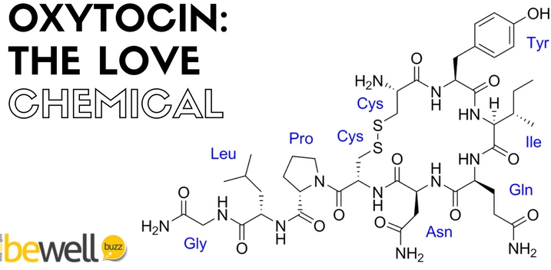
Oxytocin is a nine amino acid peptide that is synthesized in the paraventricular nuclei of the hypothalamus, but it differs from ADH in two of the nine amino acids. This hormone is produced by the hypothalamus and stored in the posterior pituitary gland.It is secreted when necessary by the pituitary gland on receiving a neural stimulation from the hypothalamus.
Its functions include contracting the milk channels. Other functions of the oxytocin hormone in the production of mother's milk is treated in detail in the section "The Wonder of Mother's Milk."
- Present in both males and females, but its physiological effects are known only for females.
- It stimulates the contraction of the estrogen – primed uterus.
- It is useful as a therapeutic agent in inducing labor.
- It stimulates the lactating mammary gland.
- Progestins are believed to inhibit the action of oxytocin.
Oxytocin has peripheral (hormonal) actions, and also has actions in the brain. The actions of oxytocin are mediated by specific, high-affinity oxytocin receptors. The oxytocin receptor is a G-protein-coupled receptor that requires Mg2+ and cholesterol. It belongs to the rhodopsin-type (class I) group of G-protein-coupled receptors.

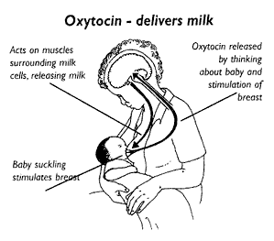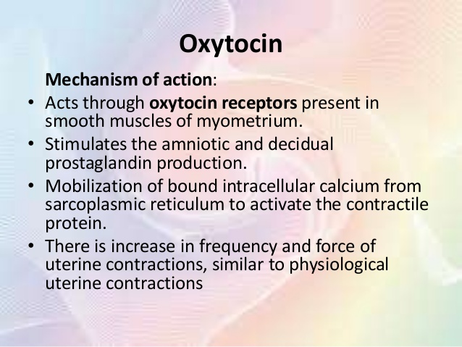

Control of Oxytocin Secretion
There’s no negative feedback loop from the mammary gland for prolactin. Milk comes out the nipple, so it can’t loop back to the pituitary. Prolactin Releasing Hormone (PRH) and nursing of a baby stimulate the release of Prolactin. Dopamine, sometimes called prolactin inhibitory hormone, inhibits the secretion of prolactin. Weaning of the baby inhibits the release of prolactin as well.
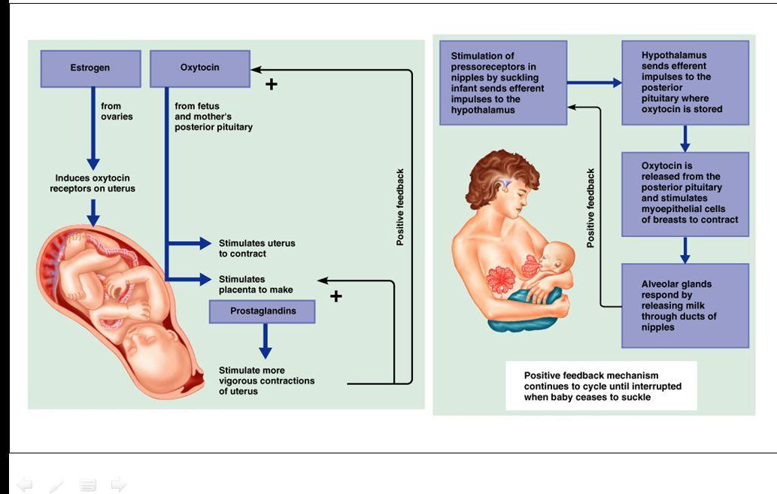

Hormone of Middle Lobe of Pituitary
Melanocyte Stimulating Hormones : The hormones secreted by intermediate lobe or middle lobe of pituitary gland are called melanocyte-stimulating hormones or MSH .

The middle lobe of pituitary gland secretes melanocytes stimulating hormone(MSH) ,also known as intermedin.

Two forms of MSH α-MSH and β-MSH , the α- is a single chain (13 amino acids) while β is a polypeptide of 22 amino acids.The secretion is inhibeted by Corticosteroids and its activity is inhibeted by Catecholamines.

Functions:
MSH darkens the skin and is involved in skin pigmentation by deposition of mammalian by melanocytes.

Abnormality:
Addison’s disease:
- MSH is in excess, which increases the synthesis of melanin resulting in brown pigmentation of the skin.
- Such a condition occurs in this disease.
The hypothalamus and the Anterior pituitary lobe:- There is no direct neural connection between the hypothalamus and the anterior pituitary gland.
The hypothalamus synthesizes small molecules (regulating hormones or factors) carried to the anterior pituitary lobe by the hypothalamic portal system.
The Releasing Hormones from the hypothalamus cause the release of hormones in the adenohypophysis. These are the releasing hormones coming from the hypothalamus:
- Corticotropin Releasing Hormone (CRH causes the release of ACTH)
- Thyrotropin Releasing Hormone (TRH causes the release of TSH;Thyroid Stimulating Hormone;Thyrotropin)
- Gonadotropin Releasing Hormone (GnRH releases LH and FSH.)
- Growth Hormone R.H. & Growth Hormone I.H.
- Prolactin R.H. & Prolactin I.H.
These releasing hormones above cause the adenohypophysis to release the following 6 hormones:
- Growth Hormone
- Prolactin
- Thyrotropin (Thyroid Stimulating Hormone; TSH)
- AdrenoCorticoTropin Hormone (ACTH)
- Luteinizing Hormone (LH)
- Follicle Stimulating Hormone (FSH)
Four of them are considered tropic hormones and two are not tropic. Tropic means they affect other endocrine glands.
The two that are not tropic are Growth Hormone (affects bone/muscles) and Prolactin (affects mammary glands).
The cells of the anterior pituitary lobe can be classified by their staining reactions as :
- Acidophils : are of two cell types:
- Somatotrophs which secrete growth hormone GH: somatotrophin.
- Lactotrophs which secrete prolactin.
These two hormones are simple polypeptide with similar amino acid sequences, and mainly effect peripheral tissue directly. Stimulation and inhibition of secretion through the hypothalamus which is influenced by neural stimuli.
- Basophils: secrete H. that affects other endocrine glands.
There are three cell types:-
A) Thyrotrophs: - secrete thyroid-stimulating hormone (TSH), (Thyrotrophin ) , which acts on the thyroid gland ,there are glycoprotein receptors on the thyroid cells membrane which bind to the receptor-binding site on β-subunit of TSH . The complex then activate adenyl cyclase system increasing c-AMP level in the cells which act as second messenger and duplicates the function of the hormone.
B) Gonadotrophs: secrete gonadotrophins, follicle- stimulating hormone (FSH) and Luteinizing hormone (LH), which act on the gonads.
These three hormones are structurally similar glycoproteins consisting of two subunits (α, β) .Their secretion is influenced more by negative feedback control than neural mechanisms.
C) Corticotrophs: it is a precursor of both adrenocorticotrophic hormones ACTH; corticotrophin and β – lipotrophin β-LPH
- ACTH stimulates the synthesis and secretion of steroids and melanocyte- stimulating. Activity from the adrenal cortex.
High ACTH conc. often associated with pigmentat ion.
- β-LPH: - is secreted inactive until rapidly converted to endorphins which is neurotransmitters, they have opiate – like effects, help to control pain.
3-Chromophobes: they are inactive, do contain secretory granules, often secrete hormones, particulary prolactin.

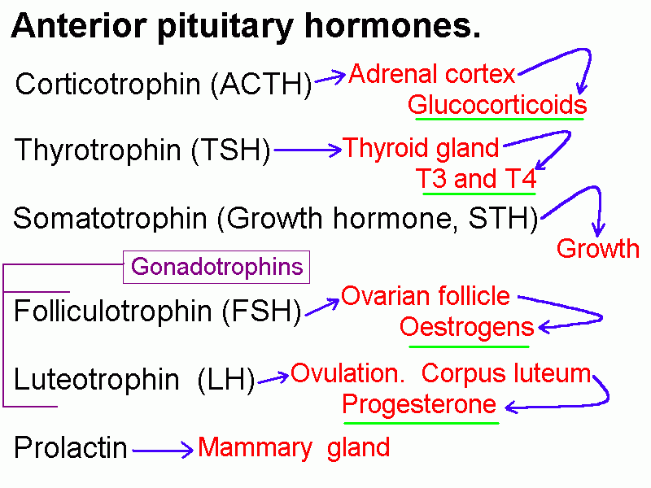
Pituitary Tropic Hormones
Anterior pituitary gland secreted some tropic hormones usually called as pituitary tropins.
A tropin or tropic hormone is the one which influences the activities of other endocrine gland,principally those involved in stress and reproduction. These are carried by the blood to other target gland. The pituitary tropins are under the positive and negative control of peptide factors from hypothalamus. Further the tropic hormones are usually subject to feedback inhibition at the pituitary or hypothalamic level by hormone product of the final target gland .
The tropic hormones produced by anterior pituitary are :
  - Thyroid stimulating hormone(TSH or thyrotropin) .
  - Adrenocorticotropic(ACTH or corticotrophin) .
  - Lactogenic hormone (LTR or prolactin or luteotropin) .
  - Gonadal hormones:-
Follicle stimulating hormone(FSH)
Luteinizing hormone (LH) . Also called as interstitial cell –stimulating hormone (ICSH).

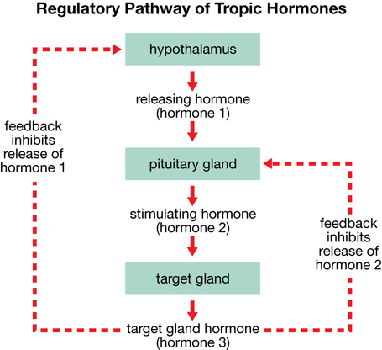

Control of Anterior Pituitary Hormone Secretion.
Is mainly by:-
- Extrahypothalamic neural stimuli: - Physical or emotional stress and mental iliness may give similar findings to, and even precipitate endocrine disease.
- Feedback control: - is mediated by the concentrations of circulating target-cell hormones, a rising concentration usually suppresses trophic hormone secretion .This negative feedback may directly suppress hypothalamic hormone secretion or may modify its effect on pituitary cells (long feedback loop). Secretion of hypothalamic H. may also be suppressed by rising concentrations of pituitary H. in a short feedback loop.
- Inherent rhythms:-
The hypothalamic and consequently pituitary H. is released intermittently, either in pulses or in a regular circadian rhythm.

Growth Hormone Growth hormone (GH), also known as somatotropin, is a peptide hormone of 191 amino acids that is synthesized and secreted by the somatotrophs of the anterior pituitary gland. Consist of 4 helices that help it bind its receptor, 2 strong sulfide bonds together.
The main action of GH is to stimulate linear growth in children; however, it also fosters a healthy body composition by increasing muscle and reducing fat mass, maintains normal blood glucose levels, and promotes a favorable lipid profile.

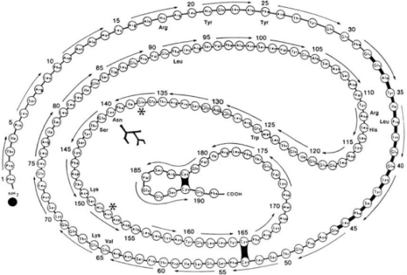

Stimulators of HGH secretion include
(1-)Peptide hormones
  - Growth hormone-releasing hormone (GHRH) through binding to the growth hormone-releasing hormone receptor (GHRHR).
  - Ghrelin through binding to growth hormone secretagogue receptors (GHSR)
(2-)Sex hormones
  - Increased androgen secretion during puberty (in males from testis and in females from adrenal cortex)
  - Estrogen.
(3-)Hypoglycemia, arginine and propranolol by inhibiting somatostatin release.
(4-)Deep sleep. (5-) Niacin as nicotinic acid. ( 6-)Fasting, and (7-)Vigorous exercise.
Inhibitors of GH secretion include:
(1)Somatostatin from the periventricular nucleus. (2) Circulating concentrations of GH and IGF-1 (negative feedback on the pituitary and hypothalamus).(3)Hyperglycemia.(4)Glucocorticoids. (5)Dihydrotestosterone.
A number of factors are known to affect HGH secretion, such as age, gender, diet, exercise, stress, and other hormones. Young adolescents secrete HGH at the rate of about 700 μg/day, while healthy adults secrete HGH at the rate of about 400 μg/day. Individuals who want to increase HGH production naturally can alter their exercise plan to include resistance training, sprinting or interval training, and endurance exercises. Because the body is pushed to fatigue during these exercises, HGH production is stimulated to repair damaged muscle tissues.
Effects of growth hormone on the tissues of the body can generally be described as anabolic (building up). Like most other protein hormones, GH acts by interacting with a specific receptor on the surface of cells.A critical concept in understanding growth hormone activity is that it has Two distinct types of effects:
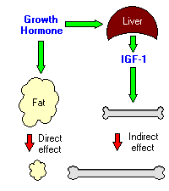
Direct effects are the result of growth hormone binding its receptor on target cells. Fat cells (adipocytes), for example, have growth hormone receptors, and growth hormone stimulates them to break down triglyceride and supresses their ability to take up and accumulate circulating lipids. Because polypeptide hormones are not fat-soluble, they cannot penetrate sarcolemma.

Indirect effects: are mediated primarily by insulin-like growth factor-I (IGF-I), a hormone that is secreted from the liver and other tissues in response to growth hormone. A majority of the growth promoting effects of growth hormone is actually due to IGF-I acting on its target cells.
In addition to increasing height in children and adolescents, growth hormone has many other effects on the body:
- Increases calcium retention, and strengthens and increases the mineralization of bone.
- Increases muscle mass through sarcomere hyperplasia.
- Promotes lipolysis.
- Increases protein synthesis.
- Stimulates the growth of all internal organs excluding the brain.
- Plays a role in homeostasis.
- Reduces liver uptake of glucose.
- Promotes gluconeogenesis in the liver.
- Contributes to the maintenance and function of pancreatic islets.
- Stimulates the immune system.
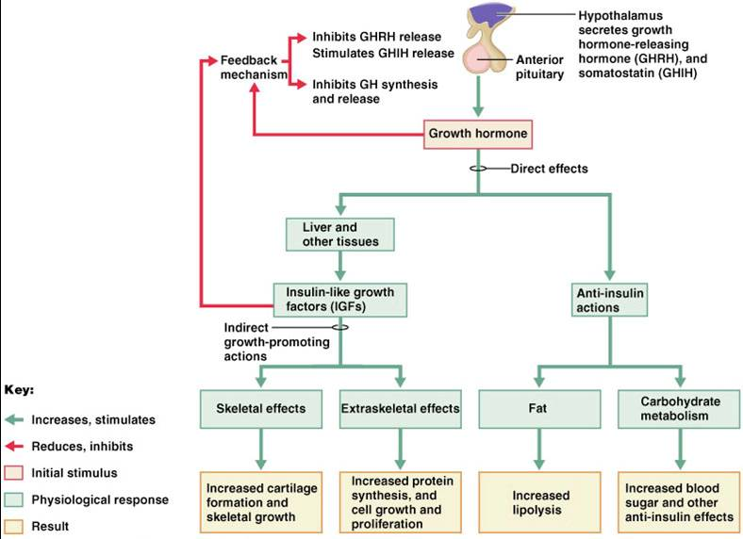

Control of Growth Hormone Secretion

Production of growth hormone is modulated by many factors, including stress, exercise, nutrition, sleep and growth hormone itself. However, its primary controllers are two hypothalamic hormones and one hormone from the stomach:
Growth hormone-releasing hormone (GHRH) is a hypothalamic peptide that stimulates both the synthesis and secretion of growth hormone.
Somatostatin (SS) is a peptide produced by several tissues in the body, including the hypothalamus. Somatostatin inhibits growth hormone release in response to GHRH and to other stimulatory factors such as low blood glucose concentration.
Ghrelin is a peptide hormone secreted from the stomach. Ghrelin binds to receptors on somatotrophs and potently stimulates secretion of growth hormone.
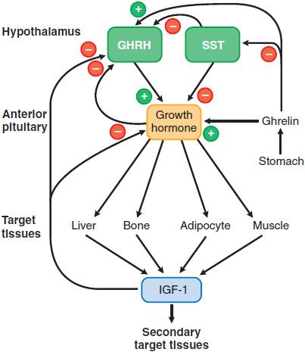
Two hypothalamic factors, growth hormone-releasing hormone (GHRH) and somatostatin (SST) stimulate or inhibit the release of growth hormone (GH) from the pituitary, respectively. Insulin-like growth factor-1 (IGF-1), a product of GH action on peripheral tissues, causes negative feedback inhibition of GH release by acting at the hypothalamus and the pituitary. The actions of GH can be direct or indirect (mediated by IGF-1).
Abnormalities of GH
During childhood: Excess GH cause gigantism while deficiency causes short stature.
During adults: Excess cause acromegaly while deficiency very rarely causes symptoms. Gigantism :-
- Is caused by excess GH secretion in childhood before fusion of the epiphyseal plates.
- Heights of up to 7 feet (2.1 m) may be reached.

Acromegaly:-
- Results from GH excess in adults after epiphseal fusion.
- Cause increase in bulk of bone and soft tissues with changes in facial appearance.
- Enlargement of thyroid gland.
- Excessive hair growth
- Menstrual disturbances.
- Impaired glucose tolerance diabetes mellitus.
- Increased plasma prolactin concentration.

Deficiency of GH: GH deficiency is one of the many causes of short stature and dwarfism. It results primarily from damage to the hypothalamus or to the pituitary gland during fetal development (congenital GH deficiency) or following birth (acquired GH deficiency). GH deficiency may also be caused by mutations in genes that regulate its synthesis and secretion.
- In adult rarely causes clinical symptoms.
- In children leads to dwarfism (short stature) the birth weight may be normal but the rate of growth is subnormal.
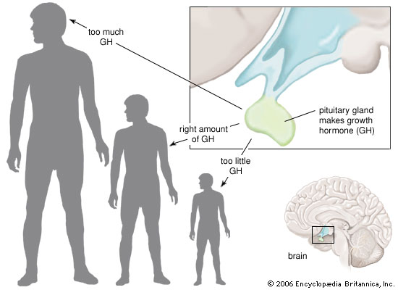
GH as Blood test
GH testing is not recommended for general screening. It is primarily ordered on those with symptoms of growth hormone abnormalities, as a follow-up to other abnormal hormone test results, or to help evaluate pituitary function.
Growth hormone tests are used to help identify excess or diminished GH production and give the doctor information about the severity of a person's condition. They are part of the diagnostic work-up required to find a cause for abnormal hormone production. In addition, GH can be measured to assess the success of therapy for acromegaly or gigantism.
Different tests are used to diagnose growth problems:
- GHRH or GHRH-arginine stimulation (to help diagnose a lack of growth hormone).
- Growth hormone stimulation test.
- IGF-1 levels.
- Oral glucose tolerance suppression (to help diagnose too much growth hormone).
An IGF-1 (Insulin-like growth factor – 1) test is often ordered along with GH. IGF-1 mirrors GH excesses and deficiencies, but its level is stable throughout the day, making it a useful indicator of average GH levels.
Testing to diagnose GH abnormalities often involves either a GH stimulation test or a GH suppression test. These are used to evaluate pituitary response and changes in GH levels.
- GH stimulation tests help to diagnose GH deficiency and hypopituitarism. For a stimulation test, a sample of blood is drawn after 10-12 hours of fasting. Then, under close medical supervision, a person is given an intravenous solution of insulin or arginine. Blood samples are then drawn at timed intervals, and GH levels are tested in each to see if the pituitary gland was stimulated by the insulin (or arginine) to produce expected levels of GH. Other GH stimulants include clonidine and glucagon.
- GH suppression tests help to diagnose GH excess, which, in addition to other blood tests and imaging scans, can help identify and locate pituitary tumors. For a suppression test, a sample of blood is drawn after 10-12 hours of fasting. A person is then given a standard glucose solution to drink. Blood samples are drawn at timed intervals, and GH levels are tested in each to see if the pituitary gland is sufficiently suppressed by the dose of glucose.

When is it ordered?
GH stimulation testing is ordered when a child has symptoms of growth hormone deficiency (GHD), such as:
- A growth rate that slows down in early childhood and the child is significantly shorter than others of the same age;
- Thyroid testing (e.g., free T4) shows that the child is not hypothyroid (low thyroid levels can also cause slowed growth);
- X-rays show delayed bone development;
- A doctor suspects that a child's pituitary gland is under-active.
GH and IGF-1 testing may be ordered at regular intervals for many years to monitor for recurrence of GH abnormalities in cases of GH excess.
Prolactin (PRL)
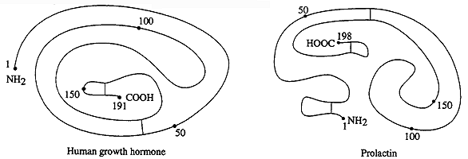
1-Prolactin is synthesized as a prohormone . Following cleavage of the signal peptide , the length of the mature hormone is between 194 and 199 amino acids and stabilized by three intramolecular disulfide bonds,with a 40% sequence homology to GH.This homology suggests that these hormones arose from a common ancestral gene.PRL is present in pituitary at 1/100 the concentration of GH.
2-It is secreted by the pituitary acidophilic cells and the no. of these cells increase in pregnancy.
3-Its secretion and inhibition is under the influenced of (Neural stimuli).
4-Thyrotropin – releasing H (TTRH) is a prolactin relasing factor (PRF), since it stimulates PRL secretion.
5-Release of PRL is episodic and varies predictably during the day with lowest levels at midday and highest values shortly after the onset of deep sleep thus the best time for blood collection is between 8:00 –10:00 a.m.
6-Increased in PRL levels in:
  - After stress of gyhecological examination
  - Stress of blood collection, nipple manipulation.
  - During sleep
  - During pregnancy
  - During lactation.
7-Pathological increase in PRL:-
1- Amenorrhea (cessation of menses)
2- Galactorrhea (breast discharge)
3- Female infertility.
8-Increased in PRL has been associated with
1- Gynecomastia (breast enlargement in men)
2- Impotence in men (decreased sperm production).

Prolactin Regulation
Bursts of prolactin secretion are stimulated so as to maintain milk production during lactation. Suckling by the infant stimulates nipple mechanoreceptors that are connected by neural circuits to two types of neurosecretory cells in the hypothalamus.
*One type of neurosecretory cell is a magnocellular cell that releases the hormone oxytocin from the posterior pituitary. These cells are stimulated by suckling.
*The other neurosecretory cell is a parvocellular cells that releases dopamine at the median eminence. Dopamine acts as a hormone, traveling to the anterior pituitary via the hypophyseal portal vessels to inhibit prolactin secretion by anterior pituitary cells. Suckling, via neural connections inhibits dopamine secretion, increasing prolactin secretion and stimulating milk production in the breast.
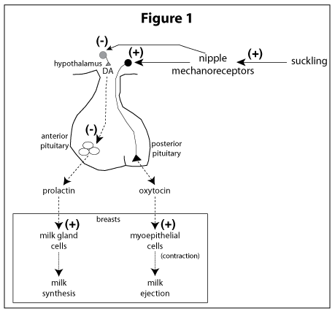
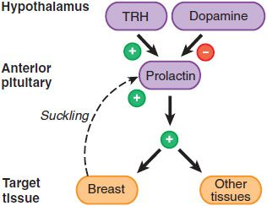
Control of Prolactin Secretion
Dopamine serves as the major prolactin-inhibiting factor or brake on prolactin secretion. Dopamine is secreted into portal blood by hypothalamic neurons, binds to receptors on lactotrophs, and inhibits both the synthesis and secretion of prolactin. Agents and drugs that interfere with dopamine secretion or receptor binding lead to enhanced secretion of prolactin.
In addition to tonic inhibition by dopamine, prolactin secretion is positively regulated by several hormones, including thyroid-releasing hormone, gonadotropin-releasing hormone and vasoactive intestinal polypeptide. Stimulation of the nipples and mammary gland, as occurs during nursing, leads to prolactin release. This effect appears to be due to a spinal reflex arc that causes release of prolactin-stimulating hormones from the hypothalamus.
Estrogens provide a positive control over prolactin synthesis and secretion. The increasing blood concentrations of estrogen during late pregnancy appear responsible for the elevated levels of prolactin that are necessary to prepare the mammary gland for lactation at the end of gestation.

