University of Mustansiriyah Dr.Shatha AL-Khateeb
Collage of Medicine Lec.7 (1-6 ) Clinical biochemistry Department 2017-2018

Parathyroid Gland
The parathyroid glands are small endocrine glands in the neck that produce parathyroid hormone. Humans usually have four parathyroid glands, are normally the size of a grain of rice,which are usually located on the rear surface of the thyroid gland. Although they are neighbors and both are part of the endocrine system, the thyroid and parathyroid glands are otherwise unrelated--they do not have the same function--just similar and confusing names!
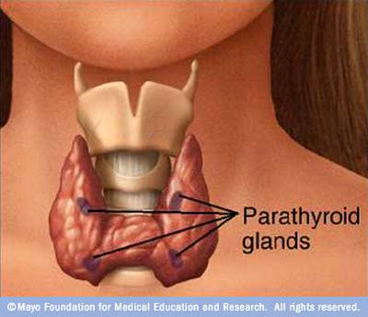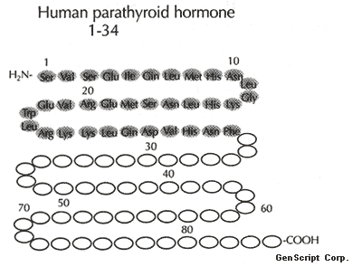
The major function of the parathyroid glands is to maintain the body's calcium level within a very narrow range, so that the nervous and muscular systems can function properly.
Parathyroid glands control the calcium in our bodies--how much calcium is in our bones, and how much calcium is in our blood. Calcium is the most important element in our bodies (we use it to control many systems), so calcium is regulated very carefully. Parathyroid glands control the calcium.
When blood calcium levels drop below a certain point, calcium-sensing receptors in the parathyroid gland are activated to release hormone into the blood.
Parathyroid hormone
Parathyroid hormone (PTH), parathormone or parathyrin, is secreted by the chief cells of the parathyroid glands as a polypeptide containing 84 amino acids. It acts to increase the concentration of calcium (Ca²⁺) in the blood, whereas calcitonin (a hormone produced by the parafollicular cells (C cells) of the thyroid gland) acts to decrease calcium concentration.
PTH acts to increase the concentration of calcium in the blood by acting upon the parathyroid hormone 1 receptor (high levels in bone and kidney) and the parathyroid hormone 2 receptor (high levels in the central nervous system, pancreas, testis, and placenta).
Biosynthesis
1-Pre-Pro PTH: Consisting of 115 amino acids is first formed in polysomes,adhering on the rough ER membrane.
2-Pro-PTH : Before the formation of Pre-Pro PTH is completed ,its N-terminal end products into the lumen of rough ER and a single peptidase of rough ER membrane hydrolyzes the molecule to split off 25 amino acid,and thus Pre-Pro PTH is changed to Pro-PTH having 90 amino acids.
3-PTH : Pro-PTH is transferred to rough ER lumen and moves to Golgi cisternae.Thus PTH formed is packaged and stored in secretary vesicles.

Regulation of PTH secretion
The stimulus for PTH secretion is hypocalcemia, in other words, low calcium in the blood. The effects of PTH in the body are to raise the ECF calcium concentration. There are three specific actions of PTH: first, it stimulates release of calcium from bone by stimulating bone resorption. Second, PTH decreases the amount of calcium excreted in the urine, by stimulating calcium reabsorption in the kidney. Finally, PTH indirectly promotes calcium absorption by the digestive tract, because it activates the enzyme in kidney cells that produces the hormone 1,25-(OH)₂D (the active form of vitamin D).
The sensor on the parathyroid gland cell that detects changes in the ECF calcium concentration is a G-protein coupled receptor that is a calcium receptor. When ECF calcium is high, calcium binds to the receptor and this inhibits PTH secretion. When ECF calcium is low, the receptor is unbound and so there is no inhibition, and PTH secretion occurs.
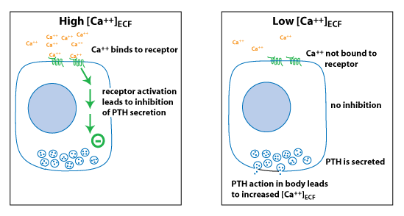
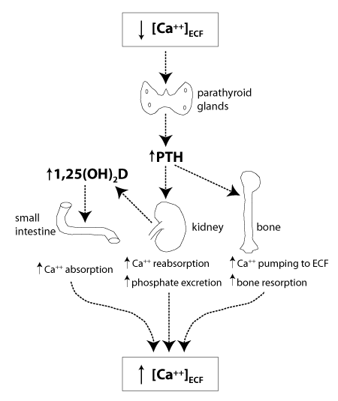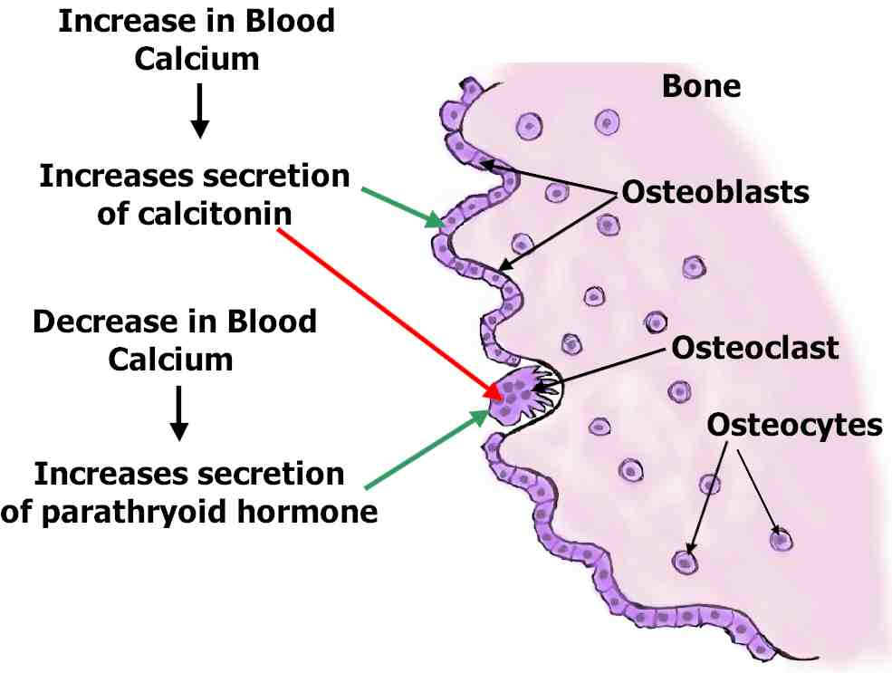
The two most important hormones for maintaining calcium levels in the body are parathyroid hormone (PTH) and 1,25(OH)₂D (the active form of vitamin D). The major regulator is PTH, which is part of a negative feedback loop to maintain [Ca⁺⁺] (ECF ).
PTH Effects on Bone :PTH has a rapid effect (occurring within minutes), whereby it stimulates osteoblasts to pump Ca⁺⁺ ions out of the fluid surrounding the bone (which has a higher Ca⁺⁺ concentration) and into the ECF. Over a longer time course, PTH stimulates bone resorption. Although PTH stimulates bone resorption, it is actually the osteoblasts that express PTH receptors. PTH stimulation of osteoblasts causes them to express a signaling molecule that activates osteoclasts.
PTH Effects on Kidney
PTH has two important effects on the kidney that work to increase [Ca⁺⁺](ECF).
1-It decreases the loss of Ca⁺⁺ ions in the urine by stimulating Ca⁺⁺ reabsorption,which is performed by the cells of the kidney tubules, allows the recovery of those useful small molecules such as sugars, amino acids, and Ca⁺⁺ ions. As well as stimulating Ca⁺⁺ reabsorption, PTH also inhibits phosphate reabsorption in the kidney.
2-Stimulate production of 1,25(OH)₂D, the active form of vitamin D. A precursor (known specifically as vitamin D₃ or cholecalciferol) is synthesized in a photochemical reaction in the skin, in response to sunlight.
In kidney disease, inadequate amounts of 1,25(OH)₂D are made thus[Ca⁺⁺](ECF) drops because of a lack of Ca⁺⁺ absorption from the diet.
Hypocalcemia stimulates high levels of PTH secretion; this is termed secondary hyperparathyroidism because the problem that causes the hyperparathyroidism is in the kidney, not at the parathyroid gland. Secondary hyperparathyroidism is treated by administering vitamin D and Ca⁺⁺ supplements.

Stimulators
- Decreased serum [Ca²⁺].
- Mild decreases in serum [Mg²⁺].
- An increase in serum phosphate (increased phosphate causes it to complex with serum calcium, forming calcium phosphate, which reduces stimulation of Ca-sensitive receptors (CaSr) that do not sense Calcium phosphate, triggering an increase in PTH).

Inhibitors
- Increased serum [Ca²⁺].
- Severe decreases in serum [Mg²⁺], which also produces symptoms of hypoparathyroidism (such as hypocalcemia).
Mechanism of Action
PTH increase serum Ca++ level by acting on bone, kidney and intestines.
They measure the amount of calcium in the blood every minute of every day... and if the calcium levels go down a little bit, the parathyroid glands recognize it and make parathyroid hormone (PTH) which goes to the bones and takes some calcium out (makes a withdrawal from the calcium vault) and puts it into the blood. When the calcium in the blood is high enough, then the parathyroids shut down and stop making PTH.
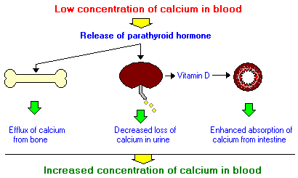
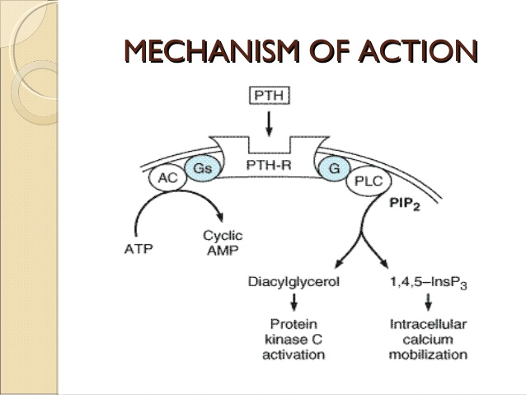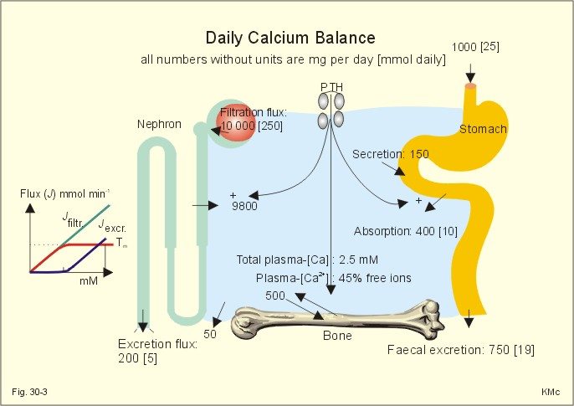

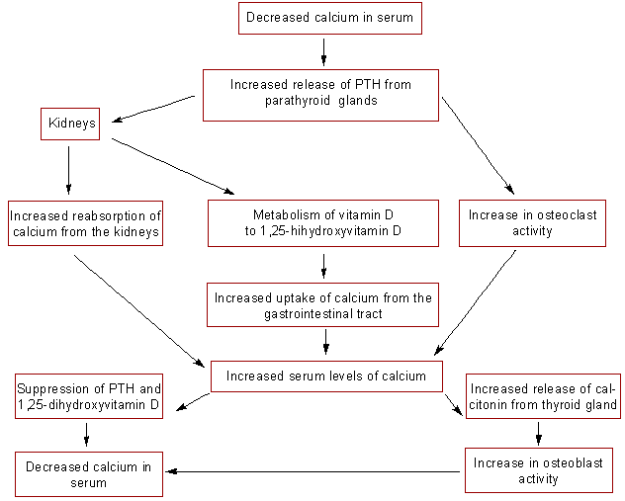

Disease States
Hyperparathyroidism
Excessive secretion of parathyroid hormone is seen in two forms:
- Primary hyperparathyroidism is the result of parathyroid gland disease, most commonly due to a parathyroid tumor (adenoma) which secretes the hormone without proper regulation. Common manifestations of this disorder are chronic elevations of blood calcium concentration (hypercalcemia), kidney stones and decalcification of bone.
- Secondary hyperparathyroidism is the situation where disease outside of the parathyroid gland leads to excessive secretion of parathyroid hormone. A common cause of this disorder is kidney disease - if the kidneys are unable to reabsorb calcium, blood calcium levels will fall, stimulating continual secretion of parathyroid hormone to maintain normal calcium levels in blood.
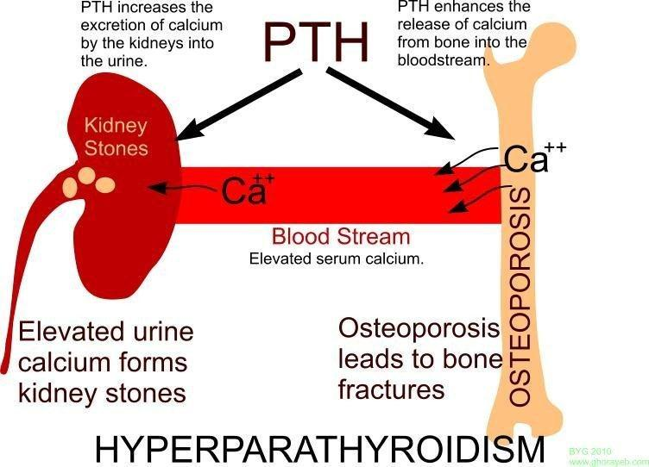

Hypoparathyroidism
Inadequate production of parathyroid hormone typically results in decreased concentrations of calcium and increased concentrations of phosphorus in blood. Common causes of this disorder include surgical removal of the parathyroid glands and disease processes that lead to destruction of parathyroid glands. The resulting hypocalcemia often leads to tetany, and can be acutely life-threatening. Treatment focuses on restoring normal blood calcium concentrations by calcium infusions, oral calcium supplements and vitamin D therapy.
A test for parathyroid hormone (PTH) is done to:
1-Help identify hyperparathyroidism.
2-Find the cause of an abnormal blood calcium level.
3- Check to see whether a problem with the parathyroid glands is causing the abnormal calcium level.
4-Watch for problems in people who have chronic kidney disease.

