Parasitology
Lecture 12 Protozoa 20.3.2018 د. وسام

Tissue Cysts Forming Coccidia
- Sarcocystis and Toxoplasma exhibit a heteroxenous life cycle (more than one obligatory host)
- The sexual reproduction (gametogony & sporogony) takes place in the intestinal epithelium of the definitive host (carnivores) and asexual reproduction (merogony or schizogony) takes place in tissues of the intermediate host (herbivores).
- The life cycle within the carnivore is similar to the life cycles of intestinal coccidia such as Isospora & Cryptosporidium involving sexual cycle (gametogony) within the intestinal epithelial cells.
- Omnivores, such as humans serve as both intermediate and definitive host in Sarcocystis infection.
Sarcocystis huminis & S. suihominis (coccidiosis huminis and coccidiosis suihominis)
- Sarcocystis hominis & S. suihominis are parasites of human intestine i. e. the human serve as definitive host and develop intestinal symptoms.
- Human acquired infection after consumption of beef or pork meat containing sarcocysts (tissue cysts i. e. meat transmitted parasites).
Life cycle:
Both sporulated oocysts (containing two sporocysts) and individual sporocysts can be passed in stool. Sporocysts contain four sporozoites and a refractile residual body. Sporocysts ingested by the intermediate host (cattle for S. hominis and pigs for S. suihominis) rupture, releasing sporozoites. sporocysts in human feces of S. hominis infect cattle but not pigs whereas sporocysts in human feces of S. suihominis infect pigs but not cattle. Sporozoites enter endothelial cells of blood vessels and undergo schizogony, resulting in first-generation schizonts. Merozoites derived from the first-generation invade small capillaries and blood vessels, becoming second-generation schizonts. The second generation merozoites invade muscle cells and develop into sarcocysts (Greek: sarkos = flesh, cysts = bladder) containing bradyzoites (Greek: brady = slow, zoite = small animal, bradyzoites (within sarcocysts) are crescent-shaped bodies), which are the infective stage for the definitive host. Humans become infected when they eat undercooked meat containing these sarcocysts. Bradyzoites are released from ruptured cysts in the small intestine and invade the lamina propria of the intestinal epithelium.
There, they differentiate into macro- and microgametocytes. Fusion of male and female gametes results in the formation of oocysts . Oocysts sporulate in the intestinal epithelium and are shed from the host in feces. Due to the fragile nature of the oocyst wall, individual sporocysts may also be detected in feces.

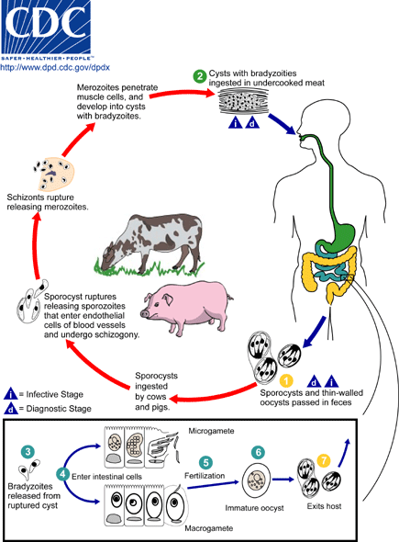

Pathology:
S. huminis & S. suihominis produce mild intestinal symptoms, abdominal discomfort, nausea, and diarrhea
Diagnosis: finding the characteristic sporocysts and occasionally oocysts in feces
Control:
- Cooking or freezing meat to kill bradyzoites (merozoites) in the sarcocysts.
- Prevent animal from ingesting the sporocyst stage from human feces in contaminated water, feed, and bedding
Sarcocystis lindmanni (sarcocystoisis or tissue cysts forming coccidian)
- The name Sarcocystis lindmanni was once proposed for all intramuscular sarcocysts in human.
- Human serve as intermediate host and develop muscular cysts (sarcocysts) after ingestion of oocysts containing infective sporozoites and asexual stages of life cycle-merogony or schizogony occur within human.
- Predator of nonhuman primates is the final host, in which, the sexual stages of life cycle- gametogony and sporogony occur within it.
- Ingestion of the sporocysts that sporulated in soil with contaminated foods and drinks by humans will result in the formation of sarcocysts (soil transmitted parasite).
- These sarcocysts are generally several 100 µm in size and cause little tissue damage.
Life cycle: The intermediate hosts (herbivore, like human) acquire the infection by ingesting the sporulated oocysts. Each oocyst containing four infected sporozoites when ingested by intermediate hosts (like human) will initiate asexual stages of reproduction that end by formation of tissue cysts.
Non human primates
Pathology:
- Sarcocystis infections in human have been documented, but are rare.
- Most hosts do not show any clinical sign or symptoms.
- Most sarcocysts in humans have been found in skeletal muscle and cardiac muscle.
- These sarcocysts (Meisher's tubes) are several 100 µm, compartments and sometimes with thick striated wall.
- The most common pathological alterations observed are myositis, hemorrhages of heart and serosa, edema, necrosis and hemorrhages of lymph nodes.
- Clinical symptoms can include episodic painful inflammatory swellings.
Diagnosis: bradyzoites in muscle biopsy specimens can be identified by microscopic examination.
Treatment: There is no known specific treatment for the muscle stages.
Control: personal hygiene.
Toxoplasma gondii (toxoplasmosis, tissue cyst forming coccidia)
- Toxoplasmosis, caused by the protozoan parasite Toxoplasma gondii, is one of the most common parasitic infections of man and other warm-blooded animals.
- It has been found worldwide from Alaska to Australia.
- Nearly one-third of humanity has been exposed to this parasite.
- In most adults it does not cause serious illness, but it can cause blindness and mental retardation in congenitally infected children and devastating disease in immunocompromised individual.

Life cycle
Members of the cat family (Felidae) are the only known definitive hosts for the sexual stages of T. gondii and thus are the main reservoirs of infection. Cats become infected with T. gondii by carnivorism . The viable organisms are released and invade epithelial cells of the small intestine of cat where they undergo an asexual followed by sexual cycle and then form oocysts, which are excreted with feces. The unsporulated oocyst takes 1 to 5 days after excretion to sporulate and become infective (soil transmitted infection).
Intermediate hosts, such as human, rodents and birds, become infected through the ingestion of undercooked infected meat containing tissue cysts or sporulated oocysts . Sporozoites are released, penetrate the intestinal epithelium, and invade macrophages and other types of cells. These intracellular forms are called tachyzoites and cause the acute stage of the infection. Tachyzoites replicate within the host cell which will rupture and release the tachyzoites which will invade new host cells and repeat the replicative cycle. Infected macrophages will disseminate the tachyzoites throughout the host during this acute infection. As the host develops immunity the replication rate will slow and the infected host cells will become encapsulated (i. e, form tissue cysts). These slowly replicating forms are called bradyzoites and represent a dormant or resting stage (chronicu stage of the infection). Bradyzoites are viable, but metabolically quiescent. The bradyzoites are primarily found in brain and muscle tissue, whereas the tachyzoites tend to be in reticuloendothelial cells (eg. liver and spleen).

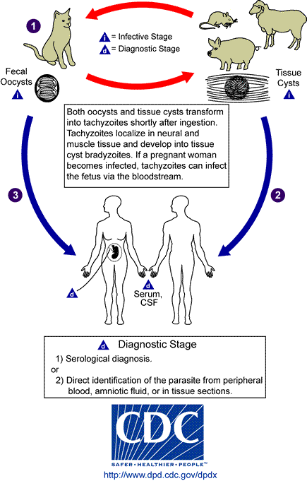

- The bradyzoite stage represents a chronic infection and probably persists for the life of the host.
- The parasites form tissue cysts, most commonly in skeletal muscle, myocardium, and brain; these cysts may remain throughout the life of the host.

Pathology

Toxoplasmosis in immunocompetent:
- Toxoplasmosis in adults and children past the neonatal stage is usually benign and asymptomatic.
- Acquisition of the infection via either oocysts or tissue cysts results in an acute infection in which tachyzoites are disseminated throughout the body via the lymphatic and hematogenously.
- This acute stage will persist for several weeks as immunity develops.
- Both humoral and cellular immunity are important, but the cellular response appears critical for the conversion from acute (i. e, tachyzoites) to chronic (i. e, bradyzoites) infection.
- When symptoms do occur they are generally mild and typically described as mononucleosis-like with chills, fever, headache, myalgia, fatigue and swollen lymph nodes.

Congenital Toxoplasmosis
Congenital (i. e, transplacental) infections are more likely to be symptomatic than postnatal infections and can be particularly severe.
- transmission only possible during acute stage (i.e., primary infection must occur during pregnancy)
- can only occur once
- one-third of mothers seroconverting during pregnancy will pass on infection to fetus
- incidence between 1 per 1000 live births
- severity varies with age of fetus (More severe early in pregnancy)
- transmission is more frequent later in pregnancy
- infection can result in: spontaneous abortion, premature birth, or full-term with or without progressive disease
- typical disease manifestations include: retinochoroiditis, intracerebral calcification, hydrocephaly, microcephaly, psychomotor disturbances, mental retardation, blindness and other visual defects
- Toxoplasmic Encecphalitis
- Noted as an opportunistic infection in regards to reactivation of latent infections due to immunosuppression associated with organ transplants and certain cancer treatments and AIDS patients.
- Early symptoms of toxoplasmic encephalitis can include headache, fever, lethargy, and altered mental status.
- Ocular Toxoplasmosis: Originally the ocular manifestations were more often associated with congenital infections (develop weeks to years after birth) or a late manifestation due to the reactivation of a congenital infection.
Epidemiology:
- Serologic prevalence data indicate that toxoplasmosis is one of the most common of human’s infections throughout the world.
- Infection is more common in warm climates and at lower altitudes than in cold climates and mountainous regions.
- Oocysts can survive in the environment for several months and are remarkably resistant to disinfectants, freezing, and drying, but are killed by heating to 70°C for 10 minutes.
- Human infection may be acquired in several ways (modes of transmission):
A) Ingestion of undercooked infected meat containing Toxoplasma cysts;
B) Ingestion of the oocyst from fecally contaminated hands or food;
C) Organ transplantation or blood transfusion;
D) Transplacental transmission;
E) Accidental inoculation of tachyzoites.
Diagnosis:
- Parasites can be detected in biopsied specimens, buffy coat cells, or cerebral spinal fluid.
- These materials can also be used to inoculated mice or tissue culture cells.
- Diagnosis relies heavily on serological procedures (detection of T. gondii Ag or anti Toxoplasma IgM &IgG Abs. High IgM titer present in acute infection while high IgG titer represent past or chronic infection.
- Imaging techniques, such as computed tomography (CT) scanning and magnetic resonance imaging (MRI), are useful in the diagnosis of toxoplasmic encephalitis.
- Sabin-Feldman dye test, is an important test in diagnosis of toxoplasmosis.

Control
- Cook meat thoroughly (66C⁰)
- Wear gloves when handling meat
- Washing vegetables and fruits very well
- Control stray's cats.

Treatment
- Recommended: anti-folates (pyrimethamine + sulfadiazine).
- Spiramycin for infection during pregnancy.

End of lecture 12 protozoa

