University of Mustansiriyah Dr.Shatha AL-Khateeb
Collage of Medicine 2017-2018
Clinical biochemistry Department Lec. 6 (1-17)

The adrenal glands

In mammals, the adrenal glands (also known as suprarenal glands) are endocrine glands that sit atop the kidneys; in humans, the right suprarenal gland is triangular shaped, while the left suprarenal gland is semilunar shaped. They are chiefly responsible for releasing hormones in response to stress through the synthesis of corticosteroids such as cortisol and catecholamines such as epinephrine. The adrenal glands affect kidney function through the secretion of
aldosterone, a hormone involved in regulating the osmolarity of blood plasma.
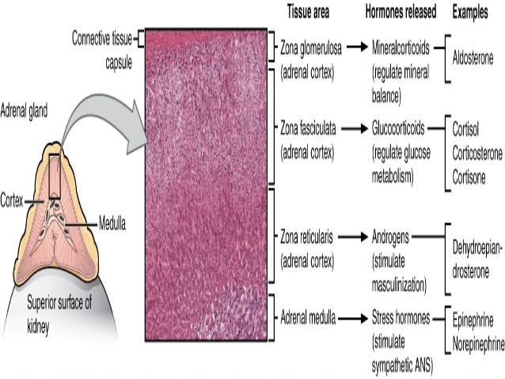
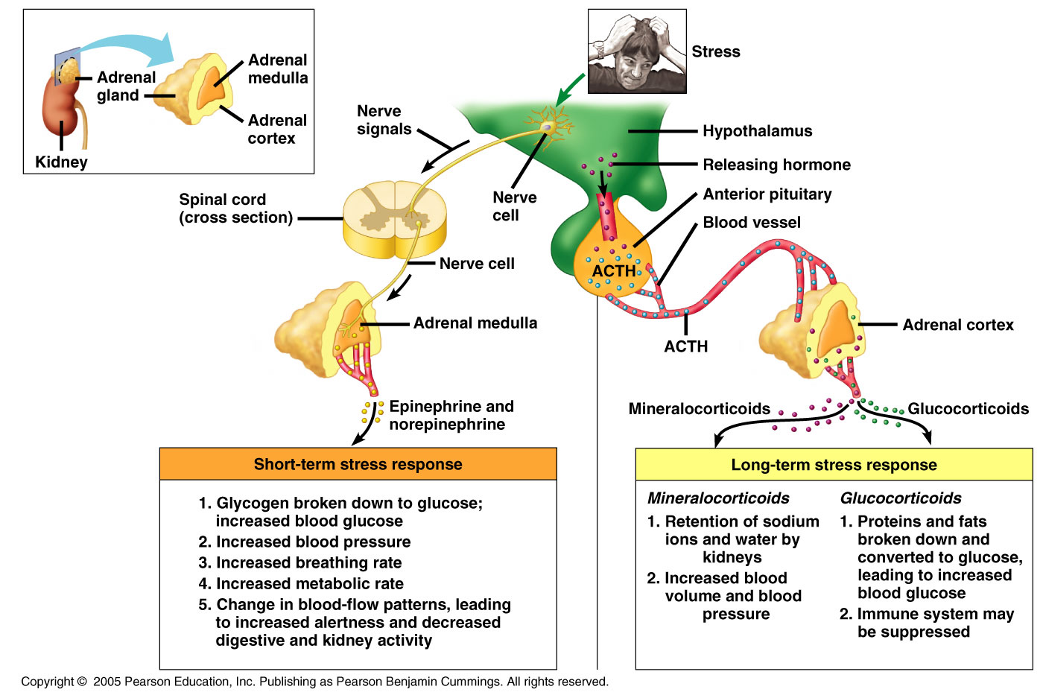
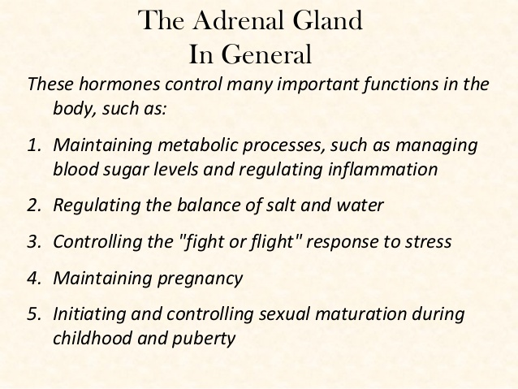
Subdivisions of the adrenal gland
The adrenal gland consists of two parts
- An outer part - the adrenal cortex
- An inner core - the adrenal medulla.
The adrenal medulla receives messages from the brain through a nerve. In response to stimulation along nerves of the sympathetic nervous system. The adrenal medulla, the inner part of the adrenal gland, helps a person cope with physical and emotional stress.
The adrenal cortex :The adrenal cortex secretes hormones that have an effect on the body's metabolism, on chemicals in the blood, and on certain body characteristics.
Using cholesterol as the starting material, the cells of the adrenal cortex secrete a variety of steroid hormones. These fall into three classes:
1-Glucocorticoids (e.g., cortisol).
2-Mineralocorticoids (e.g., aldosterone).
3-Androgens (e.g., testosterone).
These are controlled by ACTH which is transported through the blood system.
The adrenal cortex secretes corticosteroids and other hormones directly into the bloodstream.
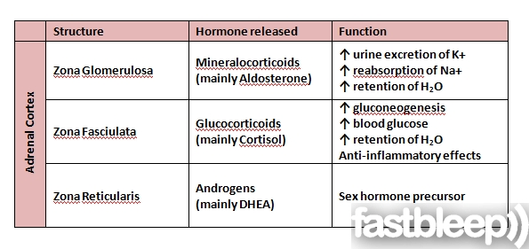
Androgens
Also called androgenic hormone or , is any natural or synthetic compound, usually a steroid hormone, that stimulates or controls the development and maintenance of male characteristics in vertebrates by binding to androgen receptors. They are produced in the zona reticularis. Androgens increase in both boys and girls during puberty. The major androgen in males is testosterone. Dihydrotestosterone (DHT) and androstenedione are of equal importance in male development.
All adrenocortical hormones are synthesized from cholesterol. Cholesterol is transported into the adrenal gland. The steps up to this point occur in many steroid-producing tissues. Subsequent steps to generate aldosterone and cortisol, however, primarily occur in the adrenal cortex:
- Progesterone → (hydroxylation at C21) → 11-Deoxycorticosterone → (two further hydroxylations at C11 and C18) → Aldosterone
- Progesterone → (hydroxylation at C17) → 17-alpha-hydroxyprogesterone → (hydroxylation at C21) → 11-Deoxycortisol → (hydroxylation at C11) → Cortisol
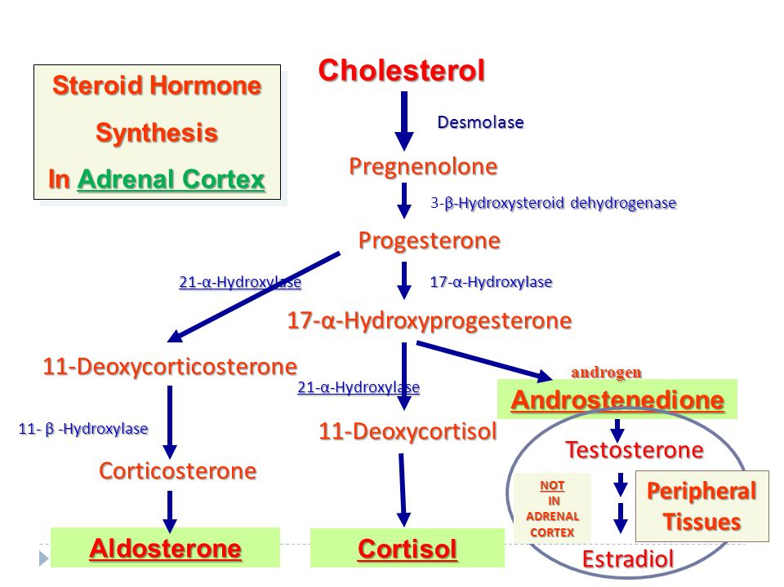

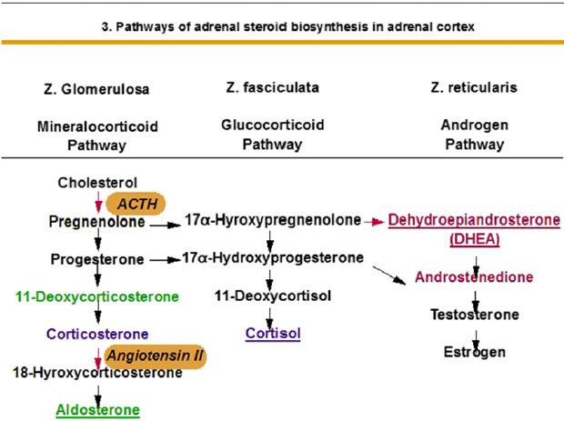

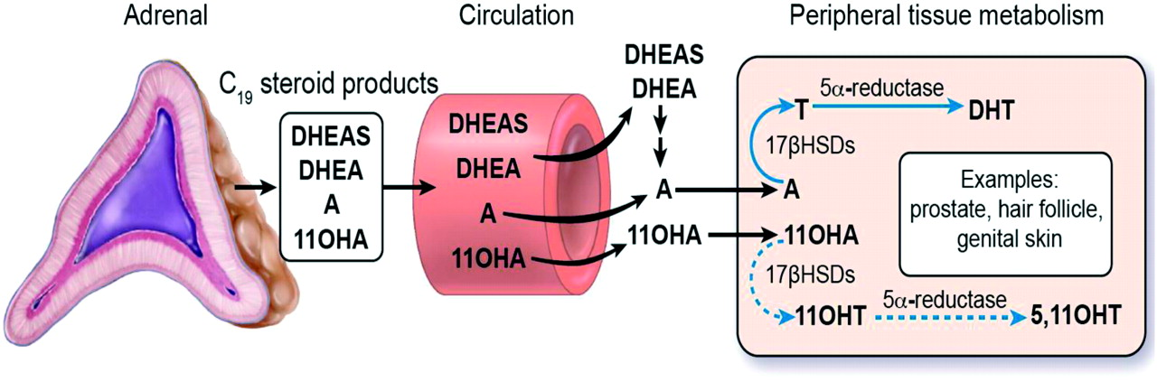

Glucocorticoids

They are produced in the zona fasciculata. The primary glucocorticoid released by the adrenal gland in humans is cortisol and corticosterone in many other animals. Its secretion is regulated by the hormone ACTH from the anterior pituitary.

The glucocorticoids get their name from their effect of raising the level of blood sugar (glucose). One way they do this is by stimulating gluconeogenesis in the liver: the conversion of fat and protein into intermediate metabolites that are ultimately converted into glucose.
The most abundant glucocorticoid is cortisol (also called hydrocortisone).
Cortisol binds to the glucocorticoid receptor in the cytoplasm and the hormone-receptor complex is then translocated into the nucleus, where it binds to its DNA response element and modulates transcription from a battery of genes, leading to changes in the cell's phenotype.
Only about 10% of circulating cortisol is free. The remaining majority circulates bound to plasma proteins, particularly corticosteroid-binding globulin (transcortin). This protein binding likely decreases the metabolic clearance rate of glucocorticoids and, because the bound steroid is not biologically active, tends to act as a buffer and blunt wild fluctuations in cortisol concentration.
Cortisol Release
Cortisol (“The Pump-Up” Hormone) is a steroid hormone produced by the adrenal cortex to deal with physical and emotional stress – by putting the body on “Red Alert” and diverting all available energy and raw materials to immediate survival tasks.
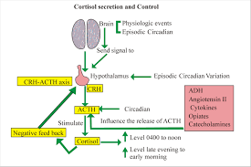
Plasma cortisol concentration shows a diurnal variation, being highest in the morning and lowest at night. Blood for cortisol measurement should usually be drawn between 08:00 h and 09:00 h. Glucocorticoids are conjecated with glucuronate and sulphate in the liver to form inactive metabolites, because they are water soluble than the mainly protein-bound parent hormones, they can be excreted in the urine. Only the unbound fraction of cortisol in plasma is filtered at the glomeruli and excreted in the urine (urinary free cortisol).
There are three major glucocorticoids in circulating blood:
1-Cortisol. 2-Cortisone. 3-Corticosterone.
Cortisol is the major free circulating glucocorticoid in human plasma.
Glucocorticoids have potent anti-inflammatory and immunosuppressive properties. This is particularly evident when they administered at pharmacologic doses, but also is important in normal immune responses. As a consequence, glucocorticoids are widely used as drugs to treat inflammatory conditions such as arthritis or dermatitis, and as adjunction therapy for conditions such as autoimmune diseases.
For this reason glucocorticoids are widely used in therapy:
- To reduce the inflammatory destruction of rheumatoid arthritis and other autoimmune diseases.
- To prevent the rejection of transplanted organs.
- To control asthma.
Physiologic Effects of Glucocorticoids
There seem to be no cells that lack glucocorticoid receptors and as a consequence, these steroid hormones have a huge number of effects on physiologic systems.
The name glucocorticoid derives from early observations that these hormones were involved in glucose metabolism. In the fasted state, cortisol stimulates several processes that collectively serve to increase and maintain normal concentrations of glucose in blood. These effects include:
- Stimulation of gluconeogenesis, in the liver: This pathway results in the synthesis of glucose from non-hexose substrates such as amino acids and lipids. Enhancing the expression of enzymes involved in gluconeogenesis .
- Mobilization of amino acids from extrahepatic tissues: These serve as substrates for gluconeogenesis.
- Inhibition of glucose uptake in muscle and adipose tissue.
- Stimulation of fat breakdown in adipose tissue: The fatty acids released by lipolysis are used for production of energy in tissues like muscle, and the released glycerol provide another substrate for gluconeogenesis.

Control and regulation of release of Cortisol
Make an accurate assessment of cortisol levels in the laboratory, it is important to recognize that cortisol secretion is highly regulated and, therefore, the timing of sample collection is crucial. Corticotropin-releasing hormone (CRH) from the hypothalamus and adenocorticotrophic hormone (ACTH) from the pituitary regulate the release of cortisol from the adrenal glands referred to as the hypothalamic-pituitary-adrenal axis.
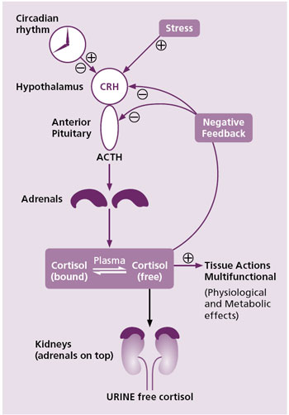
Mechanisms that initiate the regulation of cortisol release include:
- Circadian rhythm (diurnal variation) which regulates cortisol release throughout the day with the lowest levels late in the evening to around midnight and maximum levels around 08-09 in the morning .
- Homeostasis of cortisol is maintained through a negative feedback mechanism. This can occur at the level of either the hypothalamus or the pituitary.
- Stress, e.g., exercise, also stimulates the release of CRH through neurogenic amines. The negative feedback of cortisol on ACTH can be overridden by stress. Consequently, stress is an important regulator of cortisol in humans.
Cortisol and other glucocorticoids are secreted in response adrenocorticotropic hormone (ACTH) from the anterior pituitary. ACTH is itself secreted under control of the hypothalamic peptide corticotropin-releasing hormone (CRH). The central nervous system is thus the commander and chief of glucocorticoid responses, providing an excellent example of close integration between the nervous and endocrine systems. Cortisol secretion is suppressed by classical negative feedback loops. When blood concentrations rise above a certain threshold, cortisol inhibits CRH secretion from the hypothalamus, which turns off ACTH secretion, which leads to a turning off of cortisol secretion from the adrenal. The combination of positive and negative control on CRH secretion results in pulsatile secretion of cortisol. Typically, pulse amplitude and frequency are highest in the morning and lowest at night.
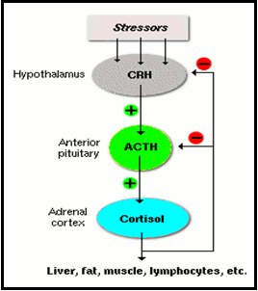
ACTH binds to receptors in the plasma membrane of cells in the zona fasiculata and reticularis of the adrenal. Hormone-receptor engagement activates adenyl cyclase, leading to elevated intracellular levels of cyclic AMP which leads ultimately to activation of the enzyme systems involved in biosynthesis of cortisol from cholesterol.

Mineralocorticoids
The primary mineralocorticoid, aldosterone, is produced in the adrenocortical zona glomerulosa by the action of the enzyme aldosterone synthase .
Aldosterone is largely responsible for the long-term regulation of blood pressure. It effects on the distal convoluted tubule and collecting duct of the kidney where it causes increased reabsorption of sodium and increased excretion of both potassium (by principal cells) and hydrogen ions (by intercalated cells of the collecting duct). Sodium retention is also a response of the distal colon, and sweat glands to aldosterone receptor stimulation. Although sustained production of aldosterone requires persistent calcium entry through low-voltage activated Ca²⁺ channels, isolated zona glomerulosa cells are considered nonexcitable, with recorded membrane voltages that are too hyperpolarized to permit Ca²⁺ channels entry.
The mineralocorticoids get their name from their effect on mineral metabolism. The primary mineralocorticoid is aldosterone. Its secretion is regulated by the oligopeptide angiotensin II (angiotensin II is regulated by angiotensin I, which in turn is regulated by renin). Aldosterone is secreted in response to high extracellular potassium levels, low extracellular sodium levels, and low fluid levels and blood volume.

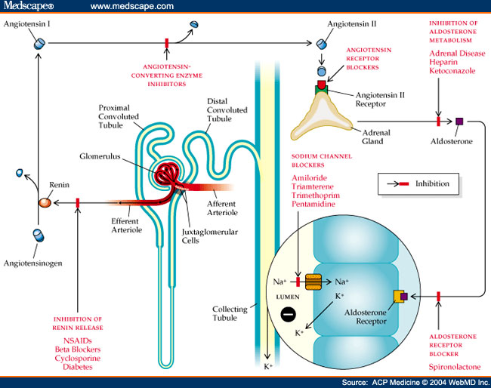

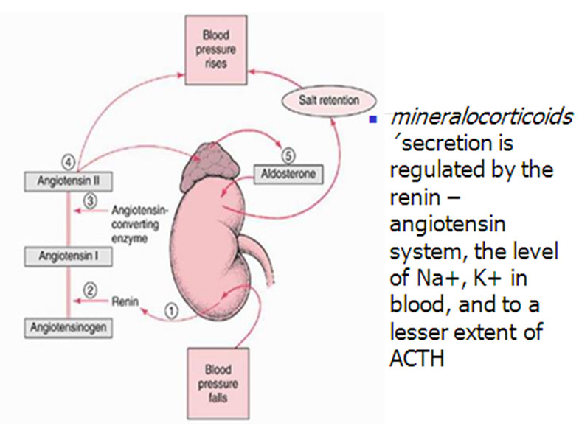

Aldosterone (salt - water hormone) secretion is under the control of another hormone, angiotensin, which itself is under control of the hormone renin produced by the kidneys. When aldosterone is too low, salt (NaCl) levels in the blood fall as does total body water. This leads to an increase in renin, which then causes an increase in angiotensin production, and subsequently a return of aldosterone concentrations back to normal. When aldosterone is too high, serum sodium, total body water and blood pressure increase, resulting in decreased renin and angiotensin production until aldosterone returns to normal. Aldosterone acts on the kidney promoting the reabsorption of sodium ions (Na⁺) into the blood. Water follows the salt and this helps maintain normal blood pressure.Aldosterone stimulates transcription of the gene encoding the sodium-potassium ATPase, leading to increased numbers of "sodium pumps" in the basolateral membranes of tubular epithelial cells. Aldosterone also stimulates expression of a sodium channel which facilitates uptake of sodium from the tubular lumen.
Aldosterone affects metabolism in different ways:
- It increases urinary excretion of potassium ions.
- It increases interstitial levels of sodium ions.
- It increases water retention and blood volume.
- Acts on sweat glands to reduce the loss of sodium in perspiration;
- Acts on taste cells to increase the sensitivity of the taste buds to sources of sodium.
The secretion of aldosterone is stimulated by:
- A drop in the level of sodium ions in the blood;
- A rise in the level of potassium ions in the blood;
- Angiotensin II ,and ACTH (as is that of cortisol)

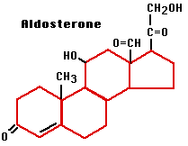
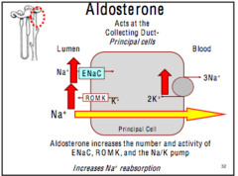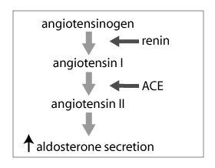
Removal of the adrenal glands leads to death within just a few days. Observation of such an unfortunate subject would reveal several key dearangements:
- The concentration of potassium in extracelluar fluid becomes dramatically elevated
- Urinary excretion of sodium is high and the concentration of sodium in extracellular fluid decreases significantly.
- Volume of extracellular fluid and blood decrease.
- The heart begins to function poorly, cardiac output declines and shock ensues.
These phenomena are a direct result of loss of mineralocorticoid activity, and can largely be prevented by replacement of salts and mineralocorticoids.
Clearly mineralocorticoids are acutely critical for maintenance of life! Aldosterone can be synthesized only by cells of zonaglomerulosa because these cells have the enzymes 18-hydroxylase and 18-hydroxysteroid dehydrogenase which are lacking in other two layers.
Structurally how aldosterone differs from cortisol?
Both are C21 steroids and have –OH group at C11 .But aldosterone has an aldehyde group (-CHO group) at C18 instead of –CH3 group of cortisol.
Aldosterone and Mineralocorticoid Receptors
Like all steroid hormones, cortisol and aldosterone bind to their respective receptors, and the resulting hormone-receptor complexes bind to a hormone response element to modulate transcription of responsive genes. Although the physiologic effects of these two steroid hormones are distinctly different, their receptors are quite similar and, most interestingly, they bind to the same consensus response element in DNA!
In aldosterone-responsive cells, cortisol is effectively destroyed, allowing aldosterone to bind its receptor without competition. Target cells for aldosterone express the enzyme 11-beta-hydroxysteroid dehydrogenase, which has no effect on aldosterone, but converts cortisol to cortisone, which has only a very weak affinity for the mineralocorticoid receptor. In essence, this enzyme "protects" the cell from cortisol and allows aldosterone to act appropriately. Some tissues express abundant mineralocorticoid receptors but not 11-beta HSD - they therefore do not show responses to aldosterone because aldosterone is not present in quantities sufficient to compete with cortisol.
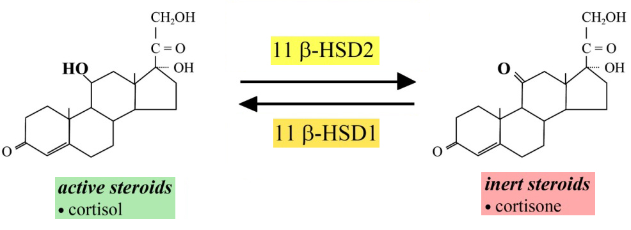

Physiologic Effects of Mineralocorticoids
Mineralocorticoids play a critical role in regulating concentrations of minerals - particularly sodium and potassium - in extracellular fluids. As described above, loss of these hormones leads rapidly to life-threatening abnormalities in electrolyte and fluid balance. Aldosterone has effects on sweat glands, salivary glands and the colon which are essentially identical to those seen in the distal tubule of the kidney.
Control of Aldosterone Secretion
The two most significant regulators of aldosterone secretion are:
- Concentration of potassium ions in extracellular fluid: Small increases in blood levels of potassium strongly stimulate aldosterone secretion.
- Angiotensin II: Activation of the renin-angiotensin system as a result of decreased renal blood flow (usually due to decreased vascular volume) results in release of angiotensin II, which stimulates aldosterone secretion.
Other factors which stimulate aldosterone secretion include adrenocorticotropic hormone . Factors which suppress aldosterone secretion include atrial naturetic hormone, high sodium concentration and potassium deficiency.
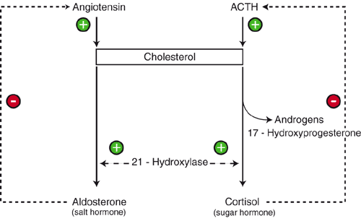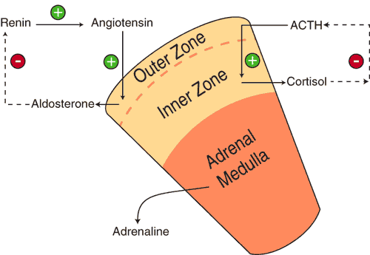
Disease States:A deficiency in aldosterone can occur by itself or, more commonly, in conjunction with a glucocorticoid deficiency, and is known as hypoadrenocorticism or Addison's disease. Without treatment by mineralocorticoid replacement therapy, a lack of aldosterone is lethal, due to electrolyte imbalances and resulting hypotension and cardiac failure.
Adrenal Androgens: During fetal life prior to birth a large amount of adrenal androgen is secreted in both males and females. At 3-6 months after birth, secretion of adrenal androgen stops. During puberty, adrenal androgen secretion resumes in both boys and girls. These androgens are responsible for the development of pubic and axillary hair in girls. In boys, the production of testicular androgens (which is about 10 times more active than adrenal androgens) play the major role in male masculinization.
Testosterone is the most powerful androgen; it is synthesized in the testes or ovaries in the adrenal cortex. In sexually-mature males, this source is so much lower than that of the testes that it is probably of little physiological significance. However, excessive production of adrenal androgens can cause premature puberty in young boys. In females, the adrenal cortex is a major source of androgens. Their hypersecretion may produce a masculine pattern of body hair and cessation of menstruation.
Disorders of the adrenal cortex
- Adrenocortical hyperfunction.
- Adrenocortical hypofunction.

Cushing's syndrome: Excessive levels of glucocorticoids
In Cushing's syndrome, the level of adrenal hormones, especially of the glucocorticoids, is too high.
It can be caused by:
- Excessive production of ACTH by the anterior lobe of the pituitary;
- Excessive production of adrenal hormones themselves (e.g., because of a tumor), or (quite commonly)
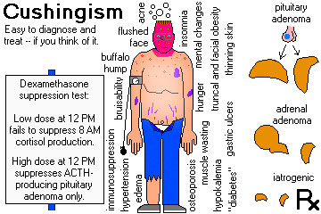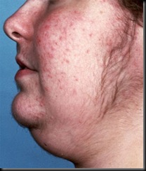
A patient with Cushing syndrome showing signs of acne and hirsuitism

Addison's Disease: Hyposecretion of the adrenal cortices
Addison's disease has many causes, such as
- Destruction of the adrenal glands by infection.
- Their destruction by an autoimmune attack.
- Primary (Addison's disease)
A-It is caused by bilateral destruction of all zones of the adrenal cortex.
B-Tuberculosis is an important cause
- Secondary:ACTH release may be impaired by disorders of the hypothalamus or the anterior pituitary gland due to tumor or infarction.

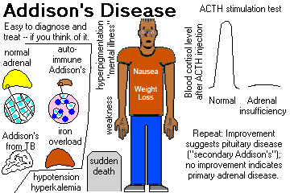

Adrenal Hormone Tests
Hormones secreted by the adrenal glands help to regulate many body processes. Measuring blood and urine levels of adrenal hormones, including the following, is often the first step in diagnosing a variety of disorders associated with adrenal gland dysfunction:
1-(Aldosterone)
Both blood levels and urinary excretion of aldosterone may be measured.
2-(Cortisol) Both blood levels and urine levels (known as free cortisol) are usually measured.
3-(18-Hydroxycortisol): It is a product of cortisol metabolism, is an unusual steroid produced in excessive amounts in patients with primary hyperaldosteronism. Measuring blood levels of this hormone can help to determine whether primary hyperaldosteronism is caused by a tumor called adrenal adenoma, or by overgrowth (hyperplasia) of adrenal tissue; levels are significantly higher in people with an adenoma.
4-(DHEA-S, or dehydroepiandrosterone-sulfate) it is a sex hormone (androgen) synthesized by the adrenal gland—is a precursor to testosterone. Elevated DHEA-S levels are associated with virilism (male body characteristics), hirsutism (excessive hair growth), amenorrhea (absence of menstruation), and infertility. Adrenal abnormalities such as tumors may lead to abnormally high DHEA-S levels.
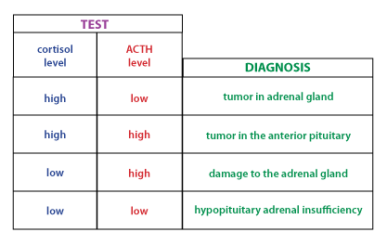

The Adrenal Medulla
The adrenal medulla consists of masses of neurons that are part of the sympathetic branch of the autonomic nervous system. Instead of releasing their neurotransmitters at a synapse, these neurons release them into the blood. Thus, although part of the nervous system, the adrenal medulla functions as an endocrine gland.
The adrenal medulla releases:
- Adrenaline (also called epinephrine) and
- Noradrenaline (also called norepinephrine)
Both are compounds that consist of amines attached to a benzene ring bearing two hydroxyl groups.
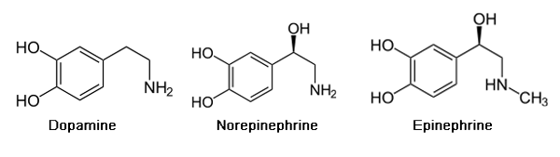
Release of adrenaline and noradrenaline is triggered by nervous stimulation in response to physical or mental stress. The hormones bind to adrenergic receptors — transmembrane proteins in the plasma membrane of many cell types.
Epinephrine is a hormone synthesized in the adrenal glands from tyrosine. Its release is subject to neuronal control. This “emergency hormone” mainly acts on the blood vessels, heart, and metabolism. It constricts the blood vessels and thereby increases blood pressure; it increases cardiac function; it promotes the degradation of glycogen into glucose in the liver and muscles; and it dilates the bronchia.
Cells in the adrenal medulla synthesize and secrete epinephrine and norepinephrine. The ratio of these two catecholamines differs considerably among species: in humans, cats and chickens, roughly 80, 60 and 30% of the catecholamine output is epinephrine. Following release into blood, these hormones bind adrenergic receptors on target cells, where they induce essentially the same effects as direct sympathetic nervous stimulation.
-Dopa is well known for its role in the treatment of parkinsonism, but its biological importance lies in the fact that it is a precursor of dopamine, a neurotransmitter widely distributed in the central nervous system, including the basal ganglia of the brain . A deficiency of dopamine in these ganglia leads to parkinsonism, and this deficiency is at least partially alleviated by the administration of l-dopa.
The tissue responses to different catecholamines depend on the fact that there are two major types of adrenergic receptors (adrenoceptors) on the surface of target organs and tissues. The receptors are known as alpha-adrenergic and beta-adrenergic receptors.
Activation of alpha-adrenergic receptors results in the constriction of blood vessels, contraction of uterine muscles, relaxation of intestinal muscles, and dilation of the pupils. Activation of beta-adrenergic receptors increases heart rate and stimulates cardiac contraction (thereby increasing cardiac output), dilates the bronchi (thereby increasing air flow into and out of the lungs), dilates the blood vessels, and relaxes the uterus.
Drugs that block the activation of beta receptors (beta blockers), such as propranolol, are often given to patients with tachycardia, high blood pressure, or chest pain (angina pectoris). These drugs are contraindicated in patients with asthma because they worsen bronchial constriction.

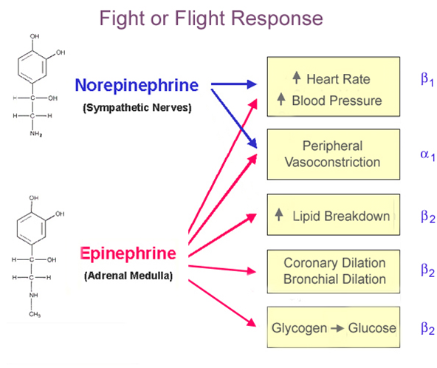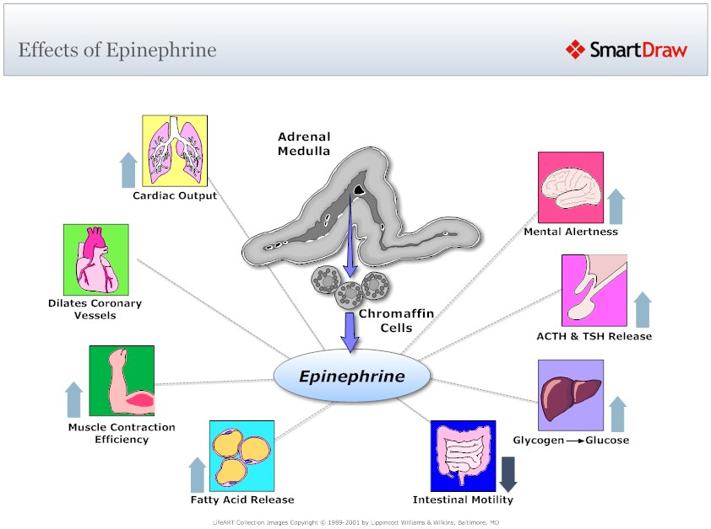

The effect of epinephrine on carbohydrate metabolism:
- Activates the decomposition of glycogen in liver and muscles;
- Activates the glycolysis, Krebs cycle and tissue respiration;
- Causes the hyperglycemia.
The effect of epinephrine on protein metabolism:
- Activates the protein decomposition.
The effect of epinephrine on lipid metabolism:
- Activates the tissue lipase, mobilization of lipids and oxidation of fatty acids.
Vanylmandelic acid(VMA) is the principle urinary metabolite of catecholamines.

Synthesis and Secretion of Catecholamines

Catecholamines three of the monoamines (dopamine, norepinephrine, and epinephrine) they contain a catechol group.

Catecholamines are a group of neurotransmitters that arise in sequence from the amino acid tyrosine. Tyrosine is created from phenylalanine via hydroxylation by the enzyme phenylalanine hydroxylase.(Tyrosine is also ingested directly from dietary protein). It is then sent to catecholamine-secreting neurons where many kinds of reactions convert it to dopamine, to norepinephrine, and eventually to epinephrine.
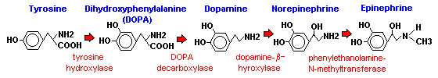
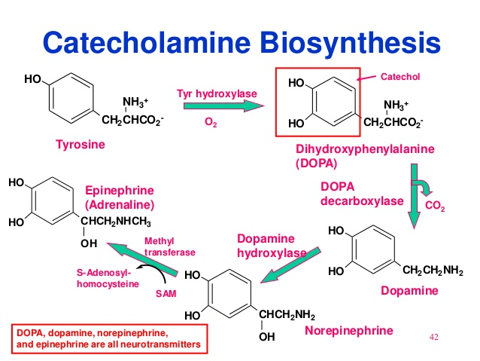
Norepinephine and epinephrine are stored in electron-dense granules which also contain ATP and several neuropeptides. Secretion of these hormones is stimulated by acetylcholine release from preganglionic sympathetic fibers innervating the medulla. Many types of "stresses" stimulate such secretion, including exercise, hypoglycemia and trauma. Following secretion into blood, the catecholamines bind loosely to and are carried in the circulation by albumin and perhaps other serum proteins.
