**Anatomy and physiology of the nose and paranasal sinuses**

**EXTERNAL NOSE**

The external nose is pyramidal in shape the ant. Nares situated in the base of the nose and open downwards they are separated by columella

**Bony constituents**

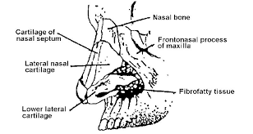 Support the upper part of the external nose:-

1-nasal processes of the frontal bones

2-nasal bones

3-ascending processes of the maxilla

**Cartilaginous constituents**

Support the lower part of the external nose

1-Upper lateral cartilages

2- Lower lateral cartilages

3-Quaderilateral cartilages of the nasal septum

Vestibules included in the external nose because it is lined with skin and contain sebaceous glands and hairs (vibrissae)

**ANATOMY OF THE NASAL CAVITY**

Each nasal cavity is bounded by:-

**1-medial wall is the Nasal Septum**

The mature nasal cavity is divided in the midline by a parting wall, the nasal septum. The nasal septum is derived from both bony and cartilaginous sources. The septum is formed anteriorly by the quadrilateral cartilage and premaxilla; posteriorly by the perpendicular plate of the ethmoid bone and the sphenoidal crest; and inferiorly by

the crests of the vomer, maxillary, and palatine bones



Floor: - Is formed by

1. Palatine process of maxilla in the ant. 3 quarters
2. Horizontal part of palatine bone in the post. 1 quarter

Roof: - is very narrow and formed by

1. Nasal process of frontal bone anteriorly
2. Cribriform plate of ethmoid through which fibers of the olfactory nerve pass
3. Body of sephenoid bone psteriorly

Lateral wall: - is formed by

1. Medial wall of maxilla
2. Lateral mass of ethmoid and lacrimal bone
3. Ascending process of maxilla anteriorly
4. Perpendicular part of palatine bone and behind it medial pterygoid process of sphenoid posteriorly

The main features of the lateral wall are :-

1. Three turbinates – superior ,middle ,inferior
2. Three meatus –named after the turbinates .each meatus lies below and lateral to the corresponding turbinate .

3-Spheno-ethmoidal -Medial to the superiorturbinate and lateral to the septum is the area of the sphenoethmoidal recess, where the sphenoid ostium can be found.

*# Superior meatus contains the ostia of the posterior ethmoidal cells*

*# Middle meatus is the most complex and by far the most important*

*The ostia of the maxillary ,anterior ethmoidal ,and frontal sinuse open into it*

*The bulla ethmodalis is a smooth rounded mass formed by the anterior ethmoidal cells .the ostia of these cells open on to the bulla or above it .*

*The hiatus semilunaris lies below and in front of the bulla and leads forward into the infundibilum . it is bounded below by the uncinate process of the ethmoid.*

*# Inferior meatus receives the nasal opening of the nasolacrimal duct*

**

An endoscopic view of the right nasal cavity

shows the nasal septum (NS), middle turbinate (MT),

ethmoid bulla (EB), and uncinate process (UP). The hiatus

semilunaris can be appreciated as the cleft between the

ethmoid bulla and uncinate process

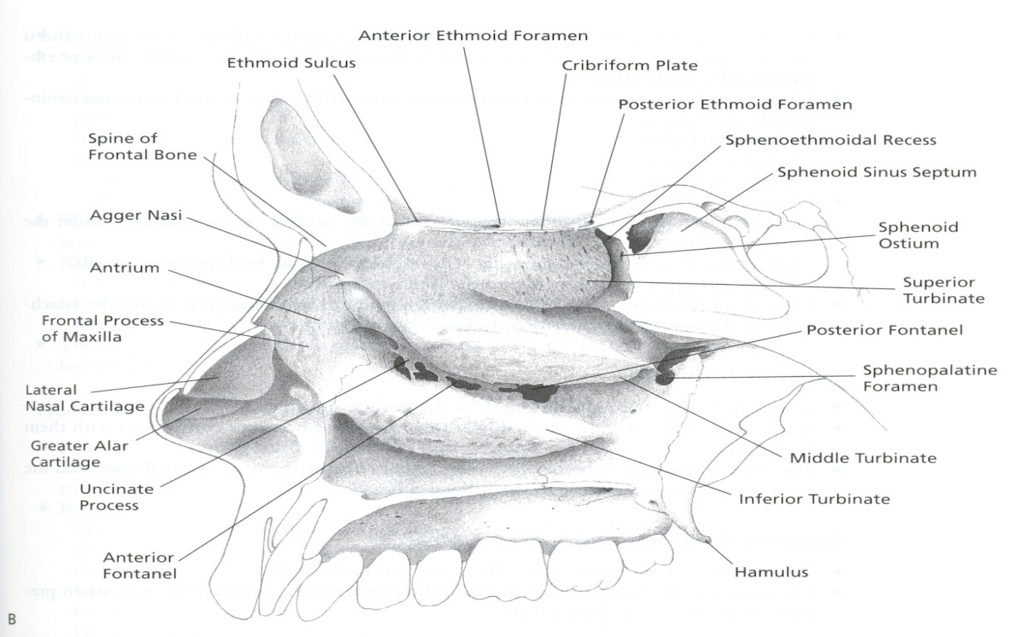

*.*

**Paranasal sinuses**

These are air spaces within certain bones of the skull .There are 4 on each side maxillary sinus ,ethmoidal sinuses ,frontal sinus , sphenoidal sinus

**Maxillary sinus**

Is pyramidal in shape and occupies the body of the maxilla

The base is medialy ,the apex in the zygomatic portion of the maxilla it is the largest of the sinuses with an average capacity of about 15 ml in the adult

4 major boundaries: the maxillary face anteriorly; the ascending process of the palatine bone medially; the orbital floor superiorly, and the pterygomaxillary space posteriorly. The infraorbital nerve traverses along the roof of the maxillary sinus and exits through the infraorbital foramen roughly 6 to 7 mm below the inferior orbital rim .

**Maxillary Ostium.** The natural maxillary ostium is the anatomic merging point for mucociliary flow in the maxillary sinus. The maxillary ostium is located at the anteromedial aspect of the sinus near the roof of the sinus. The maxillary ostium drains into the ethmoid infundibulum, lateral to the lower one-third of the uncinate process

**Ethmoid Sinus**

The ethmoid sinus is composed of multiple individual cells, separated into anterior and posterior compartments by the basal lamella of the middle turbinate. The lateral boundary of the ethmoid is the medial wall (lamina papyracea) of the orbit. The medial boundary is formed by the

middle turbinate in the anterior ethmoid and by the superior turbinate in the posterior ethmoid. The posterior border is the face of the sphenoid sinus. Superiorly, the ethmoid roof separates the ethmoid sinus from the intracranial cavity. Superomedially the ethmoid roof thins considerably

in the area of the cribriform plate, through which olfactory filae enter the cranial cavity

**Frontal Sinus**

The frontal sinus is formed by an outgrowth of the ethmoid labyrinth that pneumatizes superiorly into the frontal bone. The drainage of this sinus occurs at its inferior and medial extent. The frontal sinus outflow tract begins at the frontal infundibulum, and then descends through the frontal ostium to the middle meatus via the frontal recess. The boundaries of the frontal recess are the lamina papyracea laterally, the middle turbinate medially, the posterosuperior wall of the agger nasi anteriorly, and

the ethmoid bulla posteriorly.

**Agger Nasi.** The agger nasi, which means “nasal eminence,” is the portion of the lateral nasal wall located just anterior to the middle turbinate insertion.

**Sphenoid Sinus**

The sphenoid sinus can pneumatize as far as the clivus, the sphenoid wings, and the foramen magnum but typically takes the form of the sellar, presellar, and conchal pneumatizations The sphenoid sinus lies adjacent to vital structures such as the internal carotid artery, optic nerve, the Vidian nerve, the cavernous sinus, and foramen rotundum. Many of these structures can be identified as indentations on the roof and walls of the sinus in an extensively pneumatized sphenoid sinus.

The ostium of the sphenoid sinus can be found in the sphenoethmoidal recess, between the posterior part of the septum and the superior turbinate



The sphenoid sinus can have varying confi gurations based on degree of pneumatization: (A) conchal, (B) presellar and (C) sellar types.

**Nasal Mucous Membrane**

The epithelial lining of the nasal cavity changes as one moves from anterior to posterior. The skin within the nasal vestibule is a keratinized,

squamous cell epithelium containing vibrissae and sebaceous glands. At the leading edge of the inferior turbinate, the epithelium transitions into

a cuboidal cell type and then into pseudostratified ciliated columnar respiratory epithelium. At the most posterior aspect of the nasopharynx, the mucosa returns to a nonkeratinized, squamous cell epithelium

**Nasal Innervation**

Sensation to the nose is supplied mainly by the ophthalmic and maxillary divisions of cranial nerve V.

**Blood Supply**

The blood supply of the nasal cavity is derived primarily from the anterior and posterior ethmoid arteries, (branches of the ophthalmic artery) and the sphenopalatine artery (a terminal branch of the internal maxillary artery)

Venous drainage follows a course parallel to that of the sphenopalatine artery and its branches, draining into the ophthalmic plexus and partly into the cavernous sinus. This valveless venous system predisposes the spread of infection from the nose upward to the cavernous sinus

**PHYSIOLOGY AND MICROSCOPIC ANATOMY**

**Air Flow**

The nasal airway serves important physiologic functions, including filtration, humidification, and olfaction; these functions are dependent

upon unrestricted airflow through the nasal cavity.Air which passes from the nares to the lungs encounters its greatest resistance at the internal

nasal valve. Bounded medially by the anterosuperior aspect of the nasal septum and laterally by the upper lateral cartilage,

Nasal resistance is also affected by the nasal cycle. Present in roughly 80% of individuals, the nasal cycle is an autonomic variance of blood

flow to the erectile tissue of the nasal airway that results in alternating engorgement of the nasal airway from side to side. The periodicity of the nasal cycle varies from 2 and 1/2 to 4 hours.

**Warming and Humidification**

As air passes through the nose, it is warmed and humidified. The increase of nasal airway temperature is logarithmic as it passes from anterior to posterior. In typical ambient conditions, air is quickly heated in the anterior segment of the nose and is more slowly heated posteriorly.

The total increase in air temperature, as air leaves the nasopharynx, is approximately 8C. Inspired air is also dramatically humidifi ed by

the nose, with an increase in ambient humidity from 40 to 98% between the nasal vestibule and the glottis

**Olfaction**

Olfaction is another important physiologic function of the nasal cavity. The olfactory bulb sends fi lae through the cribriform plate to from

the olfactory neuroepithelium. The olfactory neuroepithelium is distributed in 3 major areas:-

-The superior septum; the superior aspect of the

-Superior turbinate; and to a slightly lesser degree

-The superior aspect of the middle turbinate. These structures define the olfactory cleft.

**Microscopic Anatomy**

The sinonasal cavities are lined with pseudostratified ciliated columnar epithelium composed of 4 basic cell types:

Ciliated columnar epithelial cells, nonciliated columnar cells, basal cells, and goblet cells

The ciliated cells have 50 to 200 cilia per cell, and each cilium has a 9 plus 2 microtubular structure with dynein arms. Experimental data indicate a typical ciliary beat frequency of 700 to 800 times a minute, with mucociliary transport occurring at a rate of 1cm/minute

Goblet

cells produce glycoproteins which are responsible for the viscosity and elasticity of mucus and respond to parasympathetic and sympathetic neural inputs. Between 20 and 40 mL of mucus are secreted from the normal nose daily from 160 cm2 of nasal mucosa. The cilia beat within the lubricating periciliary layer fluid, termed the sol layer. The outer, more viscous mucus layer, is termed the gel layer. The gel layer provides a confluent lining for the nasal cavity onto which inhaled particles can impact. Eighty percent of particles larger than 12.5 μg are filtered from the air before they reach the pharynx

**Mucociliary Clearance**

The ciliated cells of the respiratory epithelium move mucus through the sinonasal cavity in an organized, directional fashion toward the nasopharynx and pharynx, where the mucus is swallowed

or expectorated. Mucociliary clearance serves a hygienic function to clear the nose of particulate debris and potential by-products of infection or infl ammation.

**Function of Paranasal Sinuses**

1-Humidifying and warming inspired air

2-Regulation of intranasal pressure

3-Increasing surface area for olfaction

4-Lightening the skull

5-Resonance

6-Absorbing shock

7-Contribute to facial growth