University of Mustansiriyah Dr.Shatha AL-Khateeb
Collage of Medicine Lec. 1 (1-13)
Clinical biochemistry Department 2017-2018

Cell signaling
Cell signaling is part of a complex system of communication that governs basic cellular activities and coordinates cell actions. The ability of cells to perceive and correctly respond to their microenvironment is the basis of development, tissue repair, and immunity as well as normal tissue homeostasis. Errors in cellular information processing are responsible for diseases such as cancer, autoimmunity, and diabetes.
There are many different ways for cells to communicate with each other and the outside environment. They may communicate directly through juxtacrine signaling, over short distances through paracrine signaling and over large distances through endocrine signaling. Additionally, some cells require cell-to-cell contact in order for communication to occur. For this there are gap junctions which connect the cytoplasms of two cells together. In most cases, a molecule carries the signal from one cell and receptors on the other cell bind to the signal molecule thereby allowing communication.
Cell signaling can be classified to be mechanical and biochemical based on the type of the signal.
Mechanical signals are the forces exerted on the cell and the forces produced by the cell. These forces can both be sensed and responded by the cells.
Biochemical signals are the biochemical molecules such as proteins, lipids, ions and gases. These signals can be categorized based on the distance between signaling and responder cells.
Signaling within, between, and amongst cells is subdivided into the following classifications:
- Intracrine signals are produced by the target cell that stay within the target cell.
- Autocrine signals are produced by the target cell, are secreted, and affect the target cell itself via receptors. Sometimes autocrine cells can target cells close by if they are the same type of cell as the emitting cell. An example of this are immune cells.
- Juxtacrine signals target adjacent (touching) cells. These signals are transmitted along cell membranes via protein or lipid components integral to the membrane and are capable of affecting either the emitting cell or cells immediately adjacent.
- Paracrine signals target cells in the vicinity of the emitting cell. Neurotransmitters represent an example.
- Endocrine signals target distant cells. Endocrine cells produce hormones that travel through the blood to reach all parts of the body.
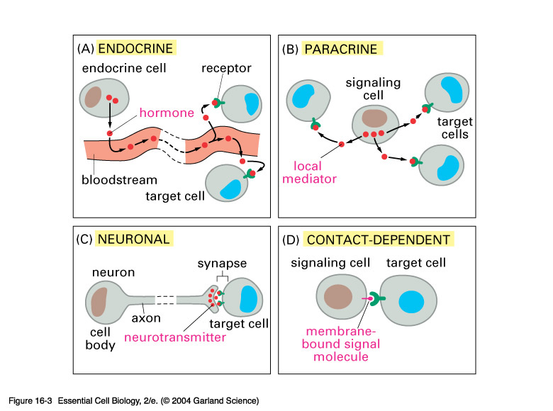
The main difference between the different categories of signaling is the distance that the signal travels through the organism to reach the target cell.
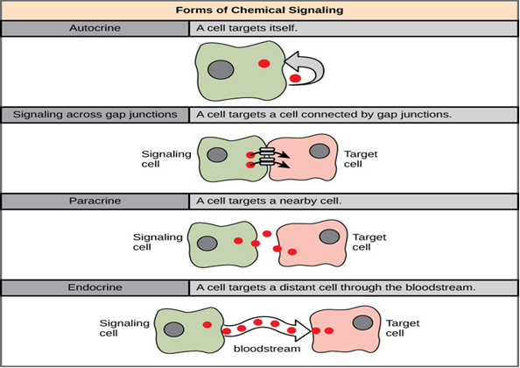
Signaling molecules are the molecules that are responsible for transmitting information between cells in the body. The size, shape, and function of different types of signaling molecules can vary greatly. Some carry signals over short distances, while others transmit information over very long distances.
Signal Transduction | Metabolism
Provides information transfer | Provides mass transfer
Quantities: 10 to 10⁴ molecules per cell | Quantity of converted material: μM or Mm
A signal pathway may  assemble dynamically | A metabolic network is determined by the present set of enzymes
Amount of catalyst and substrate in the same order of magnitude | The catalyst to substrate ratio is low (quasi-steadystate assumption in  Michaelis-Menten kinetics)

There are a diverse number of small molecules and polypeptides that serve to coordinate a cells individual biological activity within the context of the organism as a whole.
These molecules have been functionally classified as:-
- Hormones (e.g., melatonin)
- Growth factor (e.g., epidermal growth factor)
- Extra-cellular matrix components (e.g., fibronectin)
- Cytokines (e.g., interferon – gamma )
- Chemokines (e.g., RANTES)
- Neurotransmitters (e.g., acetycholine )
- Neurotrophins ( e.g., nerve growth factor)
Signaling molecules may trigger:
- An immediate change in the metabolism of the cell (e.g., increased glycogenolysis when a liver cell detects adrenaline);
- An immediate change in the electrical charge across the plasma membrane (e.g., the source of action potentials);
- A change in the gene expression — transcription — within the nucleus. (These responses take more time).
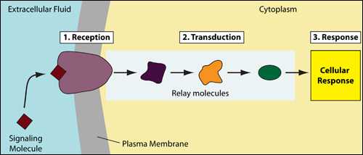

Signal transduction occurs when an extracellular signaling molecule activates a cell surface receptor. In turn, this receptor alters intracellular molecules creating a response. There are two stages in this process:
- A signaling molecule activates a specific receptor protein on the cell membrane.
- A second messenger transmits the signal into the cell, eliciting a physiological response.
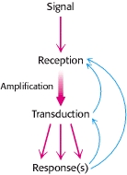

Principles of Signal Transduction. An environmental signal, such as a hormone, is first received by interaction with a cellular component, most often a cell-surface receptor. The information that the signal has arrived is then converted into other chemical

One signaling molecule can cause many responses, the signal must be amplified so that the response is carried out multiple times rather than just be a single molecule.
Amplification is built into the system. Any molecule that catalyzes a reaction can do so multiple times producing more than one product molecule. So each step in the signaling chain has the potential for amplification.
If a signaling chain is several steps long then there is a great potential for amplification of the signal. For example if the membrane receptor can produce 10 second messengers and each second messenger can generate the transcription of 10 mRNA chains then the signal has been amplified one thousand fold.
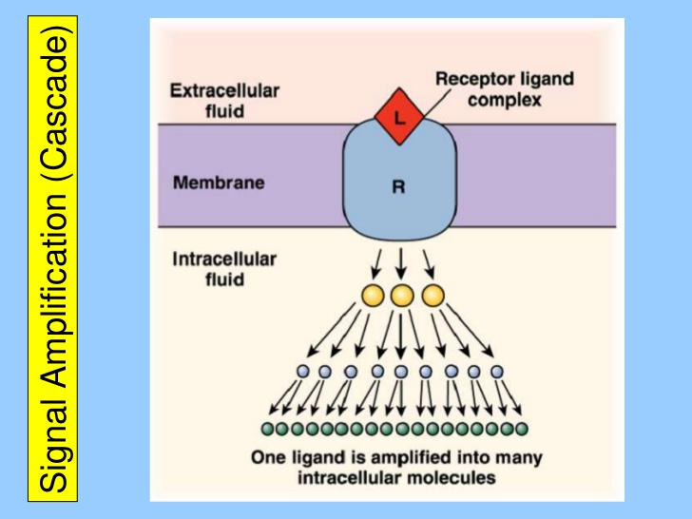
A signal transduction functions much like a switch.
The number of proteins and other molecules participating in the events involving signal transduction increases as the process emanates from the initial stimulus, resulting in a "signal cascade" beginning with a relatively small stimulus that elicits a large response. This is referred to as amplification of the signal.
The information flows from the gene to the primary transcript to mRNA to protein. However, can affect any of steps involved and can affect the rates of processing, degradation, or modification of the various products.
By selectively affecting gene transcription and the consequent production of appropriate target mRNA, the amount of specific proteins are changed and metabolic processes are influenced.
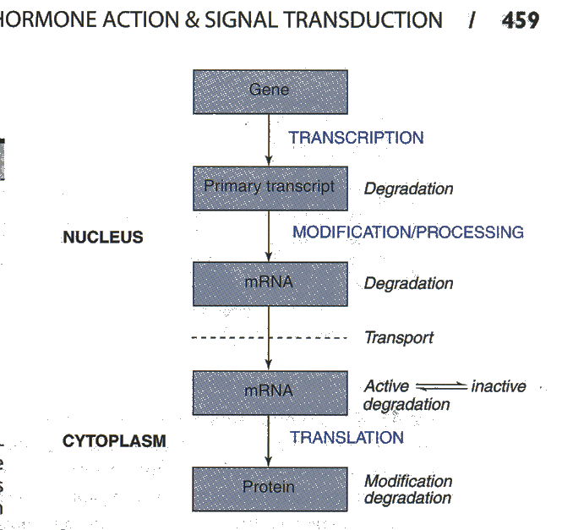

Regulation of gene expression:-
Control of transcription results from changes in the interaction of specific binding regulatory protein with various regions of DNA in the controlled gene. This can have a positive or negative effect on transcription.
Gene expression can also be modulated by gene amplification, and RNA stabilization.
These are two types of gene regulation: - positive and negative regulation. When the expression of genetic information is quantitatively increased by the presence of a specific regulatory element, the regulation is positive.
When the expression of genetic information is diminished by the presence of specific regulatory element, the regulation is negative.
The element or molecule mediating negative regulation is called negative regulator or repressor, and that mediating positive regulation is a positive regulator or activator.
General Features of Signal Transduction
Signal transductions are remarkably specific and exquisitely sensitive. Specificity is achieved by precise molecular complementarity between the signal and receptor molecules.
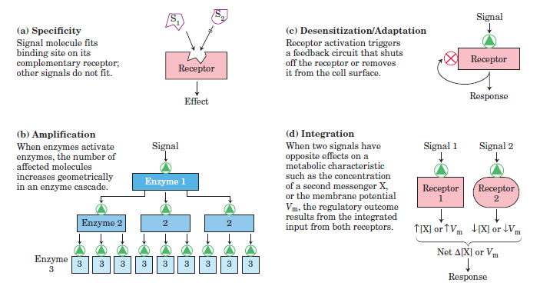
Cellular Responses:-
Activation of genes, alteration in metabolism, the continued proliferation death of the cell and the stimulation or suppression, is some of the cellular signal transduction.
Most mammalian cells require stimulation to control not only cell division but also survival.
Types of responses:-
The biologic system exhibit three types of temporal responses to a regulatory signal:-
- Type A response:-It is characterized by an increased extent of gene expression that is dependent upon the continued presence of inducing signal. When the inducing signal diminishes to its basal level, but the amount repeatedly increases in response to the reappearance of the specific signal. This type of response is commonly observed after exposure to inducer such as hormones, nutrients, or growth factor.
- Type B response:-
Exhibite an increased amount of gene expression that is transient even in the continued presence of the regulatory signal. After the regulatory signal has terminated and the cell has been allowed to recover, and a second transient response to a subsequent regulatory signal may be observed.
This type of response commonly occurs during development of an organism, when only the transient appearance of a specific gene product is required although the signal persists.
- Type C response: -Exhibites, in response to the regulatory signal, an increased extent of gene expression that persists indefinitely even after termination of the signal.
Once expression of the gene is intiated in the cell, it cannot be terminated even in the daughter cells. It is therefore an irreversible and inherited alteration.
This type of response occurs during the development of differentiated function in a tissue or organ.
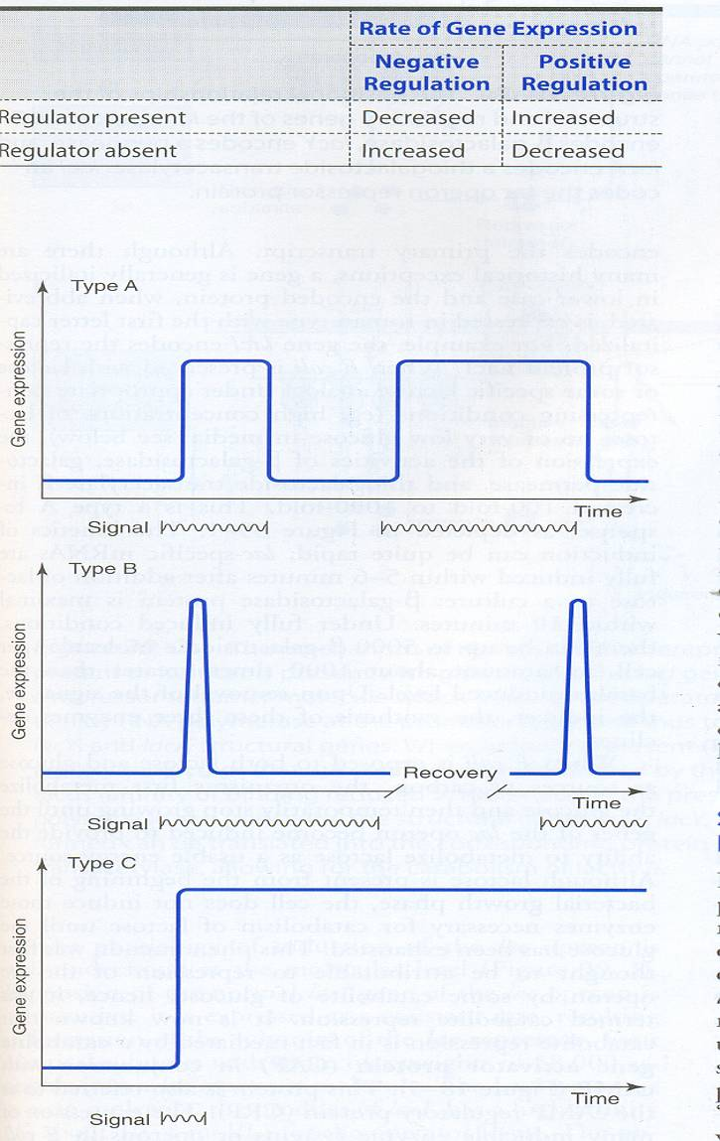

Types of Receptor:-
Receptors can be divided into:-
- Intracellular receptors.
- Cell-surface receptors.
Ligand – gated ion channel receptors are a class of receptor that may occur both at the cell-surface or intracellular.
Cell-surface receptors:-
There are many different class of transmembrane receptor that recognizes different exctracellular signaling molecules:-
- G- protein – coupled receptors. e.g., chemokine receptors.
- Receptor tyrosine Kinases. e.g., growth factor receptors.
- Integrins.
- Toll-like receptors.
The use of second messengers has several consequences. First, second messengers are often free to diffuse to other compartments of the cell, such as the nucleus, where they can influence gene expression and other processes.
Second, the signal may be amplified significantly in the generation of second messengers.
Third, the use of common second messengers in multiple signaling pathways creates both opportunities and potential problems.
Second messengers are one of the initiating components of intracellular signal transduction cascades ,they are released by the cell to trigger physiological changes such as proliferation, differentiation, migration, survival, and apoptosis.
Changes in the concentration of small molecules (second messengers), constitute the next step in the molecular information circuit. Particularly important second messengers include cyclic AMP and cyclic GMP, calcium ion, inositol 1,4,5-trisphosphate, (IP₃), and diacylglycerol .
1- G-Protein – coupled Receptors.
G-protein – Coupled receptors (GPCR) are a family of integral membrane proteins that posses seven membrane-spanning domains, and are linked to a guanine nucleotide- binding protein (or heterotrimeric G protein).
The total strength of signal amplification by a G-protein – coupled receptor (GPCR) is determined by:-
- The lifetime of the ligand – receptor-complex .If the ligand – receptor –complex is stable, it takes longer for the ligand to dissociate from its receptor, thus the receptor will remain active for longer and will activate more effector proteins.
- The amount and lifetime of the receptor-effector protein – complex. The more effector protein is available to be activated by the receptor, and the faster the activated by the receptor, and the faster the activated effector protein can dissociates from the receptor, the more effector protein will be activated in the same amount of time.
3- Deactivation of the activated receptor.
A receptor that is engaged in a hormone – receptor-complex can be deactivated either by covalent modification (for complex, phosphrylation) or by internalization.
4- Deactivation of effectors through intrinsic enzymatic activity. Either small or large G-proteins possess GTP ase activity, which controls the duration of the triggered signal. This activity may be increased through the action of other proteins such as GTPase – activating proteins. (GAPS).
2- Receptor Tyrosine Kinases(RTK):-
Receptor tyrosine kinases (RTKs) are transmembrane proteins ,they are enzymes that that transfer phosphate groups from ATP to the amino acid Tyrosine on a protein.
They are effective when cell needs to regulate and coordinate a variety of activities and trigger several signal pathways at once, so they regulate cell proliferation, differentiation, cell survival and cellular metabolism.
The signaling molecules that activate RTK are soluble or membrane bound peptide or protein hormones. Examples:
1-Nerve growth factor (NGF) 2- Platelets-derived factor(PDGF)
- Fibroblast growth factor(FGF) 4- Epidermal growth factor(EGF)
(RTK) proteins are classified depending on the:-
- Structural properties.
- Ligand specificity.

3- Integrins:-
Integrins are produced by a wide variety of cell types, and play a role in the attachment of a cell to the extracllular matrix (ECM) and to other cells, and in the signal transduction of signals received from extracellular matrix components such as fibronectin, collagen.
Important differences between integrin – signaling in circulating blood cells and that in non-circulating cells such as epithelial cells. Integrins at the cell-surface of circulating cells are inactive under normal physiological conditions. For example; cell-surface integrins on circulating leukocytes are maintained in an inactive state in order to avoid epithelial cell attachment. Only in response to appropriate stimuli are leukocyte integrins converted into an active form, such as those received at the site of an inflammatory response.
In a similar manner, it is important that integrins at the cell surface of circulating platelets are kept in an inactive state under normal conditions, in order to avoid thrombosis. Epithelial cells , in contrast , have active integrins at their cell surface under normal condition , which help to maintain their stable adhesion to underlying stromal cells.

4- Toll like receptors (TLRs):-
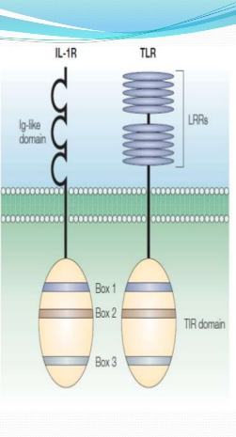

TLRs are type I membrane glycoproteins ,homology in the cytoplasmic receptors region-Interleukin-1 receptos(IL-1Rs) superfamily.
The extracellular region of TLRs contains leucine-rich repeat (LRR) motifs & IL IRs contains three immunoglobulin-like domains.

They are a type of pattern recognition receptor and recognize molecules that are shared by pathogens but distinguishable from host molecules , once they have reached physical barriers such as the skin or intestinal tract mucosa and activate immune cell responses , they are play a key role in the innate immune system.
TLRs seem only to be involved in the cytokine production and cellular activation in response to microbes, and do not play a significant role in the adhesion and phagocytosis of microorganisms.
Ligand – gated ion channel receptors:-
A ligand – activated ion channel will recognize its ligand , and then undergo a structural change that opens a gap (channel)in the plasma membrane through which ions can pass these ions will then relay the signal.
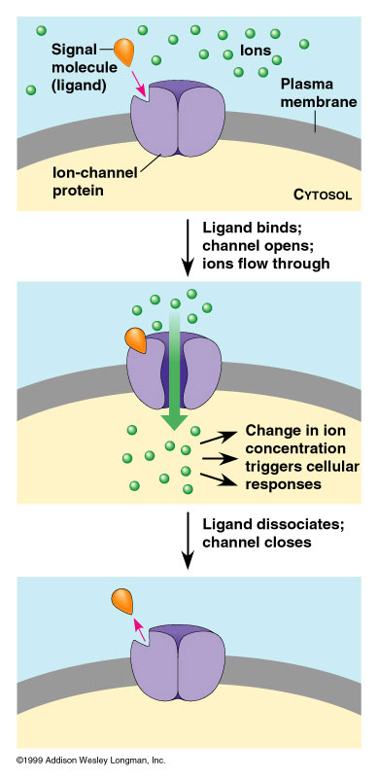
The signal is terminated
Protein phosphatases are one mechanism for the termination of a signaling process. After a signaling process has been initiated and the information has been transduced to affect other cellular processes, the signaling processes must be terminated. Without such termination, cells lose their responsiveness to new signals. Moreover, signaling processes that fail to be terminated properly may lead to uncontrolled cell growth and the possibility of cancer.
Regulation of Metabolism:-Regulatory signals that inform an individual cell to the metabolic state of the body as a whole include hormones, neurotransmitters, and the availability of nutrients. These in turn, influence signals generated within the cell.
Intracellular Receptors:-
Intracellular receptors include nuclear receptors and cytoplasmic receptor, and they are soluble proteins localized within the nucleoplasm or the cytoplasm. The typical ligands for nuclear receptors are lipophilic hormones, with steroid hormones (e.g., testosterone, progesterone, and cortisol) and derivatives of vitamin A and D among them. To reach hormone must pass through the plasma membrane, usually by passive diffusion.
Two categories of signaling molecules (steroids and nitric oxide) diffuse into the cell where they bind internal receptors.
The others, e.g., proteins, bind to receptors displayed at the surface of the cell. These are transmembrane proteins whose
- Extracellular portion has the binding site for the signaling molecule (the ligand);
- Intracellular portion activates proteins in the cytosol that in different ways eventually regulate gene transcription in the nucleus.
Calcium is Mediator of Hormone Action:-
Calcium ions are important for cellular signalling, as once they enter the cytosol of the cytoplasm they exert allosteric regulatory effects on many enzymes and proteins. Calcium can act in signal transduction resulting from activation of ion channels or as a second messenger caused by indirect signal transduction pathways such as G protein-coupled receptors.
The resting concentration of Ca²⁺ in the cytoplasm is normally maintained in the range of 10–100 nM. To maintain this low concentration, Ca²⁺ is actively pumped from the cytosol to the extracellular space and into the endoplasmic reticulum (ER), and sometimes in the mitochondria. Certain proteins of the cytoplasm and organelles act as buffers by binding Ca²⁺.
Signaling occurs when the cell is stimulated to release calcium ions (Ca²⁺) from intracellular stores, and/or when calcium enters the cell through plasma membrane ion channels.
Some fast ligand-gated channels allow calcium ion to enter the cell increasing intracellular calcium ion concentration. Calcium ion may trigger a muscle contraction, secretion by exocytosis or change the activity of intracellular proteins. In the last case, calcium ion acts as a secondary messenger. Calcium does this by first binding with a cytosolic protein called calmodulin, which is an intracellular target of the secondary messenger Ca²⁺, and the binding of Ca²⁺ is required for the activation of Calmodulin. Once bound to Ca²⁺, Calmodulin acts as part of a calcium signal transduction pathway by modifying its interactions with various target proteins such as kinases or phosphatases. The calcium-calmodulin complex usually activates a protein kinase that affects protein activity by phosphorylation.

Certain hormone- receptor interactions result in the activation of phospholipase C. This appears to involve a specific G protein, which also may activate a calcium channel. Phospholipase C results in generation of inositol triphosphate (IP3), which liberates stored intracellular Ca⁺², and diacylglycerol (DAG), a potent activator of protein kinase C (CPK).

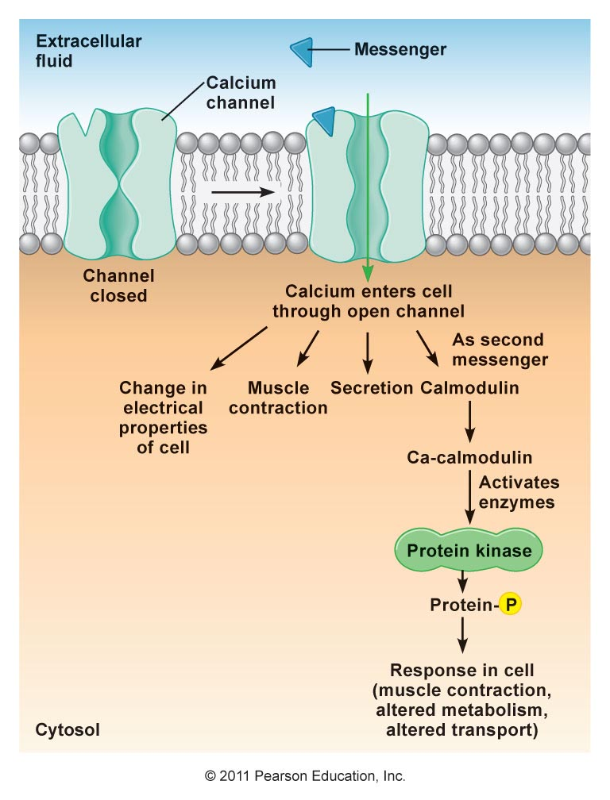
Nitric Oxide (No) as a second Messenger:-
The gas nitric oxide (No) is free radicals that diffuse through the plasma membrane and effects nerby cells. (No) is made from arginine and oxygen by the enzyme (No) synthase, with citrulline as a by-product. (No) works mainly through activation of it target receptor, the enzyme soluble gunanylate cyclase, which when activated, produce the second messenger cyclic guanosime monophosphate (cGMP). (No) can also act through covalent modification of proteins or their metal cofactors. Some of these modifications are reversible and worke through a redox mechanism. In high Conc., (No) is toxic, and is responsible for some damage after a strocke.
- NO diffuses freely across cell membranes.
- There are so many other molecules with which it can interact, that it is quickly consumed close to where it is synthesized.
- Thus NO acts in a paracrine or even autocrine fashion — affecting only cells near its point of synthesis.
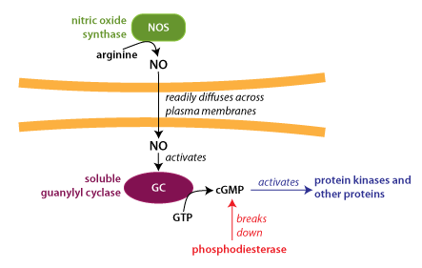
(No) serves multiple functions, some of them are:-
- Relaxation of blood vessels.
- Regulation of exocytosis of neurotransmitters.
- Cellular immune response.
- Activation of apoptosis.

