University of Mustansiriyah Dr.Shatha AL-Khateeb
Collage of Medicine (1-16)
Clinical biochemistry Department 2017-2018

Nutrition
Nutrition is the provision, to cells and organisms, of the materials necessary (in the form of food) to support life. Many common health problems can be prevented or alleviated with a healthy diet. Aside from not smoking, the most important determinants of good health are what we eat and how active we are.
Dietitians are health professionals who specialize in human nutrition, meal planning, economics, and preparation. They are trained to provide safe, evidence-based dietary advice and management to individuals (in health and disease), as well as to institutions. Clinical nutritionists are health professionals who focus more specifically on the role of nutrition in chronic disease, including possible prevention or remediation by addressing nutritional deficiencies before resorting to drugs.
The human body contains chemical compounds, such as water, carbohydrates (sugar, starch, and fiber), amino acids (in proteins), fatty acids (in lipids), and nucleic acids (DNA and RNA). These compounds in turn consist of elements such as carbon, hydrogen, oxygen, nitrogen, phosphorus, calcium, iron, zinc, magnesium, manganese, and so on. All of these chemical compounds and elements occur in various forms and combinations (e.g. hormones, vitamins, phospholipids, hydroxyapatite), both in the human body and in the plant and animal organisms that humans eat.
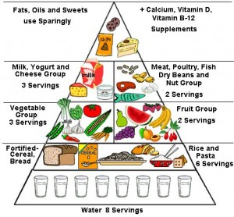



Nutrients
There are six major classes of nutrients: carbohydrates, fats, minerals, protein, vitamins, and water.
These nutrient classes can be categorized as either macronutrients (needed in relatively large amounts) or micronutrients (needed in smaller quantities). The macronutrients include carbohydrates (including fiber), fats, protein, and water. The micronutrients are minerals and vitamins.
The macronutrients (excluding fiber and water) provide structural material (amino acids from which proteins are built, and lipids from which cell membranes and some signaling molecules are built) and energy. Some of the structural material can be used to generate energy internally, and in either case it is measured in Joules or kilocalories (often called "Calories").
Carbohydrates and proteins provide 17 kJ approximately (4 kcal) of energy per gram, while fats provide 37 kJ (9 kcal) per gram though the net energy from either depends on such factors as absorption and digestive effort.
Vitamins, minerals, fiber, and water do not provide energy, but are required for other reasons.
Fiber (i.e., non-digestible material such as cellulose), is also required, for both mechanical and biochemical reasons.
Protein molecules contain nitrogen atoms in addition to carbon, oxygen, and hydrogen. The fundamental components of protein are nitrogen-containing amino acids, some of which are essential in the sense that humans cannot make them internally. Some of the amino acids are convertible (with the expenditure of energy) to glucose and can be used for energy production just as ordinary glucose in a process known as gluconeogenesis. By breaking down existing protein, some glucose can be produced internally; the remaining amino acids are discarded, primarily as urea in urine. This occurs normally only during prolonged starvation.
Most foods contain a mix of some or all of the nutrient classes, together with other substances, such as toxins of various sorts. Some nutrients can be stored internally (e.g., the fat soluble vitamins), while others are required more or less continuously. Poor health can be caused by a lack of required nutrients or, in extreme cases, too much of a required nutrient. For example, both salt and water (both absolutely required) will cause illness or even death in excessive amounts.

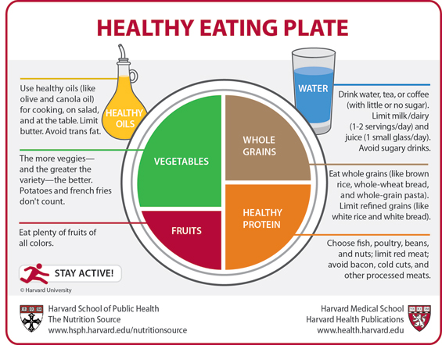
The aim of nutritional science:
- To define the complete set of nutrients required in diet
- The optimal amount of each nutrient.
- Combination or food that meets these requirements.
- To determine the variation of how these requirements vary in normal life cycle.
- Nutritional factors affect and affected by illness, injury and treatment.
There are four disorders arising from dietary causes, which are widespread in our world today:
- Protein - calorie malnutrition;
- Obesity.
- Starvation.
- Secondary starvation (insufficient food intake)
Factors which affect specific req. of individual:
(1.Heigh (2.Sex (3.Climate (4. Weight (5.Physical activity level ( (6.Age-development stage (7. Pregnancy.
The nutrient content of a food depends on:
1. Genetic strain 2.Growing location
3. Soil 4.Handling
5. Storage 6.Cooking

No single food contains adequate amount of all essential nutrients.
Calorific Value
The energy content of food materials is measured in calories. One calorie is the heat required to raise the temperature of 1 g of water through 1ᵒC ,because it is very small unit,In medical practice ,the energy content is usually expressed in Kilocalorie(Kcal) which equal to 1000 calorie[One kilo calorie is equal to 4.2 kilojoules(KJ).
Energy Requirements of a normal person
While calculating the energy requirements, we have to consider the energy required for:
1-Maintenance of basal metabolic rate (BMR).
2-Specific dynamic action or thermogenic effect of food.
3-Extra energy expenditure for physical activities.
Basal Metabolic Rate(BMR)
Is the energy required by an awake individual during physical ,emotional and digestive rest. It is the minimum amount of energy required to maintain life or sustain vital functions like the working of the heart,circulation,brain function,respiration,etc.The metabolic rate during sleep is less than BMR.
Resting Metabolic Rate(RMR)
Is the measure of energy required to maintain life or vital functions. The subject is awake and non –fasting , it is approximately about 3% higher than the BMR.
BMR is measured directly by the heat evolved or indirectly by the volume of oxygen consumed and carbon dioxide evolved per unit time.

Factors affecting BMR:
1-Age. 2-Sex. 3-Tempreture.
4-Fever. 5-Thyroid Hormones.
Since BMR is affected by body surface area, it is usually expressed in Kilocalories per hour / square meter of body surface.
For adult men normal value for BMR is 34-37 k cal/ square meter/hour, and for women 30-35 k cal /Sq.m./hour.
Physical Activity
The energy requirements would depend on the occupation, physical activity and lifestyle of the individual.
The activity level may be divided into 3 groups-Sedentary, Moderate and Heavy.
Requirement for energy during pregnancy is + 300 kcal/ day, and during lactation is + 500 kcal/day in addition to the basic requirements.
In the diet proximate principles are carbohydrates, fats and proteins. Moreover, required amounts of minerals and vitamins are also to be provided.Aditional requirements for growth,pregnancy,lactation and convalescence are to be provided in the food.

Activity | Energy required in kcal / hour
Eating | 28
Writing | 30
Driving a car | 63
Typing at high speed | 100
Walking | 140
Cycling(speed 2 km/h) | 175
Running | 490
Swimming (3.5 km / hour) | 550
Carbohydrate
Molecules of carbohydrates and fats consist of carbon, hydrogen, and oxygen atoms. Carbohydrates range from simple monosaccharides (glucose, fructose, and galactose) to complex polysaccharides (starch).
Carbohydrates may be classified as monosaccharides, disaccharides, or polysaccharides depending on the number of monomer (sugar) units they contain.

Fiber
Dietary fiber is a carbohydrate (or a polysaccharide) that is incompletely absorbed in humans and in some animals.
Dietary fiber consists mainly of cellulose, a large carbohydrate polymer that is indigestible because humans do not have the required enzymes to disassemble it.
There are two subcategories: soluble and insoluble fiber. Insoluble fiber, found in whole wheat flour, nuts and vegetables, especially stimulates peristalsis – the rhythmic muscular contractions of the intestines which move digested along the digestive tract.
Soluble fiber, found in oats, peas, beans, and many fruits, dissolves in water in the intestinal tract to produce a gel which slows the movement of food through the intestines. This may help lower blood glucose levels because it can slow the absorption of sugar.

Fat
Fats are triglycerides, made of assorted fatty acid monomers bound to glycerol backbone. Some fatty acids, but not all, are essential in the diet: they cannot be synthesized in the body.
A molecule of dietary fat typically consists of several fatty acids (containing long chains of carbon and hydrogen atoms), bonded to a glycerol. They are typically found as triglycerides (three fatty acids attached to one glycerol backbone).
Fats may be classified as saturated or unsaturated depending on the detailed structure of the fatty acids involved.
Saturated fats have all of the carbon atoms in their fatty acid chains bonded to hydrogen atoms, whereas unsaturated fats have some of these carbon atoms double-bonded, so their molecules have relatively fewer hydrogen atoms than a saturated fatty acid of the same length.
Unsaturated fats may be further classified as monounsaturated (one double-bond) or polyunsaturated (many double-bonds). Furthermore, depending on the location of the double-bond in the fatty acid chain, unsaturated fatty acids are classified as omega-3 or omega-6 fatty acids. Trans fats are a type of unsaturated fat with trans-isomer bonds; these are rare in nature and in foods from natural sources; they are typically created in an industrial process called (partial) hydrogenation. There are nine kilocalories in each gram of fat. In addition to providing energy, represent potent immune modulatory molecules.

Protein
Most meats such as chicken contain all the essential amino acids needed for humans
Proteins are the basis of many animal body structures (e.g. muscles, skin, and hair). They also form the enzymes that control chemical reactions throughout the body.
Each molecule is composed of amino acids, which are characterized by inclusion of nitrogen and sometimes sulphur (these components are responsible for the distinctive smell of burning protein, such as the keratin in hair). The body requires amino acids to produce new proteins (protein retention) and to replace damaged proteins (maintenance). As there is no protein or amino acid storage provision, amino acids must be present in the diet.
Excess amino acids are discarded, typically in the urine.About twenty amino acids are found in the human body, and about ten of these are essential and, therefore, must be included in the diet. A complete protein source contains all the essential amino acids; an incomplete protein source lacks one or more of the essential amino acids.

Minerals

Dietary minerals are the chemical elements required by living organisms, other than the four elements carbon, hydrogen, nitrogen, and oxygen that are present in nearly all organic molecules. The term "mineral" is archaic, since the intent is to describe simply the less common elements in the diet.

Some are heavier than the four just mentioned, including several metals, which often occur as ions in the body. Some dietitians recommend that these be supplied from foods in which they occur naturally or at least as complex compounds, or sometimes even from natural inorganic sources (such as calcium carbonate from ground oyster shells). Some minerals are absorbed much more readily in the ionic forms found in such sources. On the other hand, minerals are often artificially added to the diet as supplements; the most famous is likely iodine in iodized salt which prevents goiter.

Macrominerals
Many elements are essential in relative quantity; they are usually called "bulk minerals". Some are structural, but many play a role as electrolytes.Calcium, Chlorine ,Magnesium, Phosphorus, Potassium, Sodium, Sulfur, for three essential amino acids and therefore many proteins (skin, hair, nails, liver, and pancreas). Sulfur is not consumed alone, but in the form of sulfur-containing amino acids.
Trace minerals
Many elements are required in trace amounts, usually because they play a catalytic role in enzymes. Some trace mineral elements (RDA < 200 mg/day) are, in alphabetical order:Cobalt ,Copper, Chromium, Iodine, Iron, Manganese Molybdenum, Nickel , Selenium, Vanadium, and Zinc.

Vitamins

As with the minerals, some vitamins are recognized as essential nutrients, necessary in the diet for good health. (Vitamin D is the exception: it can be synthesized in the skin, in the presence of UVB radiation.).

Water
Water is excreted from the body in multiple forms; including urine and feces, sweating, and by water vapor in the exhaled breath. Therefore it is necessary to adequately dehydrate to replace lost fluids.
Early recommendations for the quantity of water required for maintenance of good health suggested that 6–8 glasses of water daily is the minimum to maintain proper hydration. However the notion that a person should consume eight glasses of water per day cannot be traced to a credible scientific source.

Other nutrients

Other micronutrients include antioxidants and phytochemicals. These substances are generally more recent discoveries that have not yet been recognized as vitamins or as required. Phytochemicals may act as antioxidants, but not all phytochemicals are antioxidants.

Antioxidants
As cellular metabolism/energy production requires oxygen, potentially damaging (e.g. mutation causing) compounds known as free radicals can form.
Most of these are oxidizers (i.e. acceptors of electrons) and some react very strongly. For the continued normal cellular maintenance, growth, and division, these free radicals must be sufficiently neutralized by antioxidant compounds.
Some are produced by the human body with adequate precursors (glutathione, Vitamin C), and those the body cannot produce may only be obtained in the diet via direct sources (Vitamin C in humans, Vitamin A, Vitamin K) or produced by the body from other compounds (Beta-carotene converted to Vitamin A by the body, Vitamin D synthesized from cholesterol by sunlight).
Different antioxidants are now known to function in a cooperative network. For example, Vitamin C can reactivate free radical-containing glutathione or Vitamin E by accepting the free radical itself.
Vitamin C is water soluble and protects those areas). When interacting with a free radical, some antioxidants produce a different free radical compound that is less dangerous or more dangerous than the previous compound. Having a variety of antioxidants allows any byproducts to be safely dealt with by more efficient antioxidants in neutralizing a free radical's butterfly effect.

Obesity
Obesity is a medical condition in which excess body fat has accumulated to the extent that it may have an adverse effect on health, leading to reduced life expectancy and/or increased health problems. People are considered obese when their body mass index (BMI), a measurement obtained by dividing a person's weight in kilograms by the square of the person's height in meters, exceeds 30 kg/m².
Obesity increases the likelihood of various diseases, particularly heart disease, type 2 diabetes, obstructive sleep apnea, certain types of cancer, and osteoarthritis. Obesity is most commonly caused by a combination of excessive food energy intake, lack of physical activity, and genetic susceptibility, although a few cases are caused primarily by genes, endocrine disorders, medications or psychiatric illness. Evidence to support the view that some obese people eat little yet gain weight due to a slow metabolism is limited; on average obese people have a greater energy expenditure than their thin counterparts due to the energy required to maintain an increased body mass.

Classification of obesity
Obesity is a medical condition in which excess body fat has accumulated to the extent that it may have an adverse effect on health. It is defined by body mass index (BMI) and further evaluated in terms of fat distribution via the waist–hip ratio and total cardiovascular risk factors. BMI is closely related to both percentage body fat and total body fat.
The BMI is a statistical measurement derived from the height and weight. Although it is considered to be a useful way to estimate healthy body weight, it does not measure the percentage of body fat. The BMI measurement can sometimes be misleading - a muscleman may have a high BMI but have much less fat than an unfit person whose BMI is lower. However, in general, the BMI measurement can be a useful indicator for the 'average person'.
BMI is calculated by dividing the subject's mass by the square of his or her height, typically expressed either in metric or US "customary" units:
Metric:
US customary and imperial:
Where is the subject's weight in pounds and is the subject's height in inches.
The distribution of the body fat also plays a role in determining your risk of obesity-related health problems. There are at least two different kinds of body fat. Studies conducted in Scandinavia have shown that excess body fat distributed around the waist ("apple"-shaped figure, intra-abdominal fat) carries more risk than fat distributed on the hips and thighs ("pear"-shaped figure, fat under the skin).
Any BMI ≥ 35 or 40 is severe obesity.
- A BMI of ≥ 35 and experiencing obesity-related health conditions or ≥40–44.9 is morbid obesity.
- A BMI of ≥ 45 or 50 is super obesity.
BMI | Classification
< 18.5 | Underweight
18.5–24.9 | Normal weight
25.0–29.9 | Overweight
30.0–34.9 | class I obesity
35.0–39.9 | class II obesity
≥ 40.0 | class III obesity

BMI in Children
Body Mass Index (BMI) is a number calculated from a child's weight and height. BMI is a reliable indicator of body fatness for most children and teens. BMI does not measure body fat directly, but research has shown that BMI correlates to direct measures of body fat, such as underwater weighing and dual energy x-ray absorptiometry (DXA).
BMI can be considered an alternative for direct measures of body fat. Additionally, BMI is an inexpensive and easy-to-perform method of screening for weight categories that may lead to health problems.
For children and teens, BMI is age- and sex-specific and is often referred to as BMI-for-age.

Why can't healthy weight ranges be provided for children and teens?
Healthy weight ranges cannot be provided for children and teens for the following reasons:
- Healthy weight ranges change with each month of age for each sex.
- Healthy weight ranges change as height increases.
Effects on Health
Excessive body weight is associated with various diseases, particularly cardiovascular diseases, diabetes mellitus type 2, obstructive sleep apnea, certain types of cancer, osteoarthritis and asthma. As a result, obesity has been found to reduce life expectancy.
Mortality
Obesity is one of the leading preventable causes of death worldwide. A BMI above 32 kg/m² has been associated with a doubled mortality rate among women over a 16-year period. On average, obesity reduces life expectancy by six to seven years, a BMI of 30–35 kg/m²reduces life expectancy by two to four years, while severe obesity (BMI > 40 kg/m²) reduces life expectancy by ten years.

Morbidity
Obesity increases the risk of many physical and mental conditions. These comorbidities are most commonly shown in metabolic syndrome, a combination of medical disorders which includes: diabetes mellitus type 2, high blood pressure, high blood cholesterol, and high triglyceride levels.
Complications are either directly caused by obesity or indirectly related through mechanisms sharing a common cause such as a poor diet or a sedentary lifestyle. The strength of the link between obesity and specific conditions varies. One of the strongest is the link with type 2 diabetes. Excess body fat underlies 64% of cases of diabetes in men and 77% of cases in women.
Health consequences fall into two broad categories:
1-Those attributable to the effects of increased fat mass (such as osteoarthritis, obstructive sleep apnea, social stigmatization).
2-Those due to the increased number of fat cells (diabetes, cancer, cardiovascular disease, non-alcoholic fatty liver disease).
Increases in body fat alter the body's response to insulin, potentially leading to insulin resistance. Increased fat also creates a proinflammatory state.
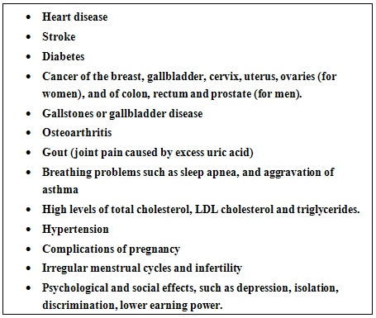

Why do people become obese?
Weight gain occurs when we eat more calories than our body uses up. If the food we eat provides more calories than the body needs, the excess is converted to fat. Initially, fat cells increase in size. When they can no longer expand, they increase in number. If we lose weight, the size of the fat cells decreases, but the number of cells does not.
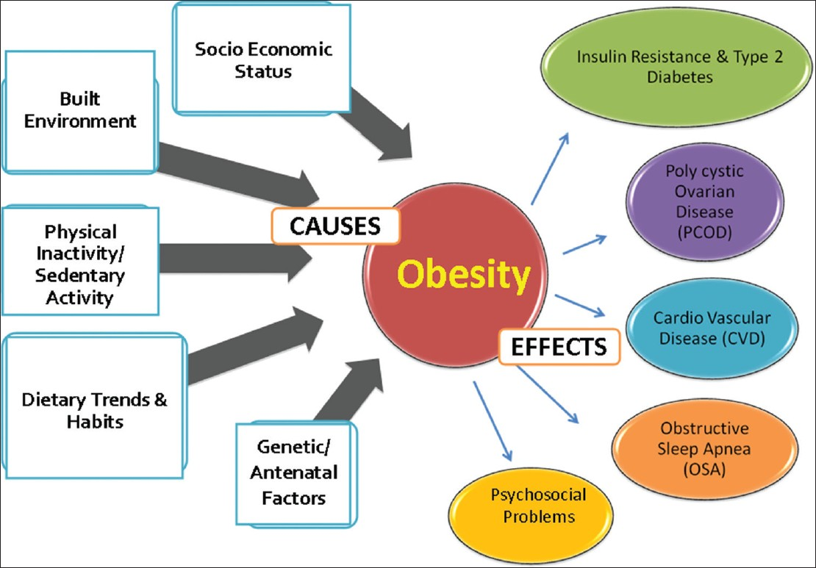
Obesity, however, has many causes. The reasons for the imbalance between calorie intake and consumption vary by individual. The age, gender, genes, psychological makeup, and environmental factors all may contribute.
Family History
The genes you have inherited from your parents have strong effects on one’s weight. If parents are enduring from obesity, than their children’s have more chances to become obese. Genes support obesity, eating habits or physical activities of parents and children’s are mostly same, children’s copied the habits of their parents .Obesity becomes family problem for most of the families.
Family lifestyle:
Obesity tends to run in families. This is caused both by genes and by shared diet and lifestyle habits. If one of the parents is obese,have a higher risk of being obese.
With the arrival of televisions, computers, video games, remote controls, washing machines, dish washers and other modern convenience devices, the majority of people are leading a much more sedentary lifestyle compared to their parents and grandparents.
Consuming too many calories:
People are eating much more than they used to.
Endocrine disruptors
Such as some foods that interfere with lipid metabolism. The molecular mechanism provides clues through which fructose (a type of sugar) in beverages may alter lipid energy metabolism and cause fatty liver and metabolic syndrome.
Fructose is mainly metabolized in the liver, the target organ of the metabolic alterations caused by the consumption of this sugar, rats receiving fructose-containing beverages presented a pathology similar to metabolic syndrome, which in the short term causes lipid accumulation (hypertriglyceridemia) and fatty liver, and eventually leads to hypertension, resistance to insulin, diabetes and obesity.
Common hormonal abnormalities associated with obesity:
1-Increased cortisol production.
2-Insulin resistance.
3-Decreased sex hormone-binding globulin in women.
4-Decreased testosterone levels in men.
5-Decreased growth hormone production.
Not sleeping enough:
If you do not sleep enough your risk of becoming obese doubles, The risk applies to both adults and children.
Emotions:
Some people overeat because of depression, hopelessness, anger, boredom, and many other reasons that have nothing to do with hunger. This doesn't mean that overweight and obese people have more emotional problems than other people. It just means that their feelings influence their eating habits, causing them to overeat.
Environmental factors: The most important environmental factor is lifestyle, eating habits and activity level are partly learned from the people around. Overeating and sedentary habits (inactivity) are the most important risk factors for obesity.
Sex: Men have more muscle than women, on average. Because muscle burns more calories than other types of tissue, men use more calories than women, even at rest. Thus, women are more likely than men to gain weight with the same calorie intake.
Age: People tend to lose muscle and gain fat as they age. Their metabolism also slows somewhat. Both of these lower their calorie requirements.
Pregnancy: Women tend to weigh an average of 4-6 pounds more after a pregnancy than they did before the pregnancy. This can compound with each pregnancy.
Lower rates of smoking (smoking suppresses appetite):
According to the National Institutes of Health (NIH) "Not everyone gains weight when they stop smoking. Among people who do, the average weight gain is between 6 and 8 pounds. Medications that make patients put on weight:
According to an article in Annals of Pharmacotherapy, some medications cause weight gain. "Clinically significant weight gain is associated with some commonly prescribed medicines. There is wide inter-individual variation in response and variation of the degree of weight gain within drug classes.
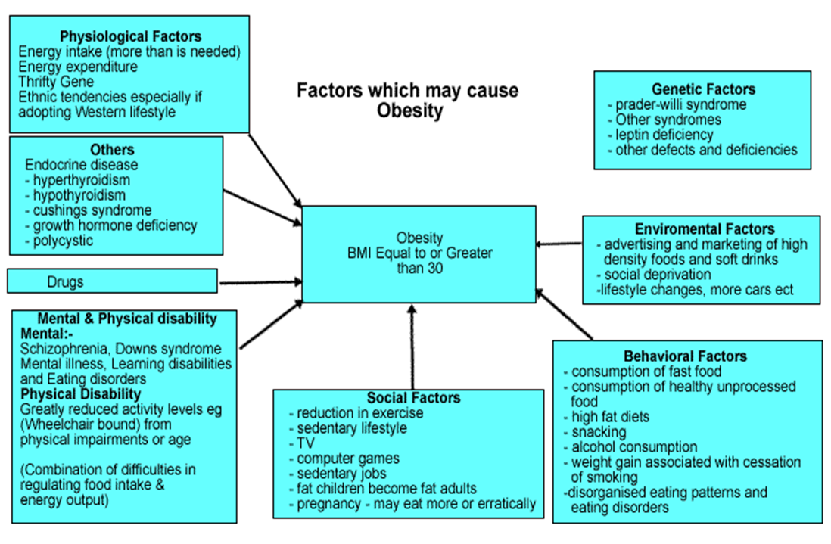

Health Effects of Obesity
1-High blood pressure - Additional fat tissue in the body needs oxygen and nutrients in order to live, which requires the blood vessels to circulate more blood to the fat tissue. This increases the workload of the heart because it must pump more blood through additional blood vessels. More circulating blood also means more pressure on the artery walls. Higher pressure on the artery walls increases the blood pressure. In addition, extra weight can raise the heart rate and reduce the body's ability to transport blood through the vessels.
2-Diabetes - Obesity is the major cause of type 2 diabetes. This type of diabetes usually begins in adulthood but, is now actually occurring in children. Obesity can cause resistance to insulin, the hormone that regulates blood sugar. When obesity causes insulin resistance, the blood sugar becomes elevated. Even moderate obesity dramatically increases the risk of diabetes.
3-Heart disease - Atherosclerosis (hardening of the arteries) is present 10 times more often in obese people compared to those who are not obese. Coronary artery disease is also more prevalent because fatty deposits build up in arteries that supply the heart. Narrowed arteries and reduced blood flow to the heart can cause chest pain (angina) or a heart attack. Blood clots can also form in narrowed arteries and cause a stroke.
4-Joint problems, including osteoarthritis - Obesity can affect the knees and hips because of the stress placed on the joints by extra weight. Joint replacement surgery, while commonly performed on damaged joints, may not be an advisable option for an obese person because the artificial joint has a higher risk of loosening and causing further damage.
5-Sleep apnea and respiratory problems - Sleep apnea, which causes people to stop breathing for brief periods, interrupts sleep throughout the night and causes sleepiness during the day. It also causes heavy snoring. Respiratory problems associated with obesity occur when added weight of the chest wall squeezes the lungs and causes restricted breathing. Sleep apnea is also associated with high blood pressure.
6-Cancer - In women, being overweight contributes to an increased risk for a variety of cancers including breast, colon, gallbladder, and uterus. Men who are overweight have a higher risk of colon and prostate cancers.
7-Metabolic syndrome - The National Cholesterol Education Program has identified metabolic syndrome as a complex risk factor for cardiovascular disease. Metabolic syndrome consists of six major components: abdominal obesity, elevated blood cholesterol, elevated blood pressure, insulin resistance with or without glucose intolerance, elevation of certain blood components that indicate inflammation, and elevation of certain clotting factors in the blood. In the US, approximately one-third of overweight or obese persons exhibit metabolic syndrome.
8-Psychosocial effects - In a culture where often the ideal of physical attractiveness is to be overly thin, people who are overweight or obese frequently suffer disadvantages. Overweight and obese persons are often blamed for their condition and may be considered to be lazy or weak-willed. It is not uncommon for overweight or obese conditions to result in persons having lower incomes or having fewer or no romantic relationships. Disapproval of overweight persons expressed by some individuals may progress to bias, discrimination, and even torment.
Treatments for obesity
Obesity treatments have two objectives:
- To achieve a healthy weight.
- To maintain that healthy weight.
People who are obese are often discouraged because they think they have to lose a lot of weight before any benefits are experienced. This is not true. Any obese person who loses just five to ten per cent of their body weight will have significant improvement in health - this would mean between 12-25 pounds for an obese person who weighs 250 pounds.
It is important for patients to realize that a small drop in weight is a good start and a great achievement. Experts have found that obese people who lose weight slowly and constantly, say one or two pounds each week, are more successful in keeping their weight down when they have reached their target weight.
Trying to lose weight quickly by crash-dieting carries the following risks:
- May develop health problems
- Will probably experience vitamin deficiencies
- Chances of failure are significantly higher

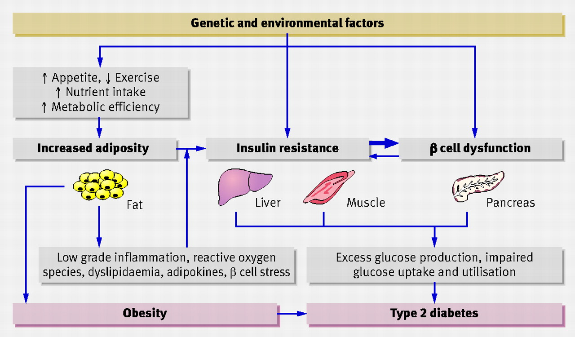

Diet and Cancer
The four leading malignancies which associated with diet are:
1. Breast Cancer:
Scientists suggested that nutrition play an important role in the incidence of breast cancer. Relationships have been established between high Lipid intake specially poly-unsaturated fatty acid type Omega-6 linolenic acid and Breast Cancer.
Breast cancer risk may be lowered by eating soy foods, fish oil and flaxseed oil. Obesity increases incidence of B.C. Potential reduction through diet and lifestyle (33%-50%).
2. Prostate Cancer:
High Lipid intake is a risk factor in this type of malignancy.
Prostate cancer risk may be reduced by eating cooked tomatoes and antioxidants such as Vitamin A and ß Carotene.
Potential reduction through diet and life style is 10- 20%
3. Colon and Rectal caner:
Saturated lipid, food poor with fiber and alcohol intake are major risk factors. Weapons against colon cancer include .calcium and fiber. Potential reduction through diet and life style (66-75%).
4. Lung Cancer:
Smoking is the major risk factor' in lung cancer. High intake of lipid play, also an important role in increasing incidence of the malignancy. For healthy lung replace cigarettes with carrots sticks and increase intake of vegetables-and fruits. Potential reduction through diet, life style and not smoking (90%-95%).

