ORTHOPAEDICS

Lecture: Date: Dr. Saad Mubarak

Primary malignant bone tumors

Osteosarcoma

Pathology: it is highly malignant tumor appear within the bone and spreading to the periosteum and surrounding tissue. Pathologically consists of spindle cells in an osteoid matrix, or may contain cartilage cells or fibroblastic tissue with little or no osteoid.

Clinical features: occurs mainly in children and adolescents. It affects the long bones metaphysis especially around the knee and the proximal end of humerus. The first symptom is pain, increased at night and become later sever in degree, and associated with lump. This lump is tender and there may be redness of the skin.

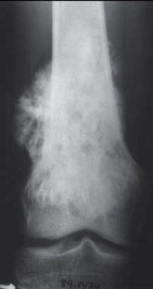
Investigations: ESR is highly raised; increase in alkaline phosphatase enzyme.
On X-ray, there is osteoblastic lesion with poor and ill-defined borders. There is reactive new bone formation between the periosteum and cortex appear as an triangle called Codman's triangle, and after that the tumor will breach the periosteum and a streaks of bone appear radiating outwards from cortex called Sunburst appearance.
Other imaging techniques are essential for staging of the disease like radioisotope scans for skip lesions. CT and MRI show the extent of the tumor. Pulmonary CT done for lung metastases.

Differential diagnosis: stress fractures with callus, chronic osteomyelitis, and large gouty tophus may mistake with osteosarcoma.
For definite diagnosis, biopsy should be taken.

Treatment: it depends on the stage.
If the tumor is intracompartmental and there is no skip lesions, radical excision done with replacement of the bony segment either by large bone graft or custom-made prosthesis. This may preceded by multi-agent chemotherapy.
If the tumor is extracompartmental, amputation may be more appropriate.
The tumor is examined, if tumor necrosis is marked, chemotherapy is continued for 6-12 months; if the response is poor, a different chemotherapeutic agent is used.
Pulmonary metastases can be resected by lobectomy.
The survival rate after resection and chemotherapy is about 60%.

Chondrosarcoma

Pathology: it is either primary or secondary to pre-existing benign chondroma or osteochondroma.
Low-grade tumors show histological features like aggressive benign cartilaginous tumors. High-grade tumors are more cellular, and there is cellular plumpness, hyperchromasia and mitoses.
Clinical features: it occurs in 4th and 5th decades, men are affected more than women. The tumor is slowly growing and need many months to be discovered, there is dull ache and enlarging lump, medullary lesions presented as pathological fractures.

Diagnosis: primary tumors show radiolucent area with central flecks of calcifications. Secondary tumors usually arise in the cartilage cup of an osteochondroma that has been present since childhood. Large osteochondroma with widespread calcification in the cartilage cup and any osteochondroma that increases in size after the end of normal bone growth should be regarded as malignant.
Biopsy should be done.

Treatment: chondrosarcoma are slow growing and late metastasize, so that the treatment usually wide excision and prosthetic replacement.
Sometimes amputation is a safer option. The tumor does not respond to either radiotherapy or chemotherapy.

Ewing's sarcoma

Pathology: it is arise from endothelial cells in the bone marrow. It affects 10-20 yrs old in the tubular bones especially the tibia, fibula, and clavicle.
The tumour is lobulated and large, and consists of sheets of small dark polyhedral cells without ground substance.

Clinical features: the patient usually presented with pain and swelling, generalized ill, fever, with warm and tender swelling mimic osteomyelitis.

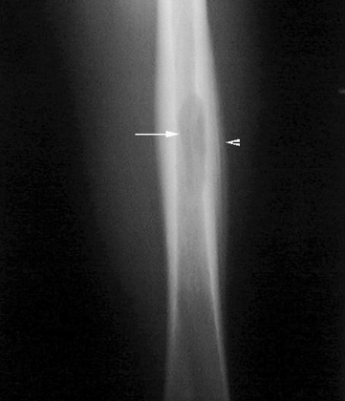
Diagnosis: increased ESR. X-ray shows area of bone destruction (unlike in osteosarcoma) in the mid-diaphysis associated with periosteal reaction extend along the shaft of the bone forming a fusiform swelling around the lesion called Onion-peel appearance.
CT and MRI used to stage the disease. Radioisotope scanning used to detect metastses.

Differential diagnosis: it should be distinguished from osteomyelitis, osteosarcoma, reticulum-cell sarcoma, and metastatic neuroblastoma by biopsy.

Treatment: the prognosis is poor.
Radiotherapy can decrease the size of tumour.
Chemotherapy is much more effective.
Surgery alone is not beneficial.
The best result is achieved by a combination of all 3 methods.

Multiple myeloma

Pathology: it is a malignant B-cell disorder of the bone marrow with predominant plasma cell. It leads to increased osteoclastic activity which lead to osteoporosis and multiple lytic lesions all over the skeleton (myelomatosis). Sometimes a large group of plasma cells aggregated to form a solitary tumour in one of the bones (plasmacytoma). Microscopically there are sheets of plasma cells.

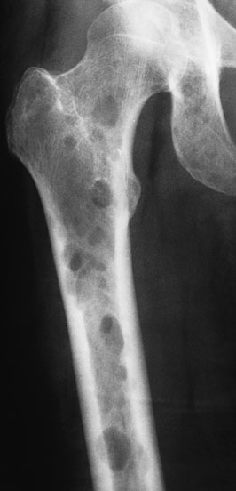
Clinical features: it affects 45-65 yrs old, weakness, backache, bone pain, or pathological fracture. Hypercalcaemia may cause thirst, polyuria, and abdominal pain.
Additional features are plasma proteins abnormalities, increased blood viscosity and anaemia.
Vertebral collapse may lead to spinal or root stenosis.

X-ray: generalized osteopenia, multiple punched-out defects in the skull, pelvis, and proximal femur, or compressed vertebrae.

Investigations: anaemia is common, very high ESR, hypercalcaemia, Bence-Jones proteins in the urine, and serum protein electrophoresis shows a characteristic abnormal M band. Bone biopsy shows plasmacytosis with typical myeloma cells.

Differential diagnosis: it should be differentiated from other causes of osteoporosis, and from metastatic bone disease.

Treatment: immediate treatment for pathological fractures, correction of fluid balance, and treatment of hypercalcaemia.
Long bone fractures are best treated by internal fixation with packing the cavities by bone cement, with preoperative antibiotics.
Vertebral compression fractures needs decompression and internal stabilization.
Chemotherapy like melphalan as specific treatment and corticosteroids for bone pain are used.

Secondary metastatic bone tumors

Secondary bone metastases are more common than primary malignant bone tumors in patients more than 50 years old. The commonest source is carcinoma of the breast, prostate, kidney, lung, thyroid, bladder, and gastrointestinal tract.
The commonest sites for bone metastases are the vertebrae, pelvis, the proximal half of the femur and humerus.

Pathology: metastatic tumors are usually osteolytic, and pathological fractures are common. Bone resorption is due to either to direct action of tumor cells or to tumor-derived factors that stimulate osteoclastic activity. Osteoblastic lesions are uncommon, usually occur in prostatic carcinoma.

Clinical features: the patient is usually aged 50-70 years. Any destructive bone lesion in this age group, the differential diagnosis must include metastasis. Pain is the commonest. The sudden appearance of backache or thigh pain in an elderly person is always suspicious.
Some deposits remain clinically silent and are discovered incidentally on X-ray or after a pathological fracture. Sudden collapse of a vertebral body or a fracture of the mid-shaft of a long bone in an elderly person is suspicious sign.
Symptoms of hypercalcaemia like anorexia, nausea, thirst, polyuria, abdominal pain, general weakness, and depression may appear.

Diagnosis:
On X-ray, skeletal deposits usually appear as osteolytic areas in the medulla or patches of bone destruction in the cortex. Osteoblastic deposits are seen in late cases of prostatic carcinoma.
Radioisotope scan is sensitive method of detecting 'silent' metastatic deposits in the bone.
The ESR is increased and the Hb is decreased, the serum alkaline phosphatase is increased, and in prostatic carcinoma the acid phosphatase is increased.

Treatment:
In those with multiple secondaries, treatment is entirely symptomatic. Occasionally, radical treatment by surgery and radiotherapy of a solitary secondary deposit and of its parent primary may be rewarding.
Control of pain: most patients require analgesics (sometimes narcotics), radiotherapy used both to control pain and to reduce metastatic growth, this combined with internal fixation.
Control of tumor: radiotherapy used to reduce metastatic growth, secondary deposits from breast or prostate can be controlled by hormonal therapy. Stilboestrol used for prostatic secondaries and androgenic drugs or oestrogens for breast carcinoma.
Control of hypercalcaemia: by adequate hydration, reducing the calcium intake and bisphosphonates.
Treatment of pathological fracture: shaft fractures should almost always be treated by internal fixation and packing with bone cement. In most cases, the intramedullary nailing is the most effective method. Postoperative irradiation is essential to prevent further extension of the metastatic lesion. Large deposits that threaten to result in fracture should be treated by internal fixation while the bone is still intact.
Vertebral fractures require posterior spinal fusion followed by radiotherapy with or without cord decompression.

