The Importance of Barriers to Infection and the Innate Response
First and foremost, in order for a pathogen to establish an infection in a susceptible host, it must breach physical and chemical barriers. In addition, normal commensal flora present at mucosal surfaces (the gastrointestinal, genitourinary, and respiratory tracts) can competitively inhibit the binding of pathogens to host cells.When pathogen dose and virulence are minimal, these barriers can often block productive infection altogether.
WHEN the basic human barriers to infection are breached (WHAT WILL HAPPEN?) more directed innate immune responses come into play at or near the site of infection.

Viral Infections
Viruses are small segments of nucleic acid with a protein or lipoprotein coat that require host resources for their replication. Typically, a virus enters a cell via a cell-surface receptor for which it has affinity and preempts cell biosynthetic machinery to replicate all components of itself, including its genome.
survival strategies available to viruses:
- A virus is more likely to thrive (to grow successfully) if it does not kill its host, as sustained coexistence تعايش in the host favors the survival and spread of the virus. However, the mutability of the viral genome sometimes gives rise to lethal variants that do not conform to this state of equilibrium with their host. If such mutants cause the early death of their host… what will happen ?, survival of the virus requires that it spread to new hosts rapidly.
- What are Among the other survival strategies available to viruses ? is a long latency period before severe illness, during which time the host may pass the virus to others unknowingly, as in the case of HIV.
- What other additional strategy used by viruses? is facile سهلة transmission, such as with influenza and the smallpox virus, where infection is efficiently transferred during even a short acute illness.
- The life cycle of some viruses pathogenic for humans, such as west nile virus WNV, may also include nonhuman hosts, providing them with additional reservoirs.
A number of specific immune effector mechanisms, together with nonspecific defense mechanisms, prevent or eliminate most viral infections.
The innate immune response to viral infection primarily begins with:
- The recognition of Pathogen Associated Molecular Patterns (PAMPs) and leads to the generation of antiviral effectors. For example, Double- Stranded RNA (dsRNA) molecules and other virus-specific structures are detected by one of several PAMP receptors
- inducing the expression of type I interferons (IFN-α and IFN- β )leads to the assembly of intracellular inflammasome complexes,
- and the activation of NK cells.
HOW ? Type I interferons can induce an antiviral response or resistance to viral replication by :
- binding to the IFN-α / β receptor, thereby activating the pathway that encodes an enzyme leads to viral RNA degradation.
- IFN-α /β binding also induces ds RNA-dependent Protein Kinase (PKR), leads to inactivation of protein synthesis, thus blocking viral replication in infected cells.
- The binding of type I interferon to NK cells induces lytic activity, making them very effective in killing virally infected cells.
Many Viruses Are Neutralized by Antibodies
Antibodies specific for viral surface antigens are often crucial in (1) containing the spread of a virus during acute infection and in (2) protecting against reinfection.

Antibodies are particularly effective in:
- interfering with their ability to attach to host cells.For example,influenza virus binds to sialic acid residues in cell membrane glycoproteins and glycolipids of target cells and Epstein- Barr Virus (EBV) binds to type 2 complement receptors on B cells.
- antibodies may block viral penetration by binding to epitopes that are necessary to mediate fusion of the viral envelope with the plasma membrane and if the induced antibody is of a complement-activating isotype → lysis of enveloped virions can ensue.
- Antibody or complement can also agglutinate viral particles and function as an opsonizing agent to facilitate Fc or C3b-receptor-mediated phagocytosis of the free virions.
Cell-Mediated Immunity Is Important for Viral Control and Clearance
Although antibodies have an important role in containing the spread of a virus in the acute phases of infection, they cannot eliminate established infection once the viral genome is integrated into host chromosomal DNA. SO [Once such an infection is established, cell-mediated immune mechanisms are most important in host defense].
In general, both CD8+TC cells and CD4+T H 1 cells are required components of the cell-mediated antiviral defense. HOW??
Activated T H 1 cells produce a number of cytokines, including IL-2, IFN-γ , and (TNF-α), which defend against viruses either directly or indirectly.
(1) directly by inducing an antiviral state in nearby cells during the first days of many viral infections, until a specific CTL response develops.
(2) IL-2 acts indirectly by assisting the development of Cytotoxic T lymphocyte (CTL) precursors into an effector population arises within 3 to 4 days after infection, peaks by 7 to 10 days, and then declines. Within 7 to 10 days of primary infection, most virions have been eliminated, paralleling the development of CTLs. CTLs specific for the virus eliminate virus-infected self cells and thus eliminate potential sources of new virus.
Viruses Employ Several Different Strategies to Evade Host Defense Mechanisms

- Some viruses have developed strategies to evade the action of IFN-α/β, these include hepatitis C virus, block or inhibit the action of Protein Kinase R(PKR).
- Inhibition of antigen presentation by infected host cells.
- Herpes Simplex Virus (HSV) produces an immediate-early protein (synthesized shortly after viral replication) that very effectively inhibits the human transporter molecule needed for antigen processing (TAP) blocks antigen delivery to class I MHC molecules in HSV-infected cells, thus preventing presentation of viral antigen to CD8 T cells.
- Other viruses, such as measles virus and HIV, reduce levels of class II MHC molecules on the surface, thus blocking the function of antigen-specific antiviral helper T cells.
- Evade complement mediated destruction
- A number of viruses, such as vaccinia virus, evade complement mediated destruction by secreting a protein that binds to the C4b complement component, inhibiting the classical complement pathway.
- Herpes simplex v.HSV also makes a glycoprotein component that binds to the C3b complement component, inhibiting both the classical and alternative pathways.
- A number of viruses escape immune attack by constantly changing their surface antigens like influenza virus is a prime example and HIV the causative agent of AIDS.
- Viruses such as Epstein- Barr Virus EBV, cytomegalo v. CMV, and HIV cause generalized or specific immunosuppression.
- Either by direct viral infection of lymphocytes or macrophages.(HIV)
- In other cases, immunosuppression is the result of a cytokine imbalance or diversion of the immune responses toward pathways less effective at virus eradication. For instance, EBV, the cause of mononucleosis, produces a protein that is homologous to IL-10 this protein suppresses cytokine production by the T H 1 subset, resulting in an immunosuppressed state.

Bacterial Infections
- Immunity to bacterial infections is achieved by means of antibody unless the bacterium is capable of intracellular growth, in which case delayed- type hypersensitivity (DTH) has an important role.
- Bacteria enter the body either through a number of natural routes (e.g., the respiratory, gastrointestinal, and genitourinary tracts) or through normally inaccessible routes opened up by breaks in mucous membranes or skin.
- Depending on the number of organisms entering and their virulence, different levels of host defense are enlisted.
- In some bacterial infections, disease symptoms are caused not by the pathogen itself but by the immune response. Pathogen-stimulated overproduction of cytokines leads to the symptoms associated with bacterial septic shock, food poisoning, and toxic shock syndrome.

Immune Responses to Extracellular and Intracellular Bacteria
Infection by extracellular bacteria induces production of antibodies, which are ordinarily secreted by plasma cells in regional lymph nodes and the submucosa of the respiratory and gastrointestinal tracts. The humoral immune response is the main protective response against extracellular bacteria.HOW ?
- including removal of the bacteria and
- inactivation of bacterial toxins.
Extracellular bacteria can be pathogenic because they (1) induce a localized inflammatory response or (2) because they produce toxins.

Mechanisms
- Antibody that binds to antigens on the surface of a bacterium can, together with the C3b component of complement, act as an opsonin that increases phagocytosis and thus clearance of the bacterium.
- In the case of gram-negative organisms, complement activation can lead directly to lysis of the organism.
- Antibody mediated activation of the complement system can also induce localized production of immune effector C3a and C5a act as anaphylatoxins, inducing local mast-cell degranulation and thus vasodilation and the extravasation of lymphocytes and neutrophils from the blood into tissue spaces.
- Antibody to a bacterial toxin may bind to the toxin and neutralize it; the antibody-toxin complexes are then cleared by phagocytic cells in the same manner as any other antigen-antibody complex.
Infection by intracellular bacterial pathogens,
- intracellular bacteria can activate NK cells, which in turn provide an early defense against these organisms.
- Intracellular bacterial infections tend to induce a cell-mediated immune response, specifically DTH.
- In this response, cytokines secreted by CD4+T cells are important—most notably IFN-γ, which activates macrophages to kill ingested pathogens more effectively.
Bacteria Can Evade Host Defense Mechanisms at Several Different Stages
There are four primary steps in bacterial infection:
1. Attachment to host cells
2. Proliferation
3. Invasion of host tissue
4. Toxin-induced damage to host cells
Host-defense mechanisms act at each of these steps, and many bacteria have evolved ways to circumvent some of them.
- Some bacteria express molecules that enhance their ability to attach to host cells.
- A number of gram-negative bacteria, for example,
- pili, which enable them to attach to the membrane of the intestinal or genitourinary tract.
- Other bacteria, such as Bordetella pertussis , the cause of whooping cough, secrete adhesion molecules that attach to both the bacterium and the ciliated epithelial cells of the upper respiratory tract.
- Secretory IgA antibodies specific for such bacterial structures can block bacterial attachment to mucosal epithelial cells and are the main host defense against bacterial attachment.However,
- some bacteria, such as the species of Neisseria that cause gonorrhea and meningitis, evade the IgA response by secreting proteases that cleave secretory IgA at the hinge region so become not able to agglutinate microorganisms.
- Some bacteria evade the antibody responses of the host by changing their surface antigens. In Neisseria gonorrhoeae , for example, pilin (the protein component of the pili) has a highly variable structure. This process generates enormous antigenic variation avoid neutralization by IgA.
- Proliferation
- Bacteria may also possess surface structures (that inhibit phagocytosis).
- A classic example is Streptococcus pneumoniae , whose polysaccharide capsule prevents phagocytosis very effectively.
- On other bacteria, such as Streptococcus pyogenes , a surface protein projection called the M protein inhibits phagocytosis, a key step in bacterial removal.
- Mechanisms for interfering with the complement system help other bacteria survive. In some gram-negative bacteria, for example,
- long side chains on the lipid A of the cell wall core polysaccharide help to resist complement mediated lysis.
- A number of bacteria escape host-defense mechanisms through their ability to survive within phagocytic cells.
- members of the Mycobacterium genus , block lysosomal fusion with the phagolysosome or resist the oxidative attack that typically takes place within the phagolysosome.
- Invation of the host tissue
- Pseudomonas secretes an enzyme, elastase, that inactivates both the C3a and C5a anaphylatoxins, thereby diminishing the localized inflammatory reaction.
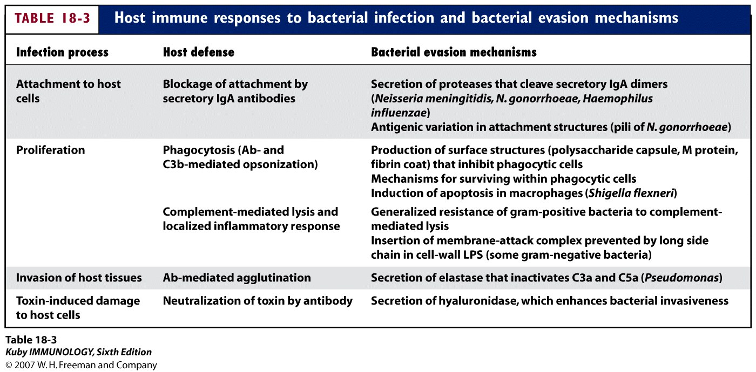

Parasitic Infections
The term parasite encompasses a vast number of protozoan and helminthic organisms (worms). The diversity of the parasitic universe makes it difficult to generalize, but a major difference between these types of parasites is that : [the protozoans are unicellular eukaryotes that usually live and multiply within host cells for at least part of their life cycle, whereas helminths are multicellular organisms that can be quite large and have the ability to live and reproduce outside their human host].
Protozoan infection
The type and effectiveness of immune response to protozoan infection depends in part on:
- the location of the parasite within the host and
- the life cycle stage of the parasite. Many protozoans spend part of their time free within the bloodstream; humoral antibody is most effective during these stages. At other stages they may grow intracellularly, making cell-mediated immune reactions the most effective host defense.

The principal innate immune response to protozoa
immune response to protozoa by phagocytosis, but many of these parasites are resistant to phagocytic killing and may even replicate within macrophages.
Some protozoa express surface molecules that are recognized by TLRs and activate
phagocytes. Plasmodium species (the protozoa that are responsible for malaria), Toxoplasma gondii (the agent that causes toxoplasmosis), all express glycosyl phosphatidylinositol lipids that can activate TLR2 and TLR4.

Adaptive Immunity to protozoa
Some pathogenic protozoa have evolved to survive within host cells, so protective immunity against these organisms is mediated by mechanisms similar to those that eliminate intracellular bacteria and viruses.

- The principal defense mechanism against protozoa that survive within macrophages is cell-mediated immunity, particularly macrophage activation by TH1 cell–derived cytokines. Leishmania a protozoan that survives within the endosomes of macrophages, is the best documented example of how dominance of TH1 or TH2 responses determines disease resistance or susceptibility. Resistance to the infection is associated with activation of Leishmania specific CD4+ TH1 cells, which produce IFN-γ and thereby activate macrophages to destroy intracellular parasites.
- Conversely, activation of TH2 cells by the protozoa results in increased parasite survival and exacerbation of lesions because of the macrophage-suppressive actions of TH2 cytokines.
- Protozoa that replicate inside various host cells and lyse these cells stimulate specific antibody and CTL responses, similar to cytopathic viruses. An example of such an organism is the malaria parasite, which resides mainly in red blood cells and in hepatocytes during its life cycle.

A number of factors may contribute to low levels of immune response to Plasmodium :
- The maturational changes allow the organism to keep changing its surface molecules, resulting in continual changes in the antigens seen by the immune system.
- The intracellular phases of the life cycle reduce the degree of immune activation generated by the pathogen and allow the organism to multiply shielded from attack.
- The most accessible stage, the sporozoite, circulates in the blood for such a short time before infecting hepatocytes (approx. 30 minutes) that effective immune activation is unlikely to occur.
- Even when an antibody response does develop to sporozoites, Plasmodium overcomes that response by sloughing off the surface antigens, thus rendering the antibodies ineffective.
Helminths infection
Parasitic worms, or helminths, are responsible for a wide variety of diseases in humans and animals. The adult forms are large, multicellular organisms that can often be seen with the naked eye. Most enter their animal hosts through the intestinal tract; helminth eggs can contaminate food, water, feces, and soil.

Although helminths are exclusively extracellular and therefore more accessible to the immune system than protozoans, [most infected individuals carry few parasites. Unlike protozoan parasites, helminths do not multiply within their hosts. Thus, the immune response is not strongly engaged, and the level of immunity generated can be very poor].
Phagocytes may attack helminthic parasites and secrete microbicidal substances to kill organisms that are too large to be phagocytosed. However, many helminths have thick teguments that make them resistant to the cytocidal mechanisms of neutrophils and macrophages, and they are too large to be ingested by phagocytes.
Defense against many helminthic infections is mediated by the activation of TH2 cells, which results in production of IgE antibodies and activation of eosinophils.
TH2 subset of effector cells, secrete IL-4 and IL-5. IL-4 stimulates the production of IgE, which binds to the Fcε receptor of eosinophils and mast cells, and IL-5 stimulates the development of eosinophils and activates eosinophils to release their granule contents, which destroy the helminths.
The combined actions of mast cells and eosinophils also contribute to expulsion of the parasites from the intestine due to IL-4–dependent mechanisms that do not require IgE, such as increased peristalsis.
Adaptive immune responses to parasites can also contribute to tissue injury. Some parasites and their products by induction of granulomatous responses with concomitant fibrosis.Schistosoma mansoni eggs deposited in the liver stimulate CD4+ T cells, which in turn activate macrophages and induce DTH reactions result in the formation of granulomas around the eggs. Such TH2-induced granulomas serve to contain the schistosome eggs, but severe fibrosis associated with this chronic cell-mediated immune response leads to cirrhosis, disruption of venous blood flow in the liver, and portal hypertension.
In lymphatic filariasis, lodging of the parasites in lymphatic vessels leads to chronic cell mediated immune reactions and ultimately to fibrosis. This results in lymphatic obstruction and severe lymphedema.
Chronic and persistent parasitic infestations are often associated with the formation of complexes of parasite antigens and specific antibodies which can be deposited in blood vessels and kidney glomeruli and produce vasculitis and nephritis, Immune complex disease is a complication of schistosomiasis and malaria.

Adult schistosome worms have several unique mechanisms that protect them from immune defenses. These include
- decreasing the expression of antigens on their outer membrane and enclosing themselves in a glycolipid-and-glycoprotein coat derived from the host, masking the presence of their own antigens. Among the antigens observed on the adult worm are the host’s own ABO blood-group and histocompatibility antigens! The immune response is, of course, diminished by this covering made of the host’s self antigens, which must contribute to the lifelong persistence of these organisms.

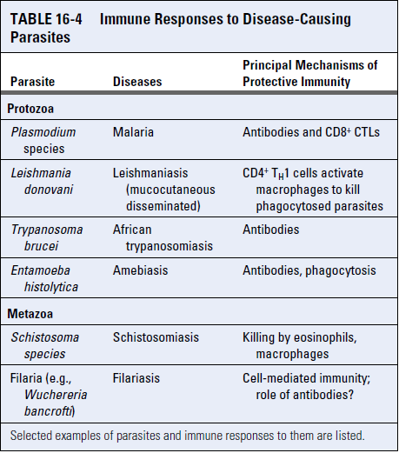

Fungal Infections
Fungal infections may result from introduction of exogenous organisms due to injury or inhalation, or from endogenous organisms such as the commensals present in the gut and on the skin.
Fungal diseases, or mycoses , are classified based on the following criteria:
• Site of infection—superficial, cutaneous, subcutaneous, or deep and systemic
• Route of acquisition—exogenous or endogenous
• Virulence—primary or opportunistic
These categories are not mutually exclusive. For example, an infection such as coccidiomycosis may progress from a cutaneous lesion to a systemic infection of the lungs.
- Cutaneous infections include attacks on skin, hair, and nails; example athlete’s foot.
- Subcutaneous infections are normally introduced by trauma and accompanied by inflammation
- Deep mycoses involve the lungs, the central nervous system, bones, and the abdominal viscera. These infections can occur through ingestion, inhalation, or inoculation into the bloodstream.
Virulence can be divided into
- primary, indicating the rare agents with high pathogenicity, and
- opportunistic, denoting weakly virulent agents that primarily infect individuals with compromised immunity.
Most fungal infections of healthy individuals are resolved rapidly, with few clinical signs. A predisposing conditions that contributed to mycotic infections include AIDS, immunosuppressive drug treatment, and malnutrition.

Innate Immunity controls Most Fungal Infections
- The barriers of innate immunity control most fungi.
- Commensal organisms also help control the growth of potential pathogens, as demonstrated by long-term treatment with broad-spectrum antibiotics, which destroy normal mucosal bacterial flora and often lead to oral or vulvovaginal infection with Candida albicans , an opportunistic agent.
- Phagocytosis by neutrophils is a strong defense against most fungi, and so people with neutropenia (low neutrophil count) are generally more susceptible to fungal disease.
- Resolution of infection in normal, healthy individuals is often rapid and initiated by recognition of common fungal cell wall(β-glucans, mannans and chitin) PAMPs.

Adaptive Immunity against Fungal Pathogens
- Strong T H 1 responses and the production of IFN-γ , important for optimal macrophage activation, are most commonly associated with protection against fungi.
- A regulatory role for T H 17 cells in controlling adaptive immunity against fungi these cells are hypothesized to help support T H 1- and discourage T H 2-cell activation. Many extracellular fungi elicit strong TH17 responses, which are driven in part by the activation of dendritic cells by fungal glucans binding to dectin-1, a receptor for this fungal polysaccharide lead to produce TH17-inducing cytokines, such as IL-6 and IL-23 stimulate inflammation, and the recruited neutrophils and monocytes destroy the fungi.
- TH1 responses are protective in intracellular fungal infections, such as histoplasmosis, but these responses may elicit granulomatous inflammation, which is an important cause of host tissue injury in these infections.
- Fungi also elicit specific antibody responses that may be of protective value.

Like other microbes, fungi have evolved mechanisms to evade the innate immune response.:
- These include production of a capsule which blocks PRR binding.
- Another evasion strategy employed by this organism involves fungi-induced expulsion عمليّة طرد from macrophages that does not kill host cells and therefore avoids inflammation.

