University of Mustansiriya Dr.Shatha AL-Khateeb
College of Medicine Lec.12(1-8)
Medical Biochemistry Dept. 2017-2018

Vitamin B₁₂, also called cobalamin, is a water soluble vitamin with a key role in the normal functioning of the brain and nervous system, and for the formation of blood. It is one of the eight B vitamins.
It is normally involved in the metabolism of every cell of the human body, especially affecting DNA synthesis and regulation, but also fatty acid synthesis and energy production. As the largest and most structurally complicated vitamin, it can be produced industrially only through bacterial fermentation-synthesis.
Vitamin B₁₂ consists of a class of chemically-related compounds (vitamers), all of which have vitamin activity. It contains the biochemically rare element cobalt. Biosynthesis of the basic structure of the vitamin in nature is only accomplished by simple organisms such as some bacteria and algae, but conversion between different forms of the vitamin can be accomplished in the human body. A common synthetic form of the vitamin, cyanocobalamin, does not occur in nature, but is used in many pharmaceuticals and supplements, and as a food additive, because of its stability and lower cost.
Vitamin B₁₂ is a collection of cobalt and corrin ring molecules which are defined by their particular vitamin function in the body. All of the substrate cobalt-corrin molecules from which B₁₂ is made must be synthesized by bacteria. However, after this synthesis is complete, the body has a limited power to convert any form of B₁₂ to another, by means of enzymatically removing certain prosthetic chemical groups from the cobalt atom. The various forms (vitamers) of B₁₂ are all deeply red colored, due to the color of the cobalt-corrin complex.

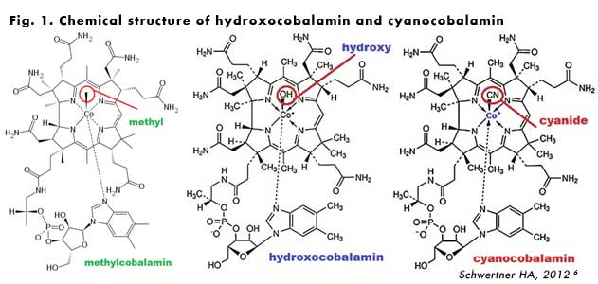
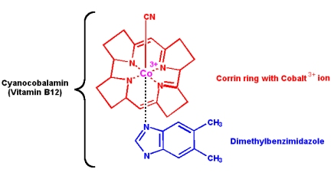
Vitamin B₁₂ was discovered from its relationship to the disease pernicious anemia, which is an autoimmune disease in which parietal cells of the stomach responsible for secreting intrinsic factor are destroyed. Intrinsic factor is crucial for the normal absorption of B₁₂, so a lack of intrinsic factor, as seen in pernicious anemia, causes a vitamin B₁₂ deficiency.

Medical uses
Vitamin B₁₂, is used to treat vitamin B₁₂ deficiency, cyanide poisoning, and hereditary deficiency of transcobalamin II. It is also given as part of the schilling test for detecting pernicious anemia.
For cyanide poisoning, large amount may be given intravenously, and sometimes in combination with sodium thiosulfate. The mechanism of action is straightforward:

the hydroxycobalamin hydroxide ligand is displaced by the toxic cyanide ion, and the resulting harmless B₁₂ complex is excreted in urine.
High vitamin B₁₂ level in elderly individuals may protect against brain atrophy or shrinkage, associated with Alzheimer's disease and impaired cognitive function.

Structure
Vitamin B₁₂ is a collection of cobalt and corrin ring molecules,B₁₂ is the most chemically complex of all the vitamins.
The structure of B₁₂ is based on a corrin ring, which is similar to the porphyrin ring found in heme, chlorophyll, and cytochrome. The central metal ion is cobalt.
Four of the six coordination sites are provided by the corrin ring, and a fifth by a dimethylbenzimidazole group. The sixth coordination site, the center of reactivity, is variable, being a cyano group (-CN), a hydroxyl group (-OH), a methyl group (-CH₃) or a 5'-deoxyadenosyl group (here the C5' atom of the deoxyribose forms the covalent bond with Co), respectively.
Cyanocobalamin is one such "vitamer" in this B complex, the cyanocobalamin form of B₁₂ is easy to crystallize and is not sensitive to air-oxidation; it is typically used as a form of B₁₂ for food additives and in many common multivitamins.
All cyanocobalamin is vitamin B₁₂, but not all vitamin B₁₂ is cyanocobalamin. Pure cyanocoblamin possesses the deep pink colour associated with most octahedral cobalt(II) complexes and the crystals are well formed and easily grown up to milimetre size.
Hydroxocobalamin is another form of B₁₂ commonly encountered in pharmacology, but which is not normally present in the human body. Hydroxocobalamin is sometimes denonoted B_{12a} . It is supplied typically in water solution for injection. Hydroxocobalamin is thought to be converted to the active enzymic forms of B₁₂ more easily than cyanocobalamin.
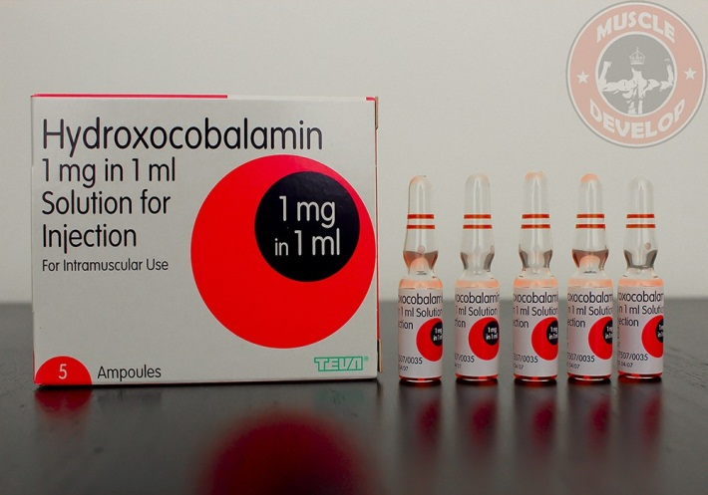
Hydroxycobalamine (B12a) is superior as:

1-It is more active in enzyme systems.

2-It is retained longer in the body when given orally.

Hence,B12a is more useful for theraptic administration of B 12a by mouth.

Metabolism

Absorption

Vitamin B12 is absorbed from ileum,for its proper absorption it requires:

Presence of HCL, and Intrinsic factor(IF) of Castle, a constituent of normal gastric juice.

Mechanism of absorption, it has been shown that two binding proteins are required:

Cobalophilin: a binding protein secreted in the saliva.

Intrinsic factor(IF) : a glycoprotein secreted by parietal cells of gastric mucosa.

1-Gastric acid (HCL) and pepsin release the Vit B12 from protein binding in food and make it available to bind to salivary protein, cobalophilin.

2-In the duodenum, cobalophilin is hydrolyzed, releasing the vitamin for binding to Intrinsic factor (IF).

3-Vitamin B12 is absorbed from the distal third of the ileum via specific binding site (receptors) that binds the B12-IF complex.

The removal of B12 from intrinsic factor (IF) in presence of Ca++ ions and a releasing factor(RF) secreted by duodenum take place and B12 enters the ileal mucosal cells for absorption into the circulation.

If ileal absorptive mechanism is functioning, it can adequately transport 0.5 to 10.0 µg of B12, small amount (1-3%) may be absorbed by simple diffusion.

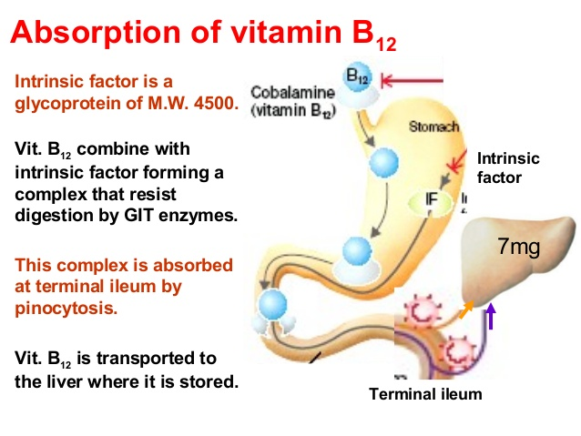
In supplements, B12 is not bound to protein, and therefore does not need digestive enzymes or stomach acid to be detached from a protein. Stomach acid is needed to dissolve some B12 tablets, especially if not chewed. When taken in large enough doses, unbound B12 can overcome intrinsic factor defects because so much can be absorbed through passive diffusion.
There is some preliminary evidence that unbound B12, especially when combined with an absorption enhancer, can be directly absorbed through the membranes under the tongue at higher rates than through passive diffusion in the digestive tract.

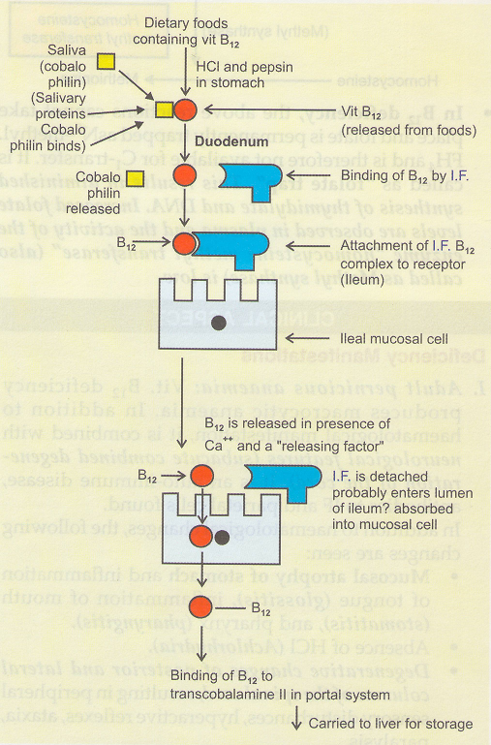

Transport in blood

Vitamin B12 is transported in blood in association with specific proteins named Transcobalamine I and Transcobalamine II and III.

Physiologically Transcobalamine II is more important.
After B12 is absorbed into the intestinal cells, it attaches to transcobalamin II (TC2). Transcobalamin II is made in the intestinal cells , where it picks up B12 and transports it to all body tissues through the blood and cerebrospinal fluid . Cyanocobalamin appears in the blood no longer than 5 hours after ingestion of B12.
While transcobalamin II transports B12 to cells, about 3/4 of the B12 in the blood is stored on haptocorrin (aka transcobalamin I and cobalophilin).
Once the B12-TC2 complex arrives at the cell where it is needed, B12 is released from TC2 in the form of hydroxocobalamin. It is then turned into methylcobalamin or adenosylcobalamin and used for their respective enzymes.
Transcobalamin II also transports B12 to the liver for storage on transcobalamin III.
If the circulating B12 exceeds the binding capacity of the blood, the excess is excreted in the urine. This normally happens only after a B12 injection.

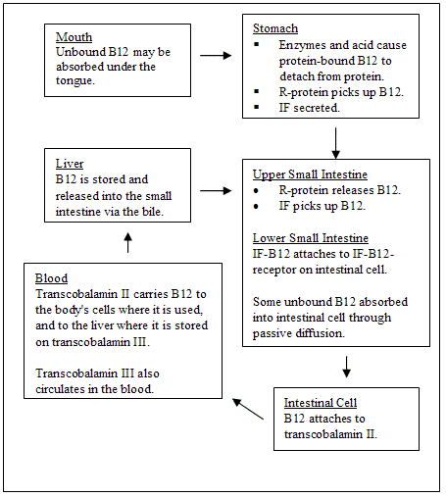

Biological Active Forms of B12

Biologically active forms are cobamide coenzymes act as coenzyme with various enzymes.

Cobamide coenzyme does not contain the cyano group attached to cobalt but instead there is an Adenine Nuceoside (5´-deoxyadenosine) which is linked to cobalt by a C→CO bond.

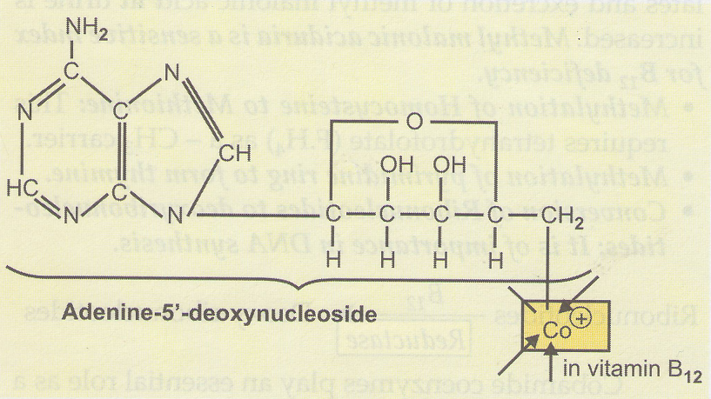
Vitamin B₁₂ is normally involved in the metabolism of every cell of the body, especially affecting the DNA synthesis and regulation but also fatty acid synthesis and energy production. However, many (not all) of the effects of functions of B₁₂ can be replaced by sufficient quantities of folic acid (vitamin B₉), since B₁₂ is used to regenerate folate in the body.

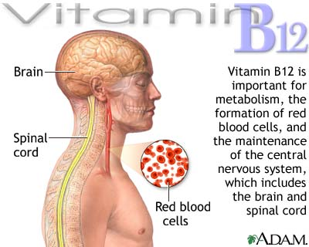

Deficiency
May be due to dietary factors, gastric factors as in post gastrostomy and in strict vegetarians.If absorption is prevented by lack of intrinsic factor it will cause pernicious anemia. Megaloblastic anemia appears due to B₁₂ deficiency.
Vitamin deficiencies often go unnoticed until they are severe mostly because the symptoms overlap with many other diseases. Diagnosis of vitamin B12 deficiency is typically based on measurement of serum vitamin B12 levels.
Vitamin B12 deficiency can lead to a multitude of symptoms based on the degree of deficiency. The symptoms are mild to start with but can progressively worsen if the deficiency is not addressed with oral or sub-muscular replenishment of Vitamin B12.
Clinical Symptoms of vitamin B ₁₂ deficiency:
1-Cardiovascular- increased risk of stroke or heart attack.
2-Psychiatric- a- Irratability and overall personality change.
b-Mild memory impairment,,occasional dementia.
c-Psyhosis.
d-Depression.
3-Hematologic- a-Megaloblastic anemia.
b-Pancytopenia.
Symptoms
Anemia as result from impaired DNA synthesis affecting the formation of the nucleus of new erythrocytes.
Homocystinuria and methylmalonic aciduria occur.
Neurological disorder is secondary to a relative deficiency of Methionine.

