University of Mustansiriya Dr.Shatha AL-Khateeb
College of Medicine Lec.10(1-8)
Medical Biochemistry Dept. 2017-2018

Vitamin B6
Vitamin B₆ is a water-soluble vitamin and is part of the vitamin B complex group. Several forms of the vitamin are known, but pyridoxal phosphate (PLP) is the active form and is a cofactor in many reactions of amino acid metabolism, including transamination, deamination, and decarboxylation. PLP also is necessary for the enzymatic reaction governing the release of glucose from glycogen.
Vitamin B₆ ,consists of a mixture of three different closely related pyridine derivatives:
* Pyridoxine , Pyridoxal and Pyridoxamine.(all of them have equal vitamin activity).
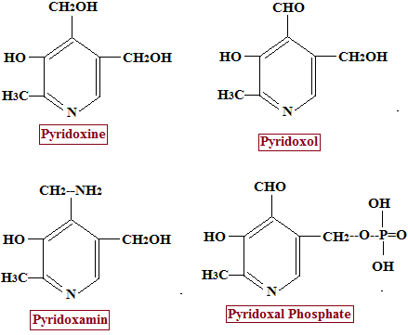

The biological active forms of the vitamin are the phosphorylated derivatives: (Pyridoxal-PO4 and Pyridoxamine-PO4)
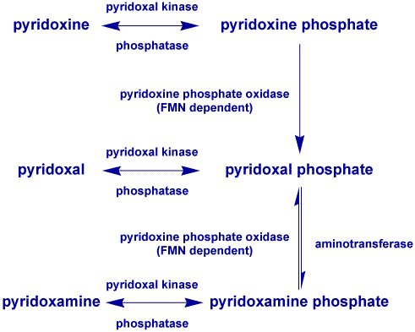

Formation of pyridoxal-P:

Phosphorylation takes place in Liver, Brain, and other tissues with the help of ATP, Zn++, and an enzyme Pyridoxal Kinase. Two pathways shown:

Pyridoxine to Pyridoxal-P.

b- Alternatively, Pyridoxine first undergoes phosphorylation with the help of ATP-dependent Kinase to produce pyridoxal-P and then oxidized by FP-dehydrogenase.

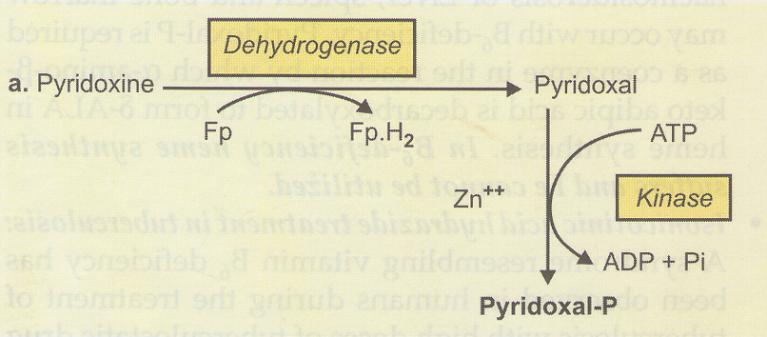

Metabolism

Absorption

Dietary vitamin B6 is ready to absorption by the intestine.

Before absorption, a phosphate group must be removed, allowing B6 to be a free molecule. Then, the vitamin is absorbed from the intestine into the blood without the need of energy. This process is called passive diffusion. Once in the blood, vitamin B6 can function and promote health.
Vitamin B₆ is absorbed in the jejunum and ileum via passive diffusion. The absorption of pyridoxal phosphate and pyridoxamine phosphate involves their dephosphorylation catalyzed by a membrane-bound alkaline phosphatase. Those products and non-phosphorylated vitamers in the digestive tract are absorbed by diffusion, which is driven by trapping of the vitamin as 5'-phosphates through the action of phosphorylation (by a pyridoxal kinase) in the jejunal mucosa. The trapped pyridoxine and pyridoxamine are oxidized to pyridoxal phosphate in the tissue.

Major urinary metabolite, about 3 mg daily is the biologically inactive form 4-pyridoxic acid.
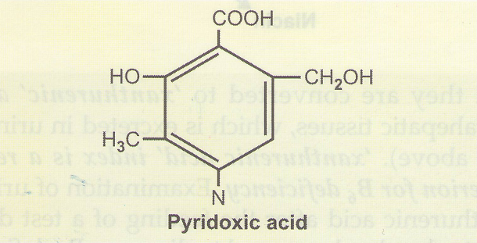
The products of vitamin B₆ metabolism are excreted in the urine; the major product of which is 4-pyridoxic acid. It has been estimated that 40-60% of ingested vitamin B₆ is oxidized to 4-pyridoxic acid.
The (4-pyridoxic acid) is undetectable in the urine of vitamin B₆ deficient subjects, making it a useful clinical marker to assess the vitamin B₆ status of an individual. Other products of vitamin B₆ metabolism that are excreted in the urine when high doses of the vitamin have been given include pyridoxal, pyridoxamine, and pyridoxine and their phosphates. A small amount of vitamin B₆ is also excreted in the feces.

Food sources
Vitamin B₆ is widely distributed in foods in both its free and bound forms. Good sources include meats, whole grain products, vegetables, nuts and bananas.
Cooking, storage and processing losses of vitamin B₆ vary and in some foods may be more than 50%, depending on the form of vitamin present in the food. Plant foods lose the least during processing, as they contain mostly pyridoxine, which is far more stable than the pyridoxal or pyridoxamine found in animal foods. For example, milk can lose 30-70% of its vitamin B₆ content when dried. Vitamin B₆ is found in the germ and milling results in the reduction of this vitamin in white flour. Freezing and canning are other food processing methods that result in the loss of vitamin B₆ in foods.
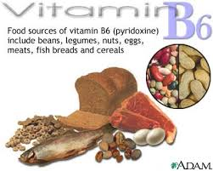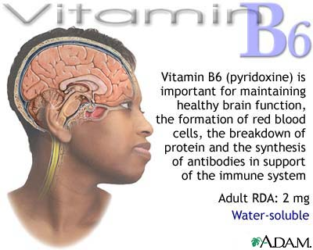
Functions
Pyridoxal phosphate, the metabolically active form of vitamin B₆, the liver is the site for vitamin B₆ metabolism.
The primary role of vitamin B₆ is to act as a coenzyme to many other enzymes in the body that are involved predominantly in metabolism. This role is performed by the active form, pyridoxal phosphate.
This vitamin is involved in 5 broad categories of reactions:
1) Protein, carbohydrate, and fat synthesis and breakdown.
2) The synthesis of neurotransmitters (which are important for nerve function).
3) The synthesis of histamine (which is involved in the allergic immune response).
4) Hemoglobin synthesis and function (which carries oxygen to tissues and carbon dioxide to the lungs).
5) Gene expression (which involves which proteins are made in the body).

Deficiencies
Weakness, Sleeplessness, Peripheral neuropathy, Personality changes, Dermatitis, and Glossitis.

Clinical assessment of vitamin B₆
The biochemical assessment of vitamin B₆ status is essential, as the clinical signs and symptoms of its deficiency are very nonspecific. The three biochemical tests most widely used are:
1-The activation coefficient for the erythrocyte enzyme aspartate aminotransferase.
2-Plasma pyridoxal phosphate (PLP) concentrations.
3-The urinary excretion of vitamin B₆ degradation products, specifically urinary pyridoxic acid.
Of these, plasma PLP is probably the best single measure, because it reflects tissue stores. When plasma pyridoxal phosphate is less than 10nmol/L, it is indicative of vitamin B₆ deficiency. Urinary 4-pyridoxic acid is also an indicator of vitamin B₆ deficiency; a level of less than 3.0 mmol/day is suggestive of vitamin B₆ deficiency.
Toxicity
Adverse effects have only been documented from vitamin B₆ supplements and never from food sources.
The primary symptoms are pain and numbness of the extremities, and in severe cases, difficulty walking. Sensory neuropathy typically develops at doses of pyridoxine in excess of 1,000 mg per day. However, a few individuals who developed sensory neuropathies at doses of less than 500 mg daily over a period of months have been reported. This condition is usually reversible when supplementation is stopped.

Vitamin B7
Vitamin B₇ (D-(+)-Biotin) , also known as vitamin H , is a water-soluble B-vitamin ,it is also a nutrient that helps us keep a young, attractive appearance since it plays a major part in maintaining the health of our hair, nails and skin (also known as the ‘beauty vitamin’ ).
In fact, biotin sometimes gets the nickname the “H” vitamin, which stems from the German words Haar andHaut that mean “hair and skin.” , therefore it is commonly added to hair and skin beauty products, although it’s believed that it is not be absorbed very well through the skin and actually must be ingested to be fully beneficial.
Biotin has an unusual structure, with two rings fused together via one of their sides. The two rings are ureido and thiophene moieties. Biotin is a heterocyclic, S-containing monocarboxylic acid. It is made from two precursors, alanine and pimeloyl-CoA.
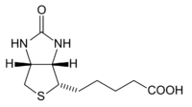
Functions:
- As a coenzyme for carboxylase enzymes:
- Acetyl coenzyme A carboxylase.
- Pyruvate carboxylase.
- Methylcrotonyl CoA carboxylase.
- Propionyl CoA carboxylase.
- Involved in the synthesis of:
1-Fatty acids.
2-Amino acids.
- Essential in many pathways for normal macronutrient , and energy yielding metabolism.
- Improve keratin ( a protein that makes up hair,nail and skin) in the body.
- Normal function of the nervous system , and psychological functions.

Sources of biotin
Biotin is consumed from a wide range of food sources in the diet, but few are particularly rich sources. Foods with relatively high biotin content include
Egg yolk (raw),egg white reduces egg yolk's biotin effectiveness in the body. People who consume just egg white for many years without biotin supplementation have a slight risk of not getting enough vitamin B7.
Liver, Peanuts,Yeast,Bread, whole-wheat,Cheese, cheddar,Pork,Salmon,Avocado,Raspberries and Cauliflower (raw).
Biotin is also available in supplement form and can be found in most pharmacies.
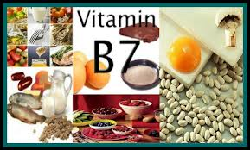

Cofactor biochemistry
D-(+)-Biotin is a cofactor responsible for carbon dioxide transfer in several carboxylase enzymes:
- Acetyl-CoA carboxylase alpha.
- Acetyl-CoA carboxylase beta.
- Methylcrotonyl-CoA carboxylase.
- Propionyl-CoA carboxylase.
- Pyruvate carboxylase.
Biotin is a coenzyme in the metabolism of fatty acids (types of molecules found in fats and oils), leucine (an essential amino acid humans cannot synthesize), and gluconeogenesis (synthesis of glucose from molecules that are not carbohydrates, e.g. amino and fatty acids). A coenzyme is a substance that enhances an enzyme's action. Coenzymes cannot themselves trigger or speed up a biological reaction, but they help enzymes do so.
Biotin plays a vital role in:
- Helping the body metabolize proteins, fats and carbohydrates.
- Helping the body process glucose.

It also contributes towards healthy nails, skin and hair. It is therefore found in many cosmetic and health products for the skin and hair.
Deficiency
Biotin deficiency is relatively rare and mild, and can be addressed with supplementation. Such deficiency can be caused by the consumption of raw egg whites (eating two or more uncooked egg whites daily for several months has caused biotin deficiency that is serious enough to produce symptoms), which contain high levels of the protein avidin, which binds biotin strongly.
Symptoms include hair loss, dry scaly skin, cracking in the corners of the mouth, swollen and painful tongue, dry eyes, loss of appetite, fatigue, insomnia, and depression, numbness and tingling of the extremities.
People who are at an increased risk for vitamin B7 biotin deficiency include those with the following:
- long-term use of certain anti-seizure medications
- prolonged antibiotic use
- intestinal malabsorption issues or serious digestive disorders like Chron’s disease, celiac disease, or leaky gut syndrome.
There isn’t a good laboratory test for detecting biotin deficiency, so this condition is usually identified by its symptoms.

Requirement increase in:

1-Pregnancy and Lactation.

2-Oral antibiotic therapy for prolonged periods.

