University of Mustansiriya Dr.Shatha AL-Khateeb
College of Medicine Lec.9 (1-11)
Medical Biochemistry Dept. 2017-2018
Vitamin B3 Niacin
Vitamin B3 is a water-soluble vitamin which refers in fact to two compounds: nicotinic acid (niacin) and nicotinamide.
We usually use the term niacin for this vitamin, but those two compounds have the same biological activity. However, nicotinic acid taken in large doses can cause "niacin flush"; a burning, itching feeling in the face, neck, arms or chest.
Niacin is a unique vitamin since it can be synthesized from tryptophan, one of the essential amino-acids.
It takes 60 g of tryptophan to make 1 g of niacin provided that the intestinal flora is healthy and the diet contains sufficient amounts of vitamins B2, B6 and proteins.
For these reasons, niacin's recommended intake is expressed as niacin equivalents (NE).
1 niacin equivalents (NE) = 1 mg of niacin or 60 mg of tryptophan.

Niacin derivatives are part of two coenzymes: NAD (nicotinamide adenine dinucleotide) and NADP (nicotinamide adenine dinucleotide phosphate). Those two coenzymes are necessary to many oxidation-reduction reactions that are vital in cell metabolism.

It is an organic compound with the formula C₆H₅NO₂ ,this colorless, water-soluble solid is a derivative of pyridine, with a carboxyl group (COOH) at the 3-position. Other forms of vitamin B₃ include the corresponding amide, nicotinamide ("niacinamide"), where the carboxyl group has been replaced by a carboxamide group (CONH₂), as well as more complex amides and a variety of esters.
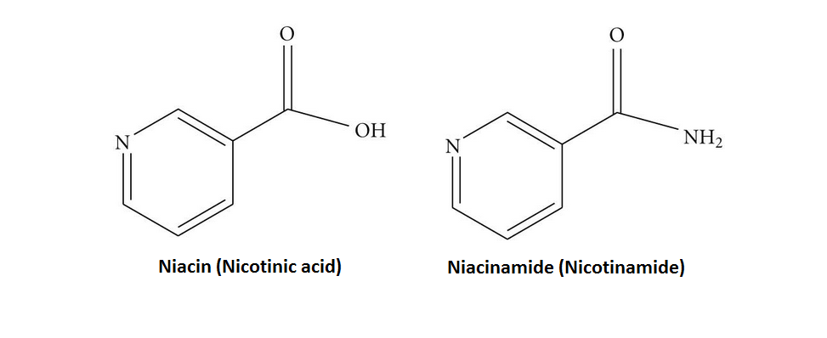

Food sources
Niacin is found in variety of foods, including liver, chicken, beef, fish, cereal, peanuts and legumes, and is also synthesized from tryptophan, which is found in meat, dairy and eggs.
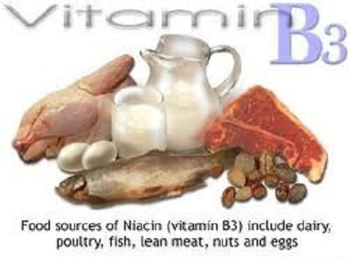
Biological Active Forms

Two nucleotide active forms are known:
1-Nicotinamide adenine dinucleotide(NAD⁺)
2-Nicotinamide adenine dinucleotide phosphate(NADP+⁾

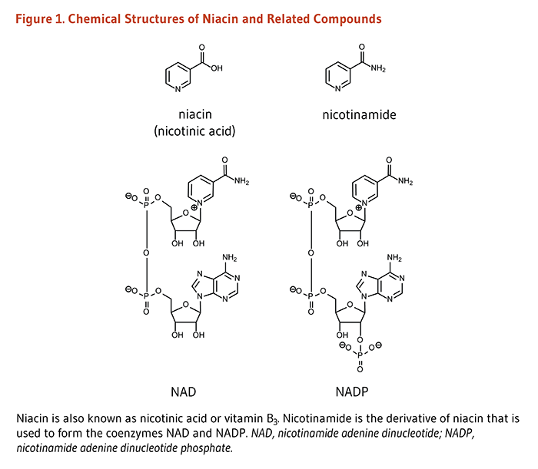

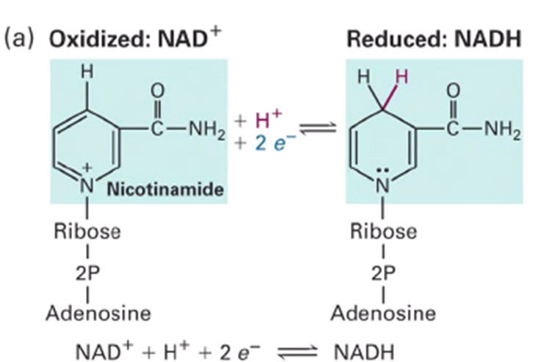

Biosynthesis and chemical synthesis
The liver can synthesize niacin from the essential amino acid tryptophan, requiring 60 mg of tryptophan to make one mg of niacin.
The 5-membered aromatic heterocyclic tryptophan is cleaved and rearranged with the alpha amino group of tryptophan into the 6-membered aromatic heterocyclic niacin.
Riboflavin, Vitamin B6 and iron are required in some of the reactions involved in the conversion of tryptophan to NAD.

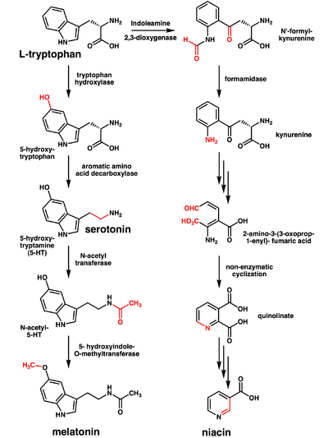
Function
1-Important part of energy production.
2-Help maintain muscle tone in the GI tract.
3-Involved in the production of sex and stress hormones.
4-Helps improve circulation.
5-Helped in cholesterol production ,and can help lower LDL cholesterol.
6-Required for DNA production.
7-Involved in blood sugar regulation.
Niacin is vital for all our body cells. It participates in many metabolic functions which are important in the release of energy from nutrients, especially carbohydrates ,also fats and proteins. This vitamin is our cells' supplier of energy.

Lipid-modifying effects
Niacin blocks the breakdown of fats in adipose tissue. These fats are used to build very-low-density lipoproteins (VLDL) in the liver, which are precursors of low-density lipoprotein (LDL) or "bad" cholesterol. Because niacin blocks the breakdown of fats, it causes a decrease in free fatty acids in the blood and, as a consequence, decreases the secretion of VLDL and cholesterol by the liver.
By lowering VLDL levels, niacin also increases the level of high-density lipoprotein (HDL) or "good" cholesterol in blood, and therefore it is sometimes prescribed for people with low HDL, who are also at high risk of a heart attack.
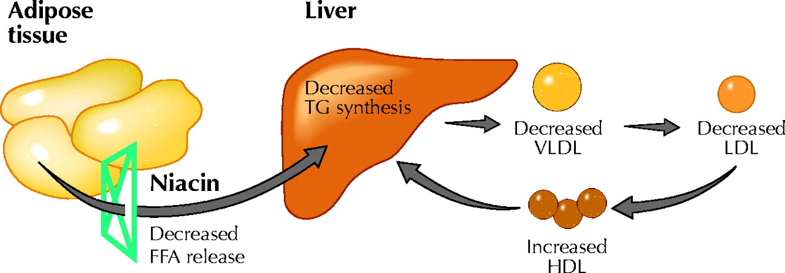

Niacin prevents adipose tissue from breaking down TAGs, which lowers hepatic VLDL synthesis

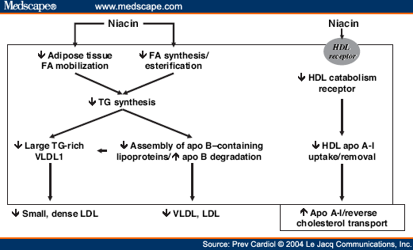

Niacin produces large, rapid decreases in TG levels by inhibiting release of fatty acids from adipose tissue as well as hepatic synthesis of fatty acids and TG.

* Reduced TG synthesis is postulated to enhance hepatic degradation of apo B,( the major lipoprotein component of VLDL), thus reducing VLDL production and the levels of IDL and LDL.

* The reduction in TG availability also results in production of smaller, TG-poor VLDL particles, with subsequent inhibition of small, dense LDL production.

* Niacin may elevate HDL cholesterol levels primarily by suppressing the hepatic removal of apo A-I, which increases levels of apo A-I as well as large apo A-I containing HDL particles.

* Niacin also appears not to inhibit hepatic removal of cholesterol esters, and so preserves the ability of retained apo A-I to augment reverse cholesterol transport.

Deficiency
Niacin deficiency is sometimes seen in developed countries, and it is usually apparent in conditions of poverty, malnutrition, and chronic alcoholism.
Mild niacin deficiency has been shown to slow metabolism, causing decreased tolerance to cold.
Severe deficiency of niacin in the diet causes the disease pellagra, which is characterized by diarrhea, dermatitis, and dementia, as well as “necklace” lesions on the lower neck, hyperpigmentation, thickening of the skin, inflammation of the mouth and tongue, digestive disturbances.Common psychiatric symptoms of niacin deficiency include irritability, poor concentration, anxiety, fatigue, restlessness, apathy, and depression.
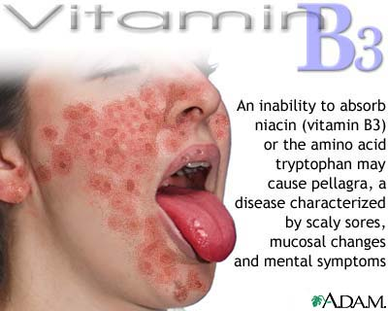
Toxicity
Pharmacological doses of niacin (1.5 - 6 g per day) occasionally lead to side effects that can include dermatological conditions such as skin flushing and itching, dry skin, and skin rashes including eczema exacerbation. These symptoms are generally related to niacin's role as the rate limiting cofactor in the histidine decarboxylase enzyme which converts l-histidine into histamine.
Although high doses of niacin may elevate blood sugar, thereby worsening diabetes mellitus, recent studies show the actual effect on blood sugar to be only 5-10%. Patients with diabetes who continued to take anti-diabetes drugs containing niacin did not experience major blood glucose changes. Thus looking at the big picture, niacin continues to be recommended as a drug for preventing CVD in patients with diabetes.
Hyperuricemia is another side effect of taking high-dose niacin, and may exacerbate gout.

Vitamin B 5
Pantothenic acid is a water-soluble vitamin B5 is an essential nutrient belongs to vitamin B family. Its name is derived from the Greek pantothen (πάντοθεν) meaning "from everywhere" and small quantities of pantothenic acid are found almost in every food.It is a precursor of coenzyme A, which is a cofactor for a variety of enzyme-catalyzed reactions involving transfer of acetyl groups.
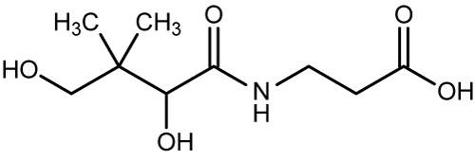
The molecular formula is C9H17NO5 and it is the amide between D-pantoate and beta-alanine; its IUPAC name is 3-[(2,4-dihydroxy-3,3-dimethylbutanoyl)amino] propanoic acid.
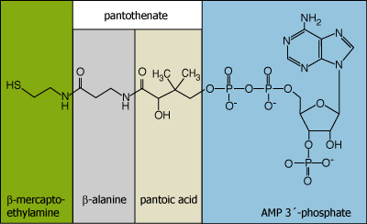
It is stable to oxidizing and reducing agents and to autoclaving, but is labile to dry heat, hot alkali, or hot acid. Pantothenic acid acetate, benzoate, and diphosphate esters are biologically active for animals but not for lactic acid bacteria.
Function
1-Helps the body extract energy from food.
2-Often called the stress vitamin because it helps the body relive emotional and physical stress on the organs.
3-Helps produce hormones and red blood cells.
4-Can help reduce high blood pressure, high triglycerides levels, and rheumatoid arthritis.
5- Pantothenic acid is essential for the metabolism of food as well as in the formation of hormones and (good) cholesterol.
Biological Role
Only the dextrorotatory (D) isomer of pantothenic acid possesses biologic activity. The levorotatory (L) form may antagonize the effects of the dextrorotatory isomer.
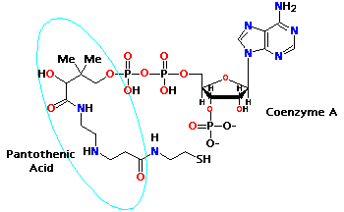
Vitamin B5, or pantothenic acid, is water-soluble and is used to make neurotransmitter acetylcholine and works in the Kreb’s cycle of energy production. It also helps release, produce, and transport energy from fats.

Sources

Dietary
Small quantities of pantothenic acid are found in most foods. The major food source of pantothenic acid is meat. The concentration found in animal muscle is about half that in human muscle. Whole grains are another good source of the vitamin, but milling removes much of the pantothenic acid, as it is found in the outer layers of whole grains.
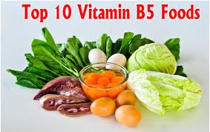

Supplementation
The derivative of pantothenic acid, pantothenol, is a more stable form of the vitamin and is often used as a source of the vitamin in multivitamin supplements. Another common supplemental form of the vitamin is calcium pantothenate. Calcium pantothenate is often used in dietary supplements because, as a salt, it is more stable than pantothenic acid in the digestive mentation may improve oxygen utilization efficiency and reduce lactic acid accumulation in athletes.
Absorption
When found in foods, most pantothenic acid is in the form of CoA or acyl carrier protein (ACP). For the intestinal cells to absorb this vitamin, it must be converted into free pantothenic acid. Within the lumen of the intestine, CoA and ACP are hydrolyzed into 4'-phosphopantetheine. The 4'-phosphopantetheine is then dephosphorylated into pantetheine. Pantetheinase, an intestinal enzyme, then hydrolyzes pantetheine into free pantothenic acid.
Free pantothenic acid is absorbed into intestinal cells via a saturable, sodium-dependent active transport system. At high levels of intake, when this mechanism is saturated, some pantothenic acid may also be absorbed via passive diffusion. As intake increases 10-fold, however, absorption rate decreases to 10%.
Deficiency
Pantothenic acid deficiency is exceptionally rare and has not been thoroughly studied. In the few cases where deficiency has been seen (victims of starvation and limited volunteer trials), nearly all symptoms can be reversed with the return of pantothenic acid.
Symptoms of deficiency are similar to other vitamin B deficiencies. There is impaired energy production, due to low CoA levels, which could cause symptoms of irritability, fatigue.
Acetylcholine synthesis is also impaired; therefore, neurological symptoms can also appear in deficiency;they include numbness, paresthesia, and muscle cramps.
Deficiency in pantothenic acid can also cause hypoglycemia, or an increased sensitivity to insulin, insulin receptors are acylated with palmitic acid when they do not want to bind with insulin. Therefore, more insulin will bind to receptors when acylation decreases, causing hypoglycemia.
Additional symptoms could include :sleep disturbances, nausea, vomiting, and abdominal cramps.
Increase the amount of fresh fruits and vegetables in the diet to decrease the likelihood of developing a vitamin B5 deficiency. If taking supplements, ensure that they are kept in a cool, dry place to make sure they are viable.
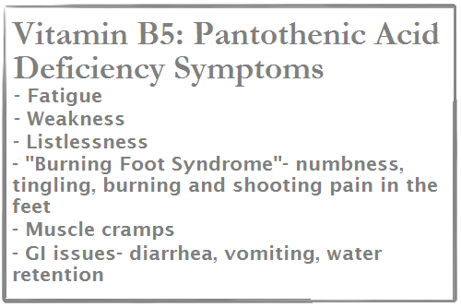
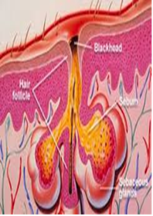
Toxicity
Toxicity of pantothenic acid is unlikely. Large doses of the vitamin, when ingested, have no reported side effects and massive doses (e.g., 10 g/day) may only yield mild intestinal distress, and diarrhea at worst.

