University of Mustansiriya Dr.Shatha AL-Khateeb
College of Medicine Lec. 6(1-9)
Clinical Biochemistry Dept. 2017-2018

vitamin B-complex
The vitamin B-complex refers to all of the known essential water-soluble vitamins except for vitamin C. These include thiamine (vitamin B1), riboflavin (vitamin B2), niacin(vitamin B3), pantothenic acid (vitamin B5), pyridoxine (vitamin B6), biotin, folic acid and the cobalamins (vitamin B12).
"Vitamin B" was once thought to be a single nutrient that existed in extracts of rice, liver, or yeast. Researchers later discovered these extracts contained several vitamins, which were given distinguishing numbers.
Each member of the B-complex has a unique structure and performs unique functions in the human body, and often coexists in the same foods. Vitamins B1, B2, B3, and biotin participate in different aspects of energy production, vitamin B6 is essential for amino acid metabolism, and vitamin B12 and folic acid facilitate steps required for cell division. Each of these vitamins has many additional functions. However, contrary to popular belief, no functions require all B-complex vitamins simultaneously.

Health benefits
The B vitamins may be necessary to:
1-Support and increase the rate of metabolism .
2-Maintain healthy skin, hair and muscle tone.
3-Enhance immune and nervous system function.
4-Promote cell growth and division, including that of the red blood cells that help prevent anemia .
5-Reduce the risk of pancreatic cancer - one of the most lethal forms of cancer - when consumed in food, but not when ingested in vitamin tablet form.
All B vitamins are water-soluble, and are dispersed throughout the body. Most of the B vitamins must be replenished regularly, since any excess is excreted in the urine.
The Vitamins B-complex are family due to :
- They are found together in the same food.
- Do similar work in the body, maintain healthy skin and muscles tone enhance immune and nervous system functions and promote cell growth and divisions.
- Symptoms of one vitamins deficiency may be undistinguishable from others.

List of B vitamins
Vitamin B₁ (thiamine), Vitamin B₂ (riboflavin), Vitamin B₃ (niacin or niacinamide),Vitamin B₅ (pantothenic acid),Vitamin B₆ (pyridoxine, pyridoxal, or pyridoxamine, or pyridoxine hydrochloride),Vitamin B₇ (biotin),Vitamin B₉ (folic acid), and Vitamin B₁₂ (various cobalamins; commonly cyanocobalamin in vitamin supplements)
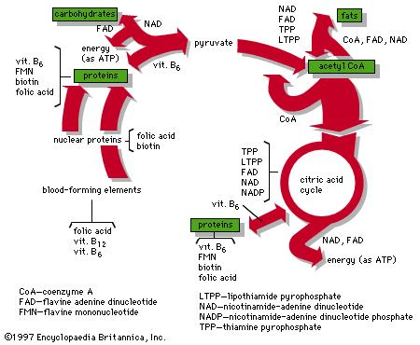

Thiamine or vitamin B₁
Thiamine or vitamin B₁, named as the "thio-vitamine" ("sulfur-containing vitamin") is a water-soluble vitamin of the B complex. Water-soluble means it can dissolve in water.

Thiamine is a water-soluble B vitamin and plays an essential role in normal cellular functions, growth and development.
Mammals, including humans cannot synthesize thiamine so it has to be obtained from diet via intestinal absorption. Absorption of vitamin B1 involves a specialized pH-dependent, Na⁺- independent carrier mediated mechanism. In order to become a coenzyme thiamine has to acquire a pyrophosphate group. This process occurs intracellularly in a reaction catalyzed by the enzyme thiamine pyrophosphokinase at the expense of cellular ATP.
Water-soluble vitamins are carried through the bloodstream. Whatever the bodies do not use up is eliminated in urine. Therefore, we need a continuous supply of vitamin B1 - we need to be consuming it daily. Thiamine is a co-enzyme - it helps some enzymes work properly.

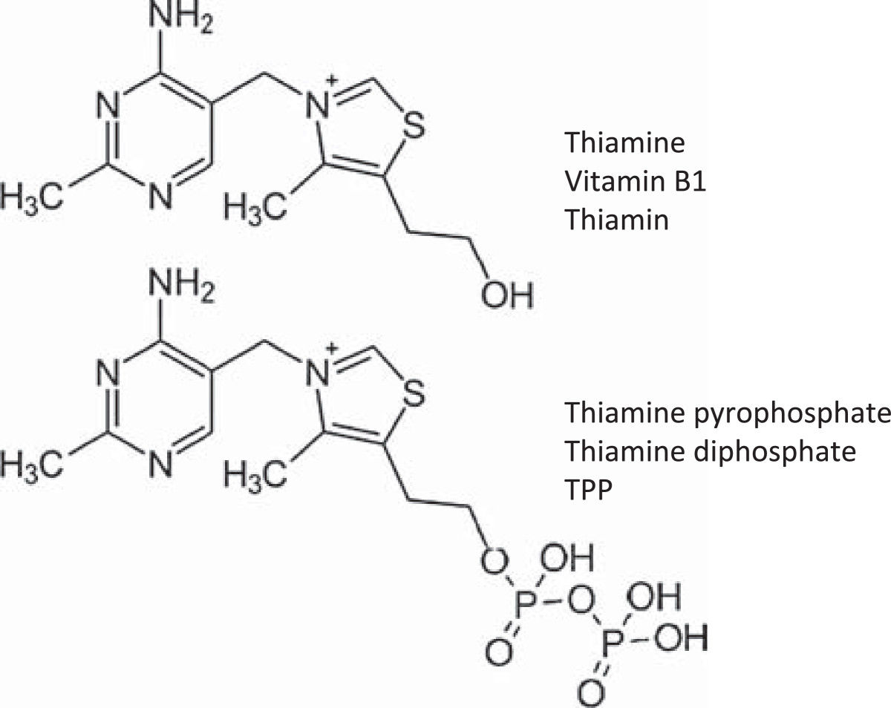

Its phosphate derivatives are involved in many cellular processes. The best-characterized form is thiamine pyrophosphate (TPP), coenzymes in the catabolism of sugars and amino acids. Thiamine is used in the biosynthesis of the neurotransmitter acetylcholine and gamma-amino butyric acid (GABA). In yeast, TPP is also required in the first step of alcoholic fermentation.
Thiamine is a colorless compound with a chemical formula C₁₂H₁₇N₄OS. Its structure contains an aminopyrimidine ring and a thiazole ring with methyl and hydroxyethyl side chains linked by amethylene bridge. Thiamine is unstable to heat, but stable during frozen storage. It is unstable when exposed to ultraviolet light and gamma irradiation.

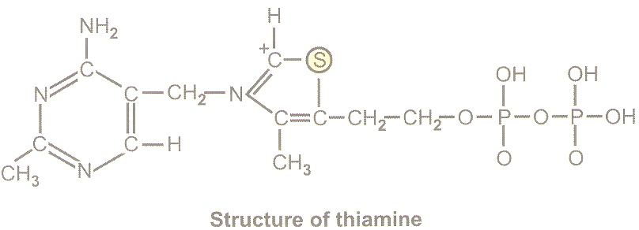

Vitamin B1 is found in high concentrations in the outer layers and germ of cereals, as well as in yeast, beef, pork, nuts, whole grains, and thiamine is found in a wide variety of foods at low concentrations. Yeast, extract. In general, cereal grains are the most important dietary sources of thiamine, by virtue of their ubiquity.
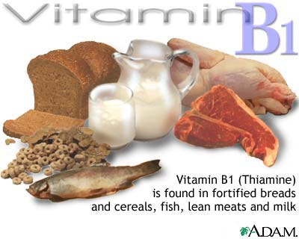
The primary function of B-1 is to help the body convert food to energy. When we eat, the body breaks food down for fuel use. The body's primary fuel source is glucose, which we get from carbohydrate foods. B-1 helps the body turn carbohydrates into glucose for fuel. B-1, along with the other B vitamins, also helps the body metabolize fats and protein and
helps keep the liver, skin, hair and eyes healthy.
Antagonists
Thiamine in foods can be degraded in a variety of ways. Sulfites, which are added to foods usually as a preservative, will attack thiamine at the methylene bridge in the structure, cleaving the pyrimidine ring from the thiazole ring. The rate of this reaction is increased under acidic conditions. Thiamine is degraded by thermo labile thiaminases (present in raw fish and shellfish.

Coenzyme function
B-1 acts as a coenzyme, which is a substance needed to mediate chemical actions. Thiamine is needed to produce adenosine triphosphate, or ATP, a major source of energy in your body. ATP transports sodium, potassium and calcium through cell membranes and binds to water, releasing energy. It is stored in every cell in the body. It helps the muscles contract and plays an important role in providing the energy needed for exercise.

Absorption
Thiamine is released by the action of phosphatase and pyrophosphatase in the upper small intestine. At low concentrations, the process is carrier-mediated, and, at higher concentrations, absorption occurs via passive diffusion.
Active transport is greatest in the jejunum and ileum (it is inhibited by alcohol consumption and by folic deficiency). The cells of the intestinal mucosa have thiamine pyrophosphokinase activity. The majority of thiamine present in the intestine is in the pyrophosphorylated form .The uptake of thiamine by the mucosal cell is likely coupled in some way to its phosphorylation/dephosphorylation.

Bound to serum proteins
The majority of thiamine in serum is bound to proteins, mainly albumin. Approximately 90% of total thiamine in blood is in erythrocytes.
A specific binding protein called thiamine-binding protein (TBP).
Excretion
Thiamine and its acid metabolites (2-methyl-4-amino-5-pyrimidine carboxylic acid, 4-methyl-thiazole-5-acetic acid, and thiamine acetic acid) are excreted principally in the urine.

Thiamine phosphate derivatives and function

Thiamine is mainly the transport form of the vitamin, while the active forms are phosphorylated thiamine derivatives. There are five known natural thiamine phosphate derivatives: thiamine monophosphate (ThMP), thiamine diphosphate (ThDP), also sometimes called thiamine pyrophosphate (TPP), thiamine triphosphate (ThTP), and the recently discovered adenosine thiamine triphosphate (AThTP), and adenosine thiamine diphosphate (AThDP).

Thiamine diphosphate
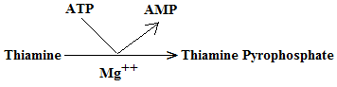
Thiamin pyrophosphate plays a key role in the production of energy from food by acting as a coenzyme for four important enzymes.
  - The synthesis of thiamine diphosphate (ThDP), also known as thiamine pyrophosphate (TPP) or cocarboxylase, is catalyzed by an enzyme called thiamine diphosphokinase according to the reaction
  - Thiamine + ATP → ThDP + AMP (EC 2.7.6.2).
  - ThDP is a coenzyme for several enzymes that catalyze the transfer of two-carbon units and in particular the dehydrogenation(decarboxylation and subsequent conjugation with coenzyme A) of 2-oxoacids (alpha-keto acids).
The enzymes transketolase, pyruvate dehydrogenase (PDH), and 2-oxoglutarate dehydrogenase (OGDH) are all important in carbohydrate metabolism. The cytosolic enzyme transketolase is a key player in the pentose phosphate pathway, a major route for the biosynthesis of the pentose sugars deoxyribose and ribose.
Thiamine is the precursor of thiamine pyrophosphate (TPP):
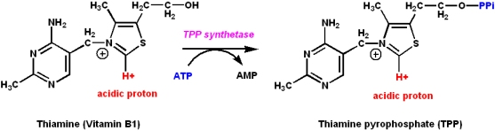
- TPP is a coenzyme
- It is a coenzyme for certain enzymes involved in carbohydrate metabolism
- It catalyzes the synthesis or cleavage of bonds to carbonyl carbons
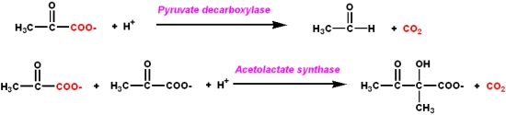

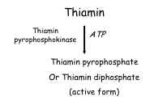

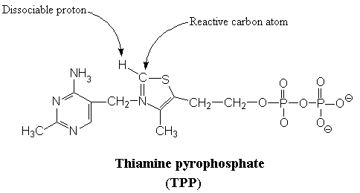

Active form: is thiamine diphosphate (pyrophosphate).
It serves as a coenzyme in enzymatic reactions, transferring an activated aldehyde unit in :

1-Acts as coenzyme to the enzyme pyruvate dehydrogenase complex (PDH) which converts pyruvic acid to acetyl COA (oxidative decarboxylation).

Pyruvate PDG Acetyl COA
TPP

2- Similarly acts as a coenzyme to α-oxoglutarate dehydrogenase complex and converts α-oxoglutarate to succinyl COA(oxidative decarboxylation).

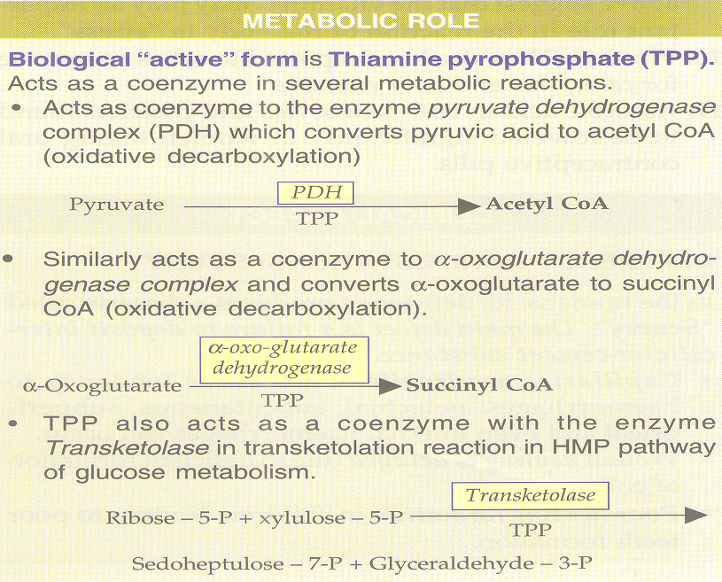

Some of the reactions in which TPP is involved are listed below:
1. Thiamine pyrophosphate (TPP) is one of the coenzymes required by the pyruvate dehydrogenase multienzyme complex for the decarboxylation of pyruvate:
pyruvate + CoA-SH + NAD⁺ ----> acetyl-CoA + CO₂ + NADH
2. TPP is also required in the degradation of branched-chain amino acids isoleucine, leucine and valine. The second stage in this process is catalyzed by a-ketoisovalerate dehydrogenase, a multienzyme complex that employs the coenzymes TPP, FAD, NAD⁺ and the lipoamide.
3. TPP is involved in a reaction of the pentose phosphate pathway, i.e.in the formation of sedoheptulose-7-phosphate. The enzyme that catalyzes this reaction (transketolase) requires TPP as coenzyme. The pentose phosphate pathway is one of the generators of reducing power (NADPH) necessary for biosynthetic processes as well as for several reductive processes, such as the regeneration of GSH in the erythrocytes whose function is to protect the integrity of cell membrane by removing the hydrogen peroxide and lipid hydroperoxides through the reaction catalyzed by GSH-peroxidase.

Importance of Thiamin:

Metabolism of carbohydrates , proteins and fats.

ATP production.

3-Myelin sheath production.

Anti-stress.

Electrolyte balance.

Life spam of RBCs.

Deficiency
Thiamine derivatives and thiamine-dependent enzymes are present in all cells of the body, thus a thiamine deficiency would seem to adversely affect all of the organ systems. However, the nervous system is particularly sensitive to thiamine deficiency, because of its dependence on oxidative metabolism.
Thiamine deficiency commonly presents subacutely and can lead to metabolic coma and death. A lack of thiamine can be caused by malnutrition, a diet high in thiaminase-rich foods (raw freshwater fish, raw shellfish, ferns) and/or foods high in anti-thiamine factors (tea, coffee, betel nuts) and by grossly impaired nutritional status associated with chronic diseases, such as alcoholism, gastrointestinal diseases, HIV-AIDS, and persistent vomiting.
Well-known syndromes caused by thiamine deficiency include beriberi, Wernicke-Korsakoff syndrome, and optic neuropathy.

Beriberi
Beriberi is a disorder of nervous system which is actually cause by the deficiency of the thiamine (deficiency of vitamin B1) in the diet of the individual, thiamine is basically found in the membranes of neurons and it is involved in the break down of the energy molecules such as glucose.
Beriberi may be found in people whose diet consists mainly of polished white rice, which is very low in thiamine because the thiamin-bearing husk has been removed. It can also be seen in chronic alcoholics (Wernicke-Korsakoff syndrome), Arsenic poisoning causes alterations in cellular metabolism resulting in blockage of thiamine use which results in thiamine deficiency without any dietary shortfall.
Beriberi is a neurological and cardiovascular disease. The three major forms of the disorder are dry beriberi, wet beriberi, and infantile beriberi.
Assay for Thiamine Deficiency:
One method for evaluation of thiamine status is the measurement of erythrocyte (red blood cell) transketolase activity.
Red blood cells, which lack mitochondria, have no alternative means of generating NADPH save the pentose phosphate pathway. Also, NADPH is required to reduce glutathione in order to maintain the normal structure of red blood cell and maintain hemoglobin in the ferrous state. Therefore, the pentose phosphate pathway is essential in red blood cells. Transketolase is a thiamine pyrophosphate-requiring enzyme, which catalyzes reactions in the pentose phosphate pathway. So the level of transketolase activity in the red blood cell is a reliable diagnostic indicator of thiamine status.

