ORTHOPAEDICS
Lecture: Date: Dr.Sa'ad Mubarak

Legg-Calve'-Perthes' disease

It is avascular necrosis of femoral head, occur in 4-10 years old, and male more than female 4 times.

Causes:
Unknown, but suggested causes are inherited thrombophilia, antithrombotic factor deficiency, and hypofibrinolysis.

Femoral head blood supply:
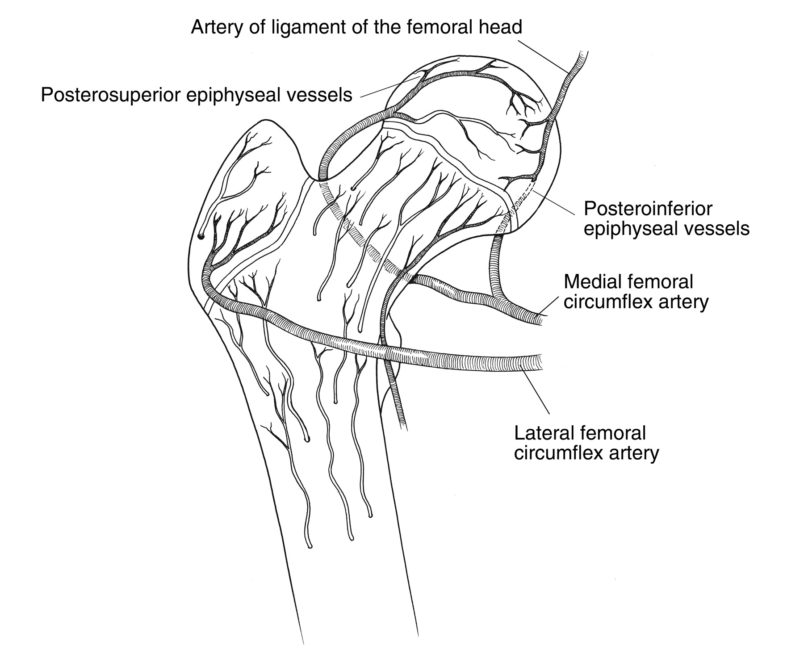
1. Metaphyseal blood vessels which penetrate the growth disc.
2. Lateral epiphyseal vessels running in the retinacula.
3. Vessels of ligamentum teres.
The metaphyseal blood vessels usually appear at age of 4 years, and the vessels of ligamentum teres atrophied at the age of 7 years. Between 4-7 years of age, the femoral head may depends for its blood supply on the lateral epiphyseal blood vessels, any trauma or effusion lead to stasis and thrombosis of these vessels and consequently ischemia and infarction of the femoral head.

Pathology:
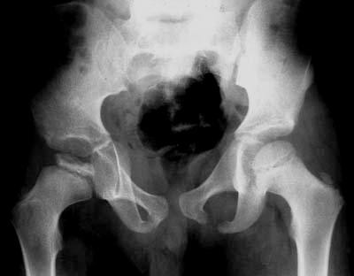
--- Stage I (ischemia and bone death): on x-ray, the head looks normal but stop enlarging.
--- Stage II (revascularization and repair): increased density on x-ray, fragmentation of epiphysis, osteoporosis of metaphysis, and mild changes appear on the acetabulum.
--- Stage III (distortion and remodeling): there is mushrooming of the head, short and broad neck, and enlargement of the head laterally, subluxation of hip joint, and distortion of the acetabulum.

Clinical features:
A boy 4-10 years old develop pain, limping, wasting of hip muscles, and all movements are restricted, especially abduction in flexion and internal rotation.

X-ray:
At first, the x-ray may appear normal. Sometimes, there is widening of joint space, and asymmetry of ossific center.
Later, there is increased density of ossific nucleus, fragmentation, and sometimes there is crescentric subarticular fracture.
Later on, there is flattening and lateral displacement of epiphysis; osteoporosis and widening of metaphysis.

Caterall classify Perthes' disease according to x-ray changes into 4 groups:
--- Group I: the epiphysis retains its height and less than 1/2 of nucleus is sclerosed.
--- Group II: 1/2 of nucleus is sclerosed and there is collapse of central portion of nucleus.
--- Group III: most of nucleus is sclerosed; and fragmentation and collapse of head.
--- Group IV: the whole head is involved and there is marked metaphyseal resorption.
MRI is the most definitive diagnostic tool.

Differential diagnosis:
It should be differentiated from Morquio's disease, cretinism, multiple epiphyseal dysplasias, sickle cell disease, Gaucher's disease, tuberculosis of hip, slipped epiphysis, and chronic juvenile arthritis.

Prognostic factors:
1. Age: < 6 years, the result is excellent.
> 6 years, the prognosis is poor.
2. Sex: male is good prognosis.
Female is poor prognosis.
3. Caterall classification: the greater the degree of femoral head involvement, the worse the outcome.
4. Progressive uncovering of epiphysis (subluxation) is a poor prognostic factor.

Treatment:
During acute stage, bed rest and skin traction with the hip slightly flexed and in external rotation.
After irritability has subsided, movements encouraged after 3 weeks.
After that treatment directed to either:
--- Symptomatic treatment: like pain control and gentile exercises.
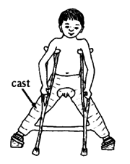
--- Containment treatment: means seating the femoral head congruently in the acetabular socket and this is achieved by:
A. Holding the hip abducted in Plaster of Paris spika or brace.
B. Operation either varus osteotomy of femur or innominate osteotomy of pelvis.

Slipped capital femoral epiphysis

It is a displacement of the proximal femoral epiphysis, also called epiphyseolysis. Boys > girls, age usually 14-16 years, left hip > right hip, and 25-40 % bilateral.
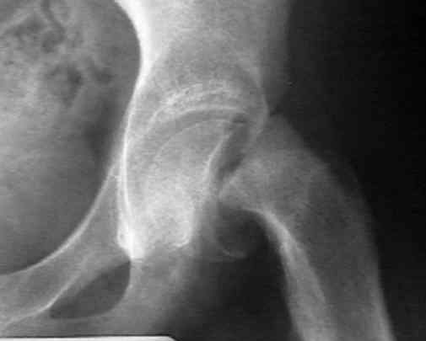
Aetiology:
The slip occurs through the hypertrophic zone of the growth plate.
1. Hormonal imbalance: hypogonadism, hypopituitarism or hypothyroidism.
2. Trauma in 30 % of cases.

Pathology:
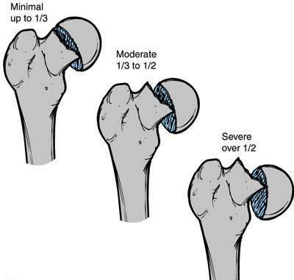
The epiphysis slips posteriorly on the femoral neck, lead to external rotation deformity of the limp. With severe slip, the retinacular blood vessels will tear, so that the femoral head will be at risk of avascular necrosis.

Classification:
--- Mild.
--- Moderate.
--- Severe.

Clinical features:
Slipping usually occurs as a series of minor episodes, the patient usually child around puberty, overweight, pain in the groin, limping, and the limb is turning out (external rotation).
On examination, the leg is externally rotated and short by 1-2 cm. a classic sign is the tendency to increasing external rotation as the hip is flexed.

X-ray:
In early stage, the x-ray may be normal.
In lateral view, the femoral epiphysis is tilted backward.
In AP view, a line drawn along the superior border of neck will pass superior to the head (normally pass through the head).

Treatment:
--- Mild slip: need no reduction. Epiphysis is fixed by one or 2 screws or pins along the femoral neck into the epiphysis.
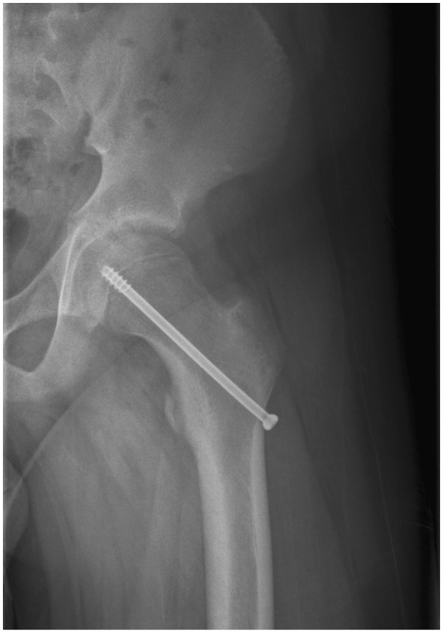
--- Moderate slip: fixed in situ with acception of the deformity and deal later on with deformity by corrective osteotomy.
Fixation is either by screws, pins, or by bone graft epiphyseodesis.

--- Severe slip:
A. Needs open reduction and then internal fixation by 2-3 screws or pins.
B. Fixation without reduction and then deal with the deformity by subtrochanteric osteotomy.

Complications:
1. Slipping of the opposite hip: 20 % of cases are bilateral.
2. Avascular necrosis: it is usually iatrogenic either due to manipulation and reduction or due to operation.
3. Articular chondrolysis: cartilage necrosis due to vascular damage.
4. Coxa vara: un-noticed slip may lead to coxa vara.

--------------------------------------------------------------------------------------

