University of Mustansiriya Dr.Shatha AL-Khateeb
College of Medicine Lec.1&2 (1-17)
Clinical Biochemistry Dept. 2017-2018
Vitamins
Vitamins are nutrients which are essential to life. They are organic compounds needed in small quantities, necessary for the healthy growth and maintenance of the body. Vitamins are found in all kinds of foods but, vegetables and fruits are particularly rich in vitamins.
The word organic means that the molecules of the substance contain the element carbon, the term also means that vitamins can be destroyed and become unable to perform their functions in our bodies, too much heat, and certain kinds of light, even oxygen can destroy some vitamins. The term vitamin was coined from the words vital +amine,since the earlier identified ones had amino groups.
Discovery of vitamins started from observation of deficiency manifestations,e.g. Scurvy,Rickets,Beriberi,etc.
Vitamins are classified by their biological and chemical activity, not their structure. Thus, each "vitamin" refers to a number of vitamer compounds that all show the biological activity associated with a particular vitamin. Vitamer is a term used to describe any of a number of compounds that possess a given vitamin activity and are sometimes inter-convertible to one another, as well.
Vitamins are classified into two categories based on their solubility: as either water-soluble or fat-soluble. In humans there are 13 vitamins: 4 fat-soluble (A, D, E, and K) and 9 water-soluble (8 B vitamins and vitamin. Many types of water-soluble vitamins are synthesized by bacteria.
Vitamins have diverse biochemical functions:
(1) Some have hormone-like functions as regulators of mineral metabolism (e.g., vitamin D), (2) Regulators of cell and tissue growth and differentiation (e.g., some forms of vitamin A). (3)Others function as antioxidants (e.g., vitamin E and sometimes vitamin C). (4)The largest number of vitamins (e.g., B complex vitamins) functions as precursors for enzyme cofactors, which help enzymes in their work as catalysts in metabolism. In this role, vitamins may be tightly bound to enzymes as part of prosthetic groups: For example, biotin is part of enzymes involved in making fatty acids. Vitamins may also be less tightly bound to enzyme catalysts as coenzymes, detachable molecules that function to carry chemical groups or electrons between molecules. For example, folic acid carries various forms of carbon group – methyl, formyl, and methylene – in the cell.
Vitamins differ from other organic food stuffs in that
1-They do not enter into tissue structures, unlike protein.
2- Do not undergo degradation for providing energy unlike carbohydrates and lipid.
3- Several B-complex vitamins play an important role as coenzymes in several energy transformation reactions in the body.

The same with hormones, vitamins differ from hormones in not being produced within the organism, and most of them have to be provided in the diet.
Characteristics of the vitamins are:
- Micronutrients.
- Do not supply energy.
- Do not contribute to body mass.
- Essential for metabolism.
- Lack results in deficiency disease.
Once growth and development are completed, vitamins remain essential nutrients for the healthy maintenance of the cells, tissues, and organs that make up a multicellular organism; they also enable a multicellular life form to efficiently use chemical energy provided by food it eats, and to help process the proteins, carbohydrates, and fats required for respiration.
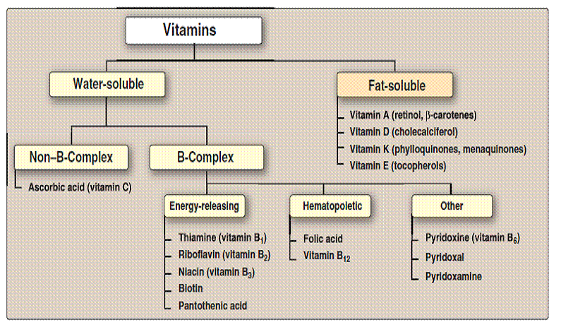
Comparison of the two types of vitamins
 | Fat soluble vitamins | Water soluble vitamins
Solubility in fat | Soluble | Not soluble
Solubility in water | Not soluble | Soluble
Absorption | Along with lipids requires bile salts | Absorption simple(except vitamin B12)
Carrier proteins | Present | No carrier proteins(except vitamin B12)
Storage | Stored in liver | No storage(except vitamin B12)
Deficiency | Manifests only when stores are depleted | Manifests rapidly as there is no storage (except vitamin B12)
Toxicity | Hypervitaminosis may result | Unlikely ,since excess is excreted
Major vitamins | A,D,E and K | B,C

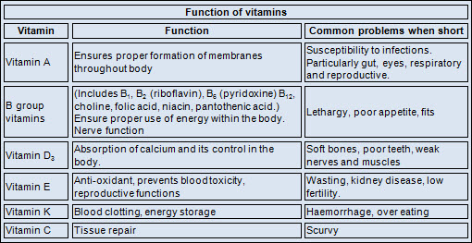

Deficiencies
Humans must consume vitamins periodically but with differing schedules, to avoid deficiency. The human body's stores for different vitamins vary widely; vitamins A, D, and B₁₂ are stored in significant amounts in the human body, mainly in the liver, and an adult human's diet may be deficient in vitamins A and D for many months and B₁₂ in some cases for years, before developing a deficiency condition. However, vitamin B₃ (niacin and niacinamide) is not stored in the human body in significant amounts, so stores may last only a couple of weeks. For vitamin C, the first symptoms of scurvy in experimental studies of complete vitamin C deprivation in humans have varied widely, from a month to more than six months, depending on previous dietary history that determined body stores.
In general, deficiency of vitamins may occur due to:
1-Reduced intake. 2-Impaired absorption. 3-Impaired metabolism.
4-Addetional requirements. 5-Increased losses.
Deficiencies of vitamins are classified as either primary or secondary:
A primary deficiency occurs when an organism does not get enough of the vitamin in its food.
A secondary deficiency may be due to an underlying disorder that prevents or limits the absorption or use of the vitamin, due to a "lifestyle factor", such as smoking, excessive alcohol consumption, or the use of medications that interfere with the absorption or use of the vitamin.
People who eat a varied diet are unlikely to develop a severe primary vitamin deficiency. In contrast, restrictive diets have the potential to cause prolonged vitamin deficits, which may result in often painful and potentially deadly diseases.

Side-effects and overdose
In large doses, some vitamins have documented side-effects that tend to be more severe with a larger dosage. The likelihood of consuming too much of any vitamin from food is remote, but overdosing (vitamin poisoning) from vitamin supplementation does occur. At high enough dosages, some vitamins cause side-effects such as nausea, diarrhea, and vomiting. When side-effects emerge, recovery is often accomplished by reducing the dosage.

Anti-vitamins
Anti-vitamins are chemical compounds that inhibit the absorption or actions of vitamins. For example, avidin is a protein in egg whites that inhibits the absorption of biotin. Pyrithiamine is similar to thiamine, vitamin B₁, and inhibits the enzymes that use thiamine.

Vitamin A

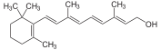
(2E,4E,6E,8E)-3,7-Dimethyl-9-(2,6,6-trimethyl-1-cyclohexen-1-yl)-2,4,6,8-nonatetraen-1-ol (Retinol)
Vitamin A is a fat soluble vitamin; the active form is present only in animal tissue. The pro-vitamin, beta carotene is present in plant tissue. Beta carotene has two beta ionone ring connected by a polyprenoid chain.
One molecule of beta carotene can theoretically give rise to two molecules of vitamin A, but it may produce only one in biological system.
Retinol, retinal, retinoic acid, and related compounds are known as retinoid. Beta-carotene and other carotenoids that can be converted by the body into retinol are referred to as provitamin A (carotenoids).
All forms of vitamin A have a beta-ionone ring to which an isoprenoid chain is attached, called a retinyl group. Both structural features are essential for vitamin activity. The orange pigment of carrots – beta-carotene – can be represented as two connected retinyl groups, which are used in the body to contribute to vitamin A levels. Alpha-carotene and gamma-carotene also have a single retinyl group, which give them some vitamin activity.
The body cannot make vitamin A and must rely on dietary sources of vitamin A. Meat sources provide vitamin A (as retinol), while vegetable and fruit sources provide carotene (a substance that can be converted into vitamin A by the liver). Deficiencies in vitamin A can impair night vision, cause eye damage, and in severe cases, lead to blindness. Acute or chronic excesses of vitamin A can be toxic, cause a range of symptoms, and sometimes lead to birth defects.
Vitamin A can be found in two principal forms in foods:
*Retinol, the form of vitamin A absorbed when eating animal food sources, is a yellow, fat-soluble substance. Since the pure alcohol form is unstable, the vitamin is found in tissues in a form of retinyl ester. It is also commercially produced and administered as esters such as retinyl acetate or palmitate.
*The carotenes alpha-carotene, beta-carotene, gamma-carotene; and the xanthophyll beta-cryptoxanthin (all of which contain beta-ionone rings), but no other carotenoids, function as vitamin A , which possess the enzyme required to convert these compounds to retinal.
Retinol is an active form of vitamin A. It is found in animal liver, whole milk, and some fortified foods.
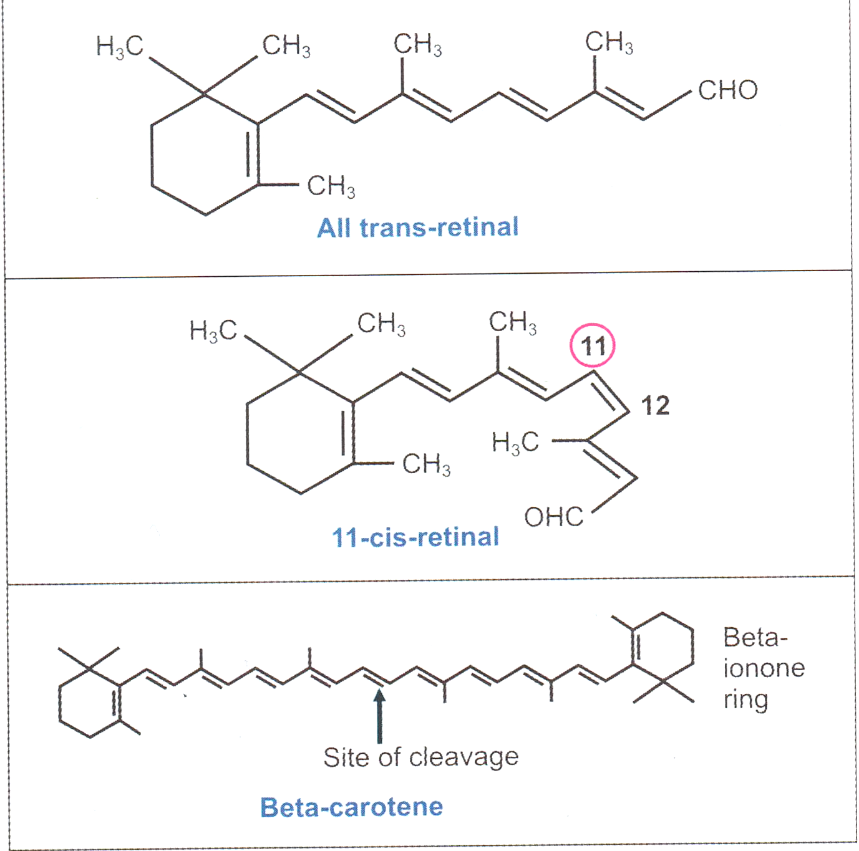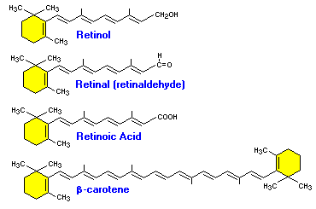

Sources
Retinol, the active form of vitamin A, is rarely found in foods. Instead, precursors to retinol, fatty acid retinyl esters, are found in the human diet. The esters are commonly found in foods of animal origin, such as egg yolks, liver, fish oil, whole milk and butter.
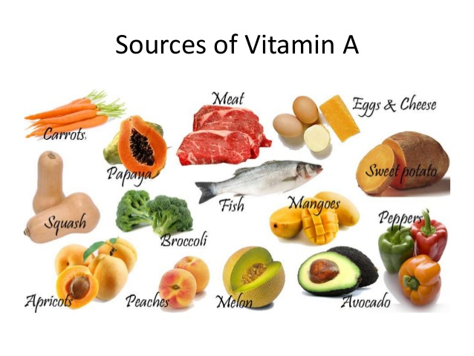

Plants can synthesize the carotenoids, but cannot convert them to retinoid; this process occurs in the human body. The carotenoids are red, yellow, and orange in color and substantial in number (over 400 types). It is estimated that only 10% of the pigments have "vitamin A activity", with beta-carotene having the greatest activity, followed by the alpha and gamma forms. Fruits and vegetables that appear bright orange or yellow in color are usually high in carotenoids. All green vegetables also contain substantial amounts of carotenoids, but the orange or yellow color is masked by chlorophyll .The wide variety of vitamin A precursors allows for adequate amounts of the vitamin in all diet types.

Vitamin A Metabolism

Vitamin A has three active forms (retinal, retinol and retinoic acid) and a storage form is (retinyl ester):

Retinyl ester ß → Retinol ß →Retinal → Retinoic acid

Circulating retinol is primarily bound to retinol-binding protein (RBP), and can enter and leave the liver several times per day in a process known as retinol recycling, which acts to relate the amount of retinol in circulation and protects cells from the damaging effects of free retinol or retinoic acid.
Retinol bound to a cellular RBP (CRBP or CRBP-II) can be esterified by the enzyme lecithin:retinol acyltransferase (LCAT), the resulting retinyl ester being stored primarily in liver stellate cells. LCAT provides a readily retrievable storage form of vitamin A, as well as regulating its availability for other pathways.

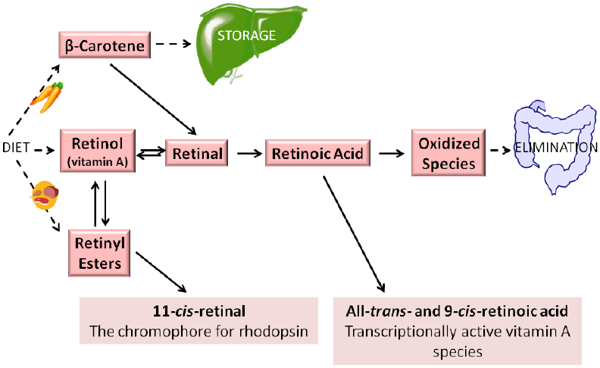
Generalized scheme for retinoid metabolism. Dietary retinyl esters, retinol, and provitamin A carotenoids (such as β-carotene) are taken into the body. Vitamin A (by definition all-trans-retinol) may be esterified into retinyl esters and stored. In times of dietary retinoid insufficiency, retinyl ester stores are hydrolyzed to retinol for delivery to peripheral tissues. Both all-trans-retinol and β-carotene may be converted enzymatically to all-trans-retinal. However, the visual chromophore 11-cis-retinal, owing to energetic considerations, is formed via the coupled enzymatic hydrolysis of all-trans-retinyl ester with the isomerization of the all-trans-retinoid to the 11-cis-isomer. Retinal either can be enzymatically oxidized to retinoic acid, which regulates transcription of over 500 retinoid-responsive genes, or reduced enzymatically to retinol. When retinoic acid is no longer needed, it is catabolized and eliminated from the body.
Absorption
Seventy to ninety percent of vitamin A from the diet is absorbed in the intestine. Greater than 90% of the retinol store within the body enters as retinyl esters that are subsequently found within the lipid portion of the chylomicron. Absorption of vitamin A is very rapid, with maximum absorption occurring two to six hours after digestion. Within the intestinal lumen the vitamin is incorporated into a micelle and absorbed across the brush border into the enterocytes. Within the enterocytes, precursors of vitamin A (carotenoids) are converted to active forms of the vitamin. The newly formed products and additional precursors are then packaged into chylomicron and readied for transport throughout the body.
Beta carotene is cleaved by a di-oxygenase,to form retinal .The retinal is reduced to retinol by an NADH or NADPH dependent retinal reductase present in the intestinal mucosa.
Intestine is the major site of absorption
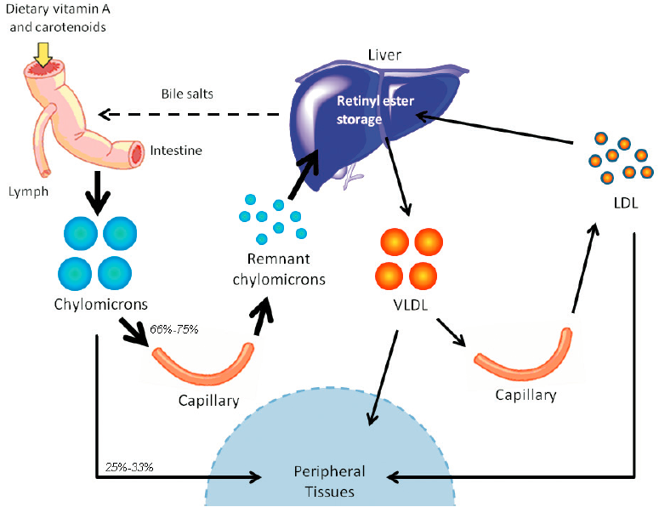

Retinoid transport in the form of retinyl esters. Dietary retinoid, in the form of retinol, retinyl esters, and provitamin A carotenoids, are absorbed in the small intestine, where they are packaged into chylomicrons and secreted into the lymphatic system. Retinyl esters in chylomicrons undergo lipolysis and remodeling while traversing the circulation. From there, retinyl esters may take one of two paths—(I) they may either be hydrolyzed into retinol (via the actions of LPL), which may be taken up by peripheral tissues (in rodents, 25-33% of chylomicron retinyl ester is delivered directly to peripheral tissues); or (II) they may be transported to the liver (in rodents, 66-75% of chylomicron retinyl ester is transported to the liver). Retinyl esters are stored in the liver. The liver can secrete some retinyl ester bound to VLDL into circulation. Upon metabolism of VLDL, some retinyl esters may be found in LDL or transferred to high density lipoprotein (HDL). Retinyl esters bound to these lipoprotein particles may also be taken up into peripheral tissues.

Transport
1-After leaving the enterocytes chylomicron, which carry retinyl esters, carotenoids, and unesterfired retinol along with triglycerides, are circulated first through the lymphatic system and then through the general circulation.
2- Upon arriving at extra-hepatic cells chylomicron release triglycerides, however vitamin A remains within the chylomicron.
3-The vitamin A is then incorporated into a chylomicron remnant.
4-The chylomicron remnant then travels back to the liver where it is taken up and further metabolized or stored.
When needed retinol is mobilized from the liver and requires the use of a carrier for transport through the blood. Retinol-binding protein (RBP) is the specific carrier used to transport all-trans retinol in the plasma.
The all-trans isoform accounts for more than 90% of all plasma vitamin A . This specific carrier is manufactured and secreted by the parenchyma cells of the liver .Each mole of retinol released binds equivocally with RBP to form holo-RBP. This compound then binds with a molecule of transthyretin (TTR), formerly known as prealbumin.
This newly formed retinol-RBP-TTR complex is not filtered by the glamorous, but instead freely circulates throughout the plasma. Tissues are then able to take the retinol up as needed via cellular retinoid-binding protein.
Uptake by Tissues
The retinol-RBP complex binds to specific receptors on the retina,skin,gonads and other tissues.The RBP does not enter in the cell. Inside the cytoplasm of cells, vitamin binds to cellular retinoic acid binding protein (CRBP) and finally to hormone responsive elements(HRE),thus gene are activated.

Storage
Approximately 50 to 85% of the total body retinol are stored in the liver when vitamin A status is adequate. Retinol returning to the liver is re-esterified before storage. Because of this, over 90% of the retinol is stored in the form of retinyl esters. The retinol is stored in hepatic stellate (star-shaped) cells along with droplets of lipid .Thus constitutes the fat-soluble property of vitamin A. The size of stellate cells increase linearly with increasing retinol levels. Once hepatic stellate cells are saturated with all the retinol they can hold, hypervitaminosis can result.
The precursor to vitamin A,( beta-carotene) can be stored in adipose cells of fat depots throughout the body . Serum levels of beta-carotene are an indicator of recent intake and not body stores.

Excretion
The kidneys are the main paths of RBP and retinol excretion from the body. This is achieved manly via renal catabolism and glomerular filtration.

Metabolic functions
The Vitamin functions effectively in our body parts. It helps not just in the growth of our body but also in the proper functioning and movement of our body parts. This vitamin performs its part in wide numbers giving help to:
- For Vision.
- Gene Transcription.
- Increasing Bone Metabolic rate.
- Well being of skin and movement.
Vitamin A, and more specifically, retinoic acid, appears to maintain normal skin health by switching on genes and differentiating keratinocytes (immature skin cells) into mature epidermal cells.
- Antioxidant action.
- Collagen breakdown: Retinoic acid inhibits the enzyme collagenase and thus prevents the breakdown of collagen.
- Role of β- Carotene as an antioxidant: The antioxidant effect of beta-carotene is due to the stabilization of peroxide free radicals within the conjugated alkyl structure of beta-carotene.
The body synthesizes the essential nutrient retinol from vitamin A. Provitamin A is a form of vitamin A that the body derives from carotenoids like beta-carotene, alpha-carotene and beta-cryptoxanthin. The body transforms beta-carotene into retinol more efficiently than any other carotenoid.
The body converts retinol into retinoic acid, which supports cellular growth and cell differentiation throughout the body.

Vision
The process of vitamin A in vision known as Rhodopsin cycle or Wards' cycle:Photorecption in the eye is the function of two specialized cell types located in the retina; Rods and Cones
Both rod and cone cells located in the retina contain a photoreceptor pigment in their membranes and vitamin A is a component of these pigments.

Visual cycle is a process by which light impacting on the retina of the eye is converted to an electrical signal, the optic nerve carries the electrical signal to the brain (nerve impulse),the brain processes the signal into an image.
Retinol is transported to the retina via the circulation, where it moves into retinal pigment epithelial cells. There, retinol is esterified to form a retinyl ester that can be stored. When needed, retinyl esters are broken apart (hydrolyzed) and isomerizes to form 11-cis-retinol, which can be oxidized to form 11-cis-retinal.
11-cis-retinal can be shuttled to the rod cell, where it binds to a protein called opsin to form the visual pigment, rhodopsin (also known as visual purple). Absorption of a photon of light catalyzes the isomerization of 11-cis-retinal to all-trans-retinal and results in its release.
This isomerization triggers a cascade of events, leading to the generation of an electrical signal to the optic nerve. The nerve impulse generated by the optic nerve is conveyed to the brain where it can be interpreted as vision. Once released, all-trans-retinal is converted to all-trans-retinol, which can be transported across the interphotoreceptor matrix to the retinal epithelial cell to complete the visual cycle.
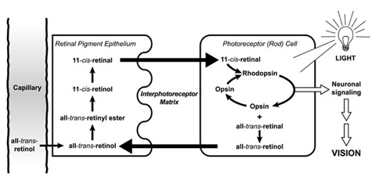
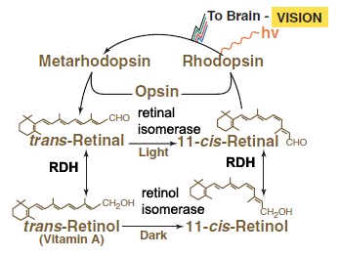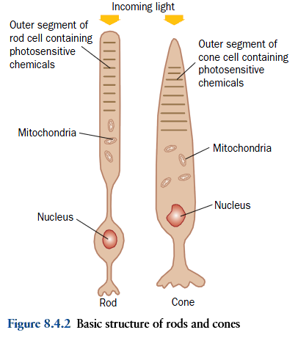
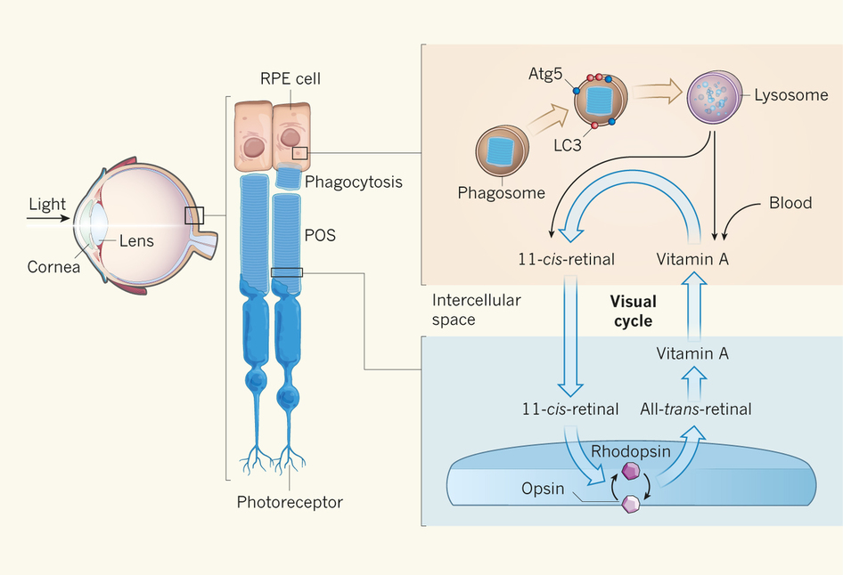
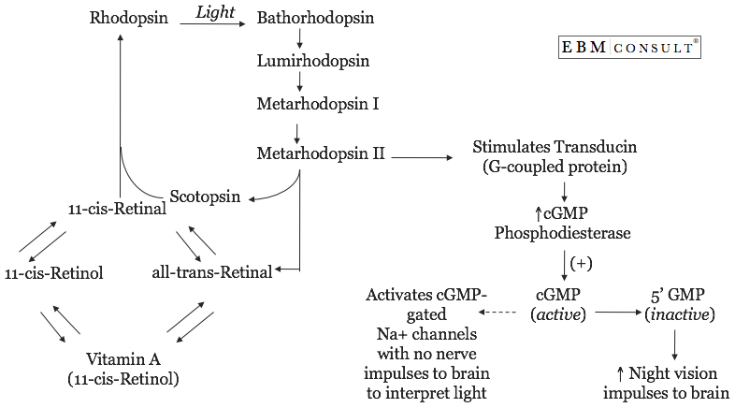
The role of vitamin A in the visual cycle is specifically related to the retinal form. Within the eye, 11-cis-retinal is bound to rhodopsin (rods) and iodopsin (cones) at conserved lysine residues. As light enters the eye, the 11-cis-retinal is isomerizes to the all-"trans" form.
The all-"trans" retinal dissociates from the opsin in a series of steps called photo-bleaching. This isomerization induces a nervous signal along the optic nerve to the visual center of the brain. After separating from opsin, the all-"trans"-retinal is recycled and converted back to the 11-"cis"-retinal form by a series of enzymatic reactions.
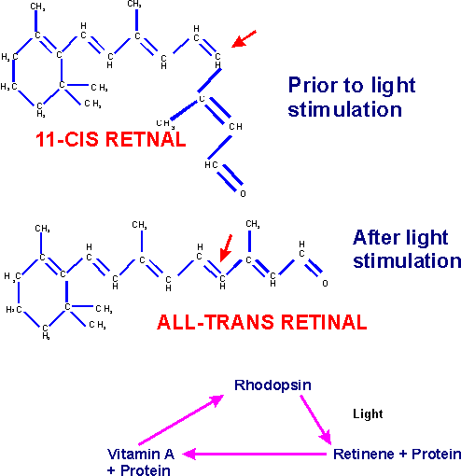
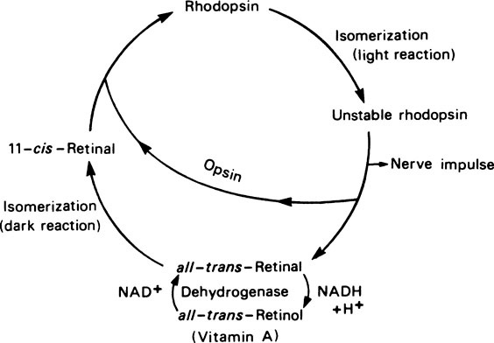
The visual cycle
In addition, some of the all-"trans" retinal may be converted to all-"trans" retinol form and then transported with an interphotoreceptor retinol-binding protein (IRBP) to the pigment epithelial cells. Further esterification into all-"trans" retinyl esters allow for storage of all-trans-retinol within the pigment epithelial cells to be reused when needed.
The final stage is conversion of 11-cis-retinal will rebind to opsin to reform rhodopsin in the retina. Rhodopsin is needed to see in low light (contrast) as well as for night vision. It is for this reason that a deficiency in vitamin A will inhibit the reformation of rhodopsin and lead to one of the first symptoms, night blindness.
Transducin (G_{t}) is a protein naturally expressed in vertebrate retina rods and cones and it is very important in vertebrate phototransduction. It is a type of heterotrimeric G-protein with different α subunits in rod and cone photoreceptors.
Light leads to conformational changes in rhodopsin, which in turn leads to the activation of transducin. Transducin activates phosphodiesterase, which results in the breakdown of cGMP. The intensity of the flash response is directly proportional to the number of transducin activated.
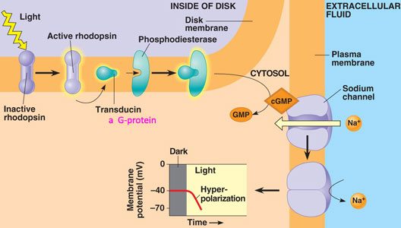
Mechanism of action of transducin:
1-Photoactivated rhodopsin, metarhodopsin III, initiates guanine nucleotide amplification. It interacts with the α-subunit of trans ducine catalyzing the exchange of bound GDP for GTP.
2-When transducine binds to GTP; the α-subunit gets dissociated from β and γ –subunits, activating the transducine (Tα-GTP complex).
3-The activated transducine in turn activate phosphodiesterase (PDE) by binding to inhibitory γ –subunit and removing this. Thus activating the α, β subunit of PDE(PDE α β).
4-The activated PDE α β then catalyzes the hydrolysis of second messenger (cGMP) to 5-AMP, lowering the c-GMP level to the plasma membrane of the outer segment, causing the Na+ channels to close.
Thus in the dark, there are high level of c-GMP, which binds to the Na+ channels, causing them to open. While the opposite in the light, photo-activated rhodopsin, through transducine and phosphodiesterase, lowers the levels of c-GMP, thus closing the most of Na+ channels.
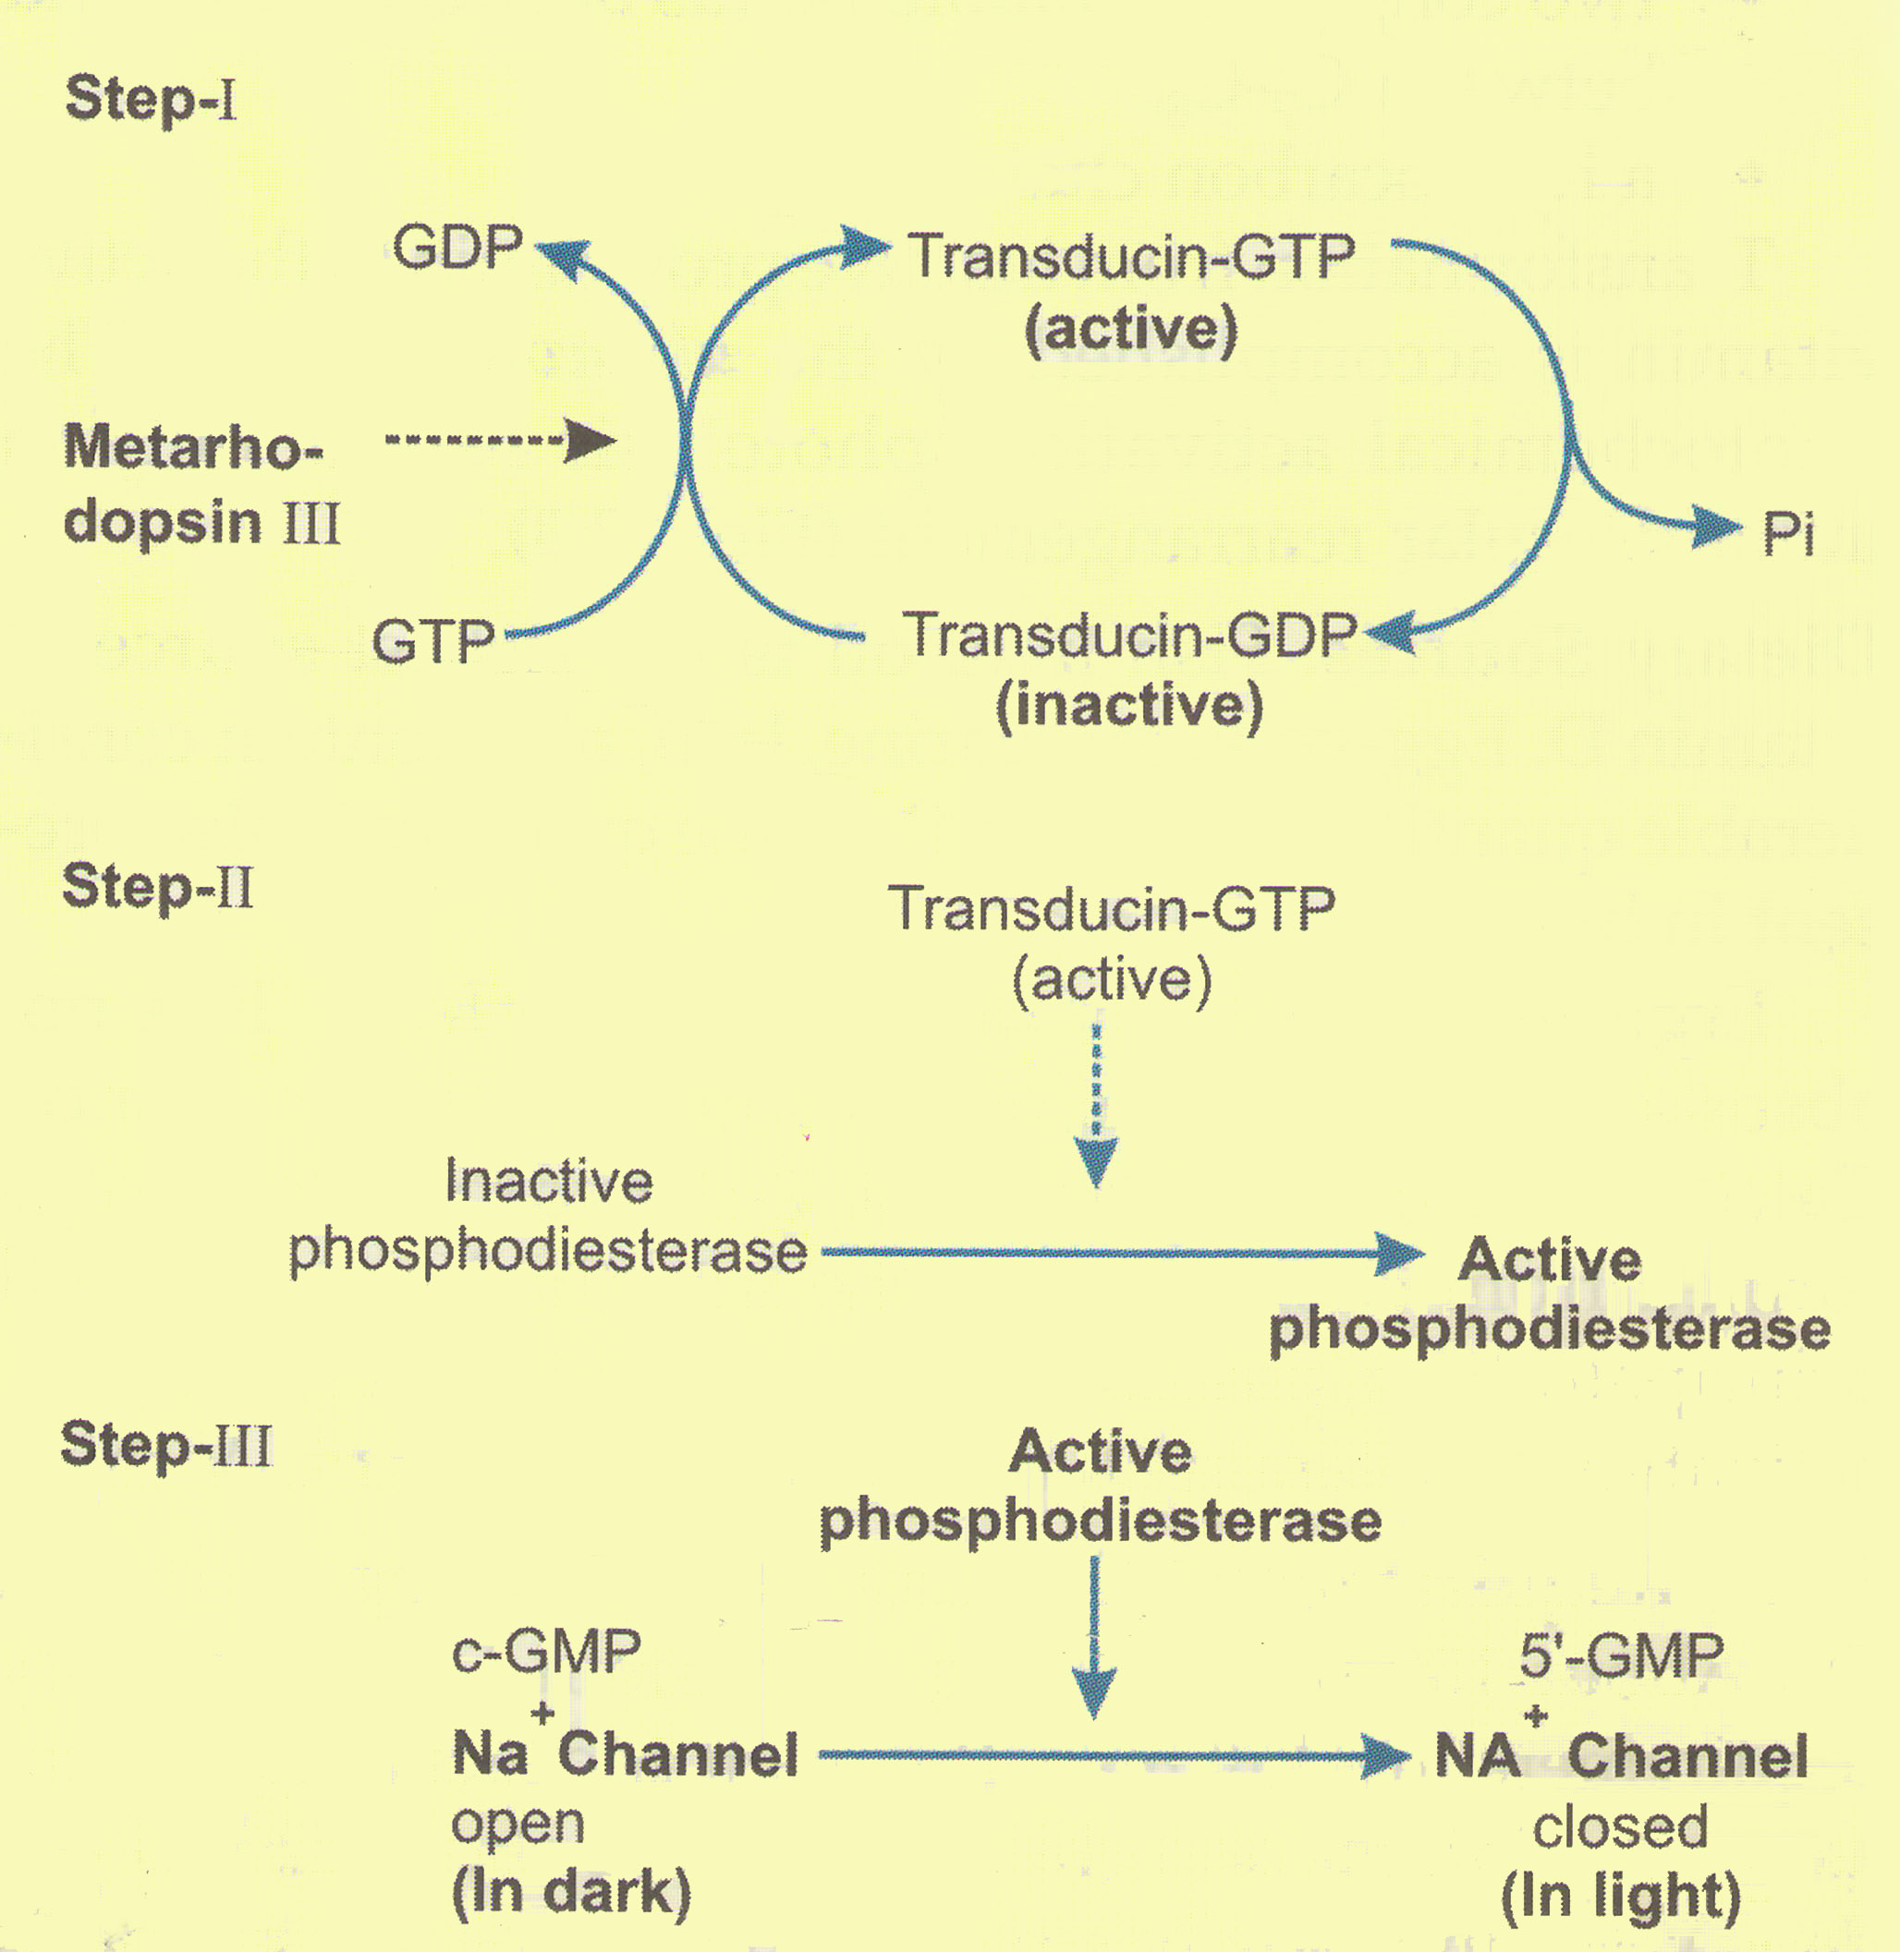
Dark adaptation mechanism: When a person shifts from a bright light to a dim light, rhodopsin stores are depleted and vision is impaired . After few minutes rhodopsin is resynthesized and vision is improved ,called as dark adaptation and is increased in Vitamin-A deficiency.
Bleaching of rhodopsin :When exposed to light, the color of rhodopsin changes from red to yellow by a process known as bleaching .
Bleaching occurs in a few milliseconds and many unstable intermediates are formed during this process .
A second very important function of vitamin A involves retinoic acid. Acting as a hormone, retinoic acid first binds to retinoic acid receptors. The receptors then interact with specific nucleotide sequences of DNA. The interaction directly affects gene expression and transcription, which in turn control cellular development and body processes. For example, epithelial cells depend on retinoic acid for structural and functional maintenance.
Deficiency:
Vitamin A deficiency can occur as either a primary or a secondary deficiency. A primary vitamin A deficiency occurs among children and adults who do not consume an adequate intake of provitamin A carotenoids from fruits and vegetables or preformed vitamin A from animal and dairy products. Early weaning from breast milk can also increase the risk of vitamin A deficiency.
Secondary vitamin A deficiency is associated with chronic malabsorption of lipids, impaired bile production and release, and chronic exposure to oxidants, such as cigarette smoke, and chronic alcoholism.
Vitamin A is a fat soluble vitamin and depends on micellar solubilization for dispersion into the small intestine, which results in poor use of vitamin A from low-fat diets. Zinc deficiency can also impair absorption, transport, and metabolism of vitamin A because it is essential for the synthesis of the vitamin A transport proteins and as the cofactor in conversion of retinol to retinal.
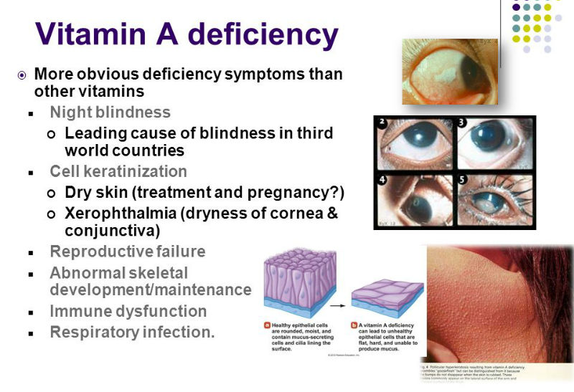
Due to the unique function of retinal as a visual chromophore, one of the earliest and specific manifestations of vitamin A deficiency is impaired vision, particularly in reduced light – night blindness. Other changes include impaired immunity (increased risk of ear infections, urinary tract infections, Meningococcal disease).
Causes for vitamin A deficiency
1-Decreased intake. 2-Obstructive jaundice causing defective absorption.
3-Cirrhosis of liver leading to reduced synthesis of RBP.
4-Severe malnutrition, where amino acids are not available for RBP synthesis.
5-Chronic nephrosis, where RBP is excreted through urine.

Assessment of deficiency
1-Dark adaptation test- it is the time required to adapt the eye to see objects in dim light,it is increased in vitamin A deficiency.
2-RBP (retinol-binding protein) level in serum is decreased.
3-Vitamin A in serum is decreased, it may be directly measured by spectrophotometry(has maximum absorption at 325 nm).

Normal blood level of vitamin A is 25 to 50 microgram / dl.

