T-Cell Function

T cells have both effector and regulatory functions:

- Effector Functions :

Cell-mediated immunity and delayed hypersensitivity reaction are produced mainly against antigens of intracellular parasites, including viruses, fungi, some protozoa, and bacteria (e.g. Mycobacteria). A deficiency in cell-mediated immunity manifests itself primarily as marked susceptibility to infection by such microorganisms and to certain tumors.
In response to allografts or tumors, CD4-positive cells can recognize foreign class II MHC molecules in addition to specific antigens and are activated. CD8-positive cytotoxic T cells then respond to the production of cytokines by CD4 cels, recognize class I MHC molecules on the " foreign " cells, and proceed to destroy those cells. In the case of virus-infected cells, the CD8 lymphocytes must recognize both virus-determined antigens and class I MHC molecules on infected cells.

Cytotoxic T cells(T c) destroy target cells:
- Recognize antigens on the surface of all cells :
    - Kill host cells that are infected with viruses or bacteria .
    - Recognize and kill cancer cells.
    - Recognize and destroy transplanted tissue.
- Release protein called perforin which forms a pore in target cell, causing lysis of infected cells.
- Undergo apoptosis when stimulating antigen is gone.

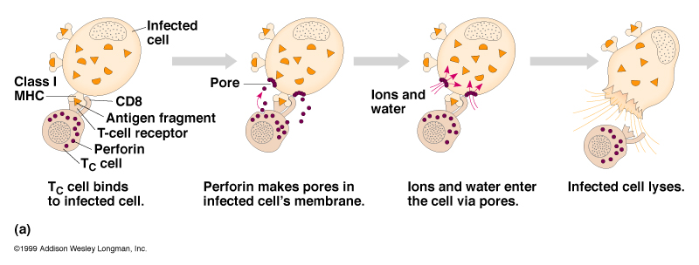

B- Regulatory Functions :

T cells play a central role in regulating both Humoral (antibody-mediated )and cellular (cell-mediated ) immunity. Antibody production by B cells usually requires the participation of T hrlper cells (T cell-dependent response ), but antibodies to some antigens (e.g. polymerized macromolecules, such as bacterial capsular polysaccharide) are the result of a T cell-independent response.
In the T cell-dependent B cell response to antigen, both B and T cells must have the same class II MHC specificity. In such T cell-dependent response the antigen interacts with IgM on the B cell surface. It is then internalized and processed. Fragments of the antigen are returned to the B cell surface in association with class II MHC molecules. These interact with the T cell receptor on the T helper cell, which produces cytokines that enhance division of the B cells and also help them to differentiate into antibody-producing plasma cells, expressing immunoglobulin of other classes (e.g. IgG, IgA). Just as for T cells, B cells require two signals for activation.
One signal is from the B cell receptor for antigen, and the second costimulatory signal results from interaction of CD40 on the B cell with CD154 (CD40 ligand) on the helper T cell.

In other cell-mediated responses, antigen is processed by macrophages, and fragments are presented in conjunction with class II MHC molecules on the macrophage surface. These interact with the T cell receptor on T helper cells, which produce cytokines to stimulate growth of appropriate CD4 (T helper ) cells.
When an imbalance exists in the number of active CD4 and CD8 cells, cellular immune mechanisms are grossly impaired. Thus, in AIDS, the normal ratio of CD4 to CD8 cells (> 1.5) is lost. Some CD4 cells are destroyed by HIV. This results in a CD4:CD8 ratio of less than 1, leading to extreme susceptibility to development of many opportunistic infections and certain tumors.

B-cell –T-cell interaction

*Reference : Jawetz, Melnick, & Adelberg's Medical Microbiology; 26th Edition; 2010
*Presented by :Dr.Zainab Fadhel Ashoor, PhD. Immunology.

