ORTHOPAEDICS
Lecture: Date: Dr. Saad Mubarak

Acetabular fractures

Mechanism of injury:
Acetabular fractures occur when the head of femur is driven into the pelvis, which caused either by a blow on the side like fall from height (FFH), or by a blow on the front of knee in dashboard injury, and usually associated with pelvic fractures.

Classification:
The most known is Tile classification:
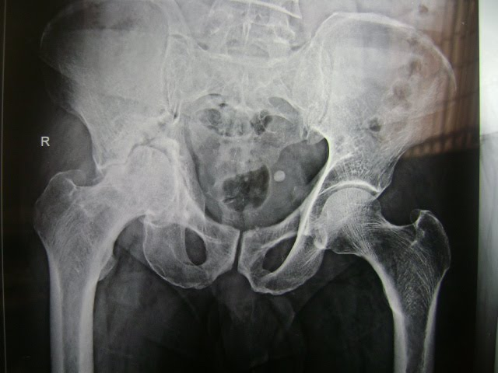
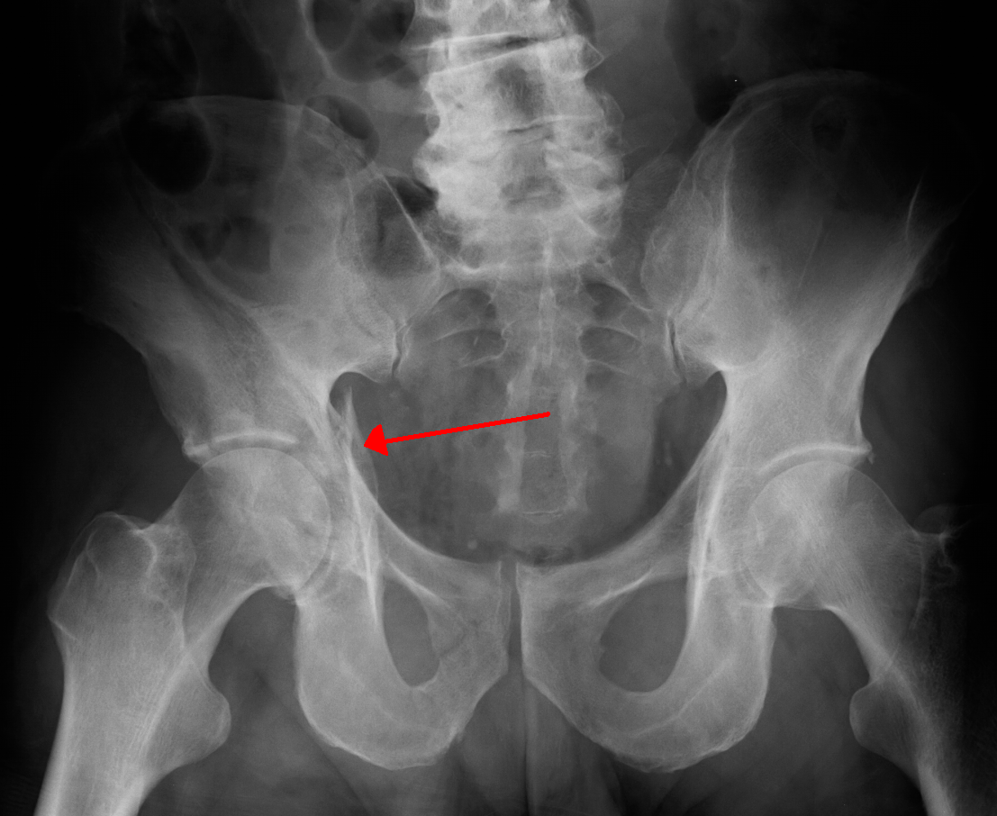
1. Acetabular wall (roof) fractures: fractures of the anterior or posterior acetabular wall will affect the depth of the socket and lead to hip instability (central hip dislocation).

2. Column fractures:
--- Anterior column fractures: extends from symphysis pubis, along the superior pubic ramus, across the anterior acetabular column to the anterior part of ilium. These fractures are uncommon, and do not involve the weight-bearing area and have a good prognosis.
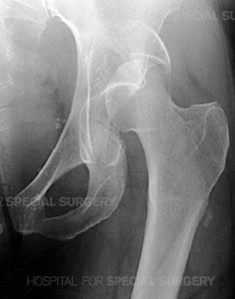
--- Posterior column fractures: extends from ischium across the posterior acetabular column to the sciatic notch and the posterior part of the ilium. It is usually breaking the weight-bearing part of acetabulum and usually associated with posterior hip dislocation and sciatic nerve injury.
3. Transverse fractures: these fractures run transversely involving both the anterior and posterior columns, separating the iliac portion from pubic and ischeal portions. Sometimes a vertical split into the obturator foramen may coexist resulting in a T-fracture.

4. Complex fractures: many acetabular fractures are complex injuries with damage to the anterior and posterior columns as well as the roof of acetabulum.
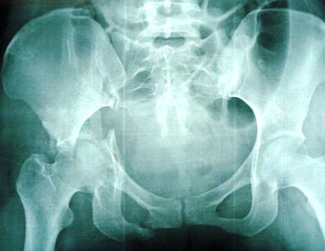

Clinical features:
The same clinical features of the pelvic fractures. The patient may be severely shocked, rectal examination is essential, there may be a bruising around the hip and the limb may lie in internal rotation (hip dislocation). Careful neurological examination is essential.

Imaging:
AP, pelvic inlet and outlet views, and 45 degree right and left oblique views are essential. CT-scan and 3-dimentional reformation scan are particularly helpful if surgical reconstruction is planned.

Management:
1. Emergency treatment: counteract shock and reduce dislocation, then traction is applied to the lower limb (10 kg). Sometimes lateral traction through greater trochanter is needed for central dislocation, and the definitive treatment is delayed until the general condition of the patient is stable.
2. Non-operative treatment: conservative treatment is indicated in:
a. Acetabular fracture with no or minimal displacement (< 3mm).
b. Displaced fractures that do not involve the superomedial weight-bearing roof of the acetabulum.
c. Both column fractures that retain the ball and socket congruence of hip.
d. Fractures in elderly patients.
e. Patients with medical contraindications to surgery.
f. When the traction is released, the hip should remain congruent.
The conservative treatments include closed reduction under general anesthesia (GA), skeletal traction supported with lateral traction is maintained for 6-8 weeks and hip movement and exercises are encouraged, then the patient is allowed up with crutches and partial weight-bearing for another 6 weeks and then full weight-bearing.

3. Operative treatment:
In recent years opinion has moved in favor of operative treatment for displaced acetabular fractures except the indications for conservative treatment.
The posterior Kocher-Langenbach approach allows good access to the posterior wall and column fractures. The ilioinguinal approach is suitable for anterior wall and column fractures. Both approaches may be needed in both column fractures and T-fractures.
Prophylactic antibiotics are needed; post-operative hip movements are started as soon as possible. The patient starts partial weight-bearing 7 days post-operatively, and exercises are continued for 3-6 months.

Complications:
1. Iliofemoral venous thrombosis is fairly common and serious.
2. Sciatic nerve injury may occur either at the time of fracture or during the subsequent operation. The treatment is waiting for 6 weeks to see if there is any sign of recovery, if not, the nerve should be explored.
3. Heterotopic bone formation is common after acetabular injuries and operations, prophylactic indomethacin is useful.
4. Avascular necrosis of the femoral head.
5. Loss of joint movement and secondary osteoarthritis are common complications after displaced acetabular fractures especially those involving the weight-bearing portion of the joint.

Sacrococcygeal injuries

Mechanism of injury:
A trauma from behind, or fall onto the tail, may fracture the sacrum or coccyx or sprain the joint between them.

Clinical features:
Clinically, there is tenderness when the sacrum or coccyx is palpated from behind or per rectum.

Imaging:
X-ray showed transverse fracture of the sacrum or fracture coccyx or a normal appearance if the joint was a sprain of the sacrococcygeal joint.

Treatment:
If the fracture is displaced, reduction is done, the lower fragment may be pushed backwards by a finger in the rectum, the patient is advised to use a rubber-ring cushion when sitting.
Rarely sacral fractures associated with urinary problems, necessitating sacral laminectomy.
Persistent pain is common after coccygeal injuries, especially on sitting, and the treatment is by analgesia, cushion, local injection of anesthetic and steroids, and if not relieved, excision of the coccyx is considered.
-------------------------------------------------------------------------------------------

