Antibody-Mediated ( Humoral ) Immunity

Antibody responses in vivo :
Lag phase : Following primary antigenic challenge, there is an initial lag phase when no antibody can be detected, This is followed by

Log phase : in which the antibody titer increases logarithmically to a plateau. Then

Decline phase : The decline occurs because antibodies are either naturally catabolized or bind to antigen and are cleared from the circulation .
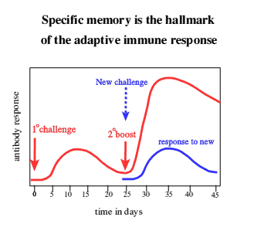

The Primary Response :
When an individual encounters an antigen for the first time, antibody to that antigen is detectable in the serum within days or weeks depending on the nature and dose of antigen and the route of administration ( e.g. oral, parenteral ).
The serum antibody concentration continues to rise for several weeks and then declines; it may drop to very low levels.
The first antibodies formed are IgM, followed by IgG, IgA, or both .
IgM levels tend to decline sooner than IgG levels .

The Secondary Response :
In the event of a second encounter with the same antigen ( or closely related " cross-reacting" one ) months or years after the primary response, the antibody response is more rapid and rises to higher levels than during the primary response .
This change in response is attributed to the persistence of antigen-sensitive "memory cells" following the first immune response.
In the secondary response, the amount of IgM produced is qualitatively similar to that produced after the first contact with the antigen ; however, much more IgG is produced, and the level of IgG tends to persist much longer than in primary response. Such antibody tends to bind antigen more firmly (i.e. ,to have higher affinity ) and thus to dissociate less easily .
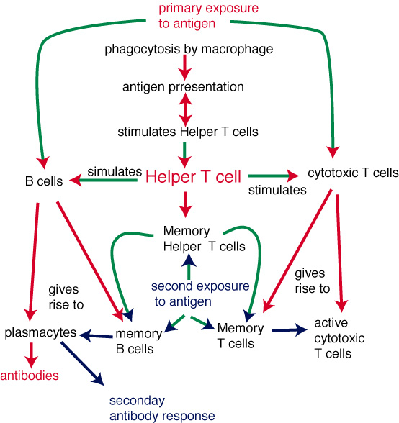

Responses following primary and secondary antigenic challenge shows that the responses differ in four major respects :
- Time course .
- Antibody titer .
- Antibody classes .
- Antibody affinity .

Binding Forces between Antigens and Antibodies :
Because of the close structural complementarily between antibodies and the antigens that elicited them, the two tend to bind to each other whenever they meet in vitro or in vivo .This binding is non covalent and involves electrostatics, Van der Waals, and other weak forces as well as hydrogen and other bonds .

Protective Functions of Antibodies :

- Opsonization : Antibodies can produce resistance to infection by opsonizing ( coating ) organisms, which makes them more readily ingested by phagocytes .
- Antibodies can bind to viruses and reduce their ability to bind to cellular receptor molecules and invade host cells.
- Antibodies can neutralize toxins of microorganisms ( e.g. diphtheria, tetanus, and botulism ) and inactivate their harmful effects .

Passive Immunization :
Antibodies can be administrated passively ( i.e. performed in another host ), which makes them immediately available for preventive or therapeutic purposes . This approach has been used in the management of "needle stick "injuries in individuals not vaccinated against hepatitis B.

Active Immunization :
Antibodies can be induced actively in the host by administering appropriate antigens or preparations containing them (toxoids of diphtheria ,tetanus ), but protection is delayed until the antibodies reach helpful concentrations .

Antibody – mediated immunity against bacteria is most effective when directed against microbial infections in which virulence is related to polysaccharide capsules ( e.g. Pneumooccus, Haemophilus, Neisseria).
In such infections, antibodies complex with the capsular antigens and make the organisms susceptible to antigens by phagocytic cells and destruction within the cells.
The binding of antibodies to antigens leads to the formation of immune complexes, and the deposition of such complexes may be an important feature in the development of organ dysfunction, e.g. poststreptococcal glomerulonephritis.

********************

*Reference : Jawetz, Melnick, & Adelberg's Medical Microbiology; 26th Edition; 2010
*Presented by :Dr.Zainab Fadhel Ashoor, PhD. Immunology.

