[ Antigen Processing & Presentation]

The Immunoglobulin Super gene Family :

All the molecules discussed ( Antibodies, the T-cell receptors, and MHC proteins ) have structural functions in common. All of these molecules- and a long list of other immunologically relevant molecules, including the T-cell subpopulation markers CD4 and CD8- have a domain structure built on the three- dimensional feature known as the Immunoglobulin fold .
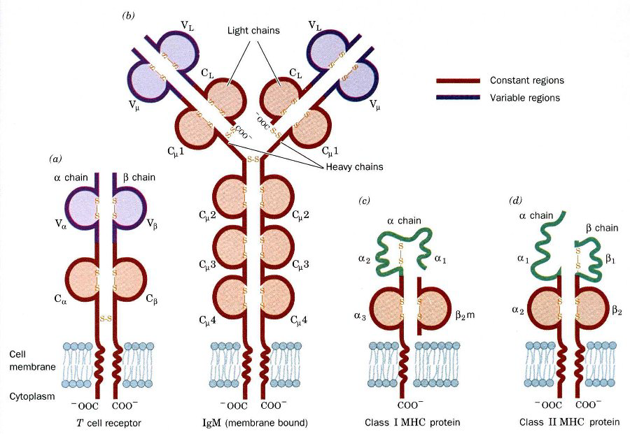

Antigen Processing & Presentation :

Ag processing and presentation are the means by which antigens become associated with self MHC molecules for presentation to T-cells with appropriate receptors .

Exogenous antigens :

Proteins from exogenous antigens, such as bacteria, are internalized via endocytic vesicles into APC such as macrophages. Then, they are exposed to cellular proteases in intracellular vesicles .
Peptides, approximately 10 to 30 amino acid residues in length, are generated in endosomal vesicles .The endosoml vesicles can then fuse with exocytic vesicles containing class II MHC molecules.
The class II MHC molecules are synthesized, as for other membrane glycoproteins, in the rough endoplasmic reticulum (RER) and then proceed out through the Golgi apparatus.
A third polypeptide, the invariant chain (Ii), protects the binding site of the Class II αβ dimmer until the lowered pH of the compartment created after fusion with an endosomal vesicles causes a dissociation of the Ii chain . The MHC class II –peptide antigen complex is then transported to the surface for display and recognition by a T cell receptor of a CD4 T-cell.

Endogenous antigens :

e.g. cytosolic viral proteins synthesized in an infected cells, are processed for presentation by class I MHC molecules.
Cytosolic proteins are broken down by a peptidase complex known as proteasome . The cytosolic peptides gain access to nascent MHC class I molecules in the RER via peptide transporter systems ( transporters associated with antigen presenting . The TAP genes are also encoded in the MHC.
Within the lumen of the endoplasmic reticulum, peptide Ags approximately 8 to 11 residues in length complex with nascent MHC class II proteins and cooperate with β₂-microgloulin to create a stable, fully folded MHC class I- peptide Ag complex. Then transported to the cell surface for display and recognition by CD8 cytotoxic T-cells .

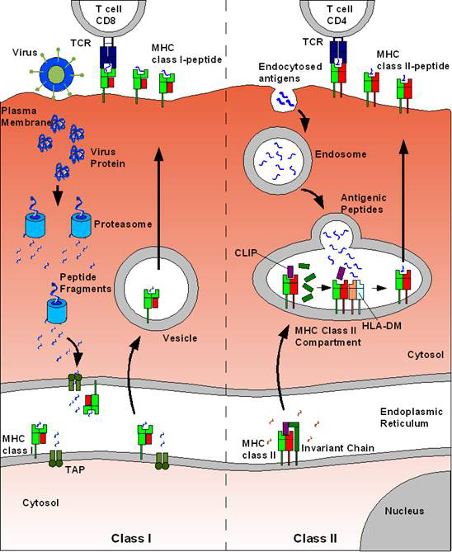

The binding groove of the class I molecules is more constrained than of the class II molecules, and for that reason shorter peptides are found in class I than in class II MHC molecules .
T-cells do not respond to carbohydrate antigens, because they would not fit in the groove. T-cells recognize only linear antigenic determinants; they respond only to proteolytically processed antigen .

Several viruses attempt to defeat the immune response by interfering with the antigen-processing pathways, for example
an HIV Tat protein is able to inhibit expression of class I molecule.
A herpesvirus protein binds to the transporter proteins (TAPs), preventing transport of viral peptides into the endoplasmic reticulum where class I molecules are being synthesized .

Super antigens :

A group of molecules, which bind to MHC molecules outside the peptide- binding cleft and can activate T-cells non-specifically .
One consequence is that whereas an individual peptide complexed to an MHC molecule will normally stimulate only a small percentage of the T-cells in an individual, superantigens cause up to 10% of T-cells to be non-specifically activated .

Examples of Superantigens : include certain bacterial toxins, including the staphylococci enterotoxins, toxic shock syndrome toxin, and group A streptococcal pyrogenic exotoxin A .

Mechanism of action :These Ags bind to the "outside" of the MHC protein and to the T cell receptor.
They are active at very low concentration (10⁻⁹ mol/L) and cause cell expressing particular Vβ sequences to be stimulated and to release large amounts of cytokines, including IL-1 and TNF .
The release of large amounts of cytokines from stimulation of a high percentage of the pool of T lymphocytes that explains to a large extent the pathogenesis of diseases caused by organisms expressing superantigens .

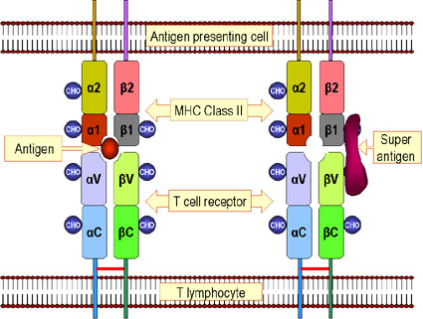

*Reference : Jawetz, Melnick, & Adelberg's Medical Microbiology; 26th Edition; 2010
*Presented by :Dr.Zainab Fadhel Ashoor, PhD. Immunology.

