Lecture: Date: Dr. Saad Mubarak
Injuries of the spine

Stable and unstable injuries

A stable injury is one in which the vertebral components will not be displaced by normal movements and the neural elements are undamaged. An unstable injury is one in which there is a significant risk of displacement and consequent damage to the neural tissues.

In assessing spinal stability, three structural elements must be considered:

--- The posterior osseoligamentous complex (or posterior column) consisting of the pedicles, facet joints, posterior bony arch, interspinous and supraspinous ligaments.

---The middle column comprising the posterior half of the vertebral body, the posterior part of the intervertebral disc and the posterior longitudinal ligament.

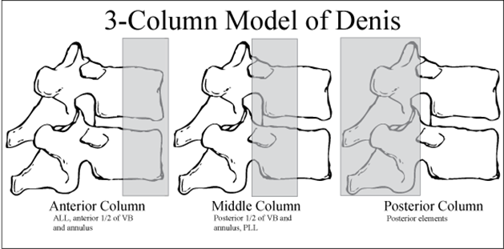
---The anterior column composed of the anterior half of the vertebral body, the anterior part of the intervertebral disc and the anterior longitudinal ligament (Denis classification).

If 2 out of 3 columns are injured, then the injury is unstable (the middle column should be involved).

Only 10 per cent of spinal fractures are unstable and less than 5 per cent are associated with cord damage.

Mechanism of injury:
There are three basic mechanisms of injury: traction (avulsion), direct injury and indirect injury.

---In the cervical spine the seventh spinous process can be avulsed (clayshoveller's fracture).
---Direct injury: Penetrating injuries to the spine, particularly from bullets are common.
---Indirect injury: This is the most common cause of significant spinal damage; it occurs most typically in a fall from a height when the spinal column collapses in its vertical axis, or else during violent free movements of the neck or trunk. A variety of forces may be applied to the spine (often simultaneously): axial compression, flexion, lateral compression, flexion-rotation, shear, and extension.
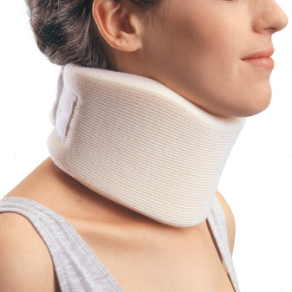
Principles of immobilization:
---ABC.
---A backboard, sandbags, a forehead tape, spinal board and a semi-rigid collar are applied.
---If the back is to be examined, or if the patient is to be placed onto a scoop stretcher or spinal board, the logrolling technique should be used.

Principle of management:
---Reduction.
---Stabilization (holding).
---Rehabilitation (execises).

Patients with no neurological injury:
---Stable injuries: If the spinal injury is stable, the patient is treated by supporting the spine in a position that will cause no further strain; a firm collar or lumbar brace will usually suffice, but the patient may need to rest in bed until pain and muscle spasm subside.
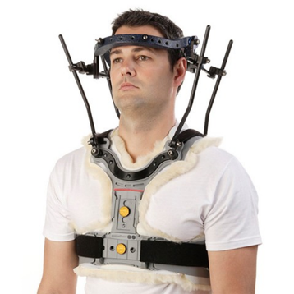
---Unstable injuries: If the spinal injury is unstable it should be held secure until the tissues heal and the spine becomes stable. In the cervical spine this should be done as soon as possible by traction, using tongs or a halo device attached to the skull. If the halo is attached to a body cast the combination can be used as an external fixator for prolonged immobilization. Alternatively (particularly in the thoracolumbar spine) internal fixation can be carried out.
Patients with a neurological injury: (spinal shock)
---Stable injuries: (which is rare), the patient can be treated conservatively and rehabilitated as soon as possible.
---Unstable injury: the benefit of surgery on ease and speed of rehabilitation.

C1 ring fracture (Jefferson's fracture)

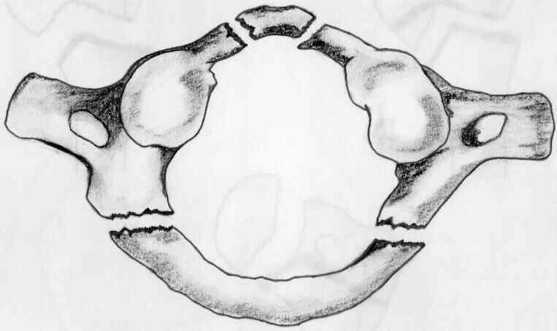
Sudden severe load on the top of the head may cause a bursting force which fractures the ring of the atlas (Jefferson's fracture). There is no encroachment on the neural canal and, usually, no neurological damage.
The fracture is seen on the open-mouth view (if the lateral masses are spread away from the odontoid peg) and the lateral view. A CT scan is particularly helpful in defining the fracture.
If it is undisplaced, the injury is stable and the patient wears a semi-rigid collar or halo-vest until the fracture unites. If there is sideways spreading of the lateral masses (more than 7 mm on the open-mouth view), the transverse ligament has ruptured; this injury is unstable and should be treated by a halo-vest for several weeks. If there is persisting instability on x-ray, a posterior C1/2 fixation and fusion is needed.

C2 fractures (Hangman's fracture)

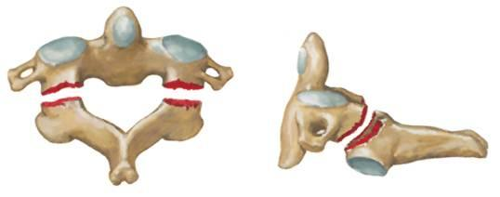
In the true suicidal hangman's fracture there are bilateral fractures of the pars interarticularis (pedicle) of C2 and the C2/3 disc is torn; the mechanism is extension with distraction.
---Undisplaced fractures which are shown to be stable on supervised flexion–extension views (less than 3mm of C2/3 subluxation) can be treated in a semi-rigid orthosis until united (usually 6–12 weeks).
---Fractures with more than 3mm displacement but no kyphotic angulation may need reduction, after reduction, the neck is held in a halo-vest until union occurs.

C2 Odontoid process fracture

Odontoid fractures have been classified:
Type I – An avulsion fracture of the tip of the odontoid process due to traction by the alar ligaments. The fracture is stable (above the transverse ligament) and unites without difficulty.
Type II – A fracture at the junction of the odontoid process and the body of the axis. This is the most common (and potentially the most dangerous) type. The fracture is unstable and prone to non-union.
Type III – A fracture through the body of the axis. The fracture is stable and almost always unites with immobilization.
Treatment:
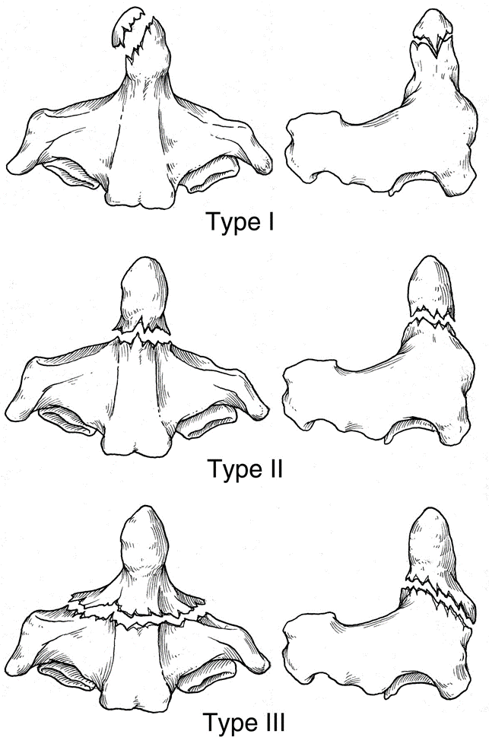
---Type I fractures: Isolated fractures of the odontoid tip are uncommon. They need no more than immobilization in a rigid collar until discomfort subsides.
---Type II fractures: These are often unstable and prone to non-union, especially if displaced more than 5 mm.
Undisplaced fractures can be held by fitting a halo-vest.
Displaced fractures should be reduced by traction and can then be held by operative posterior C1/2 fusion.
---Type III fractures: If undisplaced, these are treated in a halo-vest for 8–12 weeks. If displaced, attempts should be made at reducing the fracture by halo traction, the neck is then immobilized in a halo-vest for 8–12 weeks.

C3 to C7 fractures

Wedge compression fracture:
A pure flexion injury results in a wedge compression fracture of the vertebral body. The middle and posterior elements remain intact and the injury is stable. All that is needed is a collar for 6–12 weeks.

Burst and compression-flexion (‘teardrop’) fractures:
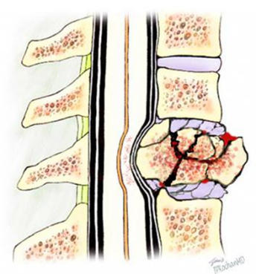
These severe injuries are due to axial compression of the cervical spine, usually in diving or athletic accidents. If the vertebral body is crushed in neutral position of the neck the result is a (burst fracture). With combined axial compression and flexion, an antero-inferior fragment of the vertebral body is sheared off, producing the (tear-drop) on the lateral x-ray. In both types of fracture there is a risk of posterior displacement of the vertebral body fragment and spinal cord injury.
Treatment: If there is no neurological deficit, the patient can be treated by confinement to bed and traction for 2–4 weeks, followed by a further period of immobilization in a halo-vest for 6–8 weeks. If there is any deterioration of neurological status, urgent anterior decompression, anterior corpectomy, bone grafting and plate fixation, and sometimes also posterior stabilization.

Facet joint fracture-dislocations:
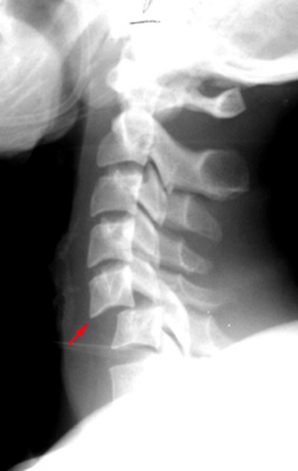
Bilateral facet joint dislocations are caused by severe flexion–rotation injuries. The inferior articular facets of one vertebra ride forward over the superior facets of the vertebra below.
The displacement must be reduced urgently. Skull traction is used, starting with 5 kg and increasing it step-wise by similar amounts up to about 30kg. The entire procedure should be done without anaesthesia (or under mild sedation and muscle relaxant only) and neurological examination should be repeated after each incremental step. If neurological symptoms or signs develop, or increase, further attempts at closed reduction should be stopped. When x-rays show that the dislocation has been reduced, traction is diminished to about 5 kg and then maintained for 6 weeks. Posterior open reduction and fusion is indicated if closed reduction fails.

Hyperextension injury:
The posterior bone elements are compressed and may fracture; the anterior structures fail in tension, with tearing of the anterior longitudinal ligament or an avulsion fracture of the anterosuperior or anteroinferior edge of the vertebral body, opening up of the anterior part of the disc space, fracture of the back of the vertebral body and/or damage to the intervertebral disc.
These injuries are stable in the neutral position, in which they should be held by a collar for 6–8 weeks. Healing may lead to spontaneous fusion between adjacent vertebral bodies.

SPRAINED NECK (WHIPLASH INJURY)

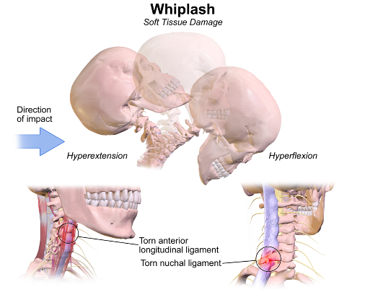
There is usually a history of a low velocity rear-end collision in which the occupant's body is forced against the car seat while his or her head flips backwards and then recoils in flexion. Women are affected more often than men. Pain and stiffness is common. Neck muscles are tender and movements often restricted. X-ray examination may show straightening out of the normal cervical lordosis, a sign of muscle spasm. Treatment is by Collar, analgesic medication, and graded exercises.

SCIWORA is an acronym for spinal cord injury without obvious radiographic abnormality. Normal radiographs in children do not exclude the possibility of spinal cord injury.

