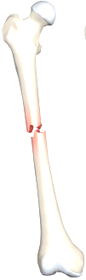
Lecture: Date: Dr. Saad Mubarak

Injuries of pelvis

It accounts about 5 % of skeletal injuries. 2/3 of pelvic injuries occur due to road traffic accident (RTA), 10 % of those are associated with visceral injuries with 10 % mortality rate.
Pelvic injuries are particularly important because of the high incidence of associated soft tissue injuries, severe blood loss, shock, sepsis, and adult respiratory distress syndrome (ARDS).

Anatomy and introduction:
The pelvic ring is made up of the 2 innominate bones and the sacrum, articulating anteroirly by the symphysis pubis and posteriorly by the sacroiliac joints.
The blood vessels which are common iliac arteries and veins and their branches and the nerves of lumber and sacral plexuses are vulnerable to injury with posterior pelvic ring injuries.
In severe pelvic injuries, the membranous urethra is damaged when the prostate is forced posteriorly while the urethra remains static.
The pelvic colon with its mesentery is a mobile structure and therefore not readily injured, while the rectum anal canal are more firmly tethered to the urogenital structures and are therefore vulnerable in pelvic fractures.
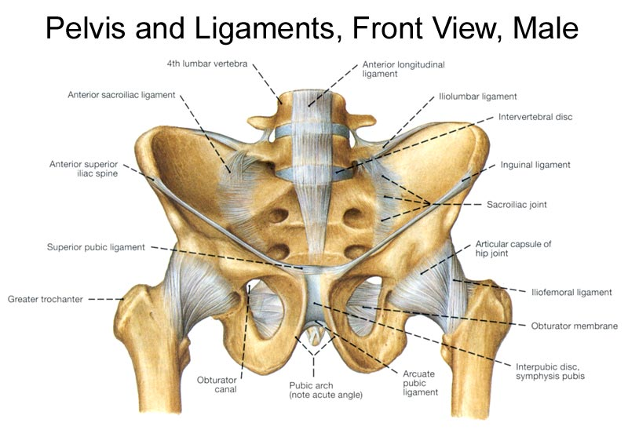

Pelvic stability:
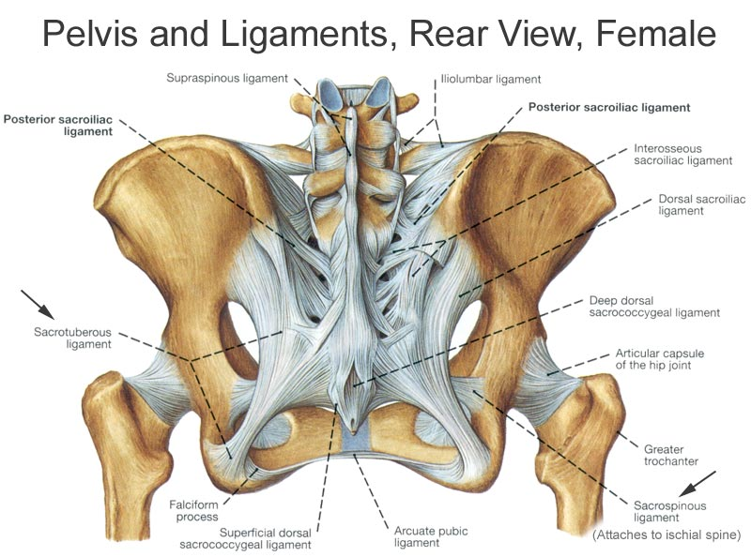
The stability of pelvic ring depends on the rigidity of the bony parts and the integrity of ligaments. The strongest and the most important ligaments are the sacroiliac and iliolumber ligaments and supported by sacrotuberous and sacrospinous ligaments and the ligaments of symphysis pubis.

If the pelvis can withstand weight-bearing loads without displacement, it is stable. If an anterior force is applied to the pelvic ring, the ligament of symphysis pubis fails, and if the force is stronger, open-book pelvic separation will occur, and if the force is further stronger, there will be failure of the anterior sacroiliac and sacrotuberous ligaments of the sacroiliac joints. This will lead to anteroposterior rotational instability of pelvic ring.
If the posterior sacroiliac and sacrotuberous ligaments are also damaged, there will be separation of 2 halves of pelvis which lead to vertical instability.

Types of pelvic injuries:
--- Isolated fractures with an intact pelvic ring.
--- Fracture of pelvic ring (stable and unstable).
--- Acetabular fractures.
--- Sacrococcygeal fractures.

Isolated pelvic fractures

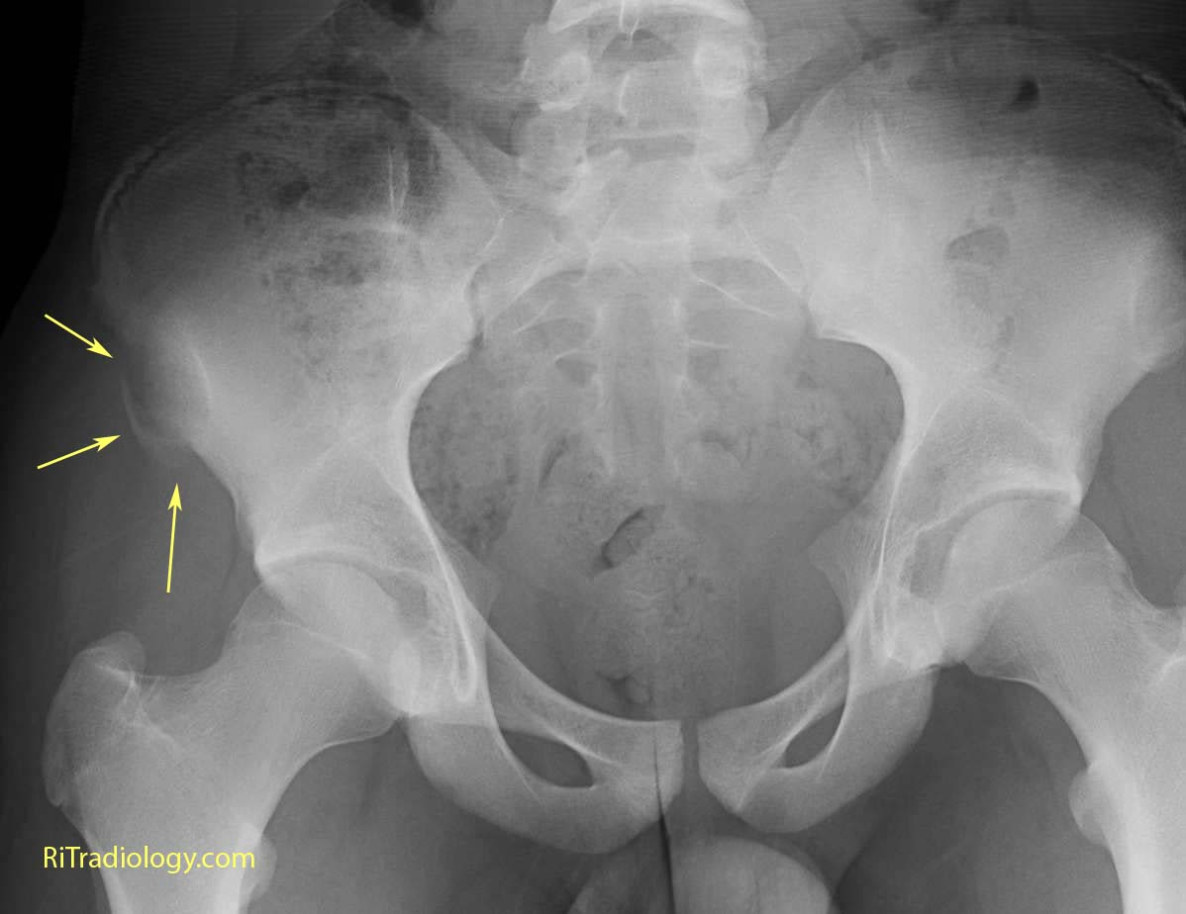
Avulsion fractures:
A piece of bone is pulled off by violent muscle contraction; this is usually seen in athletes, e.g. the anterior superior iliac spine can be pulled off by sartorius muscle, the anterior inferior iliac spine by rectus femoris muscle, the pubis by adductor longus muscle, and part of ischium by hamstring muscle.
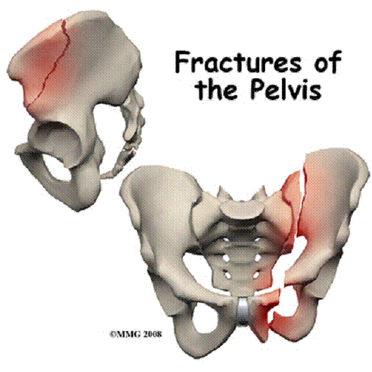
The treatment is by rest for few days and analgesia. If pain is persists especially avulsion injury of ischeal apophysis by the hamstring, open reduction and internal fixation is indicated.

Direct fractures:
A direct trauma to the pelvis leads to ischeal fracture or fracture iliac blade. The treatment is by bed rest and analgesia.

Stress fractures:
Fracture pubic rami are common especially in osteoporotic patients. Other example is stress fracture around the sacroiliac joints. In difficult cases the fractures can be demonstrated by radioisotope scanning.

Pelvic ring fractures

Mechanism of injury:
--- Anteroposterior compression: injury caused by frontal collision, the pubic rami fractured and the innominate bones externally rotated which lead to open-book injury.

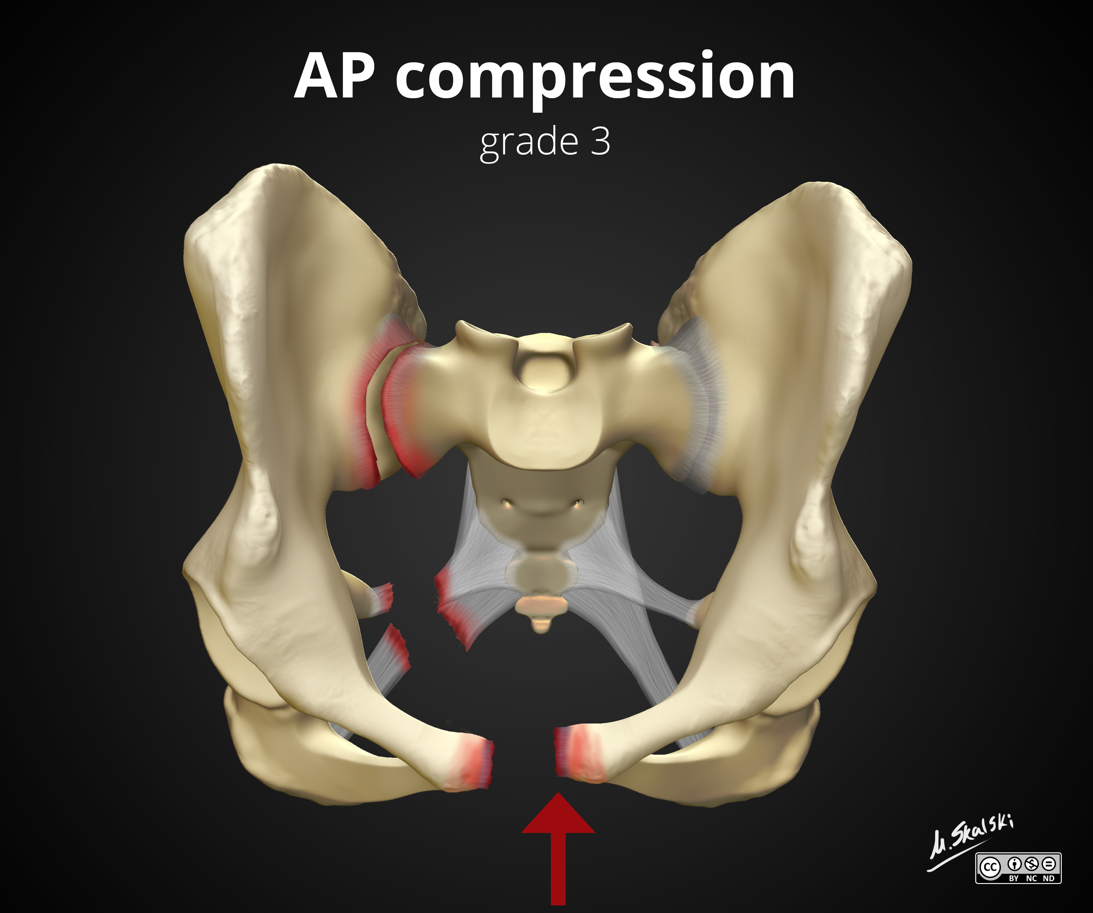
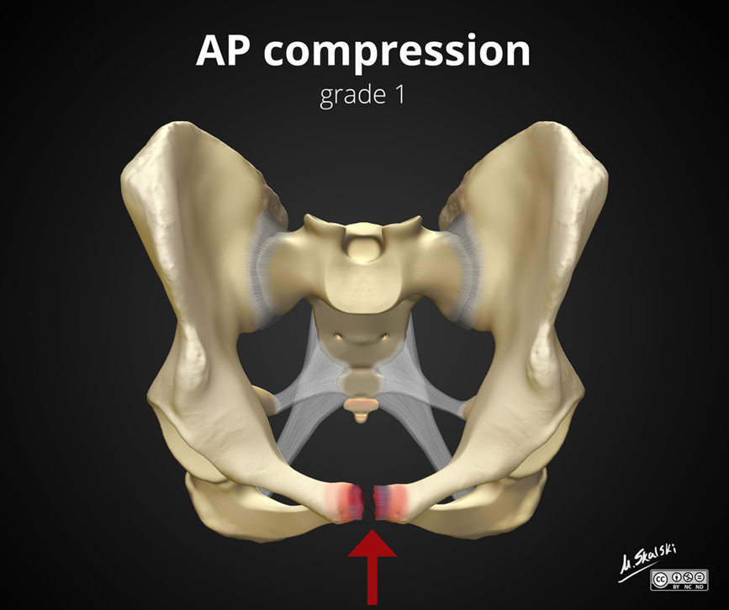

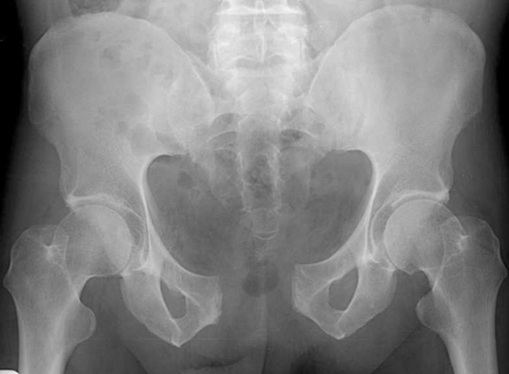

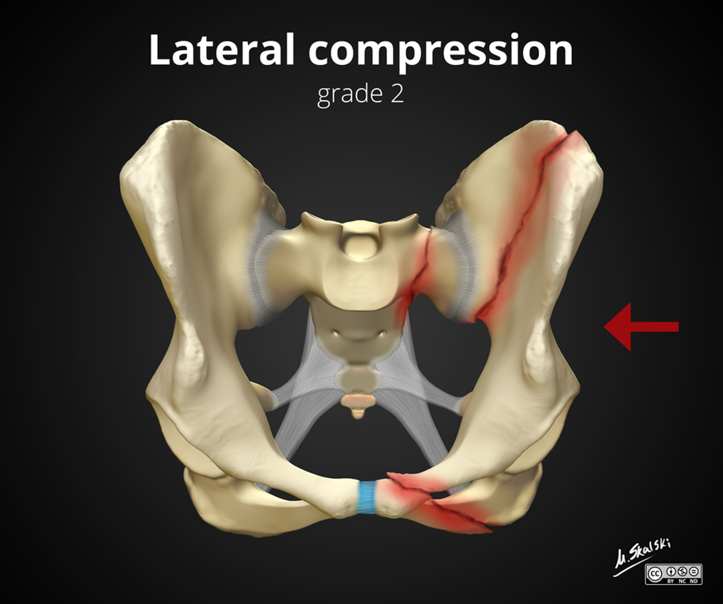
--- Lateral compression: side-to-side compression of the pelvis caused the ring to buckle and break either due to RTA or fall from height (FFH).
Anteriorly there is fracture of one or both pubic rami and posteriorly there is severe sacroiliac strain or a fracture of sacrum of ilium.
--- Vertical shear: the innominate bone on one side is displaced vertically, fracturing the pubic rami and disturbing the sacroiliac region on the same side.

--- Combination injuries.

Classification:
Stable and unstable fractures: A stable pelvic ring injury is usually defined as one that will allow full weightbearing without the risk of pelvic deformity. Of course one cannot actually perform the test in an acutely injured patient. We can differentiate between the two by using this classification.
Young and Burgess classification:
A. Anteroposteroir compression (open-book):
I- There is only slight (< 2 cm) diastasis of the symphysis, the pelvic ring is stable.
II- There is diastasis > 2 cm with tear of the anterior sacroiliac ligaments. The pelvic ring is stable.
III- There is diastasis of symphysis pubis and tear of both the anterior and posterior sacroiliac ligaments. The ring is unstable.
B. Lateral compression:
I- There is transverse fracture of pubic ramus, the ring is stable.
II- There is, in addition to the anterior fracture, a fracture of the iliac wing on the side of the impact, and the ring is stable.
III- There is fracture of pubic ramus (rami) with iliac wing and contralateral fracture of ilium. The ring is unstable.
C. Vertical shear:
The hemipelvis is displaced in vertical direction. The pelvic ring is unstable.
D. combination of injuries.

Clinical features:
1. The ring is stable:
Pain with walking, there is no shock, localized tenderness, with no damage to pelvic viscera, when the pelvic ring is gently compressed from side-to-side and back-to-front there will be moderate pain.
Rectal examination is essential, the sacrum and coccyx should be tested for tenderness, abnormal high prostate suggest urethral injury.
Inability to urinate or a blood at the external meatus is classic sign of ruptured urethra.
The abdomen should be palpated; any signs of irritation suggest the possibility of intraabdominal bleeding.
Neurological examination is important; there may be damage to the lumber or sacral plexuses.
2. The ring is unstable:
The patient is severely shocked, great pain and unable to walk. Pushing or pulling of one lower limb may reveal vertical instability. There may be associated visceral damage, intraabdominal and retroperitoneal hemorrhage, sepsis, and ARDS.

Imaging:
5 views of X-ray are necessary: AP, pelvic inlet view (the tube superior to the pelvis and tilted 30 degree downward), pelvic outlet view (the tube inferior to pelvis and tilted 40 degree upward), right, and left pelvic oblique views.

CT-scan is essential in posterior pelvic ring disruptions and for complex acetabular fractures.
Intravenous urography is performed to exclude renal and ureteric injuries.
When urethral injury is suspected, urethrography should be done.
Cystography is done to exclude bladder injury.

Management:
1. Early management:
Ensure that the airway is clear and ventilation is unimpaired, active bleeding is controlled (ABC). If the patient's general condition is stable, a more careful examination is then carried out, paying attention to the pelvis, abdomen, perineum, and rectum. The urethral meatus is inspected for signs of bleeding. The lower limbs are examined for signs of nerve injury.

2. Management of severe bleeding:
Two i.v. lines should put, i.v. fluid and plasma expander given, cross-matched blood prepared and given to the patient.
Pelvic bleeding will be reduced rapidly by applying an external fixator or pelvic binder.
Patients with suspicious abdominal signs should be further investigated by peritoneal aspiration or lavage. If there is diagnostic tap, explorative laprotomy should be done.
Large retroperitoneal hemorrhage should not be open, because it produces a tamponade effect. Pressure packing can be applied to compress the vessels. Sometimes angiography and embolization are done for continuing bleeding.

3. Management of urethral and bladder injury:
Urological injuries occur in 10 % of patients with pelvic ring injury.
There is no place for passing a diagnostic catheter (Foley's catheter) as this will convert any partial to complete tear.
For partial tear, the insertion of suprapubic catheter is required and will be healed and little need further long term management.

For complete tear, primary realignment of the urethra may be achieved by performing suprapubic cystostomy, evacuating the pelvic hematoma, and then threading a catheter across the injury to drain the bladder, if the bladder floating high (which mean prostate dislocation) it is repositioned and held down by a sling suture and deal with stricture of urethra 4-6 months later.

4. Management of fracture:
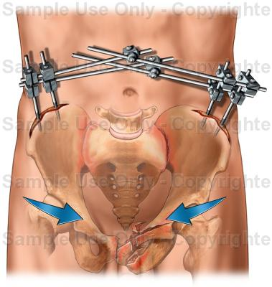
--- For isolated and minimally displaced fractures (stable fractures), bed rest and lower limb traction (skeletal traction), then 4-6 weeks the patient can use crutches for walking at first partial then full weight-bearing.

--- Open-book injuries can be treated by bed rest and posterior sling to close the book (hammock sling traction).

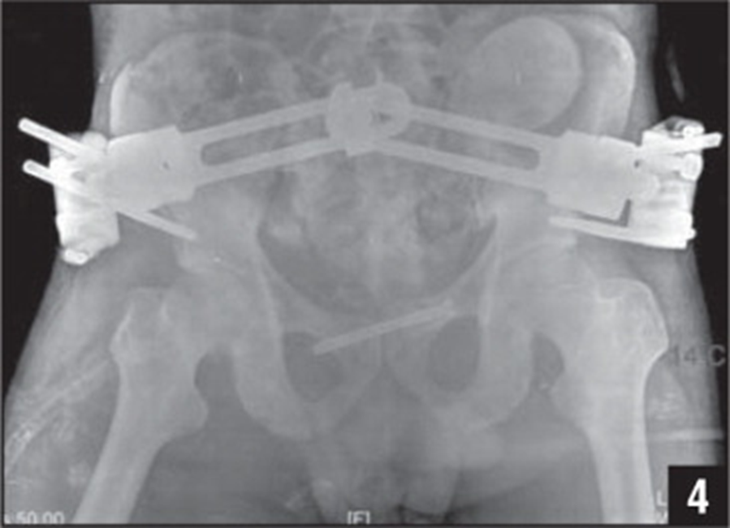
--- In more severe injuries, early application of external fixator is the most effective way for reducing hemorrhage and reverse shock.

--- Fracture of iliac blade can be treated with bed rest.

--- If displacement is marked or there is an associated anterior ring fracture or symphysis pubis separation, then open reduction and internal fixation by plate and screws done.

--- For type III fractures and vertical shear injuries, skeletal traction and external fixator can be used early and later on we do either anterior external fixator with posterior stabilization using screws across the sacroiliac joint or plating anteroirly and screws posteriorly, or continue with skeletal traction and external fixator.

--- Compound pelvic fractures (fracture with colonic injury) are managed with external fixator and diversion colostomy.

Complications of pelvic fractures:
1. Sciatic nerve injury: it is essential to test the sciatic nerve function both before and after treating pelvic fractures. The injury is usually neuropraxia and recovered after several weeks, rarely nerve exploration is needed.
2. Urogenital problems: e.g. urethral stricture, incontinence, and impotence.
3. Persistent sacroiliac pain: unstable pelvic fractures are often associated with partial or complete sacroiliac joint disruption, this can lead to persistent pain at the back of the pelvis, and rarely arthrodesis of the sacroiliac joint is needed.

-------------------------------------------------------------------------------------------

