MHC
(Major Histocompatibility Complex )

- The MHC was first detected as the genetic locus encoding the glycoprotein molecules(transplantation antigens) responsible for the rapid rejection of tissue grafts transplanted between genetically nonidentical individuals.
- It is now known that MHC molecules bind peptide Ags and present them to T-cells. Thus, these transplantation Ags are responsible for Ag recognition by the T-cell receptor.

In this respect, the T-cell receptor is different from Ab.
Ab. Molecules interact with Ag directly; while the T-cell receptor only recognizes Ag presented by MHC molecules on another cell, the APC.
The T-cell receptor is specific for Ag, but the Ag must be presented on a self MHC molecule
It is also specific for the MHC molecule.
If the Ag is presented by another allelic form of the MHC molecule in vitro (normally only in experimental situation ), there is no recognition by the T-cell receptor .This phenomenon is known as (MHC restriction ).

Human tissue cells have molecules on the plasma membrane called major Histocompatibility Complex (MHC). These cell surface proteins are called HLA (Human Leukocyte Associated Ags) in humans. They are important in Ag presentation and the regulation of the immune response .
Differences in HLA Ags among different individuals are the cause of graft rejection reactions.

MHC Classes

Mainly we have two classes of MHC which are :
Class I, and Class II, and there is Class III ,which is of less importance .

MHC Genomic Organization :
The genomic organization of MHC is important to determine compatibility between individuals (transplantation compatibility).
- On chromosome 6: a cluster of genes that are located on the short arm of this chromosome .
- The genes of the MHC exhibit a remarkable genetic variability. The MHC is (Polygenic), in that there are several genes for each class of molecule. The MHC is also (Polymorphic). Thus, a large number of alleles exist in the population for each of the genes .

- Codominant alleles, one from each parent, both expressed .
- The total set of alleles on each chromosome is called haplotype. Each individual inherits a restricted set of alleles from it’s parents. Sets of MHC genes tend to be inherited as a block or haplotype.
- Each individual has two haplotypes (e.g. HLA A1, B2, C3; A1, B4, C2)
- Both alleles make up the genotype (e.g. :HLA A1, B2, B4, C2, C3).

In Class I MHC protein, it has :
HLA-A locus
HLA-B locus
HLA-C locus
In Class II MHC protein; there are several

HLA-D loci, which are
DP, DQ, and DR .

Between Class I and II ,there is Class III which contains several immunological important genes :
C2, C4, TNF, and lymphotoxin (LT) .

MHC Structural Organization

It is known by X ray analysis which show that the domains of the molecules that is away from the membrane are composed of 2 parallel alpha helices above a platform (β-pleated sheet).
the whole structure looks like a cleft whose sides are formed by alpha helices and floored by β-sheet .This cleft are occupied by peptide Ag.
In MHC class I the molecule forms a groove which holds Ag peptides for presentation to cytotoxic T-cells. While
In MHC class II present Ag to helper T-cells .

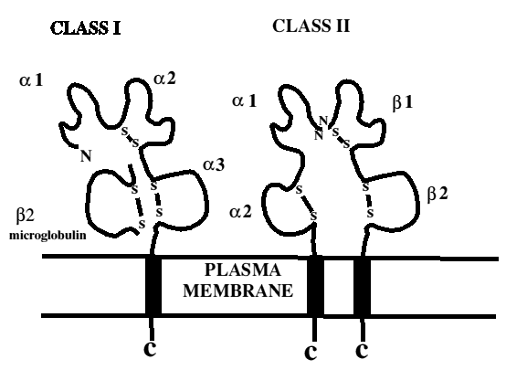

Class I MHC Proteins

Are encoded by the HLA-A, -B, and –C genes. These proteins are made up of two chains ;
1)A transmembrane glycoprotein of MW 45,000, non covalently associated with
2)A non-MHC-encoded polypeptide of MW 12,000 that is known as β2-microglobulin .
Class I molecules are to be found on all nucleated cells in the body .
the 45,000 MW heavy chain is highly polymorphic like Ig molecule with hyper variable region in it’s N-terminal region.
This polymorphism is important in recognition of self from non-self Ag .
Also heavy chain contain constant region where the CD8 protein of cytotoxic T-cells bind .

Class II MHC Proteins

Are encoded by the HLA-D region ,there are three main sets: DP-, DQ-, and DR-encoded molecules
The HLA-D locus-encoded proteins are made up of two non covalently associated transmembrane glycoproteins of about MW 33,000 and MW 29,000 .
Unlike Class I ,they have restricted tissue distribution ,and are chiefly found on MQ, B-Cells, and other APC.
Also have hyper variable region ,and constant region where CD4 protein of helper T-cell bind .

Biological importance of MHC

(1)The ability of T-cells to recognize Ag, which is dependent on association of Ag with class I or II proteins.
1.Cytotoxic T-cells respond to Ag bind to class I protein .e.g.Cytosolic viral proteins synthesized in an infected cell, are processed for presentation by class I MHC molecules.
2.Helper T-cells recognize class II proteins.It’s activity depend on both:
A-The recognition of Ag on APC .
B- Presence of these cells of self class II MHC. (MHC restriction ).

(2)MHC and it’s association with disease:
A large number of autoimmune, inflammatory, and post-infectious disease are more common in individuals with certain HLA types .This is noted by using RR( relative risk ).

RR =Frequency in patients_____________
Frequency in normal population
If RR = 1 i.e. alleles present in patients and normal population is in same frequency .
RR < 1 i.e. allele is protective.
RR > 1 i.e. allele is with increasing risk of disease development.
e.g.;
1- Type 1 diabetes-HLA DR3/4 (RR 14.3)
2- Ankylosing spondylitis HLA B-27 (RR 87.4)
3-Rheumatoid arthritis HLA DR4 (RR 5.8) .

(3) In organ transplantation .

MHC (HLA) Testing ;

HLA typing is important in transplantation .The closer ,the match ,the greater the likelihood of a successful transplant.
There are two methods that are used :
Serological Using Abs against the different Ags to determine the donor and recipient types .
Mixed Lymphocyte Reaction(MLR) using a recipient’s lymphocytes to determine if they react against the donor’s class II(HLA-D) Ags .

*Reference : Jawetz, Melnick, & Adelberg's Medical Microbiology; 26th Edition; 2010
*Presented by :Dr.Zainab Fadhel Ashoor, PhD. Immunology.

