Parasitology Lecture: 1
Dr. Azhar 3 - 10-2017
Introduction to Parasitology (Page number 1-11)
Introduction to Medical Parasitology
- Definition of Medical Parasitology.
- Conceptions related to medical parasitology.
- Relationships between parasite and host.
- The basic factors of transmission of parasitic diseases.
- The preventive measures of parasitic diseases.

In this lesson:
- Discuss how important parasites can be classified according to kingdom and phylum.
- State the meaning of commonly-used terms.
- Describe how parasitic infections affect communities in poor countries and that knowledge of their life cycle is necessary for effective prevention and control.
- Discuss the epidemiology, basic life cycle, clinical presentation, management and control of important parasitic infections.
Some definitions:
Parasitology: It is the science that deals with the study of parasites.
Medical parasitology: traditionally has included the study of three major groups of animals: parasitic protozoa, parasitic helminthes (worms), and those arthropods that directly cause disease or act as vectors of various pathogens.
The parasites such as viruses, bacteria, fungi & parasites belonging to the animal kingdom.
- Parasite: a living organism that acquires some of its basic nutritional requirements through its intimate contact with another living organism. Parasites may be simple unicellular protozoa or complex multicellular metazoa.
- Eukaryote: a cell with a well-defined chromosome in a membrane-bound nucleus. All parasitic organisms are eukaryotes.
- Protozoa: unicellular organisms, e.g. Plasmodium (malaria).
- Metazoa: multicellular organisms, e.g. helminthes (worms) and arthropods (ticks, lice).
Conceptions related to medical parasitology
- Symbiosis
- Parasite and type of parasites
- Host and common type of host
- Life cycle and type of life cycle

Symbiosis: a relationship between 2 dissimilar organisms adapted to living together (each one called symbiont). 3 types:
- Mutualism (both benefit) ex. Protozoa in the digestive tract of termites.
- Commensalism (eating at the same table, one benefit the other is neither benefit nor harm) ex. Normal-flora.
- Parasitism (parasite & host) (human& hookworm).
Parasite: an organism lives in or on the other one that called host and the
relationship called parasitism.
Host & parasite interact with each other resulting in:
- Destruction of the parasite.
- Infection or disease of host.
Type of parasites:
►Obligatory parasites. Exp: Plasmodium sp.
►Permanent parasites. Exp: itching mites.
►Temporary parasites. Exp: flea, mosquito.
►Periodic parasites. Exp: Ancylostoma duodenalae.
- Erratic parasites. Exp: Ascaris into fallopian tubes.
►Specific parasites. Exp: Ascaris.
Parasites (according to place of living):
  - Ectoparasites: live on or in the skin of their hosts (Infestation) e.g. lice, ticks.
  - Endoparasites: live in D.T., organs & tissues (Infection) e.g. malaria, Giardia.
Parasites (dependence):
- Obligate parasites
- Facultative parasites
Host:
- Definitive host (an org. Where final stage of parasite develops).
- Intermediate host (an org. Where larval stage of parasite develops).
- Paratenic host (transported org. & the parasite neither gain nor loses its infectivity).
- Reservoir host (an animal species on which the parasite depends for its survival in nature, serves as a source of infection).
Life cycle and type of life cycle
- Life cycle: The whole process of parasite growing and developing.
- The direct life-cycle : Only one host (no intermediate host).
- The indirect life cycle : Life cycle with more than one host (intermediate host and final host).
Man: is the definitive host for most human parasitic infection e.g. filaria,
roundworm and hookworm, but is the intermediate host in some infection e.g.
hydatid disease.
Vector: a living carrier (e.g. an arthropod) that transports a pathogenic organism
from an infected to a non-infected host. A typical example is the female
Anopheles mosquito that transmits malaria.
- Mechanical vectors (not essential to the life cycle, ex. filth borne flies transmit intestinal protoza).
- Biological vectors (essential to the life cycle, ex. sandfly and mosquito).

Disease:
  - Endemic disease: the constant presence of a disease or infectious agent within an area.
  - Epidemic disease: The occurrence of cases of an illness in a region with a frequency in excess of normal expectancy (or an outbreak of a disease).
  - Anthroponoses: has been applied for infections with parasitic species that are maintained in humans alone ex. Malaria and filariasis.
  - Zooanthroponoses: refers to infections in which human is not merely an incidental host, but an essential link in the life cycle of the parasite. Beef and pork tapeworms are the examples.
  - Zoonosis Disease: a disease of animals transmitted to man.
Carrier: is a person carry parasitic infection & transmitted to others yet himself show no signs or symptoms.
Classification:
- Kingdom
- Divisions
- Phylum
- Class
- Order
- Family
- Genus: group of closely related species.
- Species: the members have the same genetic characters & capable of continued reproduction of their kind.
Epidemiology:
- Although parasitic infections occur globally, the majority occur in tropical regions, where there is poverty, poor sanitation and personal hygiene.
- Often entire communities may be infected with multiple, different organisms which remain untreated because treatment is neither accessible nor affordable.
- Effective prevention and control requires "mass intervention strategies” and intense community education. Examples include:
  - General improved sanitation: pit latrines, fresh water wells, piped water.
  - Vector control: insecticide impregnated bed nets, spraying of houses with residual insecticides, drainage, and landfill.
  - Mass screening and drug administration programmes which may need to be repeated at regular intervals.

Scientific binomial nomenclature:
Entamoeba histolytica (italic).
or Entamoeba histolytica

Aims of studying parasitology: to study the parasites:
- Morphology
- Life cycle
- Pathogenesis &Symptomatology:
- Pathogen: parasites injured their host.
- Pathogenesis: injury results or caused by pathogen.
- Types of injury: mechanical, lytic, toxic & allergic.
- Symptoms: the manifestations of pathologic processes.
- Diagnosis:
- Samples: feces, blood, sputum, urine or tissues (biopsy).
- Detect the eggs, larvae, cysts or some other form of the parasites.
- Treatment
- Epidemiology
- Control & Prevention.
Sources of infection:
- Soil
- Water
- Food
- Insect vectors
- Animals e.g. cow, pig, dog & cat.
- Other persons e.g. carriers
- Self e.g. pinworm (external autoinfection) & Strongyloides (internal autoinfection)
Modes of transmission:
- Feco-orally
- Ingestion
- Inhalation
- Skin penetration
- Insect bites
The source of the infection:
- Patient: Persons who have parasites in their body and show clinical symptoms.
- Carrier: Persons, who have parasites in their body, not show symptoms.
- Reservoir host: Animals that harbors the same species of parasites as man. Sometimes, the parasites in animals can transmit into human.

The basic factor of transmission of parasitic diseases:
Parasitic diseases Infectious diseases
- The source of the infection
- The routes of transmission
- The susceptible host
Disease terminology:
- Prepatency: infected but parasite presence can not be detected yet.
- Patency: established infection, parasite stages can be detected (malaria parasites in blood smears, worm eggs in feces etc.).
- Incubation period: time between infection and the development of symptoms (from one week to one year or more).
- Acute disease can lead to crisis which can resolve in spontaneous healing, chronic infection or death (fatal anaphylactic shock as a result of rupture of hydatid cyst & fluid released).
- Convalescence: Period after healing, absence of infectious agents, no symptoms, in certain case immunity to reinfection.
- A few parasitic infections have been shown to lead to malignancy e.g. Schistosoma haematobium may lead to bladder cancer.
Effects of the host on the parasites:
The host can produce certain degree resistance to parasites in human body or re-infection. The resistance (Immunity) is not very strong. In general, it doesn't wipe out parasites completely, but may limit the number of parasites and establish balance with parasites.
- Innate immunity
- Acquired immunity

Innate immunity:
- Barrier: Prevent parasites to invade in certain degree. Skin/Mucous membranes/Placenta.
- Acid in skin or stomach can cause damage of the parasites.
- Phagocytosis of phagocyte.
----Non-specific/effective against a wide range of parasitic infection/controlled by genetic factors, but not very strong!
Acquired immunity:
Mechanism: cellular and humoral immunity.
- Sterilizing immunity: Wipe out the parasites completely; meanwhile get a long-term specific resistance to re-infection. Rare!
- Non-sterilizing immunity: Wipe out most of the parasites, but not completely. Common!
Body syndromes against parasites:
- Heat syndromes: ( malaria )
- Dysenteric syndromes: (amoebiasis)
- Hepatic syndromes: ( hydatid cyst )
- Skin syndromes: ( lieshmaniasis )

The susceptible host:
In general, most people are the susceptible host (Why?). The parasite reaching a susceptible host must gain entrance and set up a favorable residence in order to complete its life cycle and cause the transmission of parasitic diseases.
The avenues of invasion:
- Digestive tract: Most common avenue of entrance. (Food/ Water transmission)
- Skin: Infective larvae perforate skin and reach to body and establish infection. (soil/ water transmission)
- Blood: Bloodsucking insects containing infective parasites bite the skin and inject parasites into human blood. (Arthropod transmission---malaria).

Effects of parasites on the host:
- Depriving the host of essential substance
Hookworm Suck blood Anemia
- Mechanical effects of parasites on the host
Ascaris Perforate/Obstruction
- Toxic and allergy effect
E. histolytica Proteolytic enzyme Necrosis
Parasite antigen Immune system Immune response e.g Anaphylaxis
The prevention measures of the parasitic diseases:
- Controlling the source of the infection.
----Treatment of the patients, carriers and reservoir hosts.
- Intervention at the routes of transmission
----Managing feces and water resource, controlling or eliminating vectors and intermediate hosts.
- Protecting the susceptible hosts.
----Paying attention to personal hygiene, changing bad eating habit, taking medicine.

Kingdom: Animalia
- Protozoan unicellular
- Metazoan multicellular
Protozoans are microscopic one-celled organisms that are divided according to their method of movements to:
  - Amoeba –ex. Entamoeba and Endolimax.
  - Ciliates – the only parasitic ciliate that causes disease in humans in Balantidium coli.
  - Flagellates –Giardia lamblia, Trypanosome sp. and Trichomonas vaginalis.
  - Coccidia – ex. Sarcocystes &Plasmodium.

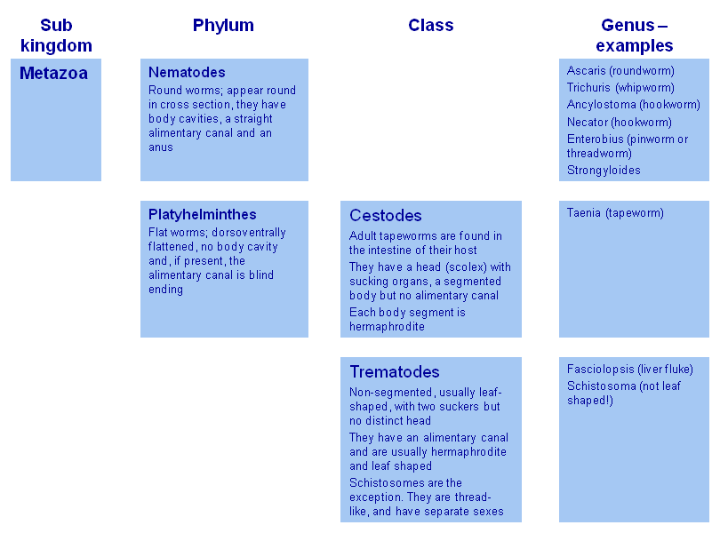

Note:
- Many parasitic infections are associated with overcrowding, poor sanitation, contaminated food and water, under nutrition and other poverty-related factors.
- A major drawback in the fight against parasitic diseases is the inability to prevent them by immunization. No effective vaccine is currently available against any parasitic disease. However, host immunity is decisive in some parasitic infections.
- Increased susceptibility to many parasitic infections is a consequence of immunodeficiency, as in the HIV infected. Many new parasitic infections have been identified in AIDS patients in the developed countries.
- Control and eradication programmes had been carried out against some important parasitic diseases, such as malaria and filariasis, with varying degrees of success. But in many cases the benefits gained could not maintained and the situation has reverted to the original level or worse. This has been due to slackening of control measures or due to drug resistance in the parasite or its vector.

HELMINTH/WORM TERMINOLOGY
- Adults: sexually reproductive life cycle stage.
- Larvae: developmental or asexually reproductive life cycle stage.
- Eggs: stage protective of zygote &/or embryo.
- Cysts: usually a larval stage encapsulated in tissues of an intermediate host.
- Monoecious/hermaphroditic: both sexes in one body.
- Dioecious: sexes separate; males & females.
- Parthenogenesis: ability to produce offspring without fertilization of eggs.
- Oviparous: production of eggs, discharged from uterus of female.
- Viviparous or larviparous: production of eggs which hatch prior to discharge from uterus of female.

End of the lecture-1

