Benign Tumors of the Ovary

Dr.Fadia J Alizzi
Assistant prof.
Consultant OBG
2017

Objectives :

At the end of this lecture, the student will be able to
1. Describe different type of ovarian tumors and there pathology.
2. Describe the mode of presentation of ovarian tumors.
3. Determine the importance of ultrasonography and other imaging technique and tumor markers in the diagnosis and follow up.
4. Describe the management of each type of ovarian tumor.
5. Predict the risk of malignancy
6. Describe the main objectives of management.
7. Describe the management of ovarian tumor in postmenopausal woman.
8. Describe the management of ovarian tumor in pregnant woman
9. Describe the management of some ovarian tumor accident.

Background

- Benign ovarian cysts are common, frequently asymptomatic &often resolve spontaneously.
- 90%of all ovarian tumors are benign although this varies with age.
- Of the tumors that require surgery are:
1)13% in premenopausal women are malignant.
2)45% in post menopausal women are malignant.

- The main objectives of management are :
- To exclude malignancy &
- To ovoid cysts accidents
- Without causing undue morbidity or mortality or impairing future fertility for younger women.
- Ovarian tumors may be physiological or pathological & may arise from any ovarian tissue.
- Most benign ovarian tumors are cystic .The finding of solid elements makes malignancy more likely; however; fibroma, thecoma, dermoid, Brenner tumor usually have solid elements.

Pathology of benign ovarian tumors:-

- Physiological cysts: follicular cyst, corpus luteal cysts, theca luteal cyst.

- Benign pathological tumors :
1. Benign germ cell tumors: dermoid cyst, mature teratoma.
2. Benign epithelial tumors: serous cyst adenoma, mucinous cyst adenoma, endometroid cyst adenoma, Brenner s tumor, clear cell tumors.
3. Benign sex cord stromal tumors: granulose cell tumors, theca cell tumors, fibroma.
4. Sertoli – leyding cell tumors.
5. Inflammatory: tubo- ovarian abscess, endometrioma.

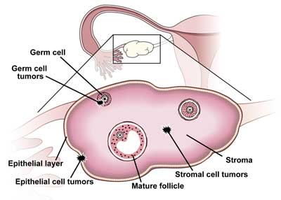

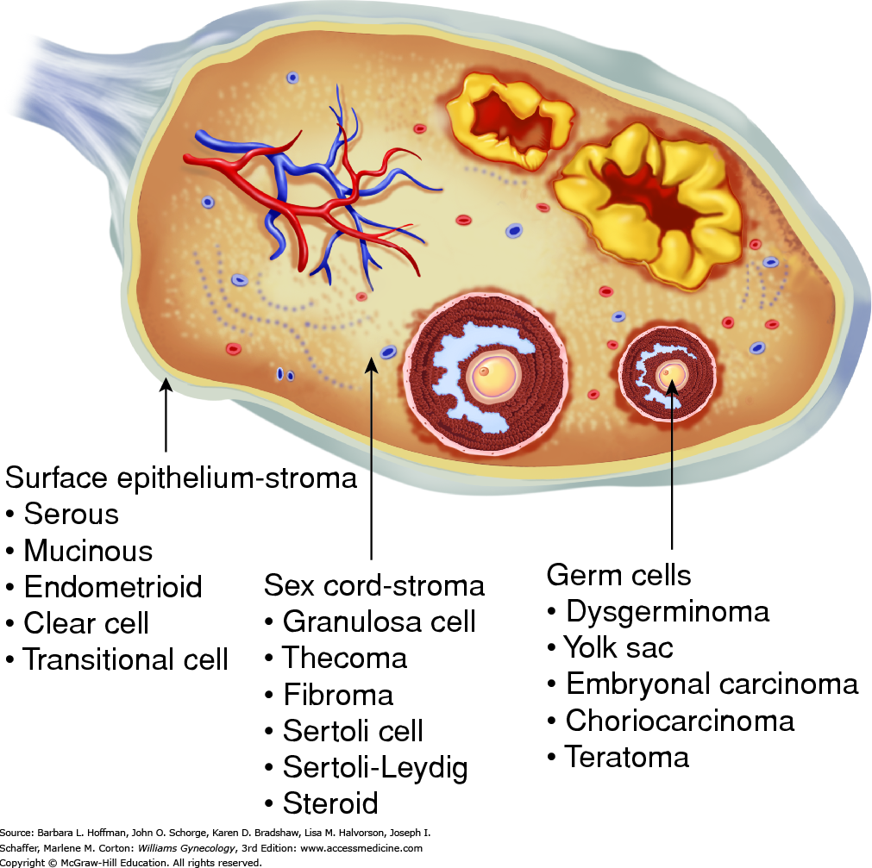

Physiological cysts:

- Common cyst form during the normal ovarian cycle.
- Most are asymptomatic & treatment is conservative.

1) Follicular cyst:-
It is the most common benign ovarian tumor and is most often found incidentally.
*It can persist for several MC & may reach diameter of up to 10 cm.
*Indication for surgery:-
- If symptoms developed.
- If the cyst doesn’t resolve after 8-16 weeks.
*Occasionally they may continue to produce estrogen causing menstrual disturbances & endometrial hyperplasia, since it is lined by granulose cells.

2) Luteal cyst:-
- Less common than follicular cyst.
- It is more than 3 cm in diameter.
- It is more common on the right side.
- They may rupture (on day 20-26 day of the cycle)& present usually with intraperitoneal bleeding.
- Treatment is expectant, with analgesia. Occasionally, surgery may be necessary if there has been significant bleeding to wash out the pelvis and perform an ovarian cystectomy.

3) Theca-luteal cysts
- may develop in association with the high levels of hCG
- present in patients with a multiple pregnancy , hydatidiform mole or choriocarcinoma or Patients undergoing ovulation induction with gonadotropins, clomiphene, or letrozole.
- Theca-lutein cysts are usually bilateral, may become quite large (>30 cm), and characteristically regress slowly after the gonadotropin level falls.
- Rarely, when follicles are stimulated with gonadotropins, theca-lutein cysts can become so extensive as to cause
massive ascites and dangerous problems with systemic fluid imbalance. This condition is referred to as ovarian hyperstimulation syndrome (OHSS).

Inflammatory ovarian cysts

- Are usually associated with pelvic inflammatory disease (PID), and are most common in young women.
- The inflammatory mass may involve the tube, ovary and bowel and can be described on imaging as a mass or an abscess.
- Occasionally, the tub ovarian mass can develop from other infective causes, for example appendicitis or diverticular disease.
- Diagnosis is similar to that for PID: inflammatory markers are helpful ( WBC & CRP )
- Treatment includes antibiotics, surgical drainage or excision.
- Definitive surgery is usually deferred until after the acute infection has resolved, due to the risks of perioperative systemic infection and bleeding from handling acutely inflamed and infected tissue.

Benign germ cell tumors:-

- It is the commonest ovarian tumor seen in women less than 30 years age.
- 2-3% is malignant only but this proportion increase to 1/3 if seen in women < 20 years age.
- Benign tumors are cystic but may have solid elements.
- They are of 2 types: dermoid (mature cyst teratoma)&mature solid teratoma.

1) Dermoid cyst (mature cyst teratoma):-
- Common (account for around 40% of all ovarian neoplasm) & it is more in young women, the median age of presentation is 30 years.
- It results from differentiation of embryonic tissues (mainly ectoderm).
- Bilateral in 11% of cases.
- It is usually unilocular cyst.
- < 15 cm in diameter.
- Monodermal teratoma is teratoma with single type of tissue like:
- Primary carcinoid tumors of the ovary: give rise in 30% of cases to carcinoid symptoms% it rarely metastasize.
- Stuma ovarii tumors predominantly composed of thyroid tissue, it form about 1.4% of cystic teratoma&only 5-6 %produce sufficient thyroid hormone to cause hyperthyroidism&5-10%of struma ovarii develop into carcinoma.
- 60% are asymptomatic
- Complication:
- Torsion

2. Rupture leading to acute abdomen &chemical peritonitis. This complication is common during pregnancy.
3.2% contain malignancy (usually sequamous carcinoma) in women >40 years age.
- Diagnosis is usually confirmed with a pelvic USS and because of the high fat content present in dermoid cysts,MRI may also be useful where there is uncertainty. In general, ovarian cystectomy is indicated because spontaneous resolution is unlikely.
- Surgery is especially indicated if
a) the dermoid cyst is symptomatic
b) is more than 5cm in diameter
c) is enlarging.
- Cystectomy will prevent ovarian torsion and provide tissue for histological analysis.

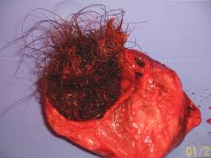

2) Mature solid teratoma:-
- Rare.
- Must be differentiated from immature teratoma which is malignant.

Benign epithelial tumors:-

- The majority of ovarian neoplasia both benign &malignant arises from the ovarian surface epithelium.
- They are therefore mesothelial in nature derived from the coelamic epithelium overlying the embryonic gonadal ridge, from which develop mullerian & wolffian structures: therefore: this may result in development along:-
- Endocervical=mucinous cyst adenoma.
- Endometrial=endometrioid.
- Tubal =serous cyst adenoma.
- Uroepithelial=Brenner.
- Although benign epithelial tumors tend to occur at a slightly younger age than their malignant counter parts, they are more common in women over 40 years.

- Serous cyst adenoma:-
  - It is the most common benign epithelial tumors.
  - Bilateral in 10% of cases.
  - Usually unilocular with papilliferous processes on the inner surface & occasionally on the outer surface.
  - The epithelium on the inner surface is cuboidal or columnar & may be ciliated.
  - They contain thin & serous fluid.
  - They are seldom as large as mucinous tumors.

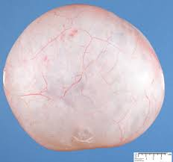

- Mucinous cyst adenoma:-

- It is the 2nd most common epithelial ovarian tumor.
- It is typically large, unilateral, multilocular cyst with smooth inner surface.
- The lining epithelium consists of columnar mucus secreting cells, so the fluid is thick &glutinous.

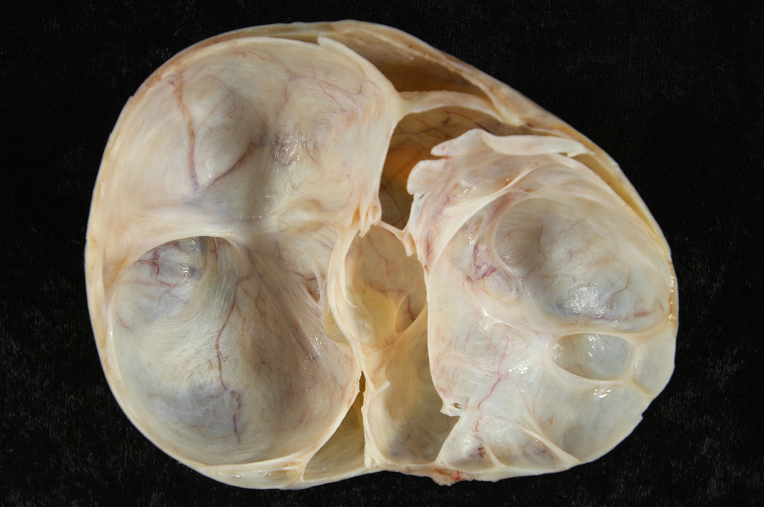

- Endometroid cystadenoma:-
Difficult to differentiate from ovarian endometriosis.

- Brenner tumor :-
- Account for 1-2 % of all ovarian tumors.
- Bilateral in 10-15 %
- The majority is benign, but borderline or malignant specimens have been reported.
- 75% occur in >40 years.
- Majority are < 2 cm.
- Some secrete estrogen causing AUB.

5) Clear cell (mesonephroid) tumors:-
Rarely benign.

Benign sex cord stromal tumors
- It represent only 4% of benign ovarian tumors
- They occur at any age.
- Many secrete hormones &present with the results of inappropriate hormone effects.

- Granulose cell tumors:
  - These are malignant but mentioned here because they are generally confined to the ovary so have good prognosis; however; they do grow very slowly & recurrences are often seen 10-20 years later.
  - They are large & solid.
  - Some produce estrogen or inhibin.
  - Call-Exner bodies are pathognomonic but are seen in less than 50%.

- Theca cell tumors:-
  - Almost all are benign, solid & unilateral.
  - Present at 6th decade.
  - Many produce estrogen causing precocious puberty, postmenapausal bleeding, endometrial hyperplasia & endometrial cancer.
  - They rarely cause ascitis or plural effusion.

- Fibroma:-
  - Hard, mobile, lobulated tumors.
  - Usually occur around 50 years age
  - <10% is bilateral.
  - May be associated with ascitis.
  - Meig s syndrome (ascitis & pleural effusion) is seen in only 1% of cases.

4) Sertoli -Leyding cell tumor:_
*These are of low grade malignancy.
*Most are found around 30 years of age.
*Rare (less than 0.2percent).
*Many produce androgen &some secrete estrogen.
*They are usually small &unilateral.

Age distribution of ovarian tumors:_

*In younger females, the most common benign ovarian tumors
Are germ cell tumor.
*epithelial cell tumors more in older women

Presentation

*Asymptomatic.
*Pain (may result from tortion, rupture, hemorrhage or infection)
*Abdominal swelling.
*Pressure effect.
*Menstrual disturbance.
*Hormonal effect.
*Abnormal cervical smear.

Differential diagnosis: _

A-PAIN
*Entopic pregnancy.
*Abortion.
*PID.
*Appendicitis.
*Meckle’s diverticulum’s.

B-ABDOMINAL SWELLING
*Pregnant uterus.
*Fibroid.
*Full bladder.
*Distended bowel.
*Ovarian malignancy.
*Colorectal carcinoma.
*Lymphoma.

C-PRESSURE EFFECT:-
*UTI.
*Constipation.

D-HORMONAL EFFECT:-
*All other causes of menstrual cycle disturbance.
*Precocious puberty and PMB.

E-Present by Complication :
- Hemorrhage.
- Rupture .
- Infection.
- Torsion :
- Torsion of an ovary refers to a situation where there is rotation of the vascular pedicle supplying the ovary, which compresses and cuts its blood supply.
- Torsion is more likely with enlargement of the ovary as is seen in the presence of an ovarian cyst.
- Up to 15% of dermoid cysts present acutely with torsion.
- Presenting symptoms are usually acute onset of lower abdominal pain associated with nausea and vomiting.
- Pelvic USS with Doppler measurement of blood flow may be useful in the diagnosis, to confirm the presence of a cyst and comment on blood flow to the ovary.
- Torsion of a normal ovary is very unlikely.
- Emergency surgical treatment to untwist the ovary and its attached pedicle is required to restore blood flow & ovarian cyst should then be removed.
- However,if this complication is not recognized within a few hours of presentation, infarction and gangrene may result, necessitating removal of the necrotic ovary.
- Decision making to operate should be based on clinical findings, with transvaginal dopplar ultrasound scan (TVUSS) support.

Management :-
*The investigations required will depend upon the circumstances of the presentation.
*Patients presented with acute symptoms will usually need emergency laprotomy while asymptomatic patient or those with chronic problem may benefit from more detailed preliminary assessment.

1) Full history
*Family history of ovarian, bowel, breast) cancers.
*Indigestion or dysphagia might indicate a primary gastric cancer metastasizing to the pelvic organs.
*History of altered bowel motion or rectal bleeding would suggest diverticulosis or rectal cancer.

2) Examination (general, abdominal, obstetric), searching for features go with malignancy.

*Acute emergency look for tachycardia, cold peripheries&signs of hypovolemia.
*Breast, neck, axillary lymph node examination. *Pleural effusion goes with malignancy.

3)Ultrasound:-
Transvaginal or transabdominal.
*Detection of ovarian mass.
*Features go with malignant ovarian tumors:-
-Solid tumor.
-Bilateral tumor.
-Free fluid in peritoneal cavity.
-Involvement of lymph nodes.
-Increased vascularity by color Doppler.
-Large tumor.>10 cm.

- Other investigations :-
*CXR.:-metastasis or pleural effusion.
*Abdominal X-ray:- calcifications in benign teratoma.
*Ba. Meal: - if symptoms or suspicion of GIT malignancy.
*Complete blood film&count.

5) Serum markers:
-CA125 is strongly suggestive of epithelial ovarian carcinoma(serous ) and borderline ovarian tumor ; especially in postmenopausal women (may increase in endometriosis).
-CA19.9 increase in epithelial ovarian carcinoma(mucinous) and borderline ovarian tumor.
-Measurement of B-HCG. In suspicion of ectopic pregnancy. But trophoblastic tumors and some germ cell tumors secrete this marker (dysgerminoma and choriocharcinoma).

-Estradiol may increase in follicular cyst and sex cord stromal tumor.
-Androgen may be increased in sertoli-leydig tumors.
-Increased alpha feto protein AFP suggests endodermal yolk sac tumor and immature teratoma.

Management:-

It depends on:
-Age.
-Symptoms.
-Plan for further pregnancy.

A-Asymptomatic patient:-

1) Older women:-
-Women over 50 years of age are far more likely to have malignancy and have little to gain from conservative management
-Pelvic mass >5cm :-physiological cysts are unlikely but still there is 17% chance possibly of benign tumors in which 50%will resolve spontaneously.
-29-50%of all ov. Cysts will be malignant in postmenopausal women.
-Therefore efforts have been made to define criteria that would enable unnecessary surgery to be avoided in older age group .
It is recommended that the (Risk of malignancy index – RMI) should be used to select those women who require surgery .

RMI = U * M *CA125.

According to this patient are classified into:

- Low risk : score < 25.
- Moderate: score 25 -250.
- High: score > 250.
e.g. Low risk:
A) Tumor marker CA125<35MU/ml
B) Ultrasound:-simple, unilateral, less than 6cm.
C) Color flow Doppler shows normal vascular resistance.

If all three criteria present then the ovarian cyst are likely to be benign &may be managed conservatively.
If there is no change in the cyst in the second ultrasound at three months follow up with six months ultrasound &CA125 estimation is safe.
The role of laparoscopic surgery in the assessment &treatment of apparently benign cysts in this age group is controversial

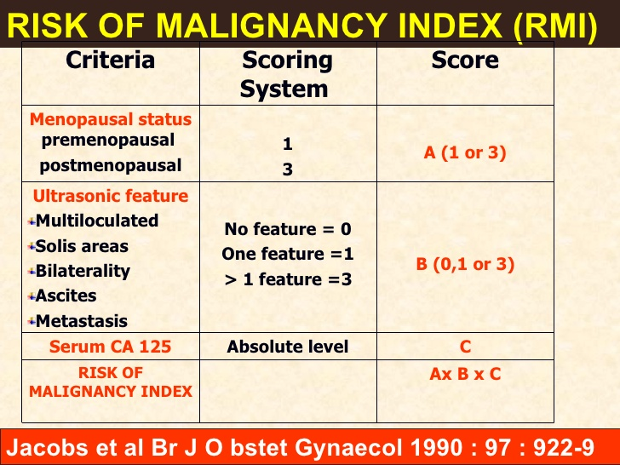

2) Premenapausal women:-
-<35 years are both more likely to wish having the option of further children and less likely to have a malignant epithelial tumor.
-A clear unilateral cyst of (3-10cm) identified by ultrasound should be re-examined 12 weeks later for evidence of decrease in size. If present, follow up by US. &CA125 for 6 months. If increased in size, laproscopy or laprotomy may be indicated.

Criteria for observation of asymptomatic ovarian tumor:-

-Unilateral
-Unilocular cyst without solid elements.
-Premenapausal women, tumor (3-10cm).
-Postmenopausal women, tumor(2-6cm).
-Normal CA125.
-No free fluid or masses suggesting omental seed or matted bowel loop.

B-Patient with symptoms:-
-Severe abdominal pain or sign of intraabdominal bleeding then do emergency laprotomy or laparoscopy
-chronic symptoms. Do investigations.
-Surgery: include:-
*Ovarian cystectomy.
*Oophrectomy.
*Adenectomy.

Pregnant women with ovarian tumors

- Increase incidence of complication (torsion, bleeding,…).
- May prevent the presenting fetal part from engagement.
- May discover incidentally during U/S or C/S.
- No place to postponed operation if acute abdomen.
- If asymptomatic, it is wise to wait until 14 weeks gestation before removing it to ovoid the risk of removing a corpus luteal cyst.
- If cyst unresolved 6 week postpartum, surgery is undertaken.
- Ovarian cancer is uncommon during pregnancy, occurring in less than 3% of cyst. However, a cyst with features suggestive of malignancy on ultrasound, or one that is growing, should be removed surgically.
- CA 125 is not useful in pregnancy since it can be elevated normally.
- Management may need to include a Caesarean hysterectomy, bilateral salpingo-oophorectomy&omentectomy.

