Gestational Trophoblastic Disease (GTD)

Dr.Fadia J Alizzi
Assistant prof.
Consultant OBG
2017
Objectives:

At the end of this lecture, the student will be able to
1. Define GTD, listing down its classification and describe the pathology and genetic predisposition.
2. Describe GTD presentations and predicting malignant potentiality.
3. Determine the investigations needed for the diagnosis of each entity of the disease.
4. Describe the optimum management plane
5. Valuing the role of tumor marker in the diagnosis, follow up and response of GTN to chemotherapy.

Definition:
Abnormal proliferation of gestational trophoblastic tissue.
It forms a spectrum of inter-related diseases originating from the placental trophoblast.

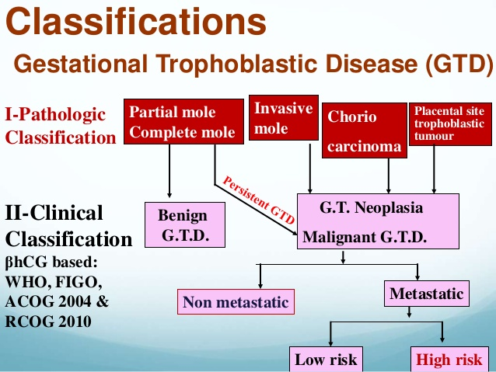

*WHO pathological & clinical classification:

1. Premalignent:
*complete mole (classical mole).
*partial mole.

2. Malignant disorders:
*choriocarcinoma.
*invasive mole.
*placental site tumors.

Incidence &Epidemiology:

- The estimated incidence of complete mole is 1/ 1000-2000 pregnancy.
- The incidence of partial mole is around 1/700 pregnancy.
- The vast majority of complete & partial moles abort spontaneously during the first trimester& the incidence of molar pregnancy has been estimated to be 2% of all miscarriages.
- The incidence of choriocarcinoma varies from 1/10000 to 1/50000 pregnancy (3-10% of hydatidiform mole).
- Higher incidence in Africa & Asia (incidence in the UK is approximately 1 in 2000 pregnancies, compared
with 1 in 200 in Asia.).
- The relative risk is highest in pregnancies at the extremes of reproductive age group (10 folds increase in those over 40).
- Previous history of molar pregnancy increase incidence in subsequent pregnancy.
- The ABO blood group of the parents appears to be a factor in choriocarcinoma developments (high in A & low in O women).

Premalignant hydatidiform mole

1. Complete mole(CM):

*pathologically described as:

1. Diffuse trophoblastic hyperplasia.
2. Generilized swelling of the villous tissue.
3. No embryonic or fetal tissue.
4. Absence of blood vessels in the swollen villi.

*genetically:
The chromosomal composition in 85% is 46, xx, with both chromosomes being of paternal origin& 15% 46, xy.

*clinically patient present with:

- Vaginal bleeding with or without passages of vesicles.
- Uterine enlargement greater than expected for GA (larger than date).
- No fetal heart sound

- Associated medical complication which includes:
a.)Hyperemesis.
b.)Pregnancy induced hypertension or early onset preeclampsia.
c.)Hyperthyroidism.
d.)Anemia.
e.)Development of theca lutein cyst.
f.)Risk of sever hemorrhage &or DIC.

- Risk of progression to gestational trophoblastic neoplasia (GTN) is 18-29%.

- The level of serum hCG is very high.

- Ultrasound typically reveals a uterine cavity filled with multiple sonolucent area of varying size &shape (snow-storm appearance) without associated embryonic or fetal structure.

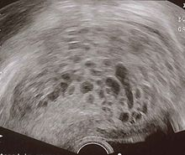

2.Partial mole(PM):
*pathologically:
1. Focal swelling of the villous tissue.
2. Focal trophoblastic proliferation.
3. There is embryonic or fetal tissue.
4. The abnormal villi are scattered within macroscopically normal placental tissue that tends to retain its shape.
*genetically:
The karyotype typically is triploid 69,xxy or 69,xyy.these are each composed of one maternal & 2 paternal sets of chromosomes.
*clinically the patient frequently present with:
- Vaginal bleeding.
- May be detected by routine ultrasound accidentally &resembles missed abortion.
- Uterine size equal or smaller than dates.
- Theca –lutein cyst are rare.
- Medical complications are rare.
- Risk of progression to GTN is 1-11%.

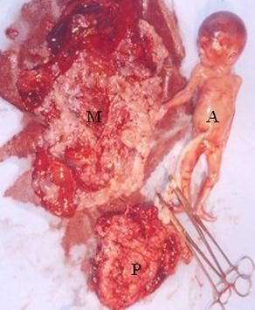

Investigation before evacuation:
- Blood group &Rh (to prepare blood before evacuation for risk of hemorrhage).
- Complete blood count (CBC).
- Pre evacuation serum hCG.
- RFT & serum electrolytes &LFT (elevated because of hyperemeseis).
- Measurements of BP & albumin in urine to exclude early onset pre- eclampsia.
- Thyroid function test if clinically suggestive thyrotoxicosis.
- ultrasound:
  - Typical CM or PM. Picture.
  - Presence of theca lutein cyst.
  - The presence of secondary in the liver in GTN.

8. Chest x-ray (to exclude metastasis in GTN).

9. Coagulation profile to exclude DIC & the profiles are:
- Prothrombine time (PT).
- Partial thromboplastine time (PTT).
- Platelets count.
- Serum fibrinogen.
- FDP.

10. CT or MRI to evaluates the liver or brain if there clinical evidence of malignancy.

Treatment:

*Registration: Register the patient at a nationally recognized center for treatment of gestational trophoblastic disease.
* Hydatidiform mole treatment consists of 2 phases:
- Immediate evacuation regardless of the size of the uterus.
- Subsequent evaluation for persistent trophoblastic proliferation or malignant changes.

* Evacuation is performed by suction evacuation & curettage under proper anesthesia regardless of the uterine size.
*compatible blood should be available before evacuation.

* Uterotonic drugs usually needed because of risk of hemorrhage (oxytocin, ergometrine, PG) &if used should be toward the end of evacuation to decrease the risk of trophoblastic migration.

* Antibiotic cover to decrease the risk of infection.
*anti D should be given after evacuation if the woman is Rh negative.

*histopathological examination of the sample to confirm GTD.

*complication of the operation includes:
1. Hemorrhage.
2. Perforation of the uterus.
3. Pulmonary complications due to trophoblastic embolization are frequently observed following evacuation &the prognosis depends on the severity of the symptoms.
4. Infection.

*secondary evacuation is indicated when there are retaind products of tissue or persistent spotting for 2 weeks.

*hysterectomy is indicated in:
- No further pregnancy is desired.
- Women aged 40 &over because of high risk of GTN (reduce the risk but not eliminate it).
- Sever uncontrolled hemorrhage.
- Invasive mole with evidence of perforation.
- Malignant form of GTD with no further desire to conceive.



Follow-up evaluation of molar pregnancy:

- Prevent pregnancy for a minimum of 6 months using proper contraception

  - Oestrogens should be avoided in women with molar pregnancy- there is a potential but low increased risk of developing GTN).

  - What is safe contraception following a diagnosis of GTD and when should it be commenced?

a. Women with GTD should be advised to use barrier methods of contraception until hCG levels revert to normal.
b. Once hCG level have normalized, the combined oral contraceptive pill may be used.
c. There is no evidence as to whether single-agent progestogens have any effect on GTN.
d. Intrauterine contraceptive devices should not be used until hCG levels are normal to reduce the risk of uterine perforation.

- Monitor serum hCG level every 2 weeks until undetectable then monthly for 1 year &then every 3 months for one year.
- If the patient’s βhCG values reach normal range within 8 weeks of evacuation, follow-up will be limited to 6 months.
Patients who do not have normal βhCG values within 8 weeks of evacuation should have 2-year follow-up.
If these women are keen to pursue a further pregnancy it is only advisable after βhCG levels have been normal for 6 months. In this group the risk of choriocarcinoma occurring is 1 in 286.
- indications for chemotherapy:
  - High levels of hCG (>20000IU/L) more than 4 weeks post evacuation.
  - Progressively increasing hCG values at any time post evacuation.
  - Any detectable level of hCG 4-6 months post evacuation.
  - Metastases (brain, hepatic, pulmonary, renal, GIT)irrespective of hCGlevels.
  - HCG level plateau in 3 consecutive serum samples.
  - Malignant type of GTD.
5. Further estimations of βhCG 6 and 10 weeks after any future pregnancy are recommended because of the small risk of choriocarcinoma developing in such patients. In some cases the choriocarcinoma arises from the new pregnancy.

Malignant trophoblastic disorders:

Invasive mole (chorioadenoma destruens)

- Nearly always arise from a CM.
- Characterized by invasion of the myometrium, which can lead to perforation of the uterus.
- The incidence decrease because of early treatment &follow up of CM.
- Histological similar to CM but with invasion of the myometrium.
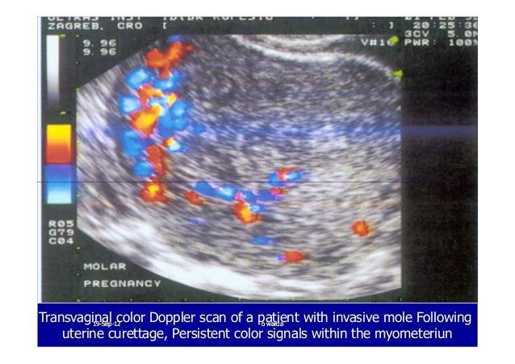
Placental site trophoblastic tumors :

- Most commonly follow a normal pregnancy but can occur after a non-molar abortion or a CM, &very rarely following a PM.
- Form less than 2% of all GTD.

Choriocarcinoma:

- Present the most frequent emergency medical problems in the management of trophoblastic disease.
- It follow:
  - CM in 50%.
  - non-molar abortion in 25%
  - Term pregnancy in 25%.

Symptoms & signs

- Clinical presentation:
*locally from uterus = bleeding: is a common symptom of uterine choriocarcinoma or vaginal metastasis.

*distant metastases= Most patients with choriocarcinoma present with symptoms of metastatic disease. Wide verity of symptoms depending on the site (lung, CNS, liver). Hemoptysis, cough, or dyspnea headaches, dizzy spells, “blacking out, rectal bleeding or “dark stools” could represent disease that has metastasized to the brain , lung or gastrointestinal tract.

* Amenorrhea= Because of the gonadotropin excretion, amenorrhea may develop, simulating early pregnancy.

- Signs

* Uterine enlargement
* A tumor metastatic to the vagina may present with a firm, discolored mass.
* Acute abdomen because of rupture of the uterus, liver, or theca lutein cyst.
* Neurologic signs, such as partial weakness or paralysis, dysphasia, aphasia, or unreactive pupils, indicate probable central nervous system involvement.

Diagnosis

* Sometimes difficult &depends on high hCG&U/S with characteristic findings show the structure of the villous trophoblast, &occasionally by biopsy.
* computed tomographic scan of the abdomen, pelvis, and head.
* lumbar puncture should be performed if the computed tomographic scan of the brain is normal, because simultaneous evaluation of the β-hCG level in the cerebrospinal fluid and serum may allow detection of early cerebral metastases . I

Treatment

- Treatment depends on International Federation of Gynecology and Obstetrics (FIGO) staging system for gestational trophoblastic tumors

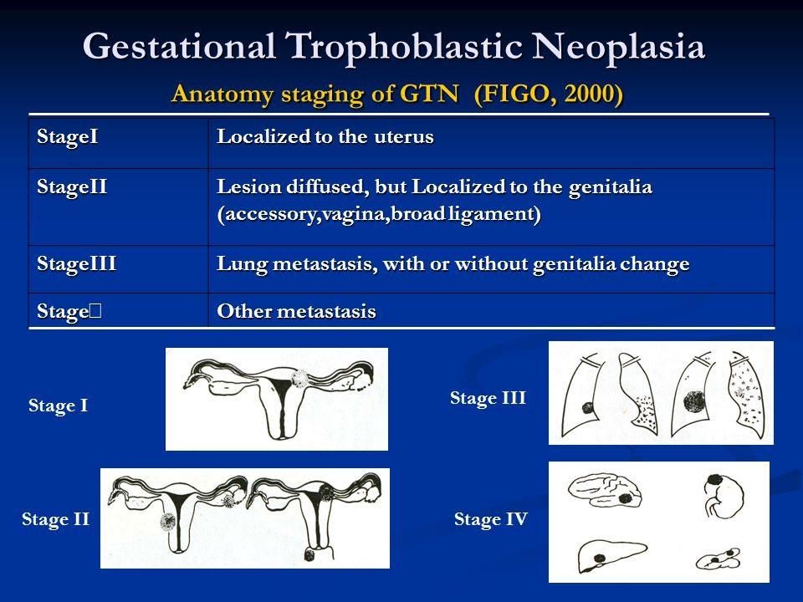

1. Low-risk disease is characterised by any one of the following:

• FIGO stage I GTN – This is characterised as a persistently elevated human chorionic gonadotropin (hCG) level and/or tumour confined to the uterus

• Stage II or III GTN with a WHO risk score 0-6. For nearly all low-risk GTN patients, single-agent chemotherapy with either methotrexate or actinomycin D is the standard treatment.

Chemotherapy for low-risk disease should be continued for three cycles of maintenance treatment after hCG normalisation.

2.High-risk gestational trophoblastic neoplasia (GTN) is characterised by any one of the following:

• Stage IV disease
• Stage II and III with risk score ≥7.

EMA/CO (etoposide, methotrexate, actinomycin-D plus cyclophosphamide and vincristine) is currently the most widely used first-line combination chemotherapy for high-risk GTN
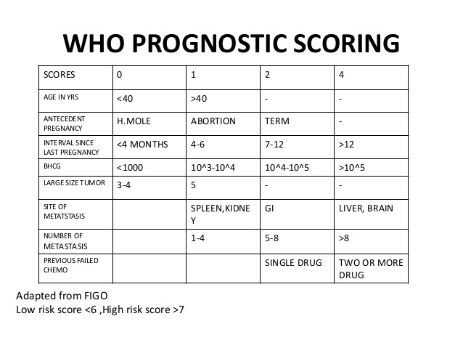
FOLLOW-UP
- All patients should have weekly β-hCG level measurements until three normal levels have been measured.
- GTN who have a good prognosis, monthly measurements should be done until 12 normal levels have been recorded.
- Patients with GTN who have a poor prognosis should have monthly levels until 24 normal measurements have been recorded.

- Patients should use effective contraception during follow-up, following which they may attempt pregnancy.

PROGNOSIS
- About 95-100% of patients with GTN who have a good prognosis are cured of their disease.
- Patients with poor prognostic features can be expected to be cured in only 50-70% of cases.
- The majority of the patients who die have brain or liver metastases.

Slides exam:
1.patient has vaginal bleeding 3 months after evacuation of complete molar pregnancy with no follow up
- What is your diagnosis
- Which stage you think

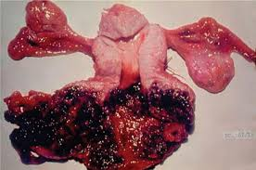

2.women with choriocharcinoma with involvement of lung belong to which stage ?
What is your further treatment ?
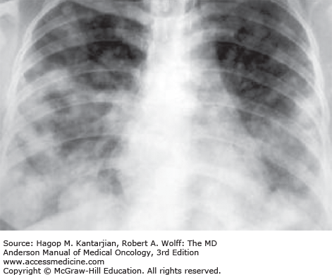

SBA Q : A 43-year-old woman undergoes a surgical curettage for miscarriage and the pathology report confirms a partial mole.What would you do? Choose the single best answer.
A Register the patient at a nationally recognized centre for treatment of gestational trophoblastic disease.
B Start the COCP.
C Prescribe methotrexate.
D Arrange an urgent TVUSS.
E Start serial hCG monitoring

