Congenital malformations of the genital tract
Objectives
The objectives of this lecture is to review in brief matter the most important congenital malformations which occur in the female genital system so the student can understand in better way connection of this lectures to others like mal presentation and other related subjects
Gonadal digenesis syndrome

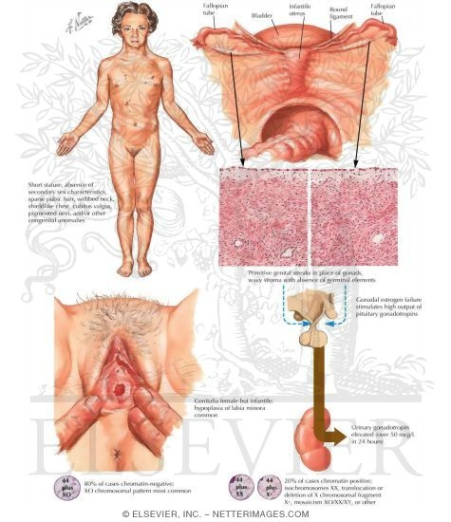
By far gonad dysgenesis syndrome is associated with a chromosomal abnormality 45 XO or turner syndrome. Those individuals have 45 chromosomes with missing X chromosome to yield a total of 45 instead of 46. Turner syndrome is a highly specific clinical picture which should presents as a spot diagnosis. Short stature, webbing of the neck, single crease line in the hand and infantile secondary sexual characteristics are the main features. The condition is also associated with defective brain perception and mostly mentally retarded. Other congenital malformations especially of the cardiovascular system may be present also. On laparoscopic view the uterus and fallopian tubes are well developed yet the gonads are replaced with streak slim cord of hard connective tissue with no germ cells can be identified. The vulva is normal in appearance yet infantile character. In some cases turner syndrome may be mosaic XO/XX with normal brain intelligence and in such cases estrogens are given at the age of 12 years followed by combined contraceptive pills to bring about normal sexual development of the breast and vulva so the woman becomes compatible with marriage. Yet this is the exception rather than the rules.
Remnants of the wolffian ducts
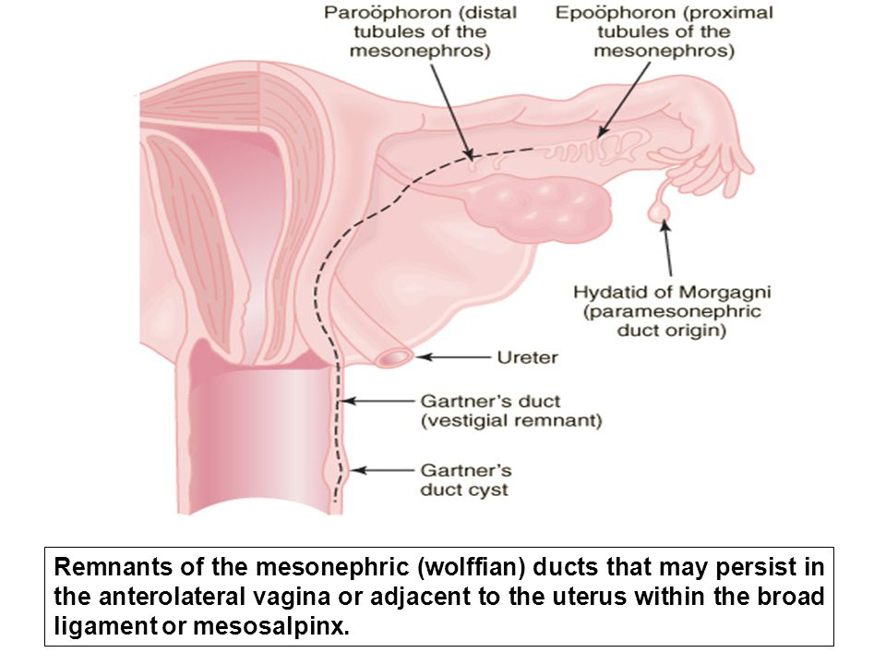
The wolffian duct in females which forms the spermatic cord in males fetus usually undergoes complete lysis and disappear at 12 weeks of gestations. It is not uncommon during the course of any pelvic surgery to see remnant of this duct as cystic structures which are usually small most commonly attached to the Fallopian tubes in both sides. Those cystic structures are called the Hydatid of Morgagni and they are completely silent causing no clinical presentations. Very rarely those remnants may present as large cystic mass which projects into the vaginal wall and even more rarely attached to incorporated into the uterine wall. Those attached incorporated into the vaginal wall are best treated by marsupilazation while those incorporated into the uterine wall may cause unexplained rupture of the gravid uterus as early as 20 weeks.
Ectopic ovary
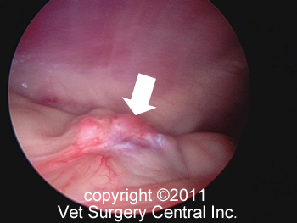
Since the embryonic origin of the gonads in females is none correlated to the rest of genital system theoretical point of view one vary may be present anywhere in the abdominal cavity. It can be present in the subphrenic area, above the kidney or even beside the celiac trunk where its removal is a challenging problem. The condition is usually totally silent unless pathological cyst arises from the ectopic ovary. The absence of one ovary in one side as revealed by normal ultrasound scan may support the diagnosis. Those ovaries near the aorta usually require the aid of general surgeon or vascular surgeon for their removal.

Congenital malformation of mullerian ducts mal fusion
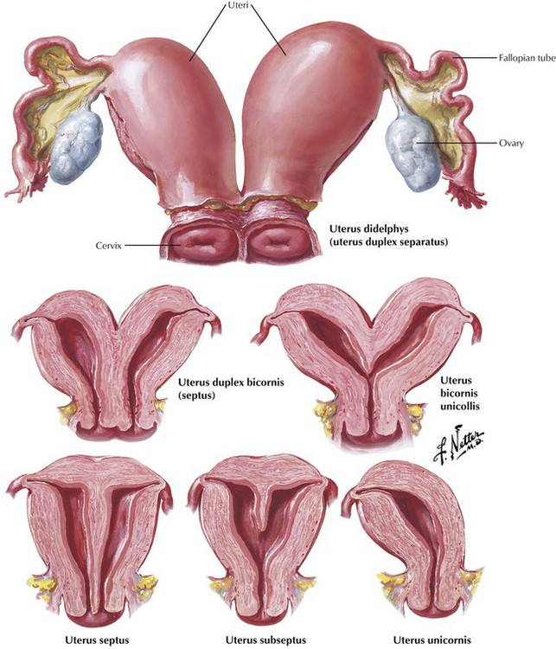

The followings are examples of mal fusion of mullerian system
- Bicornuate or heart shaped uterus with no septum
- Sub septate uterus in which the uterus contains a sagital septum from the fundus not reaching the internal oss
- Septate uterus in which a sagital septum extends from the fundus to reach the internal oss.
- Uterus bicornis unicollis in which the uterus is completely separated into 2 bodies sharing one cervix
- Uterus bicornis bicollis in which the uterus is completely divided into 2 separate parts each have its own cervix
- Uterus didelphys in which there exists complete separation of uterine body into separate horns with sagital septum extending along the vaginal dividing it into 2 cavities.
- Unicornuate uterus in which there is complete degeneration of one side mullerian duct which lead to a small uterus with one sided fallopian tube
- Unicornuate uterus with accessory horn in this case the other mullerian duct has mal developed into separate horn with tube with no attachment to the vaginal. In rare cases its cavity may communicate with the other horn. This type is associated with late rupture of ectopic pregnancy with life threatening internal hemorrhage.
- Transverse thin membrane which can be completely blocked or have fenestration to allow the menstrual blood to pass
- Atresia of the vaginal in which there is no canalization between the upper 2/3 and lower 1/3 of the vagina due to failure to canalize the mullerian part and the cloaca of the vagina leading to a challenging surgical problem
Treatment
- In septate and sub septate uterus hysteroscopic excision of the septum should be considered.
- In Isolated horn of the uterus the horn should be excised with careful dissection of the ureter as 30 % of those abnormalities are associated with urinary tract abnormalities.
- In transverse vaginal septum which appears mostly as dysparunia excision of the transverse septum is usually a simple operation
- In uterus didelphys the only available option is to excise the sagital vaginal septum to restore the vagina with one cavity and relieve dysparunia which is associated with as a rule.
- The most challenging surgery is atresia of the vaginal as any deviation may end with no choice apart from total hysterectomy. The advancement surgery if Jeffcott has been one of the most useful surgical approaches to this problem yet the details are beyond the scope of this lecture.
Mullerian agenesis
In this rare condition the 2 mullerian systems fails to develop altogether leading to a normal looking female yet with a blind vagina. The vulva is normally looking yet a membrane occludes the vestibule. The scan of ultrasound shows well the bilateral ovaries yet no uterus. Karyotype of those individuals shows 46XX perfect females. The cause is unknown though cocsacki viral infection has been implicated
Treatment
- The use of glass dilators may be used for 6 months with the formation of a dimple simulating a normal vagina may be used
- Thigh skin graft is a simple highly successful operation in which a skin graft is taken from the thigh and put on a mould and inserted into the space between the bladder and rectum for 4 weeks
- Large or small bowel graft has been also used with success as after a reasonable part is dissected from the bowel with end to end anasthomosis the intestinal tract is fitted into a space created by dissection as a new vagina.

Mal development of the eternal genitalia
Enlargement of the clitoris

The clitoris even among normal women with no known abnormality may have wide variation in its size and in few cases it may undergoes gross enlargement so leading to marital disharmony and divorce. Reduction of the size of clitoris is widely done in western world where the clitoris size is reduced by excision of erectile tissue of corpus spongiosum and suturing it to the defect.

Enlargement of labia minora
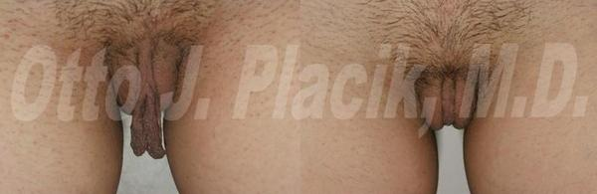

Enlargement of labia minora is more common than the previous type and it is known to occur in families with sisters in the same family. During sexual arousal those labia enlarge to huge extent so intercourse becomes impossible as it cause severe pain to the female and impotence in the male. Divorce may follow few weeks in those couples. The problem is neither the patient can describe what is wrong with her while in turn the (female doctor) doesn’t understand what is wrong with her. Treatment is very simple by excision of the hypertrophied labia with suturing the wound gently to reduce pain post operatively.

