Genital tract prolapse
Pbjectives f the lecture
Genital tract prolapse is one of the most dstressing conditions to a woman life quality. Commonly associated with obesity and grand parity both causes which are quite common in our society. In this lecture a summary of the different types and their surgical tratment will be simplified to maximum for the undergraduate candidates.
Definition
Genital tract prolapse is defined as herniation of the pelvic organs through the vaginal wall and/ or descent of uterus through the vagina

Types vaginal prolapse

Cystocele
Defined as herniation of the bladder into the anterior vaginal wall. It is caused primarily by damage to the pubo vesical fascia which extends between the back surface of the pubic symphysis up to the cervix uteri. Grand multi parity is the main associated predisposing factor for this type. Commonly associated with herniation of the urethra and in such cases it is called cystourethrocele.

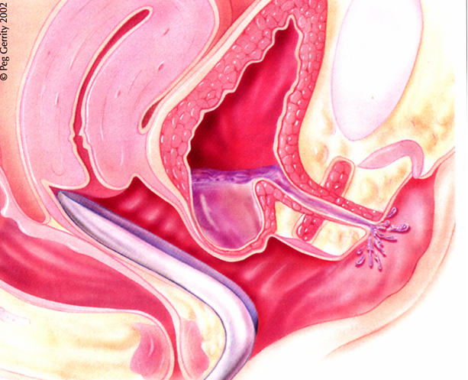

Rectocele
Defined as herniation of the rectum into the posterior vaginal wall. Primarily caused by damage to the perineal body associated with mal sutured episiotomy. In addition, mal sutured third or forth perineal tear is another predisposing factor.

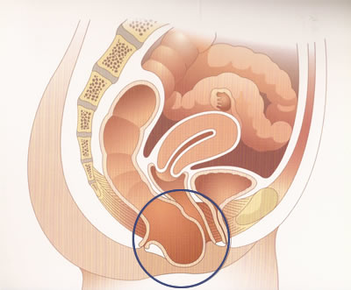

Enterocele
Defined as herniation small bowel loops into a peritoneal sac at the upper posterior vaginal wall in between utero sacral ligaments. The main etiological factors include all causes which increase unttra abdominal pressure like COLD, obesity and constipation.

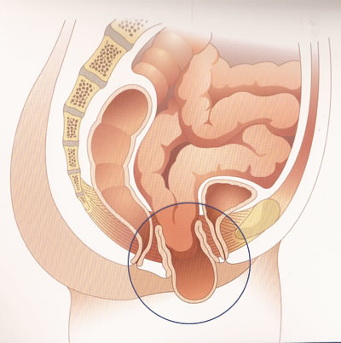

Vault prolapse
Defined as herniation of the vault among women already done hysterectomy before. The main cause of this condition is failure to support and the cardinal ligaments into the vaginal vault after removing the uterus.
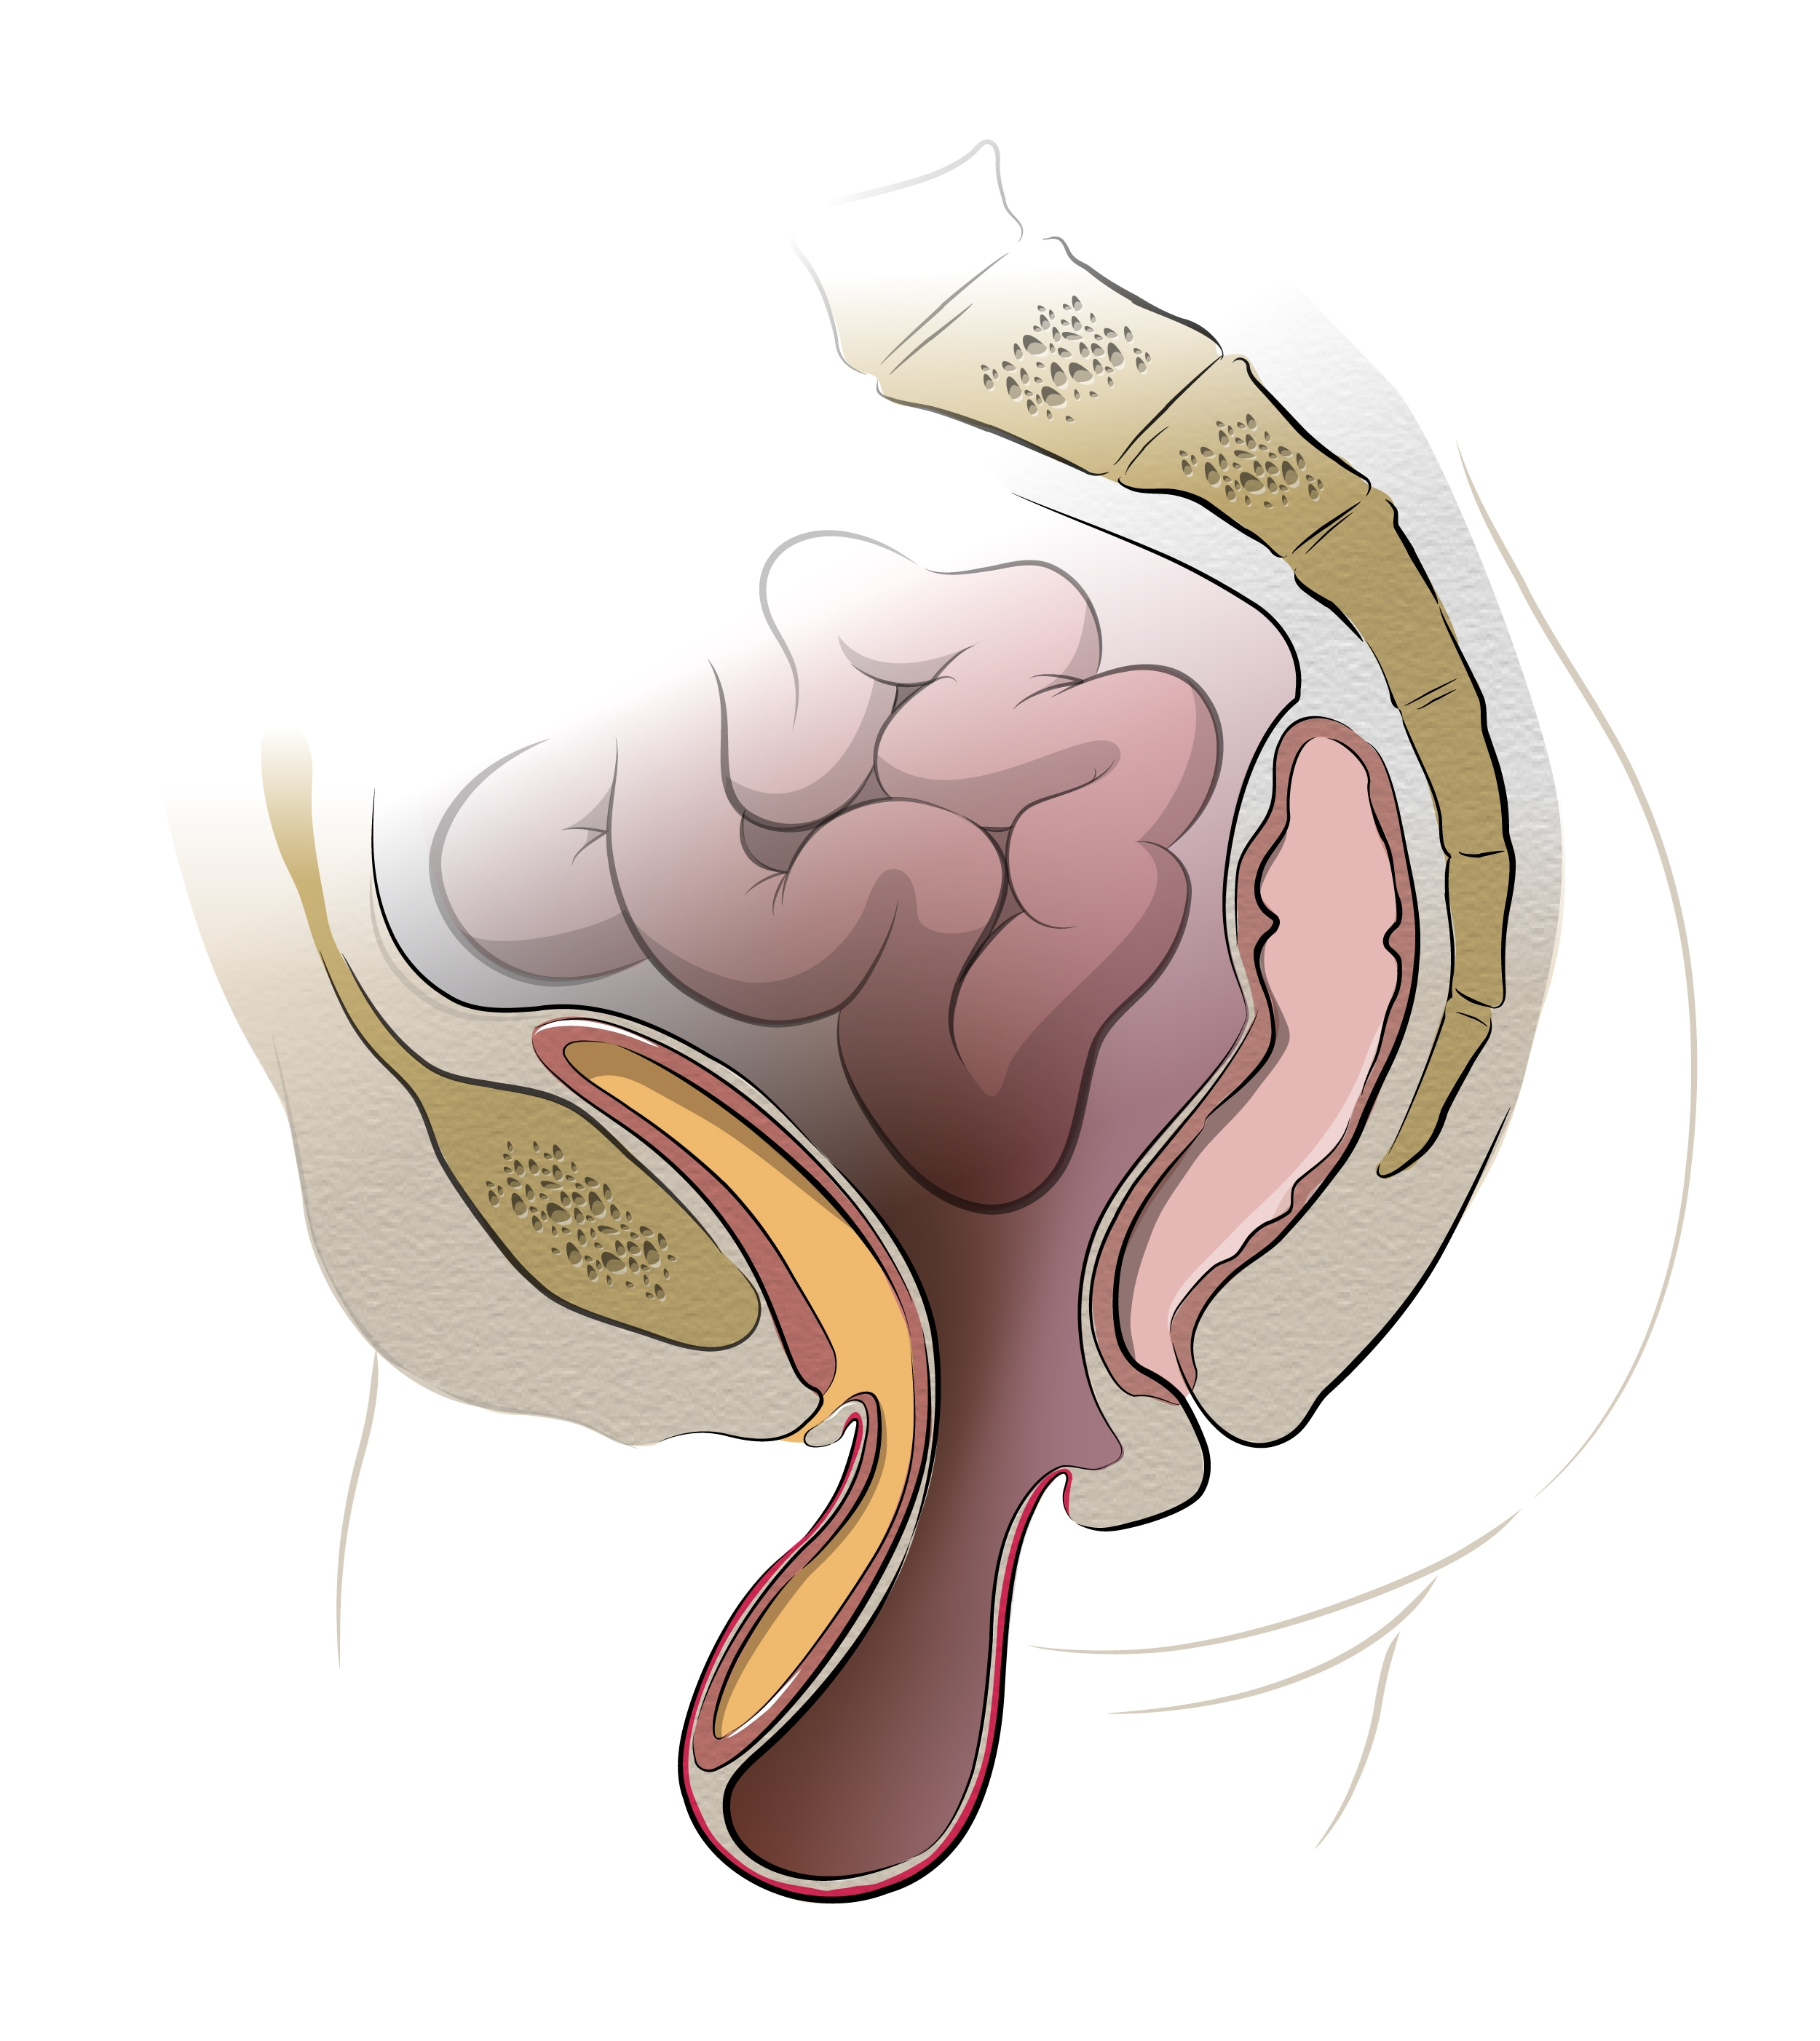

Uterine prolapse
Defined as descent of the uterus within the vaginal duct. Primarily caused by damage to the cardinal ligaments due to pushing as labor before full cervical dilatation. Other cause includes applications of forceps before full dilatation of the cervix.
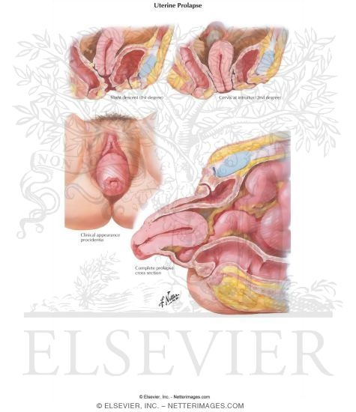

Grades of uterine prolapse
- Grade I when the uterus descent however it remains inside the vagina.
- Grade II, when the uterus
- Grade III when the uterus becomes permanently protruded outside the vagina. In such cases it is called procidentia.
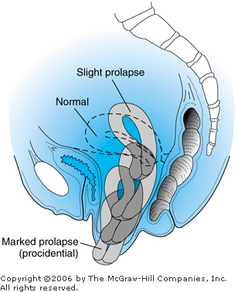

Causes of genital tract prolapse
- Grande multi parity
- Factors which increase intra abdominal pressure
- Menopause
- Racial factors, least in Negros, very common among European and North American women.
- Congenital weakness of ligaments.

Symptoms
- A symptomatic in mild cases.
- Lump in the vaginal is the most common presentation.
- Backache
- Urinary incontinence in the form of stress incontinence.
- Apareunia and dyspareunia.
- Abdominal crams.
- Nausea and vomiting.

Examination of patient with genital tract prolapse
- Standing position; in some mild cases of vaginal wall and uterine prolapse, examination of the patient in standing position is the only way to explore it.
- dorsal position; mostly for demonstration of uterine prolapse. Either the uterus will be obviously protruded, or protrude when the patient is asked to strain.
- Sim's position; in this position our aim is to demonstrate the different types of vaginal wall prolapse. The patient is asked to lie on her left side at the edge of the table. The left leg is extended, while the right leg is flexed. Afterward a sterile Sim's speculum is inserted into the vagina gently first to expose the anterior vaginal wall. Then it is pulled backward gradually to expose the posterior vaginal wall. Cystocele and rectocele are usually diagnosed by this examination.

Examination in Sim's position

Non surgical treatment of genital prolapse
Ring pessarry is the only non surgical treatment available for genital tract prolapse. Rings are made from silastic inert materials and replaced every 3 months. They are used for women who are incompatible for major surgery like the presence of ischemic heart disease, or just waiting for the time of surgery.
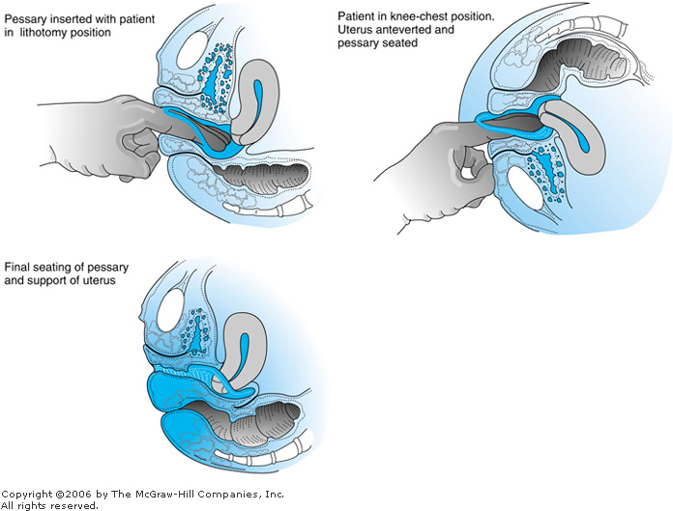

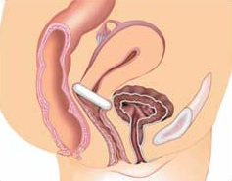

Anterior colporraphy for cystocele

This the main operation used to treat cystocele. In this operation, the damaged pubo cervical ligament is re constructed. The stretched vaginal wall is excised and then suturing the defect. The most common complications include infection, hematoma vesico vaginal fistula. Stenosis

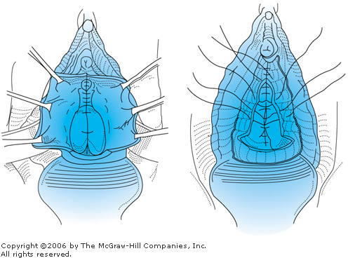

Posterior colpoperineorrhaphy for rectocele
This operation is used primarily to treat rectocele. First the damaged perineal body is re constructed. The inner most part of levator ani muscle are approximated. After trimming the stretched vaginal wall, the defect is sutured. The most commoc complications include hematoma formation and infection. Stenosis of the vagina is also likely as remote complication.

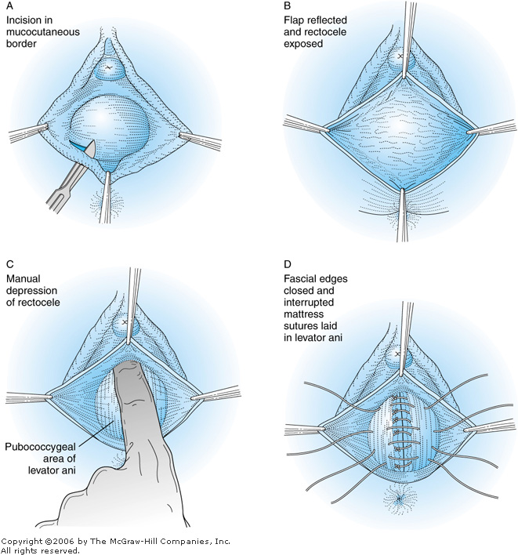

Vaginal hysterectomy
Vaginal hysterectomy is still the main operation used t treat uterine prolapse. In this operation the uterus is removed from the vagina rather than the abdominal wall. The pedicles are ligated in reverse manner than the abdominal operation. Complications include infection, hematoma, fistula and vault prolapse. Frequently concomitant reconstruction of anterior and posterior vaginal wall is done. Vaginal hysterectomy is absolutely contraindicated in the presence of ocarian, endometrial and cervical cancers. It is also relatively contraindicated when the uterine size is more than 12 weeks or fibroid are present.

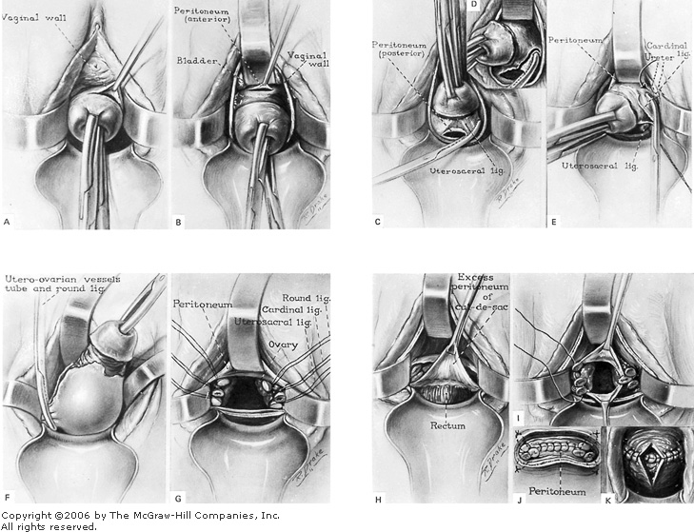

Manchester's operation
This operation is done for uterine prolapse with grade I among young women who have not completed their family size. The elongated cervix is cut. The stretched cardinal ligaments are also cut and ligated to the remaining part if the cervix, remote complications include cervical incompetence, cervical stenosis. Recurrence of uterine prolapse is also likely to occur.

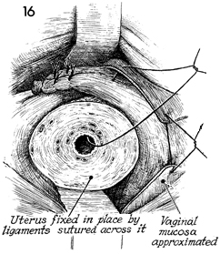

Colpocleisis or obliteration of the vagina

This operation for uterine prolapse is done as palliative procedure for very old women who are completely incompatible with general anesthesia. Simply after returning the uterus, the anterior and posterior vaginal walls are sutured together to obliterate the vaginal cavity, thus preventing the uterus from descent. The operation van be done under local anesthesia.
