Urinary incontinence

Objectives and aim of the lecture
Urinary incontinence remain a number one of most life quality damaging conditions despite they are not life threatening. It is estimated that 4.5 billion USD is being spent yearly in USA alone yet for about 40% satisfaction. The fact that over 130 operations have been invented in the last 100 years reflects the poor understanding of this subject despite the huge advances in its studying. In this lecture very precise and concentrated knowledge is summarized to the under graduate so this subject can be as easily as possible. s

Definition
Urinary incontinence is defined as involuntary loss of urine which is socially embarrassing and objectively demonstratives.

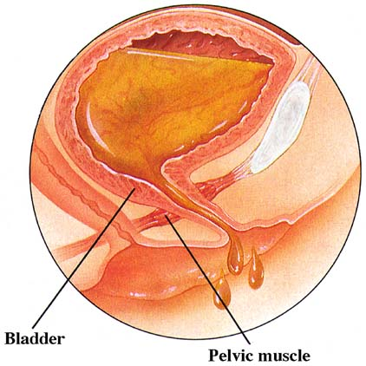

Factors which maintain continence in females
There are three factors which contribute to female continence as such
- Detrusor muscle; the wall of the bladder is surrounded by the detrusor muscle which is composed of smooth involuntary fibers. Sympathetic system causes inhibition of this muscle while parasympathetic system causes its contraction.
- Sphincter urethrae muscle; composed of inner involuntary smooth muscle fibers. While the outer part is composed of striated muscle fibers. The parasympathetic system causes its relaxation while the sympathetic system promotes its contraction.
- The proximal part of the urethra; in normal continent women the proximal part of the urethra is usually above the levator ani. In other words it is an intra abdominal organ. Descent of this portion bellows the levator ani muscle cause loss of continence. The most common cause is genital tract prolapse

Genuine stress incontinence
Genuine stress incontinence is defined as involuntary loss of urine upon any maneuver which increases intra abdominal pressure like cough. Pri
marily caused by weakness of sphincter urethrae muscle.

Etiology
- Genital tract prolapse. By far almost all women with genital tract prolapse have variable degree of stress incontinence.
- Menopause; all the ligaments of female pelvic organs have receptor for estrogen. Depletion of estrogen predispose to genuine stress incontinence.
- Pelvic nerve denervation; still menopause significantly associated with reduction of the pelvic muscles. Other causes may involve extensive pelvic surgery like radical hysterectomy.

Clinical presentation
The only clinical presentation of GSI is just like the name indicates; involuntary loss of urine. However the bladder is called the poor witness; as clinical manifestations alone does not correlate significantly with the true underlying disorder. Almost always further investigations are always required to confirm the diagnosis.

Investigations and test
In order to confirm the true diagnosis of GSI the followings may be used

Q tip test
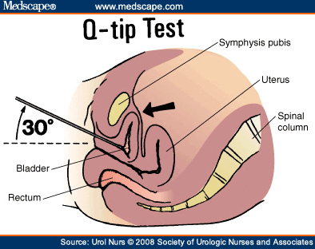

The figure above shows the principle of this simple bedside test. A sterile swab stich is inserted into the bladder cavity. As the patient to strain afterward. In continent women the angle between the horizon and the swab should not exceed 30 degree. While women with stress incontinence the angle may reach up to 60 degree.

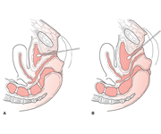
Example of positive Q Tip test

Perineal and inter labial ultrasound scan for bladder neck

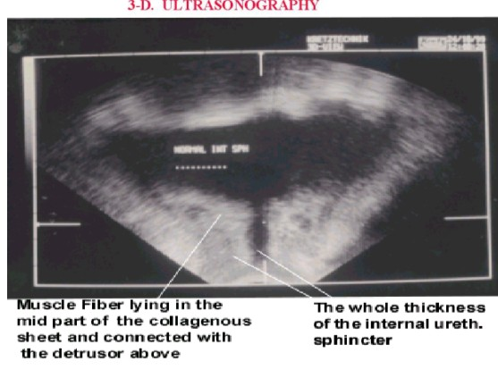
In this U/S scan the balder neck as well as the urethra can be visualized clearly as shown above. Many parameters can be measured from this scan which can predict bladder neck hyper mobility. The most useful parameter is the angle between the bladder base and the urethra. In healthy continent women this angle should not exceed 60 degree. The photo above shows urethra perpendicular to the base bladder or angle equal 90 degree.

GUE and MSU C/S
It is very important before starting invasive methods of diagnosis that any UTI infection should be scrutinized and treated. Urinary infections may hugely cause difficulty in interpreting urodynamic study. Cystoscopy and U/S scan may be used to diagnose calculi and vesical diverticulae which should be treated before implementing urodynamic study.

Cystometry
Cystometry is simply evaluation of the bladder volume- pressure relationship. In clinical cystometry the bladder is repeatedly filled with fixed amount of normal saline. After full inflation the women is asked to pass urine and the intra vesical pressure is measured. The table bellow summarizes the difference of cystometric findings between women with genuine stress incontinence and women with bladder hyper reflexia;

Character | Genuine stress incontinence | Bladder hyper reflexia
First volume to sense voiding desire | 150- 250 cc | < 150 cc
Maximum bladder capacity | 500 600 cc | < 400 cc
Maximum resting intra vesical pressure | < 15 cm water | > 15 cm water
Voiding intra vesical pressure | < 50 cc water | > 50 cc water

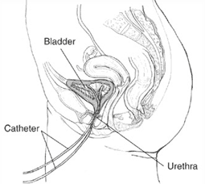

CT scan and MRI
Both CT and NRI scans are being increasingly used nowadays to evaluate bladder neck descent. However they are expensive and no global agreement exist about the exact parameters that should be evaluated per scan to confirm the diagnosis of genuine stress incontinence.

Surgical treatment of genuine stress incontinence
Briefly over the last century, over 100 operations have been invented to combat GSI. This reflects the poor understanding of this disorder as far as its etiological caused are concerned. However, all the surgical operations aim at one goal; restoring the proximal urethra into the intra abdominal position. In other words; aiming to elevate the bladder base. The most commonly used operations nowadays include the followings

Burch colpo suspension
In this operation the Para urethral tissues are ligated to the ipsi lateral ilio pectineal ligament so to elevate the bladder base.

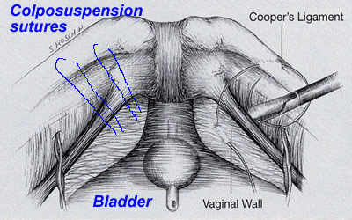

Trans vaginal tape TVT
In this operation a synthetic inert tape is passed bellow the urethra and attached to the anterior abdominal; wall. Remote complications include urethra injury, stricture and retention of urine

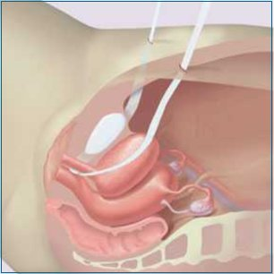

Trans obturator tape or TOT
In this operation a tape is still passed bellow the urethra, however it is passed through the lower part of obturator membrane into the medial aspect of thigh. It requires special needle. This operation is most widely used nowadays to combat GSI. Also has the highest rate of remission.

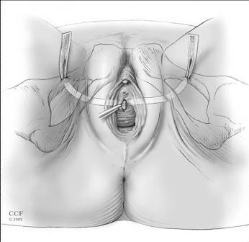

Non surgical treatment of genuine stress incontinence
In recent years lot of surgical methods have been introduced to treat mild form of GSI especially among young post partum women or post menopausal women who have no associated genital tract prolapse. Bellow are some examples

Estrogen cream locally
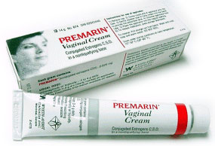
Estrogen cream is useful in mild genuine stress incontinence among post menopausal women. The medication may be used for 6- 12 months.

Phenyl propanolamine
This alpha agonist drug has special affinity to adrenergic receptors in the sphincter urethrae muscle. It is most useful among you women who have GSI post partum.

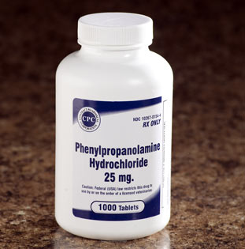

Kegel's pelvic floor exercise
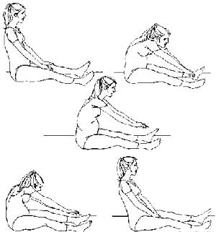
In this exercise the women is instructed first to stretch her hands towards the feet. Then try to extend her back at about 135 degree. This maneuver is repeated may times for 15 minutes per day. It is designed to contract especially the levator ani muscle. Mostly effective in young women having GSI following vaginal delivery.

Graduated vaginal cones
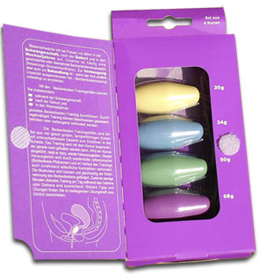

Vaginal cones are usually supplied as four pieces which are similar in size but different in weight.

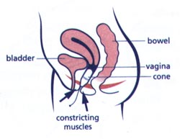
First the woman should be able to hold the inserted cone for at least 15 minutes. Then she is asked to use next heavier cone. The aim is strengthen the pelvic floor muscles. And this is usually associated with gradual improvement of mild GSL over 6- 12 months. Mostly this procedure is used to treat mild GSI following vaginal delivery in young women.

Electrical nerve stimulation
In this procedure the levatoe ani is stimulated with a variety of direct or alternating current. Electrical nerve stimulation increases the number of synapse with the nerve fibers. Electrical stimulation is primarily used to treat mild GSI following vaginal delivery.

Detrusor instability or bladder hyper reflexia

Definition
This is primarily a disease of unknown cause in which the bladder contracts strongly to expel the minimum amount of urine which is normally tolerated by normal balder.
Sometime this disorder is called bladder neurosis.

Etiology
Despite the fact in most of the cases physical examination reveals nothing; psychological factors are important in its etiology. Most of those wome are psychologically unstable or have deep problems like depression, death phobia, and cancer phobia. In few cases bladder hyper reflexia may be the earliest sigh of multiple sclerosis. And that is why meticulous search should be done exclude this serious disorder before truly diagnosing detrusor instability.

Clinical presentation
Urgency and urge incontinence are the main presentations of this disorder. Ultimately the woman becomes depressed and afraid from getting outside.
Investigation

General urine examination
GUE with mid stream urine for culture and sensitivity is mandatory to find and treat before diagnosis of bladder instability is reached. Most infections of urinary tract are also associated with frequency and urgency.

Bladder cystometry

Character | Genuine stress incontinence | Bladder hyper reflexia
First volume to sense voiding desire | 150- 250 cc | < 150 cc
Maximum bladder capacity | 500 600 cc | < 400 cc
Maximum resting intra vesical pressure | < 15 cm water | > 15 cm water
Voiding intra vesical pressure | < 50 cc water | > 50 cc water

Bladder cystometry is mostly required to confirm the diagnosis of bladder hyper eflexia. The characteristics in second column in table shown above represent the criteria to confirm the diagnosis.

Treatment of bladder hyper reflexia or detrusor instability
Unlike GSI the treatment of bladder hyper reflexia is usually by medical agents. Any of the followings may be used

Imipramine
Imipramine is tricyclic anti depressant drug which has also anti cholinergic properties. In a dose of 25 mg for 3 months up to 90 % of women get improvement

Terodiline
This calcium channel blocker has specific affinity to bladder detrusor muscle. It is much more effective than imipramine, however it is more expensive.

Oxybutynin

Oxybutynin is anti cholinergic drug which has special affinity to the detrusor muscle. It is much superior to imipramine though it it is ore expensive.

Desmopressin
This vaso pressin analogue acts on the renal tubules to re absorb water. Thus significantly reduce the urinary execration. However its use is associated with significant risk of water intoxication.

Presaral neurectomy
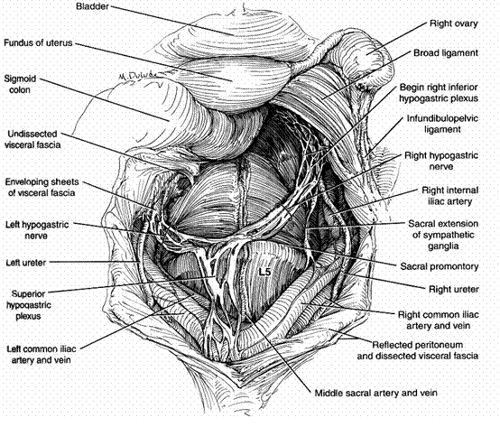

In highly resistant cases pre sacral neurectomy may be done. It can be done through laparoscopy. Pre sacral neurectomy improves remarkably the symptoms for at least 5 years. However recurrence of symptoms may occur thereafter.

