Overview of normal development of the fetus with associated clinical significance
Objectives
to review the clinical aspect associated with normal development the fetus and their significance so the student become well acquainted with clinical signs and symptoms of pregnancy

IMPLANTATION AND EARLY DEVELOPMENT OF OVUM
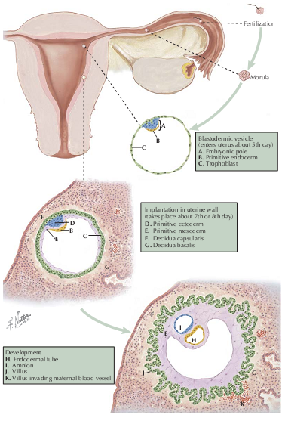
- Fertilization of the human ovum usually occurs in the ampullary portion of the oviduct, although in rare instances it may take place elsewhere in the genital tract or even in the ovary.
- Soon after the spermatozoon enters the ovum, the male and female pronuclei fuse to form the segmentation nucleus, which rapidly fertilized ovum is transformed into a mass of cells called the morula.
- At this early stage, two types of cells can be distinguished; some proliferate more rapidly, forming a sphere that encloses the aggregate of more slowly dividing cells.
- A semi fluid substance is excreted from the outer cells and is collected in a cavity, which forms simultaneously. The sphere-shaped structure is called the blastocyst.
- One layer of ectodermal cells, the primitive trophoblast, covers it except at one pole where the rapidly dividing cells have formed the “inner cell mass while these changes take place, the ovum continues its passage into the uterine cavity, where it becomes implanted on the seventh or eighth day after ovulation.
- Estrogen and progesterone, act upon the endometrium, producing the premenstrual mucosa, which is sloughed or cast off during menstruation but remains when fertilization occurs. The pregravid endometrium gradually undergoes further changes to become the early decidua to which the blastocyst rapidly adheres once it has reached the uterus.
- By the invasive capacity of its trophoblastic cells, the blastocyst sinks into the endometrium, which then closes over it and seals it from the uterine cavity, forming the decidua capsularis. The remaining decidua surrounding the blastocyst is called the decidua basalis, whereas the term decidua vera or parietalis designates the entire endometrium lining the uterus, except for the parts surrounding the blastocyst.
- During the period of migration and implantation of the blastocyst, marked cellular proliferation has been taking place in the embryonic area.
- Three types of cells can be differentiated within the “inner cell mass.” These constitute the three primary germ layers, the ectoderm, endoderm, and mesoderm.
- From the ectoderm will derive the central nervous system, the epidermis, and certain skin appendages. The endoderm will furnish the epithelial linings and the glands of the gastroenteric and respiratory tracts. The mesoderm will give rise to the epithelium of the urinary and genital systems, the linings of the serous cavities, the various supporting tissues of the body, the blood, and the cardiovascular system.
- After implantation, mesodermic cells grow out beneath the primitive trophoblast, which, by prolifera-tion, forms villous projections into the surrounding decidua. Each villus consists of a mesodermic core covered by two layers of trophoblastic cells.
- The outer cells have dark-staining nuclei and indefinite cell out-lines. They are called syncytial trophoblasts.
- The more distinct cells of the inner layer are designated cyt-trophoblasts or Langherans cells. These decrease in number as pregnancy progresses and are difficult to find after the third month of gestation.

DEVELOPMENTAL EVENTS OF THE FIRST TRIMESTER

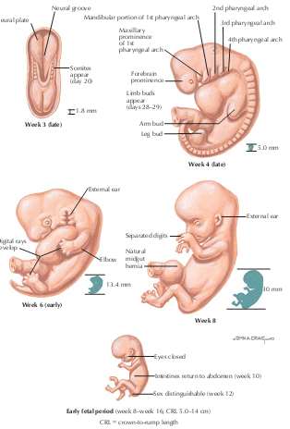
- The first weeks following fertilization represent the most critical period for the success of a pregnancy. A high percentage (as high as 50% to 60%) of fertilized oocytes do not result in pregnancies completing the first trimester of gestation.
- Despite the dramatic changes that the conceptus undergoes in the first 14 weeks of gestation, many patients are unaware of their pregnancy or delay seeking prenatal care.
- During the first trimester of gestation, the developing embryo implants in the endometrium the placental attachment to the mother is created, and the major structures and organs of the body are formed. About the 12th week of gestation, the placenta takes over hormonal support for the pregnancy from the corpus luteum.
- If this transition does not happen smoothly, the pregnancy can be lost. When the serum level of β–human chorionic gonadotropin (β-hCG) is greater than 1500 mIU/mL, the level known as the discriminatory zone, transvaginal ultrasonography should visualize an intrauterine gestational sac in a normal, intrauterine, singleton pregnancy.
- Most patients do not have any specific signs or symptoms of implantation, although it is not uncommon to experience light bleeding at implantation or cramping during the first trimester.
- Clinical blood and urine tests (β-hCG) can detect pregnancy soon after implantation, which is as early as 6 to 8 days after fertilization.
- Home urine pregnancy tests normally cannot detect a pregnancy until at least 12 to 15 days after fertilization.
- Morning sickness occurs in about 70% of all pregnant women and typically improves after the first trimester.
- Some women will experience cramping during their first trimester, though this is usually of little concern unless there is bleeding as well. Symptoms of fatigue and breast fullness may occur relatively early in the course of gestation, and abdominal distension begins later in this trimester.
- For the first 2 months of growth, the conceptus is referred to as an embryo.
- During this phase, the developing embryo is most sensitive to exposures to toxins, medications, radiation, and the effects of maternal condition that can disrupt the development process. Errors may result in major disruptions in structure or function of the fetus, or the complete loss of the pregnancy.
- Embryonic development is said to be complete when the embryo attains a crown-to-rump length of 30 mm (start of the fetal stage), corresponding in most cases to day 49 after conception.
- At the start of the third month of gestation, the risk of miscarriage decreases sharply, all major structures including hands, feet, head, brain, and other organs are present, and they continue to grow and develop.
- The fetal heart can be seen beating on ultrasonography, and the fetus bends its head and also makes general and startle movements.
- The gender of the individual may be seen as early as the 12th week. Brainstem activity has been detected as early as 54 days after conception, and
- First measurable signs of brain electroencephalographic activity occur in the 12th week of gestation. If a genetic evaluation of the fetus is indicated, chorionic villus sampling may be performed between the 10th and 12th week of gestation or amniocentesis may be done between 15 and 20 weeks.

DEVELOPMENTAL EVENTS OF THE SECOND TRIMESTER

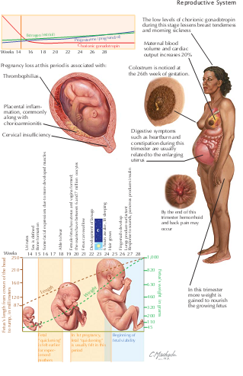

- The second trimester (14 to 28 weeks) is a time of growth and refinement of function; all major structures including hands, feet, head, brain, and other organs are present, and they continue to grow and develop.
- During this trimester, the risk of pregnancy loss dramatically lessens and levels of human chorionic gonadotropin plateau and often decline, easing many of the early adverse symptoms of pregnancy such as breast tenderness and morning sickness,
- Though the enlarging uterus may now precipitate heartburn and constipation.
- Any weight loss experienced in the first weeks of gestation is regained and further weight is gained to provide stores needed to provide nutrition for the growing fetus.
- Although the fetus begins moving during the first trimester, it is not until the second trimester that movement of the fetus (“quickening”) is felt. This typically happens around 20 weeks for first pregnancies and as early as 18 weeks for experienced mothers.
- Fetal viability (ability to survive apart from the mother) begins about 24 weeks, though neurologically intact survival at this stage is unlikely.
- There is an increase in maternal blood volume and cardiac output (20% greater) to feed the needs of the growing pregnancy.
- Toward the end of this trimester, maternal hemorrhoids and low back pain may make their appearance.
- Colostrum (the first form of breast milk) is present by 26 weeks of gestation.
- The placenta is fully functional, taking over the role of making estrogen and progesterone that had been performed by the corpus luteum.
- The fetus is making insulin and urinating, with fetal urine being a significant component of amniotic fluid.
- The fetus will begin to outweigh the placenta sometime around the 16th week of gestation
- The teeth have formed inside the fetus’s gums, and
- vernix caseosa and anal fecal meconium make their first appearance.
- By the end of the second trimester, babies hear and respond to external sounds.
- By the early portion of the second trimester, the external genitalia have formed so that they can be recognized on ultrasonographic studies, distinguishing the fetus as male or female.
- It is also at this point that a female fetus will have the most egg cells of any point in her life. Oocytes peak at 6 to 7 million about 16 to 20 weeks’ gestation, declining to about 1 million at birth.
- Screening for open neural tube and other defects (via measurement of maternal serum α-fetoprotein and other markers) is generally performed between 15 and 20 weeks.
- If a genetic evaluation of the fetus is indicated, an amniocentesis may be performed between the 15th and 20th weeks of gestation. It is generally during the second trimester that ultrasonographic screening for appropriate gestational age, fetal growth, and major fetal malformations is performed.

DEVELOPMENTAL EVENTS OF THE THIRD TRIMESTER
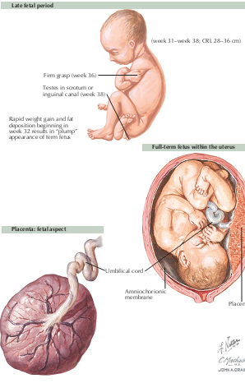
- During the third trimester (27 to 40+ weeks) the fetus continues to grow and develop, and maternal physiology changes in preparation for childbirth.
- It is most often during this phase of pregnancy that complications such as preeclampsia, bleeding, complications of diabetes or hypertension, abnormalities of growth or amniotic fluid and preterm labor may emerge.
- Fetal fat accumulates to provide nutrition and insulation for the first few days of independent life, accounting for about 15% of fetal weight at term.
- By the 29th week, the fetus has 300 bones, though eventual fusion of more than 90 of these fetal growth plates following birth will leave the adult total of 206.
- At the beginning of this trimester, in the male, the testes descend into the scrotum under the guidance of the gubernaculum, which in the female become the round ligaments supporting the fundus of the uterus.
- Most babies will settle into their final birth presentation (cephalic, breech, or transverse) by about 36 weeks’ gestation.
- Maternal blood volume increases by almost twice and cardiac output reaches its maximum.
- At term, 20% of maternal cardiac output goes to the uterus and placenta.
- Late in this trimester, changes in the cervix prepare for dilation and effacement during labor and delivery.
- It is also in the latter portion of this trimester that the number of oxytocin receptors on the uterine muscle cells increases markedly and there is an increase in the number of intercellular gap junctions. These micro-pores between cells provide a mechanism to facilitate the organized and effective coordinated contractions necessary for successful labor.
- Uterine contractions that have been present since conception become progressively stronger and more noticeable as the trimester progresses.
- These are the Braxton-Hicks contractions of late pregnancy and the contractions of labor and delivery. Amniotic fluid volume peaks at about a liter at 37 weeks.
- As the uterus grows, displacement of the abdominal contents results in early fullness with meals, heartburn, and constipation.
- The growth also results in relocation of the maternal center of gravity, causing the mother to lean backwards to compensate. This results in low back pain and the characteristic ‘Lumbar Lordosis'
- When the fetal presenting part begins descent into the maternal pelvis (about 36 weeks’ gestation), causing a decline in fundal height, the patient experiences improved respiratory and gastric function but at the expense of greater pelvic pressure and a reduced bladder capacity.
- Planning and preparation for breastfeeding should be undertaken during this trimester.
- No special physical preparation is needed for successful breastfeeding, but discussion, questions, and the acquisition of needed supplies (e.g., nursing bra) are best taken care of before delivery. Normal amounts of colostrum have been present from the beginning of this trimester, and some women experience breast leakage throughout, this period.
- For selected patients, “kick counts” may be used to assess the overall health of the fetus. In general, the detection of more than four fetal movements over the course of an hour indicates a healthy fetus.
- All patients should be encouraged to monitor their baby’s activity levels and be evaluated for any prolonged reduction or absence in activity.
- Because placental function declines after 40 weeks, testing of fetal and placental reserve through fetal non-stress testing, contraction stress testing, biophysical profiles, or measurements of fetal blood flow in various vessels may be indicated when there are complications of pregnancy or it extends beyond term.

