Ante partum feral surveillance

Background and objectives
Fetal hypoxia and acidosis can result from any cause of placental insufficiency. Placental insufficiency is commonly associated with hypertensive disorders during pregnancy, diabetes mellitus and any cause of placental insufficiency. Ante partum fetal surveillance tests are group of procedures to identify fetal hypoxia before the onset of labor.

Kick count
Kick count is simply defined as the number of fetal movements felt by the pregnant woman during 12 hours. It is still the most reliable ante partum fetal distress. Simply the pregnant woman is asked to record the number of fetal movements per 12 hours. In well oxygenated fetus, at least 10 movements is felt. Should the number is less that 10, further evaluation is required.

Non stress test

Definition
Correlation between fetal heart rate changes compared with fetal movement

Technique
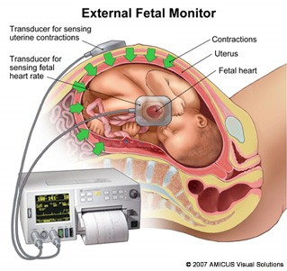

Ultrasound device is usually used to record fetal heart sound over 30 minutes. The results are plotted in a strip paper which is called NST strip. During this 30 minutes the fetal heart rate is usually plotted while fetal movements are plotted whenever they occur

Finding in NST strip
For each NST strip the followings should be evaluated
- Baseline fetal heart which should be 110 to 150 beats per minutes.
- Beat to beat variability which shown as zigzag shaped line.
- Fetal heart rate acceleration associated with fetal movement. With each fetal movement the fetal heart rate should increase 15 beats above the base line and endure at least15 seconds.

Interpretation
- In well oxygenated fetus there should be at least 2 movements during 30 minutes tracing. Each movement is associated with rise in the fetal heart rate by 15 beat per minutes and last for 15 seconds. In such cases the tracing is assuring and called reactive non stress test
- Otherwise in the absence of fetal of fetal movement, beat to beat variability or fetal heart acceleration the strip is called non reactive NST and the fetus requires further assessment.
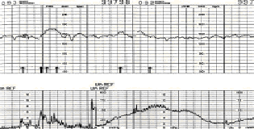

Example of reactive non stress test

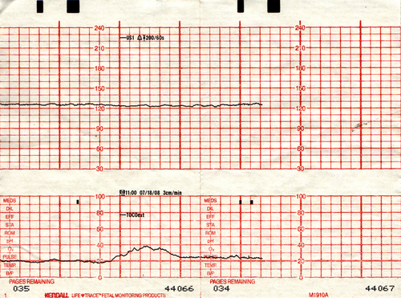

Example of non reactive NST strip

Biophysical profile of the fetus
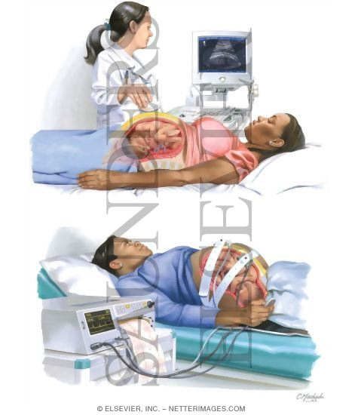

Background and technique
An ultrasound based investigation which last for 30 minutes. During this 30 minutes the followings should be noticed and scored
- Fetal attitude which should be in flexion position. Extended fetus indicates fetal hypoxia.
- Fetal gross body movements. During 30 minutes observation the fetus should move at least once. The fetal movement should swing from fetal flexion, extension and back to flexion.
- Fetal respiratory movements. During 30 minutes observation the fetus should have one episode of fetal breathing movement which last for 30 seconds.
- Amount of liquor. The amount of liquor can be easily assessed by ultrasound scan. Should the amount of liquor is normal this indicates well oxygenated fetus. Oligohydramnios indicates fetal a risk for hypoxia.
- Fetal heart rate changes with fetal movement. Should the fetal heart rate increase with fetal movement this indicates well oxygenated fetus. Otherwise absence of fetal movement indicates fetal hypoxia

Scoring of biophysical profile

parameter | present | absent
Gross body movement | 2 | 0
Respiratory movement | 2 | 0
Fetal tone | 2 | 0
oligohydramios | 0 | 2
Fetal heart rate variability with movement | 2 | 0

Score may be 0, 2,4,6,8 and 10

Interpretation and clinical management
- Score 8- 10 repeat after 1 week.
- Score 6 repeat after 24 hours.
- Scores 0, 2, 4 are indication for immediate delivery

Doppler of the umbilical artery

Background
Doppler of the umbilical artery is defined simply as measuring the blood velocity in the artery by the use of ultrasound probes. The red blood cells in the blood reflect the ultrasound wave from the probe. With this reflection there frequency of the ultrasound wave is shifted or changed. The degree of change is dependent on the velocity of blood. And from this frequency change the blood velocity can be calculated and plotted as strip paper.

Technique

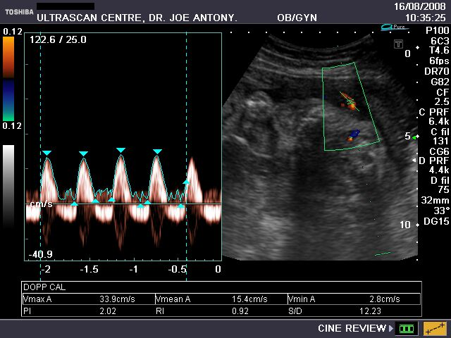

The procedure is usually done by special ultrasound probe which is equipped with Doppler facility. First the umbilical artery is visualized and insinuated with ultrasound wave at 60 degree. The results are plotted on strip paper as well as the on the screen.

Clinical interpretation of Doppler

Normal Doppler
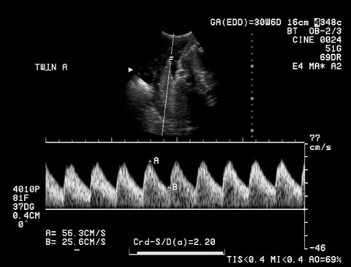

In normal Doppler strips with assuring adequate blood flow to the fetus, both systolic and diastolic waves are shown. The peak systolic wave represents the maximum blood flow velocity during systole.

Non assuring Doppler
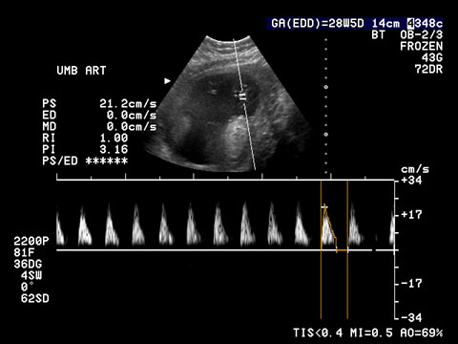

None assuring Doppler is said to be present when the diastolic wave is absent a pattern with is called
Absent end diastolic wave
As shown in the picture above. The absence of diastolic wave indicates high resistance in placental blood flow. A pattern commonly associated with severe feta, acidosis and hypoxia. In such cases prompt delivery is required.

