Pharmacology of bone disorders

The human skeleton undergoes a continuous process of remodelling throughout life-some bone being resorbed and new bone being laid down. With advancing age, there is an increasing possibility of structural deterioration and decreased bone mass (osteoporosis). This constitutes a major health problem throughout the world, and there are, in addition, various other conditions that can lead to pathological changes in bone that require therapy. In the past decade, there have been significant advances in the understanding of bone biology, which have led to new drugs and may yet lead to further new drugs.
BONE STRUCTURE AND COMPOSITION

The human skeleton consists of 80% cortical bone and 20% trabecular bone. Cortical bone is the dense, compact outer part, and trabecular bone the inner meshwork. The former predominates in the shafts of long bones, the latter in the vertebrae, the epiphyses of long bones and the iliac crest. Trabecular bone, having a large surface area, is metabolically more active and more affected by factors that lead to bone loss

The main minerals in bone are calcium and phosphates. More than 99% of the calcium in the body is in the skeleton, mostly as crystalline hydroxyapatite but some as non-crystalline phosphates and carbonates; together, these make up half the bone mass.

The main cells in bone homeostasis are osteoblasts, osteoclasts and osteocytes.

- Osteoblasts, which are derived from precursor cells in the bone marrow and the periosteum, secrete important components of the extracellular matrix-the osteoid, particularly the collagen. They also have a role in the activation of osteoclasts (see below).
- Osteoclasts are multinucleated bone-resorbing cells derived from precursor cells of the macrophage/monocyte lineage.
- Osteocytes are derived from the osteoblasts, which, during the formation of new bone, become embedded in the bony matrix and differentiate into osteocytes. These cells form a connected cellular network that, along with the nerve fibres in bone, is thought to have a role in the response to mechanical loading.
- Other cells of importance are monocytes/macrophages, lymphocytes and vascular endothelial cells; these secrete cytokines and other mediators necessary for bone remodelling

The organic matrix of bone is termed osteoid the principal component of which is collagen. But there are also other components such as proteoglycans, osteocalcin and various phosphoproteins, one of which, osteonectin, binds to both calcium and collagen and thus links these two major constituents of bone matrix.

Calcium phosphate crystals in the form of hydroxyapatite [Ca₁₀(PO₄)₆(OH)₂] are deposited in the osteoid, converting it into hard bone matrix.

The process of remodelling involves the following:

- the activity of two main cell types: osteoblasts that secrete new bone matrix and osteoclasts that break it down
- the actions of a variety of cytokines;
- the turnover of bone minerals-particularly calcium and phosphate
- the actions of several hormones: parathyroid hormone (PTH), the vitamin D family, oestrogens, growth hormone, steroids, calcitonin and various cytokines
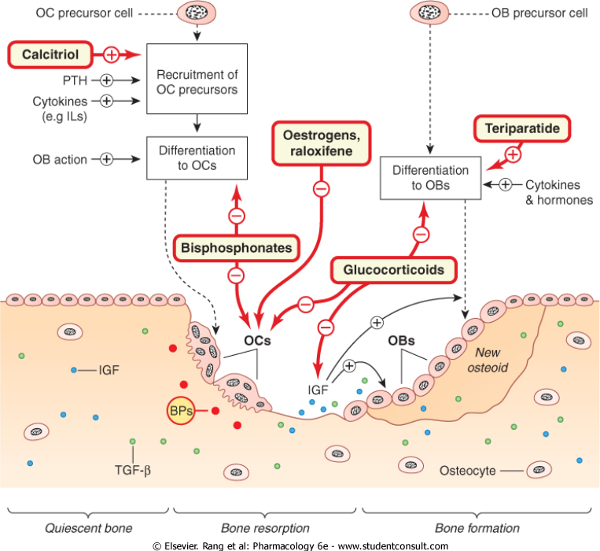
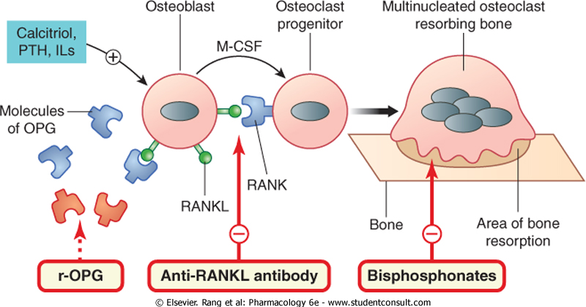

A cycle of remodelling starts with recruitment of the cells that give rise to osteoclast precursors, and their differentiation to mature multinuceated osteoclasts by cytokines The osteoclasts adhere to an area of trabecular bone, developing a ruffled border at the attachment site. They move along the bone, digging a pit by secreting hydrogen ions and proteolytic enzymes. This process gradually liberates cytokines such as insulin-like growth factor (IGF)-1 and transforming growth factor (TGF)-β, which have been embedded in the osteoid (these in turn recruit and activate successive teams of osteoblasts that have been stimulated to develop from precursor cells and are awaiting the call to duty The osteoblasts invade the site, synthesising and secreting the organic matrix of bone, the osteoid, and secreting IGF-1 and TGF-β (which become embedded in the osteoid; see above). Some osteoblasts become embedded in the osteoid, forming terminal osteocytes; others interact with and activate osteoclast precursors-and we are back to the beginning of the cycle.

Cytokines involved in bone remodelling other than IGF-1 and TGF-β include other members of the TGF-β family, such as the bone morphogenic proteins, a range of interleukins, prostaglandins, various hormones, and members of the tumour necrosis factor family. A member of this last family-a ligand for a receptor on the osteoclast precursor cell-is of particular importance. The receptor is termed (wait for it-biological terminology has fallen over its own feet here) RANK, which stands for receptor activator of nuclear factor kappa B (NFκB)-NFκB being the principal transduction factor involved in osteoclast differentiation and activation. And the ligand is termed, unsurprisingly, RANK ligand (RANKL).

The stromal cell and the osteoblast synthesise and release a molecule termed osteoprotegerin (OPG), identical with RANK, which functions as a decoy receptor. In a sibling-undermining process by the two cells (osteoblast/stromal cell and osteoclast precursor), OPG can bind to RANKL¹ (generated by the very cell that OPG itself is generated by) and inhibit RANKL's binding to its intended receptor, RANK, on the osteoclast precursor cell

The ratio of RANKL to OPG is critical in the formation and activity of osteoclasts

The main bone minerals are calcium and phosphates.

CALCIUM METABOLISM

The daily turnover of bone minerals during remodelling involves about 700 mg of calcium. Calcium has numerous roles in physiological functioning. Intracellular Ca²⁺ constitutes only a small proportion of body calcium, but it has a major role in cellular functionAn influx of Ca²⁺ with increase of Ca²⁺ in the cytosol is part of the signal transduction mechanism of many cells, so the concentration of Ca²⁺ in the extracellular fluid and the plasma needs to be controlled with great precision. The concentration of Ca²⁺ in the cytoplasm of cells is about 100 nmol/l, whereas in the plasma it is about 2.5 mmol/l. The plasma Ca²⁺ concentration is regulated by complex interactions between PTH and various forms of vitamin D calcitonin also plays a part.

Calcium absorption in the intestine involves a Ca²⁺-binding protein whose synthesis is regulated by calcitriolIt is probable that the overall calcium content of the body is regulated largely by this absorption mechanism, because urinary Ca²⁺ excretion normally remains more or less constant. However, with high blood Ca²⁺ concentrations, urinary excretion increases, and with low blood concentrations urinary excretion can be reduced by PTH and calcitriol, both of which enhance Ca²⁺ reabsorption in the renal tubules

PHOSPHATE METABOLISM

Phosphates are important constituents of bone, and are also critically important in the structure and function of all the cells of the body. They play a significant part in enzymic reactions in the cell; they have roles as intracellular buffers and in the excretion of hydrogen ions in the kidney.

Phosphate absorption is an energy-requiring process regulated by calcitriol. Phosphate deposition in bone, as hydroxyapatite, depends on the plasma concentration of PTH, which, with calcitriol, tends to mobilise both Ca²⁺ and phosphate from the bone matrix. Phosphate is excreted by the kidney; here PTH inhibits reabsorption and thus increases excretion.

HORMONES INVOLVED IN BONE METABOLISM AND REMODELLING

The main hormones involved in bone metabolism and remodelling are PTH, members of the vitamin D family, oestrogens and calcitonin. Glucocorticoids and thyroid hormone also affect bone

PARATHYROID HORMONE

Parathyroid hormone, which consists of a single-chain polypeptide of 84 amino acids, is an important physiological regulator of Ca²⁺ metabolism. It maintains the plasma Ca²⁺ concentration by mobilising Ca²⁺ from bone, by promoting its reabsorption by the kidney, and in particular by stimulating the synthesis of calcitriol, which in turn increases Ca²⁺ absorption from the intestine and synergises with PTH in mobilising bone Ca²⁺ PTH promotes phosphate excretion, and thus its net effect is to increase the concentration of Ca²⁺ in the plasma and lower that of phosphate.

The mobilisation of Ca²⁺ from bone by PTH is mediated, at least in part, by stimulation of the recruitment and activation of osteoclasts. Pathological oversecretion of PTH (hyperparathyroidism) inhibits osteoblast activityBut given therapeutically in a low intermittent dose, PTH and fragments of PTH paradoxically stimulate osteoblast activity and enhance bone formation (see below).

Parathyroid hormone is synthesised in the cells of the parathyroid glands and stored in vesicles. The principal factor controlling secretion is the concentration of ionised calcium in the plasma, low plasma Ca²⁺ stimulating secretion, high plasma Ca²⁺ decreasing it by binding to and activating a Ca²⁺-sensing G-protein-coupled surface receptor 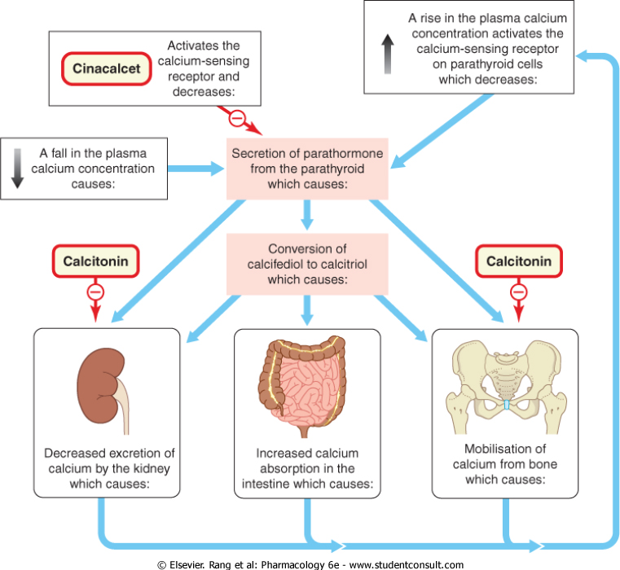

VITAMIN D

Vitamin D is a prehormone that is converted in the body into a number of biologically active metabolites that function as true hormones, circulating in the blood and regulating the activities of various cell types Their main action is the maintenance of plasma Ca²⁺ by increasing Ca²⁺ absorption in the intestine, mobilising Ca²⁺ from bone and decreasing its renal excretion Vitamin D itself is really a family of hormones belonging to the superfamily of steroid hormone receptors. In humans, there are two sources of vitamin D:

- dietary ergocalciferol (D₂), derived from ergosterol in plants
- cholecalciferol (D₃) generated in the skin from 7-dehydrocholesterol by the action of ultraviolet irradiation, the 7-dehydrocholesterol having been formed from cholesterol in the wall of the intestine.

Cholecalciferol (vitamin D₃) is converted to 25-hydroxy-vitamin D₃ (calcifediol) in the liver, and this is converted to a series of other metabolites of varying activity in the kidney, the most potent of which is 1,25-dihydroxy-vitamin D₃ (calcitriol)

The synthesis of calcitriol from calcifediol is regulated by PTH, and is also influenced by the phosphate concentration in the plasma and by the calcitriol concentration itself through a negative feedback mechanism Receptors for calcitriol have been identified in virtually every tissue except liver, and it is now considered that calcitriol may be important in the functioning of many cell types.

The main actions of calcitriol are the stimulation of absorption of Ca²⁺ and phosphate in the intestine, and the mobilisation of Ca²⁺ from bone, but it also increases Ca²⁺ reabsorption in the kidney tubules Its effect on bone involves promotion of maturation of osteoclasts and indirect stimulation of their activityIt decreases collagen synthesis by osteoblasts, and its effect on these cells is by the classic steroid pathway, involving intracellular receptors and an effect on the DNA. However, the effect on bone is complex and is clearly not confined to mobilising Ca²⁺, because in clinical vitamin D deficiency (see below), in which the mineralisation of bone is impaired, administration of vitamin D restores bone formation. One explanation may lie in the fact that calcitriol stimulates synthesis of osteocalcin, the vitamin K-dependent, Ca²⁺-binding protein of bone matrix

OESTROGENS

During reproductive life in the female, oestrogens have an important role in maintenance of bone integrity. They inhibit the cytokines that recruit osteoclasts, and oppose the bone-resorbing, Ca²⁺-mobilising action of PTH. Withdrawal of oestrogen, as happens at the menopause, can lead to osteoporosis.

CALCITONIN

Calcitonin is a hormone secreted by the specialised 'C' cells found in the thyroid follicles.

The main action of calcitonin is on bone; it inhibits bone resorption by binding to a specific receptor on osteoclasts, inhibiting their action. In the kidney, it decreases the reabsorption of both Ca²⁺ and phosphate in the proximal tubules. Its overall effect is to decrease the plasma Ca²⁺ concentration.

Secretion is determined mainly by the plasma Ca²⁺ concentration.

GLUCOCORTICOIDS

Physiological concentrations of glucocorticoids are required for osteoblast differentiation. Excessive pharmacological concentrations inhibit bone formation by inhibiting osteoblast differentiation and activity, and may stimulate osteoclast action-leading to osteoporosis. This latter effect is also evident when pathological concentrations of endogenous glucocorticoids are present, as in Cushing's syndrome

DRUGS USED IN BONE DISORDERS

BISPHOSPHONATES

Bisphosphonates are enzyme-resistant analogues of pyrophosphate that inhibit bone resorption by an action mainly on the osteoclasts. After administration, they are bound to bone minerals in the matrix and are released slowly as bone is resorbed by the osteoclasts, which are thus exposed to high concentrations of the drugs.

The main bisphosphonates available for clinical use are alendronate and risedronate. Others are disodium pamidronate and sodium clodronate. A newer compound, zoledronic acid, which is given only once in a single intravenous infusion, is now used for malignancy and is in clinical trial for Paget's disease and osteoporosis.

Mechanism of action

In terms of their molecular mechanism of action, the bisphosphonates can be grouped into two classes.

- The simple compounds that are very similar to pyrophosphate are incorporated into ATP analogues that accumulate within the osteoclasts and promote their apoptosis.
- The potent, nitrogen-containing bisphosphonates-such as alendronate and ibandronate-interfere with the formation of the ruffled border at the attachment site of the cell to bone, preventing bone resorption

- The nitrogen-containing bisphosphonates appear to inhibit farnesyl diphosphate synthase, an enzyme in the mevalonate pathway. Inhibition of this enzyme prevents the synthesis of certain lipids that are essential for the activity of small GTPase signalling proteins necessary in the formation of the ruffled border

It is now known that bisphosphonates are incorporated into the bone matrix and ingested by osteoclasts when these resorb bone.

Pharmacokinetic aspects

Bisphosphonates are usually given orally and are poorly absorbed. They may be given intravenously in malignancy. About 50% of a dose accumulates at sites of bone mineralisation, where it remains, potentially for months or years, until the bone is resorbed. The free drug is excreted unchanged by the kidney.

Absorption is impaired by food, particularly milk, so the drugs must be taken on an empty stomach.

Unwanted effects include gastrointestinal disturbances, which can be severe, and occasionally bone pain. Peptic ulcers have occurred. Alendronate can cause oesophagitis.

Disodium etidronate can increase the risk of fractures due to reduced calcification of bone; this is less likely if it is given cyclically
Clinical uses of bisphosphonates (e.g. alendronate, pamidronate)

- Paget's disease of bone.
- Hypercalcaemia caused by malignant disease.
- Prevention or treatment of postmenopausal osteoporosis (as an alternative or addition to oestrogens).
- Prevention or treatment of glucocorticoid-induced osteoporosis.
- They are under investigation for the treatment of cancer metastases in bone
OESTROGENS AND RELATED COMPOUNDS

The decline in oestrogen levels is a major factor in postmenopausal osteoporosis, and there is evidence that giving hormone replacement therapy can ameliorate this condition. But HRT has actions on many systems, and newer non-hormonal agents have now been developed that exhibit agonist actions on some tissues and antagonist actions on others. These are termed selective oestrogen receptor modulators (SERMS). Raloxifene is a SERM that has agonist activity on bone and the cardiovascular system, and antagonist activity on mammary tissue and the uterus.

RALOXIFENE

Actions and mechanism of action

Raloxifene produces a dose-dependent increase in osteoblast activity and reduction in osteoclast action.

It is well absorbed in the gastrointestinal tract, and undergoes extensive first-pass metabolism in the liver to give the glucuronide. (Colestyramine, given with it, reduces the enterohepatic cycling of raloxifene by 60%.)

Thus bioavailability is only about 2%. It is widely distributed in the tissues, and is converted to an active metabolite in liver, lungs, bone, spleen, uterus and kidneys. Its half-life averages 32 hours. It is excreted mainly in the faeces.

Unwanted effects

Hot flushes and leg cramps are common. In a recent clinical trial, raloxifene was found to be associated with venous thromboembolism; however, other authorities state that there is less risk of this adverse effect in younger patients.

PARATHYROID HORMONE

Until recently, there had been little or no clinical use for PTH as such, but then it was realised that PTH and fragments of PTH paradoxically stimulate osteoblast activity and enhance bone formation, and they are now considered to be important compounds in the treatment of osteoporosis (see below). The main compound used is teriparatide-the peptide fragment (1-34) of recombinant parathormone.

Actions and mechanism of action

Teriparatide has anabolic effects on bone. It increases bone mass, structural integrity and bone strength by increasing the number of osteoblasts and by activating those osteoblasts already in bone. It also reduces osteoblast apoptosis.

It acts on the G-protein-dependent PTH receptor-1 in the membrane of target cells, and its effects are mediated through adenylate cyclase, phospholipases A, C and D, and increases in intracellular Ca²⁺ and cyclic AMP.

Pharmacokinetic aspects

Given subcutaneously once daily, peak concentrations occur after 30 minutes. The serum distribution half-life is 10 minutes after intravenous injection and 1 hour after subcutaneous injection.

Unwanted effects

Teriparatide is well tolerated, and serious adverse effects are few. Nausea, dizziness, headache and arthralgias can occur. Mild hypercalcaemia, transient orthostatic hypotension, nausea, dizziness, headache and leg cramps have been reported.

Clinical use

Note that there is controversy as to whether or not this drug should be given sequentially or in combination with one of the bisphosphonates; however, a bisphosphonate should be given at the end of a course of teriparatide to prevent teriparatide withdrawal bone loss.

STRONTIUM RANELATE

This compound, newly introduced for treatment of osteoporosis, is composed of two atoms of strontium combined with organic ranelic acid, the latter being a carrier for the active strontium component. It inhibits bone resorption and also stimulates bone formation. In recent trials, it has been shown to be effective in preventing vertebral and non-vertebral fractures in older women

The precise mechanism of action is not clear. Strontium is similar to calcium as regards its absorption in the gastrointestinal tract, its incorporation into bone and its renal elimination. Strontium atoms are adsorbed on to the hydroxyapatite crystals, but eventually they exchange for calcium in the bone minerals and remain in the bone for many years.

The drug is well tolerated; a low incidence of nausea and diarrhoea is reported.

VITAMIN D PREPARATIONS

Vitamin D preparations are used in the treatment of vitamin D deficiencies, bone problems associated with renal failure, and hypoparathyroidism-acute hypoparathyroidism necessitating the use of intravenous calcium and injectable vitamin D preparations.

The main vitamin D preparation used clinically is ergocalciferol; also available for clinical use are alfacalcidol and calcitriol. All can be given orally and are well absorbed from the intestine. Vitamin D preparations are fat-soluble, and bile salts are necessary for absorption. Injectable forms of calciferol are available. Newer vitamin D analogues with less potential to cause hypercalcaemia are the vitamin D sterols 19-nor-paracalcitol and doxercalciferol

Pharmacokinetic aspects

Given orally, vitamin D is bound to a specific α-globulin in the blood. The plasma half-life is about 22 hours, but vitamin D can be found in the fat for many months. The main route of elimination is in the faeces.

The clinical use of vitamin D preparations are:

- Deficiency states: prevention and treatment of rickets, osteomalacia and vitamin D deficiency owing to malabsorption and liver disease (ergocalciferol).
- Hypocalcaemia caused by hypoparathyroidism (ergocalciferol).
- Osteodystrophy of chronic renal failure, which is the consequence of decreased calcitriol generation (calcitriol or alphacalcidol).
- Plasma Ca²⁺ levels should be monitored during therapy with vitamin D.

Unwanted effects

Excessive intake of vitamin D causes hypercalcaemia, the manifestations of which include constipation, depression, weakness and fatigue. There is a reduced ability to concentrate the urine, resulting in polyuria and polydipsia. If hypercalcaemia persists, calcium salts are deposited in the kidney and urine, causing renal failure and kidney stones.

Some anticonvulsant drugs (e.g. phenytoin; increase the requirement for vitamin D.

CALCITONIN

The main preparation available for clinical use is salcatonin (synthetic salmon calcitonin). Synthetic human calcitonin is now also available. Calcitonin is given by subcutaneous or intramuscular injection, and there may be a local inflammatory action at the injection site. It can also be given intranasally. Its plasma half-life is 4-12 minutes, but its action lasts for several hours.
Clinical uses of calcitonin/salcatonin

- Hypercalcaemia (e.g. associated with neoplasia).
- Paget's disease of bone (to relieve pain and reduce neurological complications).
- Postmenopausal and corticosteroid-induced osteoporosis (with other agents).

Unwanted effects include nausea and vomiting. Facial flushing may occur, as may a tingling sensation in the hands and an unpleasant taste in the mouth.

CALCIUM SALTS

Calcium salts used therapeutically include calcium gluconate and calcium lactate, given orally. Calcium gluconate is also used for intravenous injection in emergency treatment of hyperkalaemia intramuscular injection is not used, because it causes local necrosis.

Calcium carbonate, an antacid, is poorly absorbed in the gut, but there is concern about systemic absorption and the potential to cause arterial calcification. An oral preparation of hydroxyapatite is available.
Clinical uses of calcium salts

- Dietary deficiency.
- Hypocalcaemia caused by hypoparathyroidism or malabsorption (intravenous for acute tetany).
- Calcium carbonate is an antacid; it is poorly absorbed and binds phosphate in the gut. It is used to treat hyperphosphataemia
- Prevention and treatment of osteoporosis (often with oestrogen, bisphosphonate, vitamin D or calcitonin).
- Cardiac dysrhythmias caused by severe hyperkalaemia

Unwanted effects: oral calcium salts can cause gastrointestinal disturbance. Intravenous administration requires care, especially in patients on cardiac glycosides

CALCIMIMETIC COMPOUNDS

Calcimimetics enhance the sensitivity of the parathyroid Ca²⁺-sensing receptor to the concentration of blood Ca²⁺. The effect is to decrease the secretion of PTH and reduce the serum Ca²⁺ concentration. There are two types of calcimimetics.

- Type I are agonists, and include inorganic and organic polycations.
- Type II are allosteric activators that activate the receptor by altering its conformation. One such compound is cinacalcet, which is in clinical trial for the treatment of hyperparathyroidism
POTENTIAL NEW THERAPIES

There is growing interest in the possible value of anabolic compounds that stimulate bone formation-for use alone or in combination with the antiresorptive drugs Teriparatide, the first anabolic compound licensed for osteoporosis, is already available for use. A new antiresorptive compound, an anti-RANKL antibody named denosumab, is now available; this specifically blocks RANKL binding to RANK and is in phase III trial

Other potential anabolic agents being considered for future development are IGF-1 and insulin-like growth hormone and the statins. These last, commonly given to reduce blood cholesterol have been shown to increase the gene expression of bone morphogenic protein-2, and to increase bone formation in vitro. Thiazides have a small effect in slowing bone loss and might be of value in combination therapy.

Possible new antiresorptive agents on the horizon include agents related to OPG-a physiological inhibitor of bone resorption.

Recombinant OPG has been tried in juvenile Paget's disease, with promising results

Conclusions
- Osteoporosis is ↓ bone mass lead to bone fragility, more in postmenopausal female.
- The drugs used for osteoporosis are:
- Biphosphonate:(etidronate,alendronate, risedronate), these act by:
- Inhibition of osteoclast proton pump.
- ↓ Osteoclast cell formation.
- ↓ Osteoclast cell activation.
All are orally active, rapid bind to bone mineral.
Indications:
- Pagets disease , Ostepporosis., Breast cancer metastasis.
- Teriparatide: its recombinant segment of parathyroid hormone, stimulate bone formation and ↑ spinal density.
Uses:
- Prevent vertebral fracture, Treat glucocorticoid induced osteoporosis.
- Selective estrogen receptor modulator (SERM):
- only. Rolexifen prevent and treat osteoporosis.
- Not ↑ risk of estrogen side effect. It acts on bone
- Calcitonin: Prevent and treat osteoporosis. Given intravenously. ↓ Bone resorption and ↑ bone formation.
- Tolerance occurred within long therapy.

