GIT PATHOLOGY

Lec.3 Dr.Methaq Mueen

The stomach

Histology:
A-The mucosa: composed of gastric pits (foveolae)& gastric glands which are either:
* Mucous secreting in the antrum and cardia
* Glands composed of chief cells that secrete pepsin, and parietal cells that secrete acid (HCl) and intrinsic factor (IF).
B- The submucosa
C- The muscular layer
D- The serosa

Gastritis:

It is defined as inflammation of the gastric mucosa.
- Acute gastritis with neutrophilic infiltration.
- Chronic gastritis with lymphocytic infiltration.

Acute gastritis:
Is acute inflammation of the gastric mucosa.

Etiology:
- Heavy use of( non steroidal anti-inflammatory drugs NSAID)
- Excessive alcohol intake
- Heavy smoking
- Uremia
- Severe stress (burn , trauma, surgery)
- Systemic infection (e.g salmonellosis).
- Treatment with chemotherapeutic drugs.

Clinical features:
Epigastric pain, nausea and vomiting, sometimes hematamesis
Grossly:
Congested, edematous surface .
Microscopically:
- Neutrophils among the surface epithelial cells.
- Erosion (loss of superficial epithelial cells) resulting in a defective mucosa.
- Sometimes hemorrhage → acute hemorrhagic gastritis.

Chronic gastritis:
Defined as presence of mucosal inflammatory changes leading to:
- Mucosal atrophy
- H-pylori are found nestled within the mucus layer overlying the mucosal epithelium.
- Epithelial metaplasia (replacement of the gastric epithelium with columnar &goblet cells of the intestinal variety).
- Sometimes dysplasia which makes the background for carcinoma.
- H-pylori induced proliferation of lymphoid tissue within gastric mucosa is a precursor of gastric lymphoma.
- There is No Erosion (to differentiated from gastric ulceration)
Etiological factors:
- Chronic inflammatory processes (helicobacter pylori H.P) which makes the most important factor and present in about 50% of cases.
- Immunological (autoimmune) in association with pernicious anemia which makes about 10% of cases.
- Toxic e.g alcohol &cigarette smoking.
- Post surgical e.g reflux of biliary duodenal secretion
- Motor and mechanical causes including: obstruction, bezoars.
- Radiation
- Granulomatous conditions
8- Miscellaneous e.g amyloidosis.
Classification:
- Type “A” chronic gastritis.
- Type “B” chronic gastritis.

Type A:
*Is also called autoimmune chronic gastritis.
*It can be associated with other autoimmune diseases e.g diabetes, thyroiditis.
* Occur in late adult life.
* The body (fundus) mucosa is mostly affected.
* There is a production of antibodies against the parietal cells which causes:
- Decrease the HCL secretion.
- Decrease in intrinsic factor secretion.
- Impaired Vit B12 absorption and later on pernicious anemia as a result of the above cause.
- There is high risk of developing gastric carcinoma.

Microscopically:
The changes run in three stages:
1-Chronic superficial gastritis: there is infiltration of the foveolar part of the mucosa by chronic inflammatory cells (lymphocyte and plasma cells).
2-Chronic atrophic gastritis:
* The inflammatory infiltrate involve the foveola and deeper parts of the mucosa
* There is glandular destruction &loss
* Decrease in the mucosal thickness
* Epithelial metaplasia in the form of intestinal mtaplasia (conversion of the gastric mucosa into intestinal type of mucosa, s.t with villi or goblet cells).
3- Gastric atrophy:
*there is thinning of the mucosa
* Minimal inflammatory infiltrate of the lamina propria.

See the diagrams for demonstration

Clinical picture:
- Asymptomatic.
- Or with epigastric pain.
- Or pernicious anemia.
Type “B”:
* Is called environmental type.
* It is more common than type A
* It can arise at any age.
* It involves the antrum of the stomach
* The main causative agent is: helicobacter pylori infection, it is found in 80% of type B cases.
*Less common causes are: chronic alcohol abuse, cigarette smoking, NSAID.
The importance of type B comes from:
- It is highly associated with peptic ulcer
- Associated with gastric carcinoma but less than type A.

Microscopically:
- The mucosa is infiltrated by chronic inflammatory cells (lymphocyte and plasma cells), and neutrophils in case of active inflammation.
- Some glandular atrophy.
- Intestinal metaplasia.

Characteristics of Helicobacter pylori–Associated and Autoimmune Gastritis

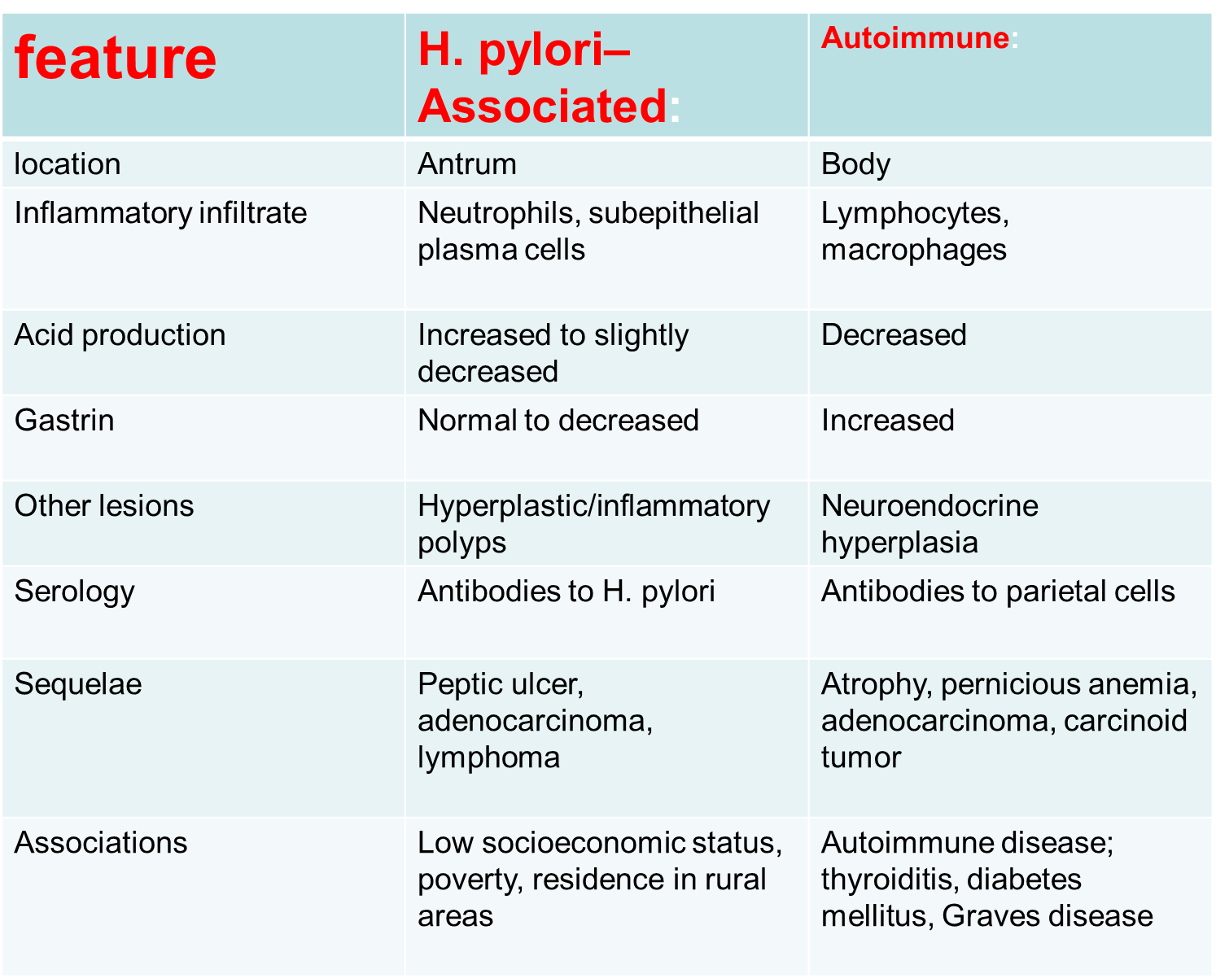

Acute gastric ulcer:

It means the development of: focal, acutely developing mucosal defects.
Causes:
- Non steroidal anti-inflammatory drugs (NSAID).
- May appear after severe physiological stress, whatever it’s nature ,
So it is called (STRESS ulcer) e.g
-After severe burn (CURLING ulcer)
-After head or CNS injury (CUSHING ulcer
- After severe trauma e.g (sepsis and major surgery)

Pathogenesis:
The development of acute mucosal defects in the above causes results from different settings:
1- e.g in case of patient taking NSAID there will be a decrease in PG secretion which has an important protective effect on the mucosa.
2- Direct stimulation to the vagal nuclei (in head traumas) by increased intracranial pressure may cause hypersecretion of gastric acid.
- In severe trauma &burns, systemic acidosis which lowers the mucosal cell PH which are already hypoxic by impaired mucosal blood flow.

Morphologically:
Multiple, small, round-oval, superficial-deep, and may lead to perforation.
Clinical features:
Either asymptomatic or bleeding .
-----------------------------------------

Chronic peptic ulcer:

An ulcer: is a defect in the mucosa causing a discontinuity of the surface epithelium which may extend into the muscularis mucosae into the submucosa, or deeper.
Peptic ulcer: is an ulcer occurring in the areas of the GIT that are exposed to the acid –pepsin secretion as in:
- duodenum
98% of cases
- stomach
- lower esophagus
- margin of gastroenterostomy
- Meckel diverticulum that have an ectopic gastric mucosa

Epidemiology:
- The ratio of duodenal ulcer/ gastric ulcer = 4/1
- Male/female = 3/1 for duodenal ulcer, 2/1 for gastric ulcer
- There is no racial difference in the incidence
- It is characterized by remission and relapse

Pathogenesis:
Peptic ulcer appears to be produced by an imbalance between the gastroduodenal mucosal defense mechanisms and the damaging forces.

Defense forces:
- Surface mucous layer secreted by the epithelial cells.
- Bicarbonate secretion into the mucous.
- Mucosal blood flow
- Apical surface of the mucosal cells protect against back diffusion of H ion.
- Epithelial regenerative capacity
- Elaboration of prostaglandins from adequate blood flow

Aggressive forces:
- Gastric acidity (Hcl) secretion.
- Peptic enzymes.
- Other induced cause:
- H.pylori infection.
- Aspirin
- NSAIDs
- Cigarette
- Alcohol

*This concludes that HYPERACIDITY is not the actual cause because only few patients with D.U (duodenal ulcer) and less than few in G.U (gastric ulcer) have hyperacidity.

*The most important cause for developing GU found to be a decrease in the defense mechanism
-H.pylori infection is the most important cause &present in 70% of GU.
- H.pylori related disorders:

Chronic gastritis – 90%
Peptic ulcer disease – 95-100%
Gastric carcinoma – 70%
Gastric lymphoma
Reflux Oesophagitis.
Non ulcer dyspepsia

*For D.U, H. pylori present in 70-90%
- Genetic susceptibility play role also that is 20-40% of D.U have a +ve family history.
- other diseases associated with D.U e.g:
- Alcoholic cirrhosis
- Chronic obstructive pulmonary diseases
- Hyperparathyroidism
- Chronic renal failure
- Hypercalcemia

Morphologically:
1-site: G.U usually located at the lesser curvature
D.U at the first 2.5 cm of the duodenum
2- size: 2-4 cm, sometimes larger
3- number: usually solitary, sometimes two
- shape: round- oval or margins: punched out appearance, edges overhanging , floor is clean , firm base with variable depth, scarring leads to puckering which appears as puckering or radiating mucosal folds(like spokes)
the margin of the crater are perpendicular but unlike ulcerated cancers, there is no significant elevation or beading of the edges
comparison between benign and malignant ulcer

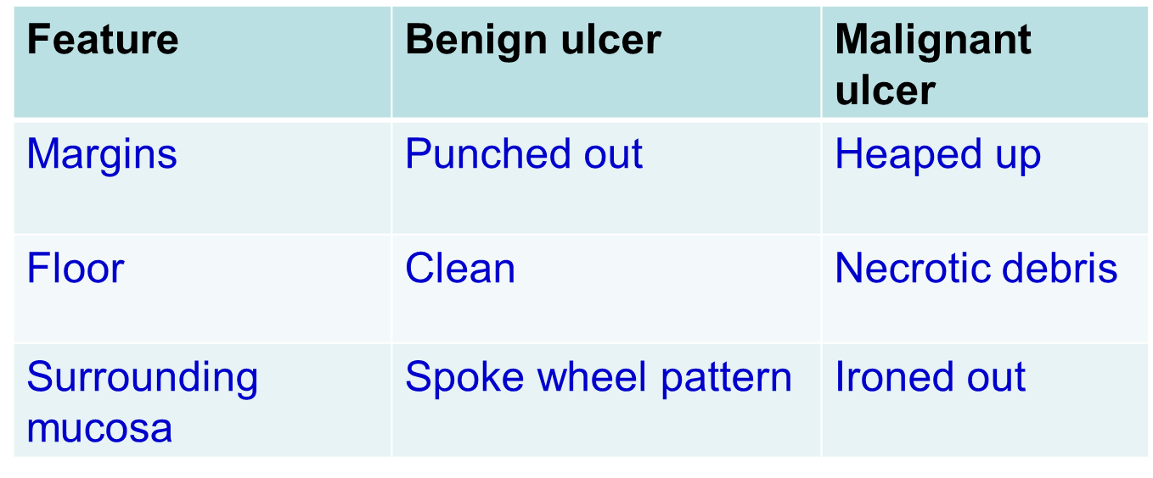

5- Microscopically:
Four zones could be identified.
- Base &margin have a thin layer of necrotic fibrinoid debris
- Beneath is a layer of neutrophilic inflammatory cell infiltration
- In the deeper layers there is a granulation tissue formation.
- The granulation tissue rests on a fibrous tissues scarring.

Clinical features:
- Peptic ulcers are chronic, recurring lesions.
- It occurs most often in middle-aged to older adults.
- A majority of patient complaints is epigastric burning or aching pain,
- Other present with complications such as iron deficiency anemia, frank hemorrhage, or perforation.
- The pain tends to occur 1 to 3 hours after meals during the day, is worse at night, and is relieved by alkali or food.
- Nausea, vomiting, bloating, and belching may be present.
- A variety of surgical approaches formerly were used to treat PUD, but current therapies are aimed at H. pylori eradication with antibiotics and neutralization of gastric acid, usually through use of proton pump inhibitors.
- These efforts have markedly reduced the need for surgical management, which is reserved primarily for treatment of bleeding or perforated ulcers

Complications:
- Healing and scarring: which lead to contracture, caused by contraction of the fibrous scar-→ *pyloric obstruction especially if the ulcer is located in the prepyloric area→ vomiting, dehydration and hyperkalemic alkalosis.* hour-glass deformity, if the ulcer is higher up in the stomach.
- Bleeding: occur in 1\3 of patients &lead to:
  - Hematemesis(coffee ground appearance due to blood hemolysis by acid) and malena
  - iron deficiency anemia due to chronic loss of small amounts of blood
- Perforation: leading to escape of the gut content into the peritoneal cavity→ peritonitis presented with acute abdominal pain &is the major cause of death.
- Penetration: of the ulcer into the adjacent structures e.g small intestine.
- Malignant transformation: occur in less than 1% of G.U
N.B: D.U never show a malignant transformation

