Carbohydrate Metabolism (5)
Dr. Walaa AL - Jedda – 2016

Gluconeogenesis
Gluconeogenesis: The formation of glucose or glycogen from non carbohydrate source.
Some tissues, such as the brain, red blood cells, kidney medulla, lens and cornea of the eye, tests and exercising muscle, require a continuous supply of glucose as a metabolic fuel.
Liver glycogen, can meet these needs for only ten to eighteen hours in the absence of dietary intake of carbohydrates.
During a prolonged fast, hepatic glycogen stores are depleted, and glucose is formed from precursors such as lactate, pyruvate, glycerol and α - ketoacids.
The formation of glucose does not occur by a simple reversal of glycolysis, because the overall equilibrium of glycolysis strongly favors pyruvate formation. Instead, glucose is synthesized by a special pathway, gluconeogenesis.

The principle organs involved in gluconeogenesis are liver and kidneys, as they possess the full complement of enzymes necessary for gluconeogenesis.

During an overnight fast, approximately (90%) of gluconeogenesis occurs in the liver, with the kidneys providing (10%) of the newly synthesized glucose molecules.
However, during prolonged fasting, the kidneys become major glucose producing organs, contributing an estimated (40%) of the total glucose production.

Biomedical importance of gluconeogenesis

1-Gluconeogenesis meets the requirements of glucose in the body when carbohydrates are not available in sufficient amounts from the diet. Even in conditions, where fat is utilized for energy still certain "basal level" of glucose is required to meet the need for glucose for special uses like:
- Source of energy for nervous tissues and erythrocytes,
- Required for maintaining level of intermediates of TCA cycle.
- Source of glyceride-glycerol-p required for adipose tissue.
- It is a precursor of milk sugar (lactose) for lactating mammary gland.
- It serves as only fuel for skeletal muscles in anaerobic conditions.

2- Gluconeogenesis mechanisms are required to clear the products of metabolism of other tissues from the blood, like:
- Lactic acid produced by muscles and erythrocytes.
- Glycerol which is continuously produced by adipose tissues by lipolysis of TG (triacyl glycerol).

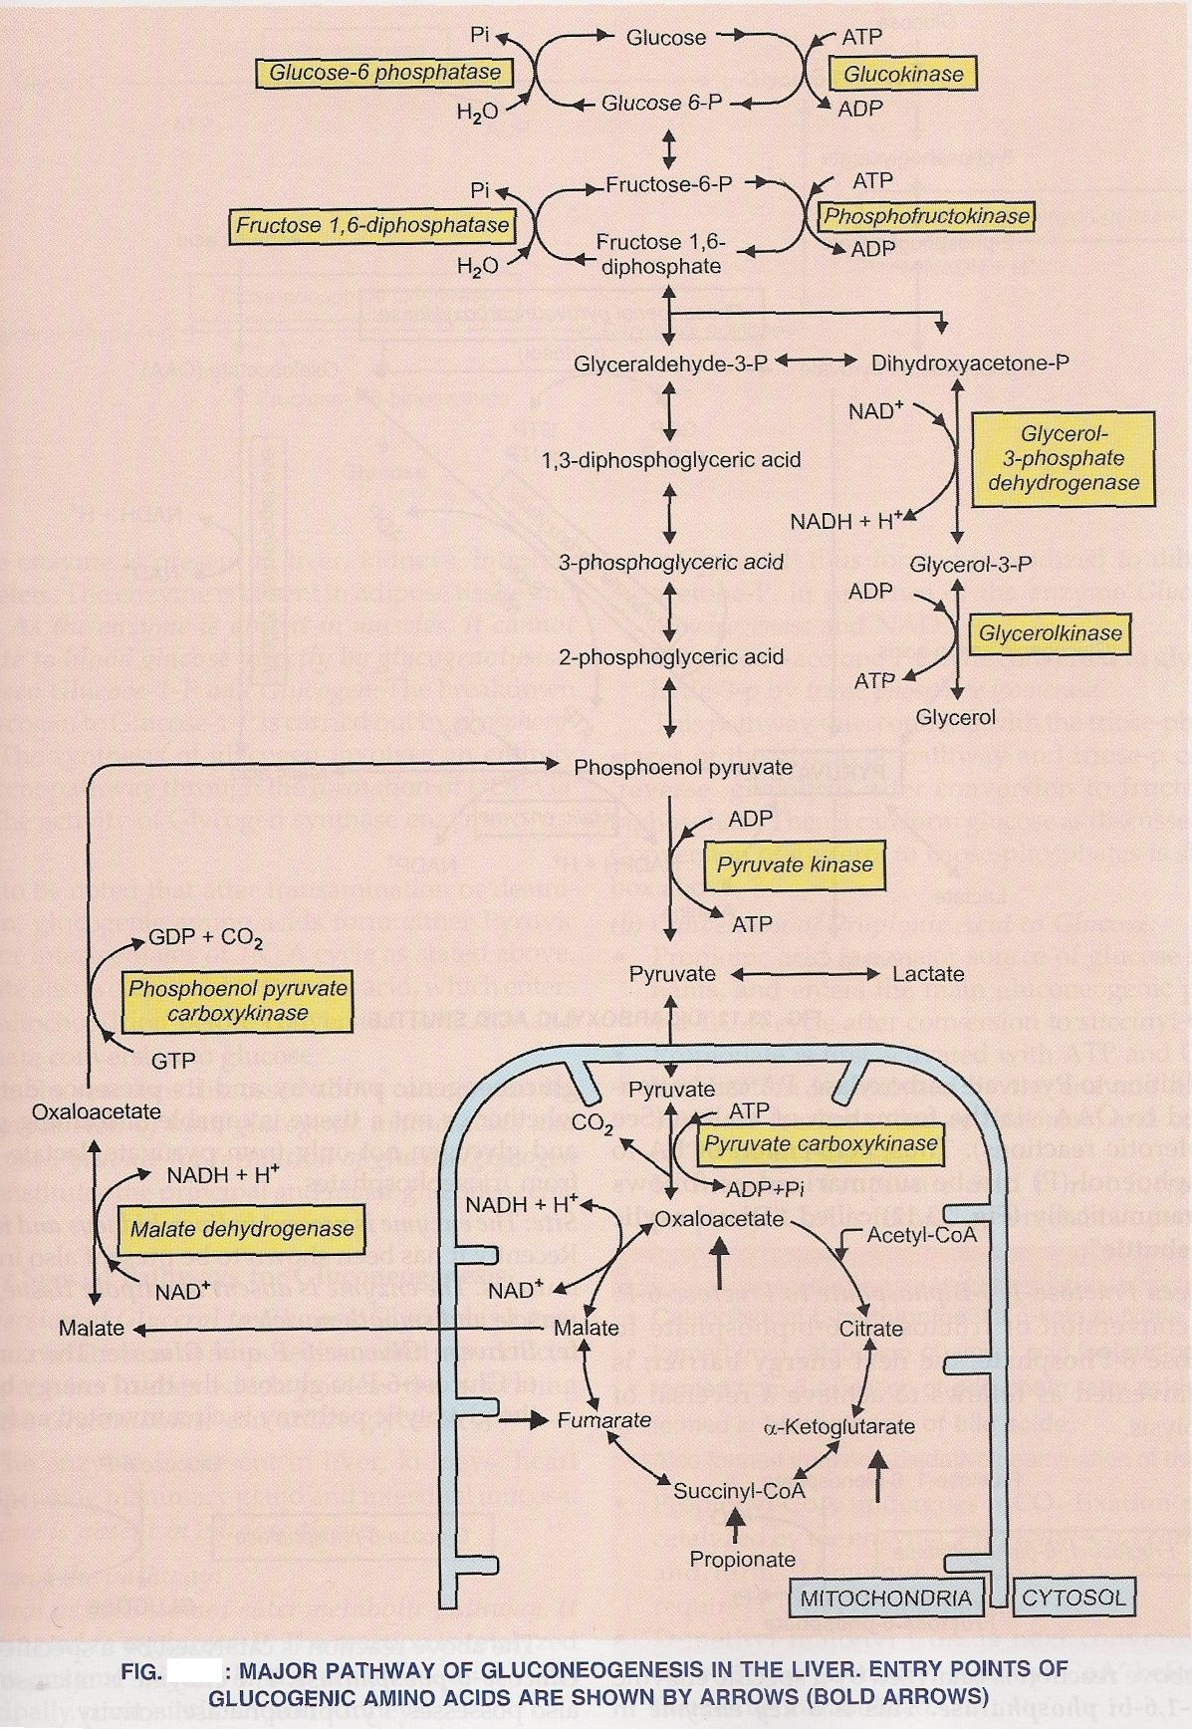
1.
Substrate for gluconeogensis

1-Glucogenic amino acids: Amino acids which form glucose are pyruvate
forming amino acids like alanine, glycine, serine, cysteine, cystine, and threonine. Those that produce intermediates of TCA cycle like oxaloacetic acid and α - ketoglutarate.
These amino acids come from degradation of muscle protein. Some amino acids are released directly into the blood from muscle, or carbons from amino acids are converted to alanine and glutamine and released.
Other amino acids travel to the liver and provide carbon for gluconeogenesis.

**Alanine is the major gluconeogenic amino acid.

2- Lactate and Pyruvate: Source of lactate includes RB cells and exercising muscle.

3- Glycerol: Obtained from lipolysis of fats, glycerol is released during the hydrolysis of triacylglycerols in adipose tissues and delivered by the blood to the liver.

4- Propionic acid: propionyl- CoA is formed in metabolic pathways, which can form glucose.

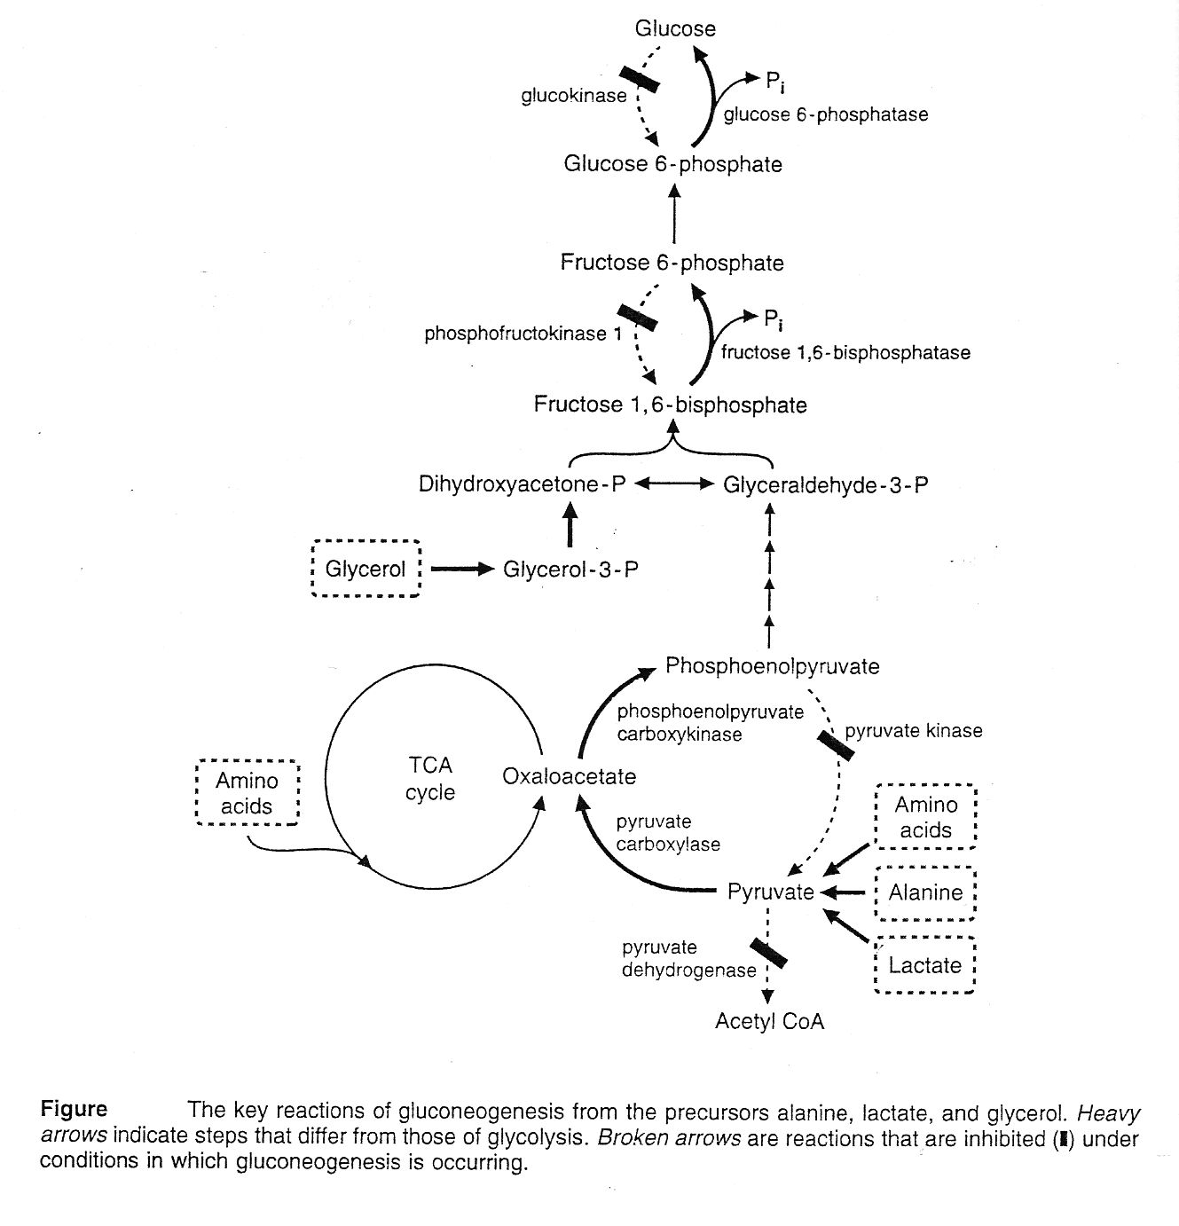
2.
Reactions of gluconeogenesis
1- Conversion of pyruvate to phosphoenol pyruvate (PEP) in the liver:
- Pyruvate which is produced from lactate, alanine and other amino acids, is first converted to oxaloacetate (OAA) by pyruvate carboxylase, a mitochondrial enzyme that requires biotin and ATP.
- OAA can not directly cross the inner mitochondrial membrane. Therefore, it converted to malate or to aspartate, which can cross the mitochondrial membrane and converted to OAA in the cytosol.
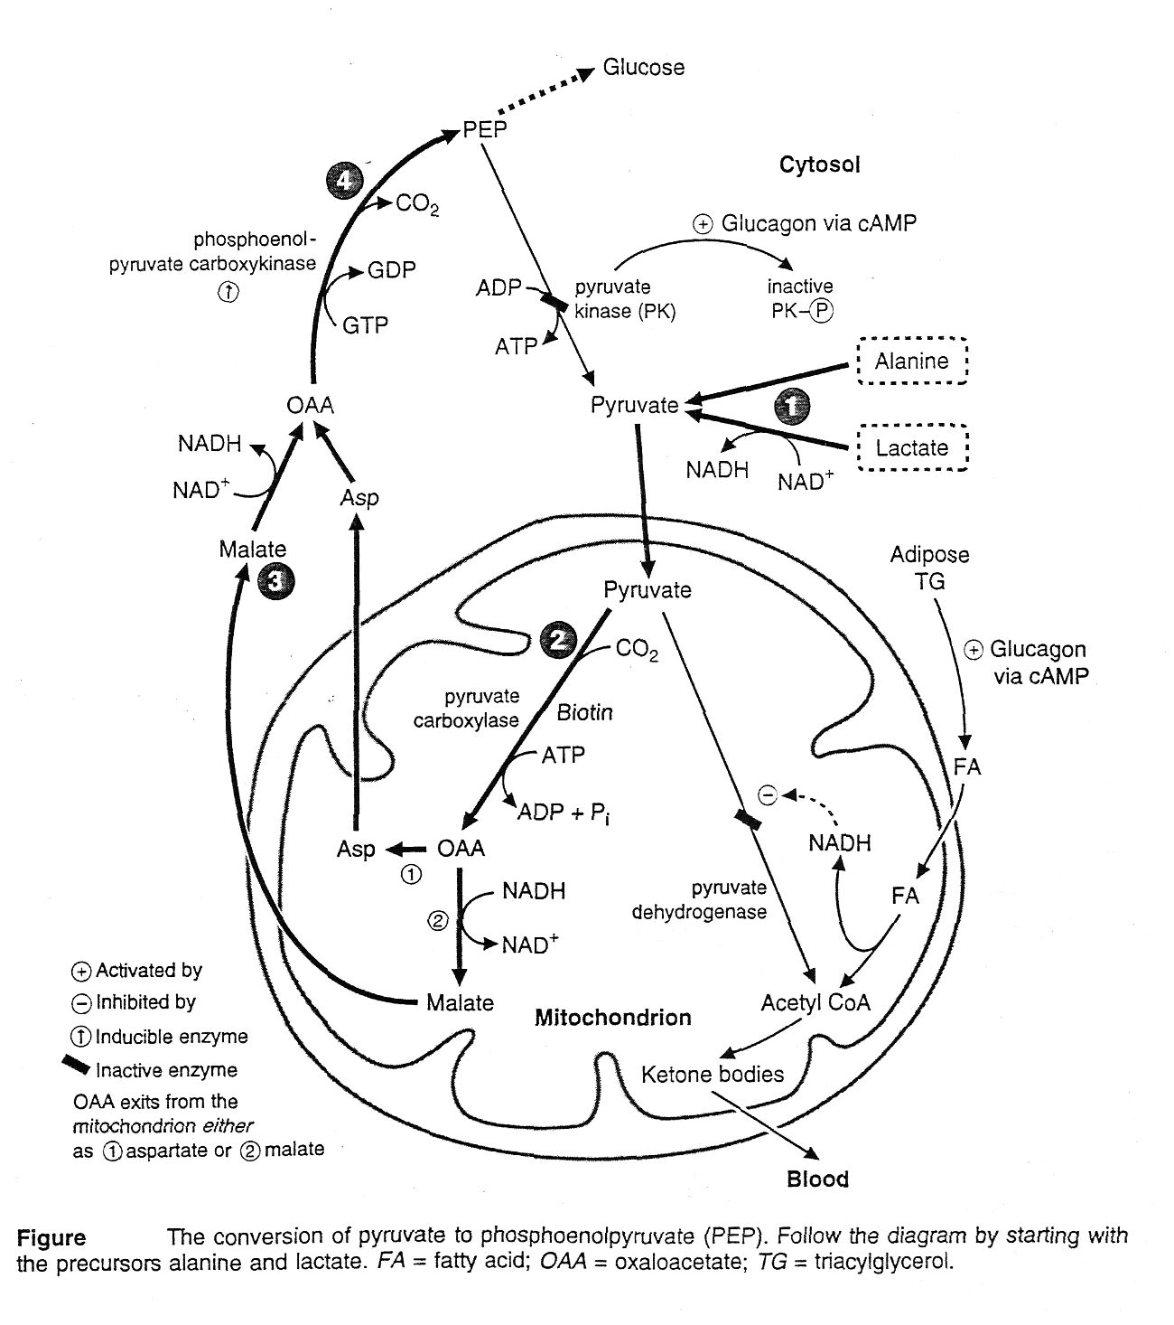
3.

- OAA is decarboxylated by phosphoenol pyruvate carboxykinase, to form PEP.

2- Conversion of fructose 1, 6 – bisphosphate to fructose -6-phosphate
- Fructose 1, 6 – bisphosphate is converted to fructose 6-p in a reaction that releases inorganic phosphate and is catalyzed by fructose1,6- phosphatase.
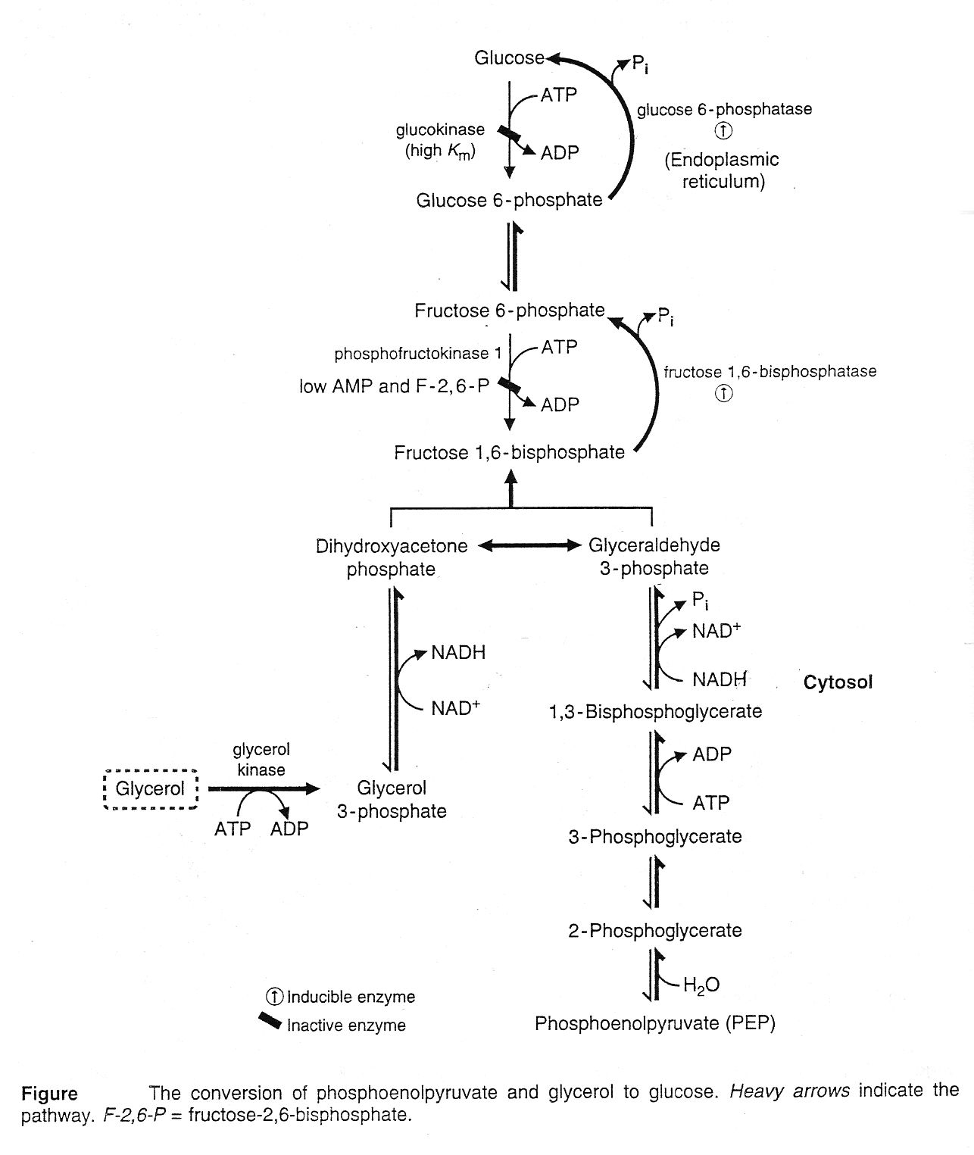
4.

3- Conversion of G-6-P to glucose.
A- G-6-p releases inorganic phosphate, which produces free glucose enters the blood. The enzyme is glucose -6- phosphatase.
B- Glucose-6-phosphatase is involved both in gluconeogenesis and glycogeneolysis.

Regulation of Gluconeogenesis:
Gluconeogenesis achieves the metabolic opposite of glycolysis. Therefore, the two processes wouldn’t be expected to proceed maximally at the same time.
When gluconeogenesis is active, glycolysis is inhibited, and vice versa.

1- Hormones:
- glucagon: under fasting condition, glucagon is elevated and stimulates gluconeogenesis.
- glucocorticoides: they stimulate gluconeogenesis by increasing protein catabolism in the peripheral tissues and increasing hepatic uptake of amino acids.
- insulin reduces gluconeogenesis as it represses the phosphoenol - pyruvate carboxykinase (PEPCK) and glucose -6- phosphatase enzymes.

2- Substrate availability: The availability of gluconeogenic precursors, particularly glucogenic amino acids, significantly influences the rate of hepatic glucose synthesis.

3- Allosteric activation by acetyl COA.
Allosteric activation hepatic pyruvate carboxylase by acetyl COA occurs during fasting.
When acetyl CoA accumulates, this leads to activation of pyruvate carboxylase and inhibit pyruvate dehydrogenease so pyruvate is divert toward gluconeogenesis away from TCA cycle.

4- Allosteric inhibition by AMP.
Fructose 1,6–bisphosphatase is inhibited by AMP, but is activated by citrates.

5- High carbohydrate diet : which reduces gluconeogenesis by increasing the insulin/ glucagon ratio and thereby reducing the activities of all four key regulating enzymes.

Energy requirements for gluconeogenesis

1- From pyruvate.
- Since 2 moles of pyruvate are required to form 1 mole of glucose,
(6) moles of high energy phosphate (ATP) are required for synthesis of 1 mole of glucose.
2- From glycerol.
- Since 2 moles of glycerol are required to form 1 mole of glucose,
(2) moles of high energy phosphate (ATP) are required for synthesis of 1 mole of glucose.

