Renal function test
Both kidneys (300 mg). Each made up of about one million of nephrons (functional units form urine)

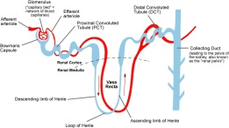
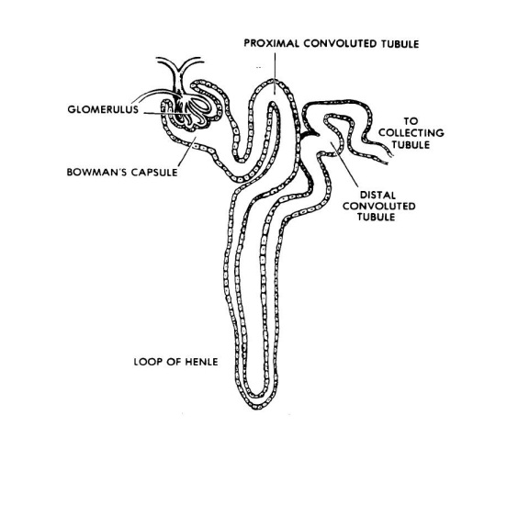
The main mechanisms by which the nephrons clear the plasma of unwanted substances are:
- Filtration(done by the glomerulus):
25% of cardiac output(5L/min)pass to kidney (1100ml/min) about one fifth of this blood is filtered through the glomerulus (by a net filtration pressure of about 15 mmHg) which form about 200 liters/day (ultrafiltrate) but only 2 liters of urine are formed each day (99% reabsorbed).

- Reabsorption:(carried out by the tubules):
Active selective reabsorption of wanted substances such as water, glucose & electrolytes occurs in the tubules leaving the unwanted substances (mainly the nitrogenous waste products of metabolism) pass to urine.

- Secretion: (through the tubular cells)
By direct active secretion of unwanted substance through the epithelial cells that lines the tubules & also through spaces between them. Through the processes of filtration, reabsorption & section, the urine is formed.

Main functions to kidney:
- Excrete waste products of metabolism.
- Regulate the plasma electrolytes, plasma PH & body water content.
- Production of Erythropoietin.
- Production of renin & Prostaglandin.
- The conversion of 25-Hydroxycholecalciferol to active 1,25 Dihydroxycholecaliciferol (active Vit. D3).
- Site of degradation of insulin, glucagon & aldosteron.
Threshold substances:
Glucose and amino acids are completely reabsorbed from the tubules (by specific transport systems in the tubular cells) when they are present in physiological concentration in the filtrate but they are excreted only when their conc. exceeds a particular limit conc. (exceeding reabsorption rate of its transport system) this may occur owing either to elevated plasma conc. (this point is called the threshold value for a specific substance) or to a defect in the transport system. So glucose & amino acids are called high threshold substances, while others substances like creatinine, urea & uric acid are always excreted in urine independently on their conc. In plasma, these are called low threshold substances.
The renal threshold of filterable compounds is therefore that plasma conc. of the substance at which the tubular reabsorptive rate is not sufficiently fast to remove all of the substance from the plasma ultrafiltrate, so that substance spills into the urine.
Raising the plasma glucose & so the filtrate conc., above about (10 mmol/L(180 mg/dl) (renal threshold for glucose ) causes glucose appear in the urine (glycosuria), this is because there is threshold above which reabsorption stops.
Amino acids are reabsorbed in the same kind of way as glucose but on different carrier. The threshold reabsorption is so high that it is rarely exceeded.

Renal function test (RFT):
The main role of RFT 1- to diagnose renal disease 2- to assess the severity 3- to follow its progression.
Renal function tests can be divided into three categories:
- Measurement of substances in the blood that are normally excreted by kidney (mainly urea , creatinine & uric acid)
- Determination of renal clearance.
- Chemical & physical analysis of urine
- One of the major functions of the kidney is the elimination of nitrogenous product of protein metabdism. One should on a fact that there is a big reserve in the kidney for excretion of these products; so creatinine & urea do not increase above normal level in serum, unless there is more than 60% renal damage. So urea & ereatinine estimation is not helpful in the early discovery of renal disease, as one third (30%) of normal nephrons can handle with urea & creatinine and only 5% of normal nephrons is sufficient to keep electrolytes (Na⁺,K⁺,Cl⁻) In normal balance.
Urea: - 20 -45 mg/dl (3.3- 7.5 mmol/L)
Urea is a nitrogen containing metabolic product of protein catabolism. As amino acids are deaminated, ammonia is produced. Ammonia is toxic, so it is converted into urea in the liver. 70% is exerted by kidney & rest by gastro-intestinal tract & skin.
In normal kidney 40-70% of urea diffuses back through the renal tubules into plasma. It is less useful as indicator of renal function due to variability of it blood level as a result of non-renal factors, like mild dehydration, high protein diet, muscle wasting, G.I.T bleeding or increase in protein catabolism, as well as obstruction to urine flow by stone or tumour increase blood urea too.

Significantly high plasma urea conc. always indicated impaired renal flow (this is certain at level above 90 mg/dl). The probability is increased if a cause for renal dysfunction is present or if there are cast or cells in urine. If still doubt send for serum ereatinine which may resolve the problem.
Creatinine: 0.7 -1.4 mg/dl (62-124 micro-mol/L)
Most is produced endogenously by tissue creatine breakdown, about 2% of total creatine converted spontaneously into creatinine which excreted in urine. It is less affected by diet (unlike urea). It is proportional to muscle mass, so it varies with age & sex. Constancy of endogenous creatinine production & constancy of plasma level over 24 hours of day make it a useful substance to measure clearance. However, small quantity reabsorbed by renal tubules & small quantity secreted by tubules (7-10%) to the urine.
Theoretically, creatinine estimations would seem preferable to urea estimation as an index of renal function. If urea & creatinine are significantly raised & if there is oliguria or history suggestive of renal disease, or if there is proteinuria & the urine contains casts, cells, or bacteria in significant amount, the chemical finding can be safely assumed to be due to renal impairment.
Uric acid: 3- 7 mg /dl (180 -420 mmol/L)
It is the end product of purine metabolism. 75% excreted through the kidney. It is completely filtrated through the glomerulus but this then mostly reabsorbed in the proximal tubules. Distal tubular secretion of urate is normally responsible for the presence of urate in urine. With advanced chronic renal failure there is a progressive increase in plasma uric acid. Nevertheless, serum rate level increases only little until G.F.R fall below 20 ml/min.

B-Renal clearance test:
The maintenance of glomerular filtration rate is dependent upon
a-An adequate renal blood flow as well as
b- adequate perfusion pressure.
Glomerular filtration rate can be measured by renal clearance test. More than 60% of the kidney must be destroyed before either plasma urea ore creatinine level is significantly raised. Clearance test which are more sensitive measure the amount of blood which could be completely clear of substance per minute. The amount of a substance removed from the plasma during its passage through the kidney must equal that appearing in the urine i.e.
Plasma conc. X volume of plasma cleared = urine conc. X urine volume
$$Ps×Cs=Vs×V so Cs=\frac{Vs×V}{Ps }$$

$$\frac{creatinine clearnce test:}{creatninie clearnce (ml/min)}= \frac{excretion rate }{plasma conc.}$$

Creatinine clearance (ml/min.) = UV / P

U=urinary creatinine (mg/dl)
V= urine volume (ml/min)
P=plasma creatinine (mg /dl)
N.R. Male= 105 -125 ml/min., Female = 95-115 ml/min
The test is performed by 24- hours urine collection, the bladder is emptied, hydrate the patient, administering a minimum of 600 ml water. Where after all urine passed the time of collection is kept in a single containor, a sample of blood is drawn during the urine collection period. Precise collection of urine using a preservative is essential in this test. The substance that can be chose in such test should fulfill the following criteria:
1-is solely excreted by glomeruli.
2-Not reabsorbed or excreted by the tubules.
It should be noted that clearance test will give equally low values with renal circulatory insufficiency, or with post renal causes, as with true renal damage & cannot distinguish between them.

