Lecture12:
Athletics
Athletics contains the basic human skills; running, jumping and throwing. All these events, except pole vault, were used by Man to survive. It takes place in an oval shaped track of eight lanes that encloses a large field.
Athletics is divided into two events:
1. Track Events
1. Walking Events 2. Hurdles 3.Running events 4. Relay
some words look plural but they are singular in fact. They are ended with -s but they take a singular verb!
- • • • Acronym: news
- • • • Some Diseases: measles, mumps, rickets, shingles.
- • • • Subject Names in –ics : classics, linguistics, mathematics, phonetics,
gymnastics,
athletics.
- • • • Some Games: billiards, darts, dominoes, checkers.
- • • • Some Proper Nouns: Athens, Wales, United Nations, United States.
26
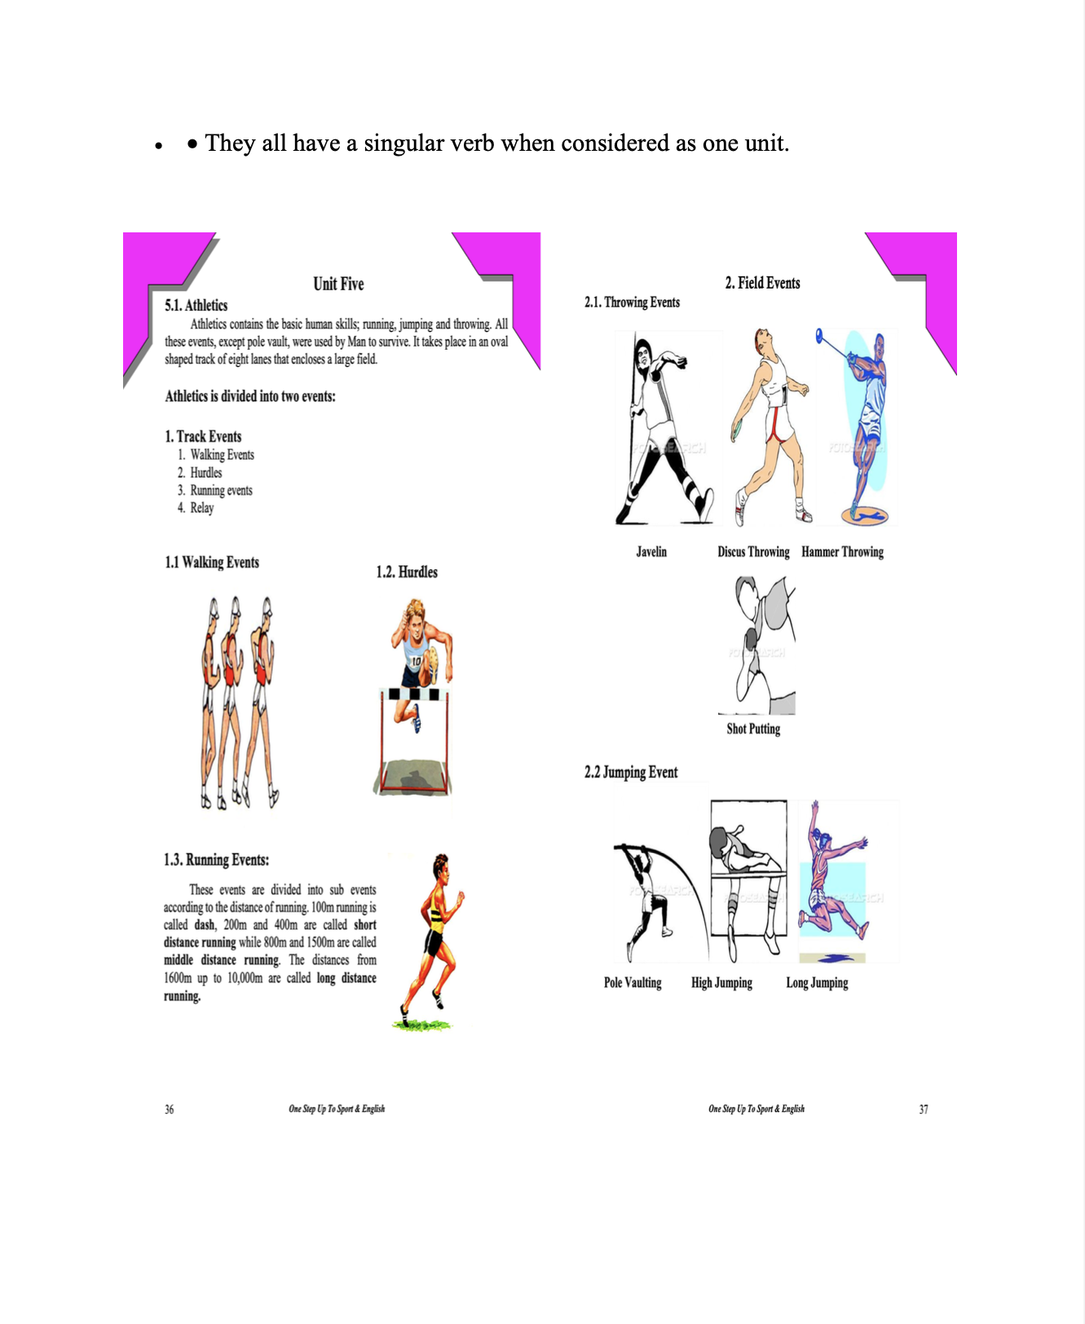
27
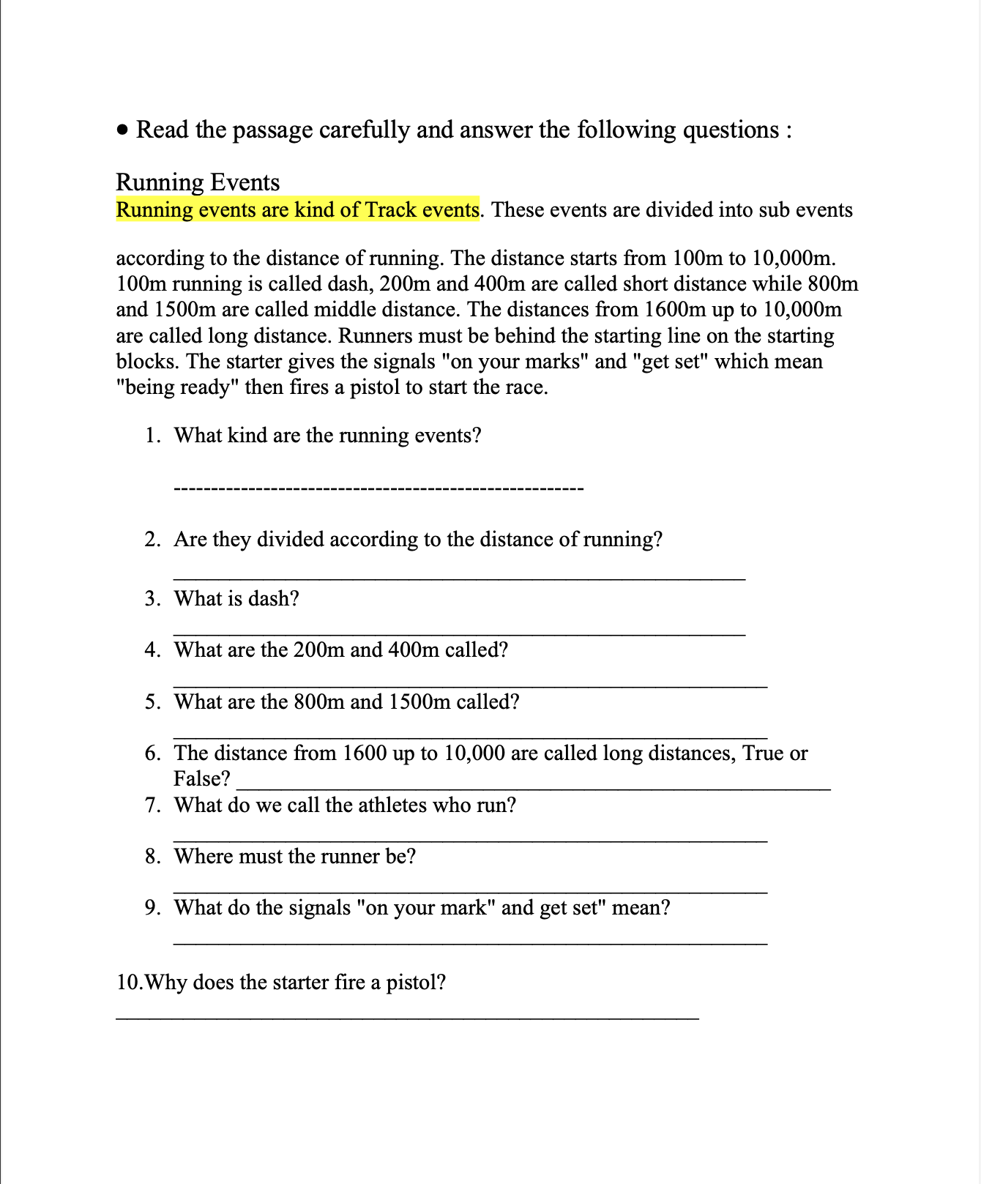
28
29
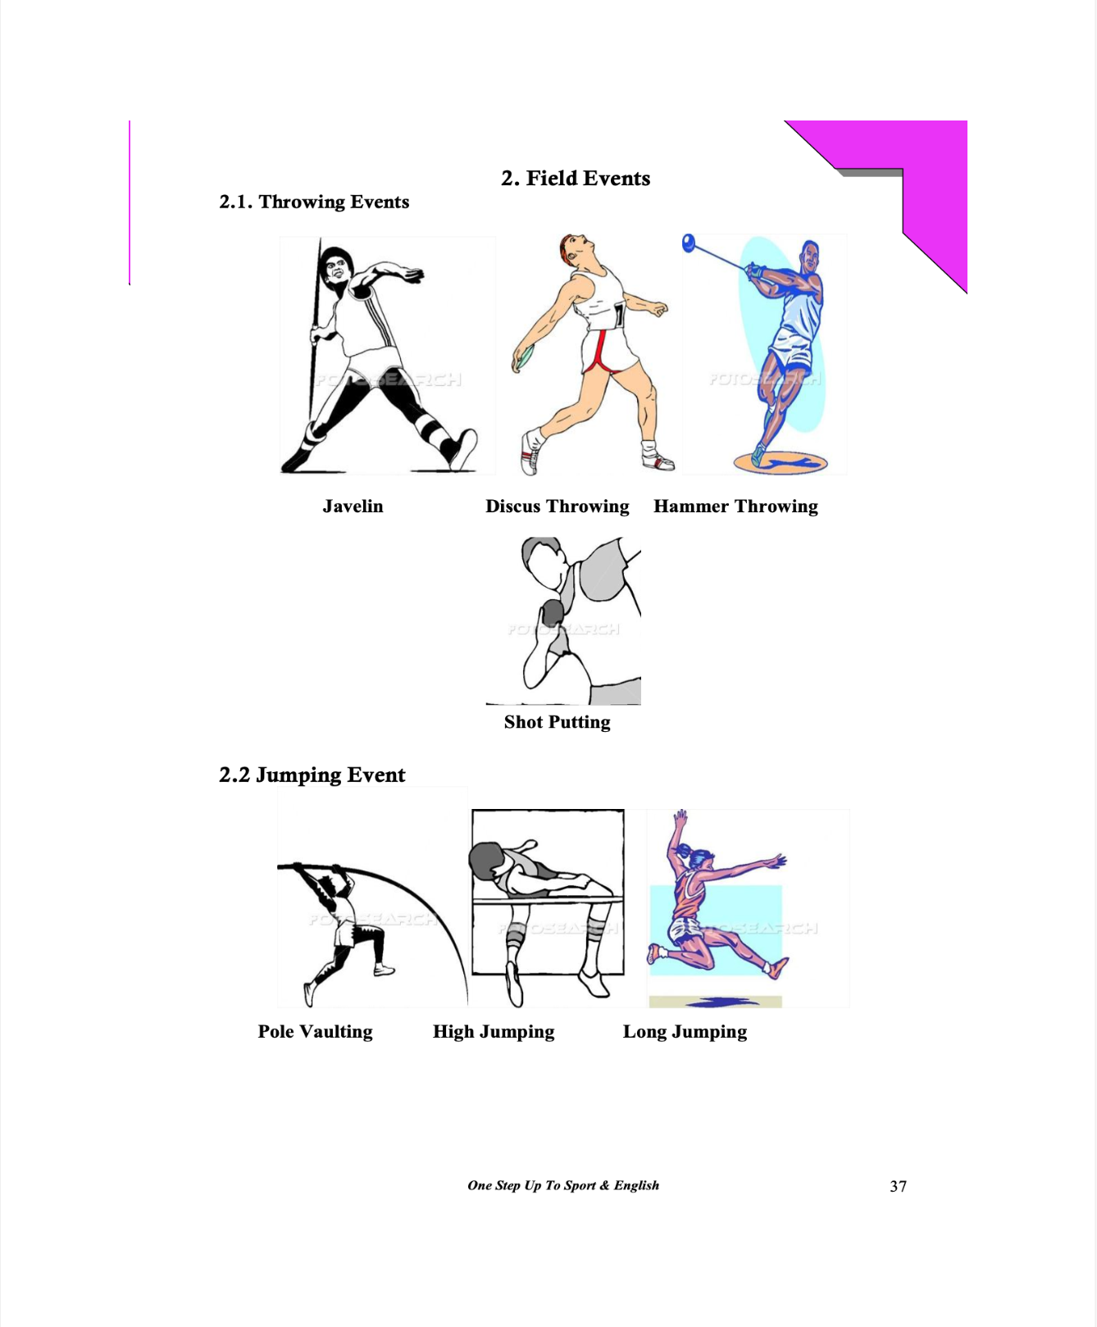
30

