Lec 4 third class
Program (7) :- write a prolog program to find the capital of Iraq, Egypt, Jordan, (using rule)
predicates
information( symbol,symbol).
capital(symbol,symbol).
clauses
capital(baghdad,iraq).
capital(amman,jordan).
capital(cairo,egypt).
information (X,Y):- capital(X,Y).
GOAL : information(A,B).

GOAL: information (A,iraq)

Goal: information (cairo,Z).

Program ( 8 ) :- run this program
Predicates
ask_que(string,string).
clauses
ask_que (Que,Ans):- write (Que, ‘?’),nl, readln(Ans), nl.

Goal: ask_que(“what is your name “, Ans).

- Family Tree
domains 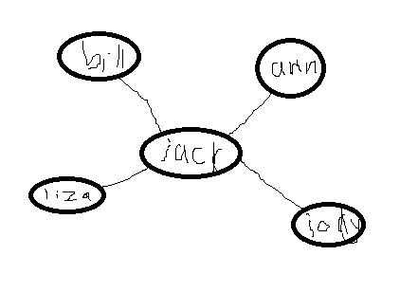
X,Y,Z =symbol.
predicates
parent(x,x).
male(x).
female(x).
grandfather(x,x).
grandmother(x,x).
sister(x,x).
brother(x,x).
uncle(x,x).
aunt(x,x).
clauses
parent(bill,jack).
parent(ann,jack).
parent (jack,liza).
parent(jack,jody).

male(bill).
male(jack).

female(ann).
female(liza).
female(jody).

father (X,Y):- parent (X,Y), male(X).,
mother(X,Y):- parent (X,Y), female(X).

grandfather(X,Y):- parent (X,Z),parent(Z,Y),male(X).
grandmother(X,Y):- parent (X,Z),parent(Z,Y),female(X).

sister(X,Y):- parent (Z,X), parent (Z,Y), female (X).
brother(X,Y):- parent (Z,X), parent (Z,Y), male (X).

uncle (X,Y):- brother (X,Z), parent(Z,Y),male(X) .
aunt(X,Y):- sister(X,Z),parent (Z,Y), female(X).

