Network Layer
The network layer is responsible for carrying data from one host to another. It provides means to allocate logical addresses to hosts, and identify them uniquely using the same. Network layer takes data units from Transport Layer and cuts them in to smaller unit called Data Packet. Network layer defines the data path, the packets should follow to reach the destination.
Network layer : مسؤولة عن نقل البيانات من host إلى آخر. يخصيص عناوين منطقية hosts ، وتحديدها بشكل فريد . تأخذ Network layer البيانات من Transport Layer وتقطعها إلى وحدة أصغر تسمى Packet Data. يحدد Network layer مسار البيانات الذي يجب أن تتبع Packets للوصول إلى الجهة المعنية.

OSI Model:-
OSI stands for Open Systems Interconnection. It has been developed by ISO – ‘International Organization of Standardization‘, in the year 1974. It is a 7 layer architecture with each layer having specific functionality to perform. All these 7 layers work collaboratively to transmit the data from one person to another across the globe.The OSI Model has the following seven layers:

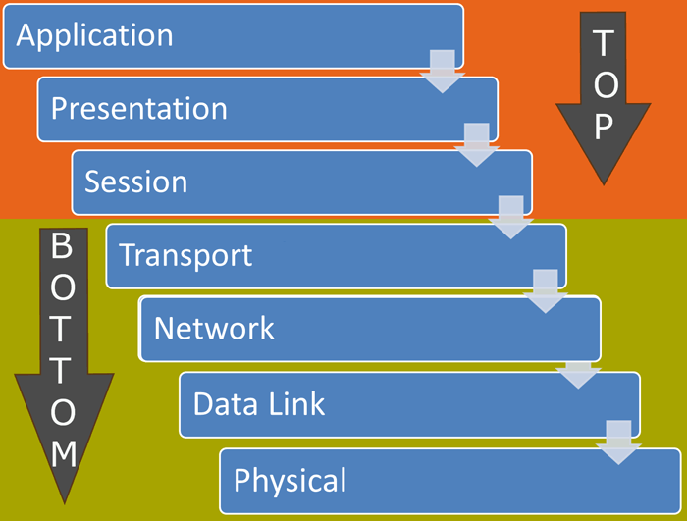

(OSI)Open Systems Interconnection: تم تطويره من قِبل المنظمة الدولية للتوحيد القياسي (ISO) - International Organization of Standardization ، في عام 1974. وهو عبارة عن هيكل مكون من 7 طبقات مع كل طبقة لها وظيفة محددة الأداء. تعمل كل هذه الطبقات السبع بشكل تعاوني لنقل البيانات من شخص إلى آخر في جميع أنحاء العالم. يحتوي نموذج OSI على الطبقات السبع التالية:
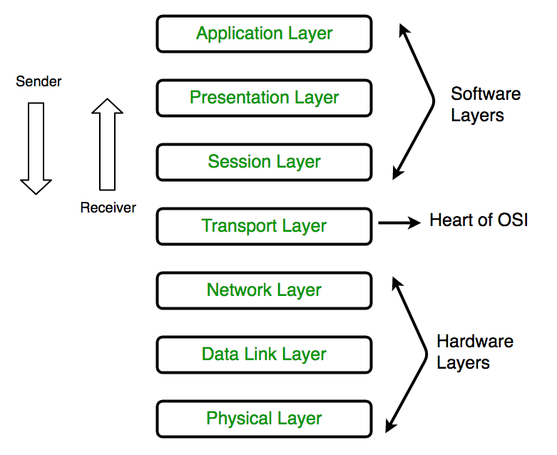

Group | Layer Number | Layer Name | Description
Top Layers | 7 | Application | Provide user interface to send and receive the data
 | 6 | Presentation | Encrypt, format and compress the data for transmission
 | 5 | Session | Initiate and terminate session with remote system
Bottom Layers | 4 | Transport | Break data stream in smaller segments and provide reliable and unreliable data delivery
 | 3 | Network | Provide logical addressing
 | 2 | Data Link | Prepare data for transmission
 | 1 | Physical | Move data between devices

SCENARIO:

OSI Model Layers
Application Layer (Layer-7): At the very top of the OSI Reference Model stack of layers, we find Application layer which is implemented by the network applications. These applications produce the data, which has to be transferred over the network. This layer also serves as a window for the application services to access the network and for displaying the received information to the user.
في الجزء العلوي من مجموعة نموذج الطبقات OSI ، نجد الـApplication layer التي يتم بواسطة تنفيذ تطبيقات الشبكة. هذه التطبيقات تنتج البيانات ، والتي يجب نقلها عبر الشبكة. تعمل هذه الطبقة أيضًا كنافذة لخدمات التطبيقات للوصول إلى الشبكة ولعرض المعلومات المستلمة للمستخدم.
Ex: Application – Browsers, Skype Messenger etc.
**Application Layer is also called as Desktop Layer.
The functions of the Application layer are :
1. Network Virtual Terminal
2. FTAM-File transfer access and management
3. Mail Services
4. Directory Services

Typical protocols:
• FTP – File Transfer Protocol
For file transfer
• Telnet – Remote terminal protocol
For remote login on any other computer on the network
• SMTP – Simple Mail Transfer Protocol
For mail transfer
• HTTP – Hypertext Transfer Protocol
For Web browsing

Presentation Layer (Layer-6):
Presentation layer is also called the Translation layer. The data from the application layer is extracted here and manipulated as per the required format to transmit over the network.
تسمىPresentation layer أيضًا بـ Translation layer. يتم استخراج البيانات من application layer هنا ومعالجتها وفقًا للتنسيق المطلوب للإرسال عبر الشبكة.
The functions of the presentation layer are:
1. Translation: For example, ASCII to EBCDIC.
2. Encryption/ Decryption: Data encryption translates the data into another form or code. The encrypted data is known as the cipher text and the decrypted data is known as plain text. A key value is used for encrypting as well as decrypting data.
3. Compression: Reduces the number of bits that need to be transmitted on the network.

Session Layer (Layer-5):
This layer is responsible for establishment of connection, maintenance of sessions, authentication and also ensures security.
هذه الطبقة هي المسؤولة عن إنشاء الاتصال ، وصيانة الدورات ، والتوثيق ، وكذلك يضمن الأمن.
The functions of the session layer are:
1. Session establishment, maintenance and termination: The layer allows the two processes to establish, use and terminate a connection.
2. Synchronization: This layer allows a process to add checkpoints which are considered as synchronization points into the data. These synchronization point help to identify the error so that the data is re-synchronized properly, and ends of the messages are not cut prematurely and data loss is avoided.
3. Dialog Controller: The session layer allows two systems to start communication with each other in half-duplex or full-duplex.
**All the below 3 layers (including Session Layer) are integrated as a single layer in TCP/IP model as “Application Layer”.
**Implementation of these 3 layers is done by the network application itself. These are also known as Upper Layers or Software Layers.

Transport Layer (Layer-4):
Transport layer provides services to application layer and takes services from network layer. The data in the transport layer is referred to as Segments. It is responsible for the End to End delivery of the complete message. Transport layer also provides the acknowledgment of the successful data transmission and re-transmits the data if an error is found.
توفر Transport Layer خدمات application layer وتأخذ الخدمات من network layer. يشار إلى البيانات الموجودة في Transport Layer على أنها Segments. وهي مسؤولة عن تسليم الرسالة كاملة من End to End. توفر Transport Layer أيضًا إقرارًا بنقل البيانات بنجاح وإعادة إرسال البيانات في حالة العثور على خطأ.
- At sender’s side:
Transport layer receives the formatted data from the upper layers, performs Segmentation and also implements Flow & Error control to ensure proper data transmission. It also adds Source and Destination port number in its header and forwards the segmented data to the Network Layer.
تستقبل Transport Layer البيانات المنسقة من الطبقات العليا ، وتنفذ التقسيمات وتنفذ أيضًا التحكم في التدفق والخطأ لضمان نقل البيانات بشكل صحيح. كما يضيف رقم منفذ المصدر والوجهة في رأسه ويعيد توجيه البيانات المقسمة إلى network layer.
• At receiver’s side:
Transport Layer reads the port number from its header and forwards the Data which it has received to the respective application. It also performs sequencing and reassembling of the segmented data.
تقوم Transport Layer بقراءة رقم المنفذ من الرأس وتحويل البيانات التي تلقتها إلى التطبيق المعني. كما أنه ينفذ التسلسل وإعادة تجميع البيانات المجزأة.
Typical protocols:
• TCP – Transmission Control Protocol
Provide further the functions such as reordering and data resend
• UDP – User Datagram Service
Use when the message to be sent fit exactly into a datagram
Use also when a more simplified data format is required
Network Layer (Layer-3):
Network layer works for the transmission of data from one host to the other located in different networks. It also takes care of packet routing i.e. selection of the shortest path to transmit the packet, from the number of routes available. The sender & receiver’s IP address are placed in the header by network layer.
تعمل Network Layer على لنقل البيانات من host إلى آخر موجود في شبكات مختلفة. كما أنه يأخذ في الاعتبار توجيه الـ packet ، أي اختيار أقصر مسار لنقل الـ packet ، من عدد المسارات المتاحة. يتم وضع عنوان IP الخاص بالمرسل والمستقبل في header حسب Network Layer.
The functions of the Network layer are :
- Routing: The network layer protocols determine which route is suitable from source to destination. This function of network layer is known as routing.
- Logical Addressing: In order to identify each device on internetwork uniquely, network layer defines an addressing scheme. The sender & receiver’s IP address are placed in the header by network layer. Such an address distinguishes each device uniquely and universally.
* Segment in Network layer is referred as Packet.
** Network layer is implemented by networking devices such as routers.

Typical protocols:
• IP – Internet Protocol
Provide packet delivery
• ARP – Address Resolution Protocol
Define the procedures of network address / MAC address translation
• ICMP – Internet Control Message Protocol
Define the procedures of error message transfer

Data Link Layer (DLL) (Layer-2): This layer takes the raw transmission data (signal, pulses etc.) from the Physical Layer and makes Data Frames, and sends that to the upper layer and vice versa. This layer also checks any transmission errors and sorts it out accordingly. When a packet arrives in a network, it is the responsibility of DLL to transmit it to the Host using its MAC address.
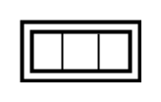
تأخذ هذه الطبقة بيانات النقل الأولية (إشارة ، نبضات وما إلى ذلك) منPhysical Layer وتصنع Data Frames ، وترسل ذلك إلى الطبقة العليا والعكس. تقوم هذه الطبقة أيضًا بفحص أي أخطاء في الإرسال وترتيبها وفقًا لذلك. عندما تصل الحزمة packetإلى إحدى الشبكات ، تكون مسؤولية DLL نقلها إلى host باستخدام عنوان MAC الخاص بها.
The functions of the data Link layer are :
- Framing: Framing is a function of the data link layer. It provides a way for a sender to transmit a set of bits that are meaningful to the receiver. This can be accomplished by attaching special bit patterns to the beginning and end of the frame.
- Physical addressing: After creating frames, Data link layer adds physical addresses (MAC address) of sender and/or receiver in the header of each frame.
- Error control: Data link layer provides the mechanism of error control in which it detects and retransmits damaged or lost frames.
- Flow Control: The data rate must be constant on both sides else the data may get corrupted thus , flow control coordinates that amount of data that can be sent before receiving acknowledgement.
- Access control: When a single communication channel is shared by multiple devices, MAC sub-layer of data link layer helps to determine which device has control over the channel at a given time.

Physical Layer (Layer-1): This layer deals with hardware technology and actual communication mechanism such as signaling, voltage, cable etc.
The lowest layer of the OSI is the physical layer. It is responsible for the actual physical connection between the devices. The physical layer contains information in the form of bits. It is responsible for the actual physical connection between the devices. When receiving data, this layer will get the signal received and convert it into 0s and 1s and send them to the Data Link layer, which will put the frame back together.
تتعامل هذه الطبقة مع تكنولوجيا الأجهزة وآلية الاتصال الفعلية مثل signaling, voltage, cable ، إلخ. الطبقة الدنيا من الـ OSI هي الطبقة المادية physical layer. وهي مسؤولة عن الاتصال الفعلي بين الأجهزة. تحتوي الطبقة المادية physical layer على معلومات في شكل وحدات bits. وهي مسؤولة عن الاتصال الفعلي بين الأجهزة. عند تلقي البيانات، فإن هذه الطبقة تحصل على إشارة ثم تحولها إلى 0 و1 و إرسالها إلى physical layer ، مما سيضع frame لكلاهما.

