Classification of fungi :
Classification : is the systematic arrangement of organisms into groups based on specific standards .
Standard Endings :
Division ………....mycota
Sub division …….mycotina
Class …………….mycetes
Subclass………….mycetidae
Order ……………ales
Family …………..aceae
Writing scientific name: The first letter of the genus written with a capital letter , while the species with small letter, The scientific name written in italics or underlined .ex: aspergillus niger
Aspergillus niger OR Aspergillus niger
The fungal characteristics that use in Classification :
- Cell wall
- The cell wall chemical component
- Somatic phase
- Reproduction
- The structural that formed by fungi
- Fruiting bodies
- Spores

Fungal Webster , Weber and Hibbett Classification(2007):
- Kingdom : protozoa (protista)
Phylum : myxomycota
Phylum : plasmodiophoromycota
- Kingdom : Chromista (Stramenopila)
Phylum : Hyphochytriomycota
Phylum : Labrinthulomycota
Phylum : Oomycota
- Kingdom : Fungi
Phylum : Chytridiomycota
Phylum : Zygomycota
Phylum : Ascomycota
Phylum : Basidomycota
Phylum : Deutromycota

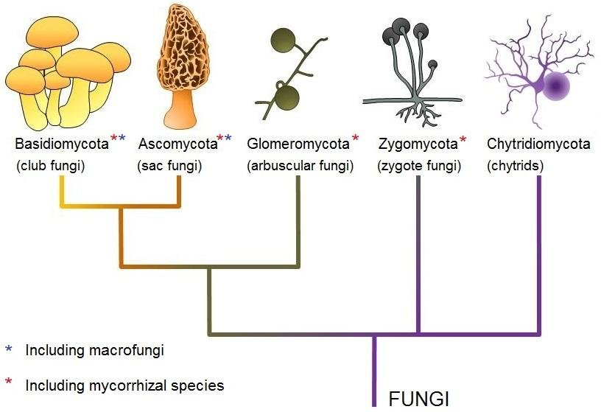
Deutromycota

Figure (1) kingdom fungi

Kingdom : protozoa (protista)
- No cell wall so also called Gymnomycota
- Phagotrophic nutrition .
- Somatic phase are plasmodium .
- Plasmodium: protoplasmic mass Similarity Amoeba , multinucleated also called true slime mold.
- Pseudo Plasmodium : Accumulation of Amoeba cells surrounded by membrane , also call cellular slime mold.
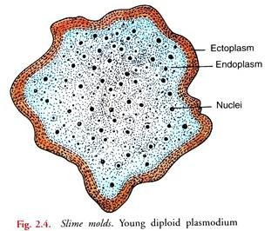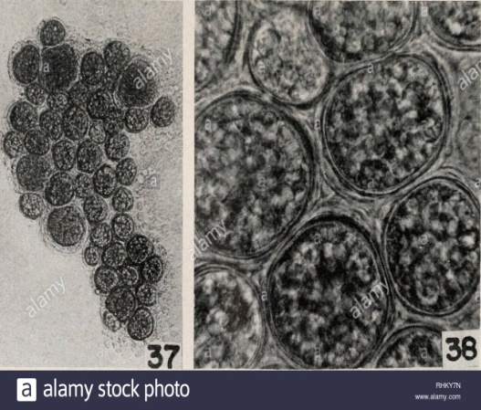
B
A
Figure (2) (A)plasmodium (B) Pseudo Plasmodium

Type of plasmodium
- Protoplasmodium : microscopic,slow movement,produce one sporangium .
- Aphanoplasmodium : grow as Protoplasmodium at the beginning , and then it will change into net work .
- Phaneroplasmodium : grow as Protoplasmodium at the beginning then it will change into granular and more density plasmodium . it is visible .
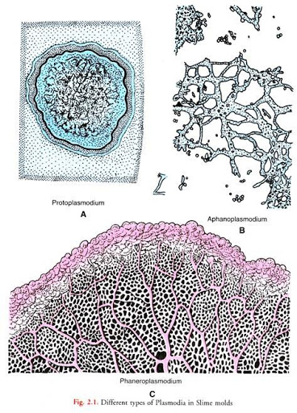
Figure (3) type of plasmodium

