Economic importance of fungi
Fungi have both positive and negative roles in our daily life. So they are our friends as well as enemy.
- Benefit of fungi :
Directly or indirectly fungi are beneficial to human being. Fungi is used in medicine industry, as food, in food preparation, in other industry and also in agriculture. Some of the useful activities are:
- Preparation of Medicine:
Different types of fungi are used in the production of important numbers of drugs. The most important species are Penicillium notatum, Claviceps purpurea, Saccharo myces cerevisiae, Aspergillus proliferous etc.
- Antibiotics
are the metabolic product of some micro­organisms which are active against other microorganism . wonder drug Penicillin from Penicillium notatum. and drug Fusidin( Fusidic acid) from Fusidium coccineum .
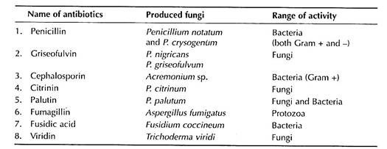
- Vitamins:
Vitamins are the micronutrients required for the growth of living organisms. Vitamin B-complex, Vitamin A and Vitamin B-12 are found respectively from Saccharomyces cerevisiae, and Eremothemium ashbyii.
(c) Steroid:
Rheumatic arthritis, allergy and some other diseases are con­trolled by steroid. Many fungi have the capacity to synthesize different steroids. Steroid like cortisone is produced by Aspergillus niger from plant glycosides by fermentation.
(D) Alkaloid:
Several alkaloids are produced and accumulated in the sclerotium of Claviceps purpurea which causes Ergot disease of rye. Out of several alkaloids, Ergo- metrine and its semisynthetic ana­logues like methyl ergometrine and methyl ergometrine maleate have notable uterine action; those control haemorrhage of mother during child’s birth, having side- effect with increase in blood pres­sure and decreased milk secretion
- Foods
Fungi are used as food by humans from a long time ago. Some fungi have been used directly as food and some are used in food processing:
Direct Use:
Fruit bodies of some fungi, like Mushroom and truffles. are used as food due to their high protein con­tent (21-30% on dry weight) and have good amount of lysine, an amino acid; minerals like Na, Ca, K and P; Vitamins like B, C, D and K and very little amount of fat. These are recommended as ideal foods for heart patients and diabetes. The above-mentioned fungi can grow artificially at the commercial level. Mushroom cultivation has recently gained considerable popularity and has contributed to the national economy in some East Asian countries.
Mushroom 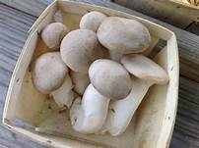
3. Fungi in Industry:
Many fungi are used in the production of alcohol, bread, cheese, enzyme and organic acids.
(a) Alcohol Production:
Alcoholic fermentation by fungi is the basis of brewing industry. The enzyme zymase of microorganisms like yeast is responsible for alcohol production. Wines are produced from grapes or other fruits by Saccharomyces ellipsoideus with about 14% alcohol concentration. Beer is brewed from barley malt by Saccharomyces cerevisiae with 3-8% alcohol production.
(b) Bread and Cake Production:
During alcoholic fermentation by yeast, CO₂ being released as bubbles are used in baking industry to make the breads and cakes as spongy in appearance.
(c) Cheese Production:
Some species of Penicillium (P. roquiforti and P. camemberti) are used in the production of Roquefort and Camembert cheese by hydrolysis of fats and also to develop specific flavour to cheese.
(d) Enzyme and Organic acid Production:
Many fungi are used in the commercial production of enzymes and different organic acids .
List of some fungi along with produced enzymes and/or acids and their uses are given:
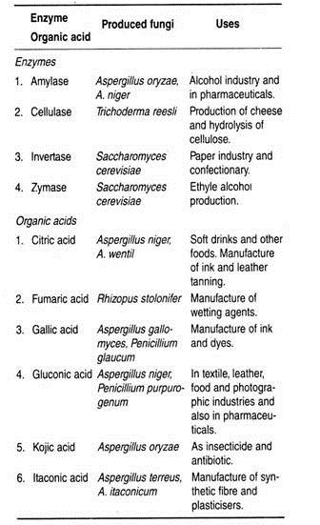
4. Soil Fertility:
Decomposition of litter and wood, mainly in the forest, takes place by the combined action of diffe­rent type of fungi. Fungi like Fusarium, Chaetomium, Chitridium, Penicillium, Aspergillus etc., can decompose the structural polymers such as cellulose, hemicellulose, lipid, protein, starch etc.
By decomposing the organic matters, fungi help to increase minerals and other sub­stances, thereby the fertility of soil is increased.
5. Plant Nutrition:
Several fungal members like Rhizoctonia, Tricholoma, Boletus, Phallus, Amanita etc., associated with the roots of higher plants form mycorrhizal relationship. The fungal partner supplies water and minerals and in turn, they take nutrition from the plant.
6. As Insecticide:
Fungi like Cordyceps sp. , are used as insecticides to control different types of insects.
7. Biological Research:
Fungi like Neurospora, Yeast etc., have been used in genetical and cytological studies. Physarum polysephalum has been used to study DNA-synthesis .
9. Test Organism:
Some strains of Aspergillus niger have been used to detect trace elements like Zn, Cu, and Mo, even if the substances are present in very minute quantity in the substrate. These elements when absorbed by the fungus give a particular colour to the conidia. Similarly, Neurospora crassa has been used to detect Vitamin B complex .

10. Production plant hormone:
Some fungi are used to produce plant hormone like Gibberellin by soil fungus Gibberella fujikuroi .
11. Biological control:
The antagonistic activity of some fungi like Trichoderma sp. showed that it is parasitic on many soil-borne and foliage pathogens. Trichoderma sp. is being used to control plant diseases in sustainable diseases management systems, Beauveria bassiana is a naturally occurring fungus in soils throughout the world and has been researched for control of soil borne insects e.g. the beetle in Europe,

Harmful Activities of Fungi:
Fungi are also harmful to the human beings in various ways, either directly or indirectly. They may cause diseases of plants, human beings, and animals; spoilage of food etc.
1. Fungi Causing Plant Diseases:
Fungi cause several minor and major plant diseases. Some of them also cause famine in different parts of the world. such as late blight of potato diseases cause by phytophthora infestans and damping of seeding diseases cause by pythium debaryanum white rust cause by family albuginaceae and family peronosporaceae cause downey mildew etc.
2. storage fungi cause rot in fruit and food .
Poor storage of crops and fruits leads to the growth of fungi causing high economic losses like Penicillium sp. cause green rot on fruit and Aspergillus sp. cause black rot in fruit and Aspergillus flavus cause green rot in grains etc.
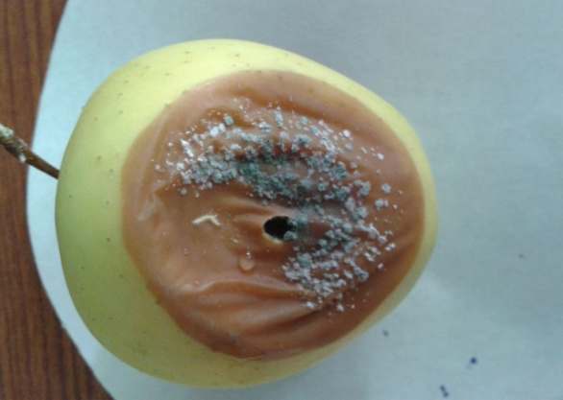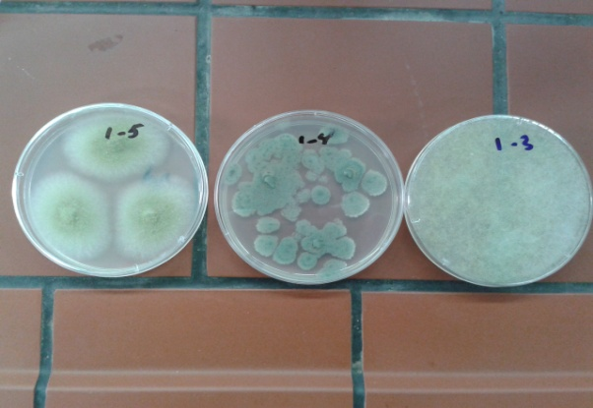
rot fruit some storage fungi isolation
3. Fungi Causing Human and animals Diseases:
Some fungi parasitism on humans and animals, causing infections of the skin, hair or nails like Malassezia species ,and dermatophytes which have the ability to use keratin as a nutrient source so have a unique enzymatic capacity [keratinase]by Trichophyton rubrum etc.
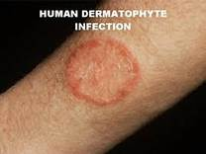
In animals fungi like Saprolegnia parasitica, an aquatic fungi live as parasite on egg and gills of fishes. also Achlya sp. cause severe damage to fishes.
4. Production of fungal toxins
Some fungi have the ability to produce toxic secondary metabolite call mycotoxins which have a role in the infection of some diseases in both humans and other animals ,The adverse health effects of mycotoxins range from acute poisoning to long-term effects such as immune deficiency , Liver and kidney fibrosis and cancer. such as patulin , aflatoxin , Ergot Alkaloids , Ochratoxin etc .
5. Hallucinogenic Drug:
LSD (d-lysergic acid diethylamide), the well-known hallucinogenic drug, is extracted from the sclerotia of Claviceps purpurea, the causal agent of ergot disease of rye. Other fungi like Psilocybe mexicana produce Psilocin and Psilocybin that have hallucinogenic properties. The hallucinogenic substances may destroy brain cells and cause distortion of perception power of human beings.
6. damage of clothes :
fungi can grow on wet clothes and shoes thus causing damage to them. Clothes made from natural fibers such as cotton, linen, rayon, wool and silk are more susceptible to microbial damage than those made from synthetic fibers. Mold on clothes produce enzymes that breakdown the cellulose or protein to compounds which the mold use as food ex: Aspergillus niger .
6. damage of paper and wood :
Filamentous fungi belonging to the Ascomycota phylum are the main microorganisms deteriorating paper-based collections worldwide, being mainly responsible for the appearance of different colour patches with biological origin on paper , including genera Aspergillus, Penicillium, Chaetomium etc.

7. Building materials damage

Stachybotrys chartarum is a black mold that produces its conidia in slime heads. It is sometimes found in soil and grain, but the mold is most often detected in cellulose-rich building materials from damp or water-damaged buildings. It requires very high moisture content in order to grow and is associated with wet gypsum material and wallpaper .

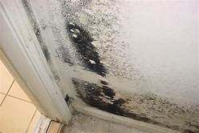

Stachybotrys chartarum

LAB 1 Kingdom fungi

LAB 2 Economic Importance of Fungi

Fungi Practical Second class

2019 -2020

